Jerry Olds

1001533643

CSE-4344-001

12/03/2019

Project 3

1. ipconfig /all

IP address of the machine: 129.107.53.182  
How did the machine obtain this IP address: DHCP   
Subnet: 255.255.255.0  
MAC address: 64-00-6A-87-51-A1  
How does NIC card obtain this MAC address: Assigned by manufacturer of NIC  
DNS servers addresses: 129.107.35.89, 129.107.56.180

ipconfig /renew

Lease Expires time has changed

(*Sorry about phone screenshots, school WiFi was not working and Maverick Activity Center computers would not let me print screen)

2. ping omega

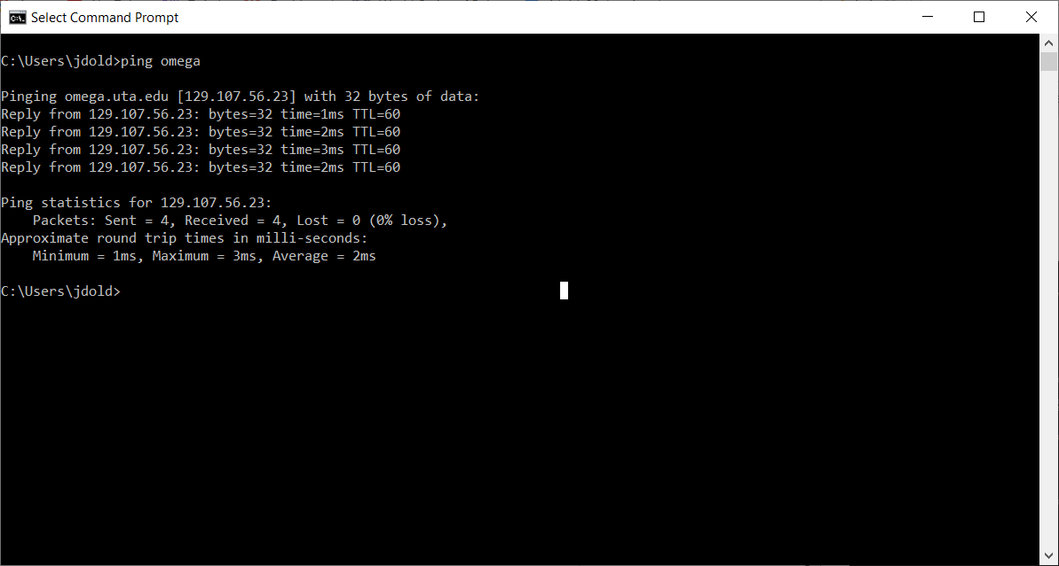

Conclusions from PING results:  
1. Packets sent and received reliably because close proximity to omega servers. The farther the machine is from the omega servers, the higher the chance that packets aren’t received.  
2. The round trip time of package is quick due to close proximity of machine to omega servers (very little propigation delay)  
3. The farther the machine from the servers, the higher the propigation delay and round trip time of packets take longer.

3. ping [www.utexas.edu](http://www.utexas.edu)

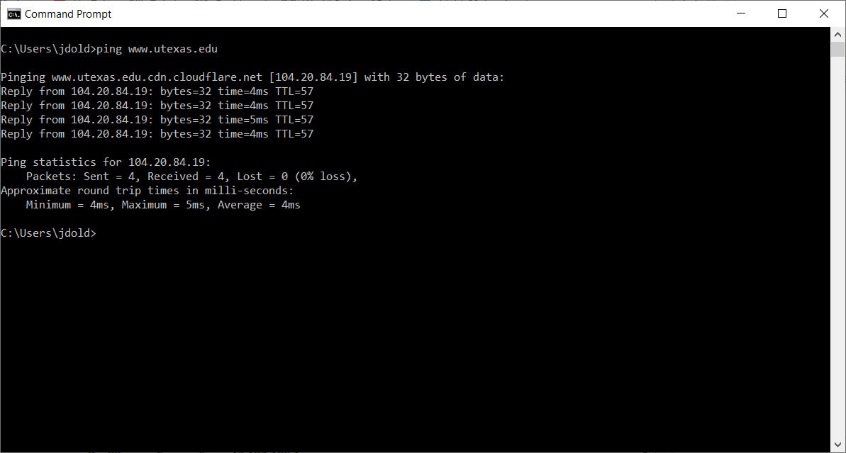

Because the machine is farther away from the utexas servers, the round trip times of the packets are longer.

4.

a) The box you get the first response from is usually the router or access point that your machine is connected to.

b) With a tracert, you see how many hops from machine to machine it takes for a packet to reach its final destination. You don’t see the individual hops with the ping command.

5.

a) Traveling across the ocean is the reason why hop 10 took so long.

b) 111.90909091

6. University of Texas at Arlington owns this IP address. UTA owns IP addresses from 129.107.0.0-129.107.255.255, so UTA owns 255 * 255 = 65,025 IP addresses

7. 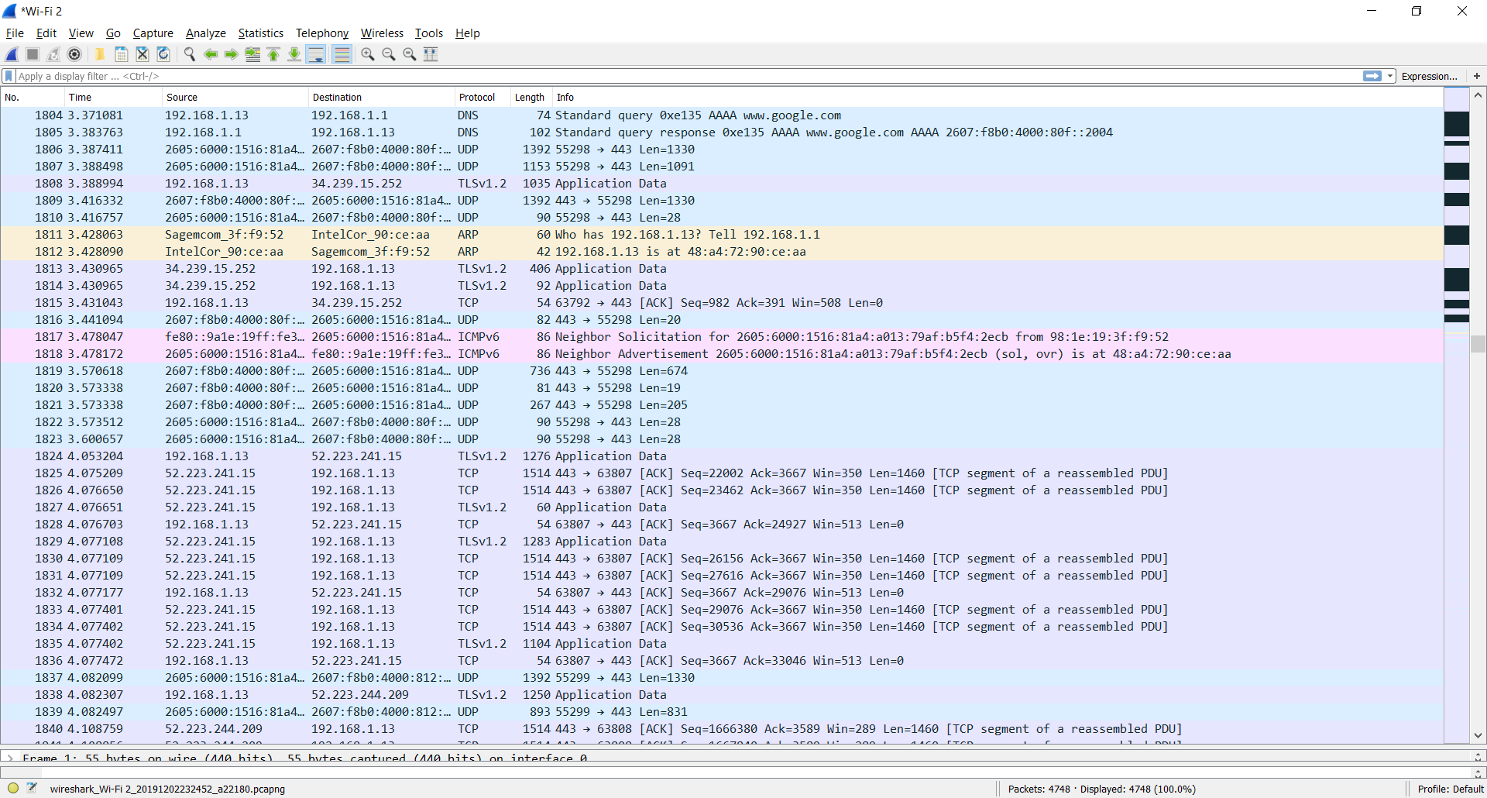

(May have to zoom)