BODY SIZE FROM UNCONVENTIONAL SPECIMENS

Jonathan Dombrosky | [jdombrosky@crowcanyon.org](mailto:jdombrosky@crowcanyon.org)

10/22/2021

# INTRODUCTION

This Rmarkdown file is organized into six major sections: Introduction, Packages Needed, Validating Centroid Size-Based Body Size Reconstruction, Archaeological Body Size Estimations, Modern Comparisons, and Intra- Interindividual Error Testing. This file corresponds to analyses and figures produced in the manuscript *Body Size from Unconventional Specimens*. However, it also provides supplemental figures and analyses not presented in the body of the manuscript. All data are directly imported from their most raw formats (housed in corresponding folders in this Supplemental file) so that data manipulation is explicit and analyses are reproducible. The section *INTRA- AND INTERINDIVIDUAL ERROR TESTING* and the subsection *Error Associated with SL to TL Length-Length Conversion* are referenced to in the manuscript but statistical analyses and interpretation are presented here.

# PACKAGES NEEDED

library(geomorph)  
library(dplyr)  
library(tidyr)  
library(ggplot2)  
library(effectsize)  
library(ggrepel)

# VALIDATING CENTROID SIZE-BASED BODY SIZE RECONSTRUCTION

mydata <-read.table(  
 "Validating Centroid Size/Vertebra_Analysis_Centroid.txt", header=TRUE,   
 row.names=1, stringsAsFactors = FALSE)  
  
body.size <- read.table("Basic Files/Body_Size.txt", header=TRUE)  
  
width <- read.table("Validating Centroid Size/Vertebra_Analysis_Width.txt",  
 header=TRUE)  
  
species <- read.table("Basic Files/Species.txt", header=TRUE)  
  
a <-arrayspecs(mydata, ncol(mydata)/3, 3)  
  
mydata.gpa <- gpagen(a, curves = NULL, surfaces = NULL, PrinAxes = TRUE,   
 max.iter = NULL, ProcD = TRUE, Proj = TRUE,   
 print.progress = FALSE)  
  
centroid.df <- data.frame(mydata.gpa$Csize)  
centroid.df <- tibble::rownames_to_column(centroid.df, "ID")  
  
centroid.clean <- centroid.df %>%   
 separate("ID", into = c("ID", "Vert_Num")) %>%  
 merge(body.size, by="ID") %>%  
 dplyr::rename(Csize = mydata.gpa.Csize)  
  
centroid.clean.width <- width %>%   
 separate("ID", into = c("ID", "Vert_Num")) %>%  
 merge(centroid.clean, by= c("ID", "Vert_Num"))  
  
lm1 <- lm(data = centroid.clean.width, SL ~ Width)  
  
lm2 <- lm(data = centroid.clean, SL ~ Csize)  
  
full.dataset <- centroid.clean.width %>%  
 mutate(Size.Centroid = (lm2$coefficients[[2]]*Csize)+lm2$coefficients[[1]],  
 Size.Width = (lm1$coefficients[[2]]*Width)+lm1$coefficients[[1]],  
 PE.Centroid = ((SL - Size.Centroid)*100)/Size.Centroid,  
 PE.Width = ((SL - Size.Width)*100)/Size.Width)  
  
MPE <- full.dataset %>%  
 group_by(ID) %>%  
 dplyr::summarize(MPE.Centroid = mean(PE.Centroid),  
 MPE.Width = mean(PE.Width))

## Standard Length and Centrum Width

p <- ggplot(data = full.dataset, mapping = aes(x = Width, y = SL))  
  
p + geom_point(aes(color = ID), alpha = 0.5, size = 3) +   
 geom_smooth(formula = y ~ x, method = "lm", size = 1.25,   
 color = "#4d4d4d") +  
 theme_classic() +  
 ylim(166, 500) +  
 annotate("text", x = Inf, y = 166,   
 label =  
 "paste(italic(R^2), \" = .91 \")",  
 parse = T, hjust = 1, vjust = 0, color = "#4d4d4d") +  
 labs(x = "Centrum Width (mm)", y = "Standard Length (mm)") +  
 theme(legend.position = "none",  
 axis.line = element_line(color = "#4d4d4d", size = 1),  
 axis.text.x = element_text(color = "#4d4d4d", size = 12),  
 axis.text.y = element_text(color = "#4d4d4d", size = 12),  
 axis.title.x = element_text(color = "#4d4d4d", size = 14,   
 face = "bold"),  
 axis.title.y = element_text(color = "#4d4d4d", size = 14,   
 face = "bold"),  
 axis.ticks.x = element_line(color = "#4d4d4d", size = 1),  
 axis.ticks.y = element_line(color = "#4d4d4d", size = 1))

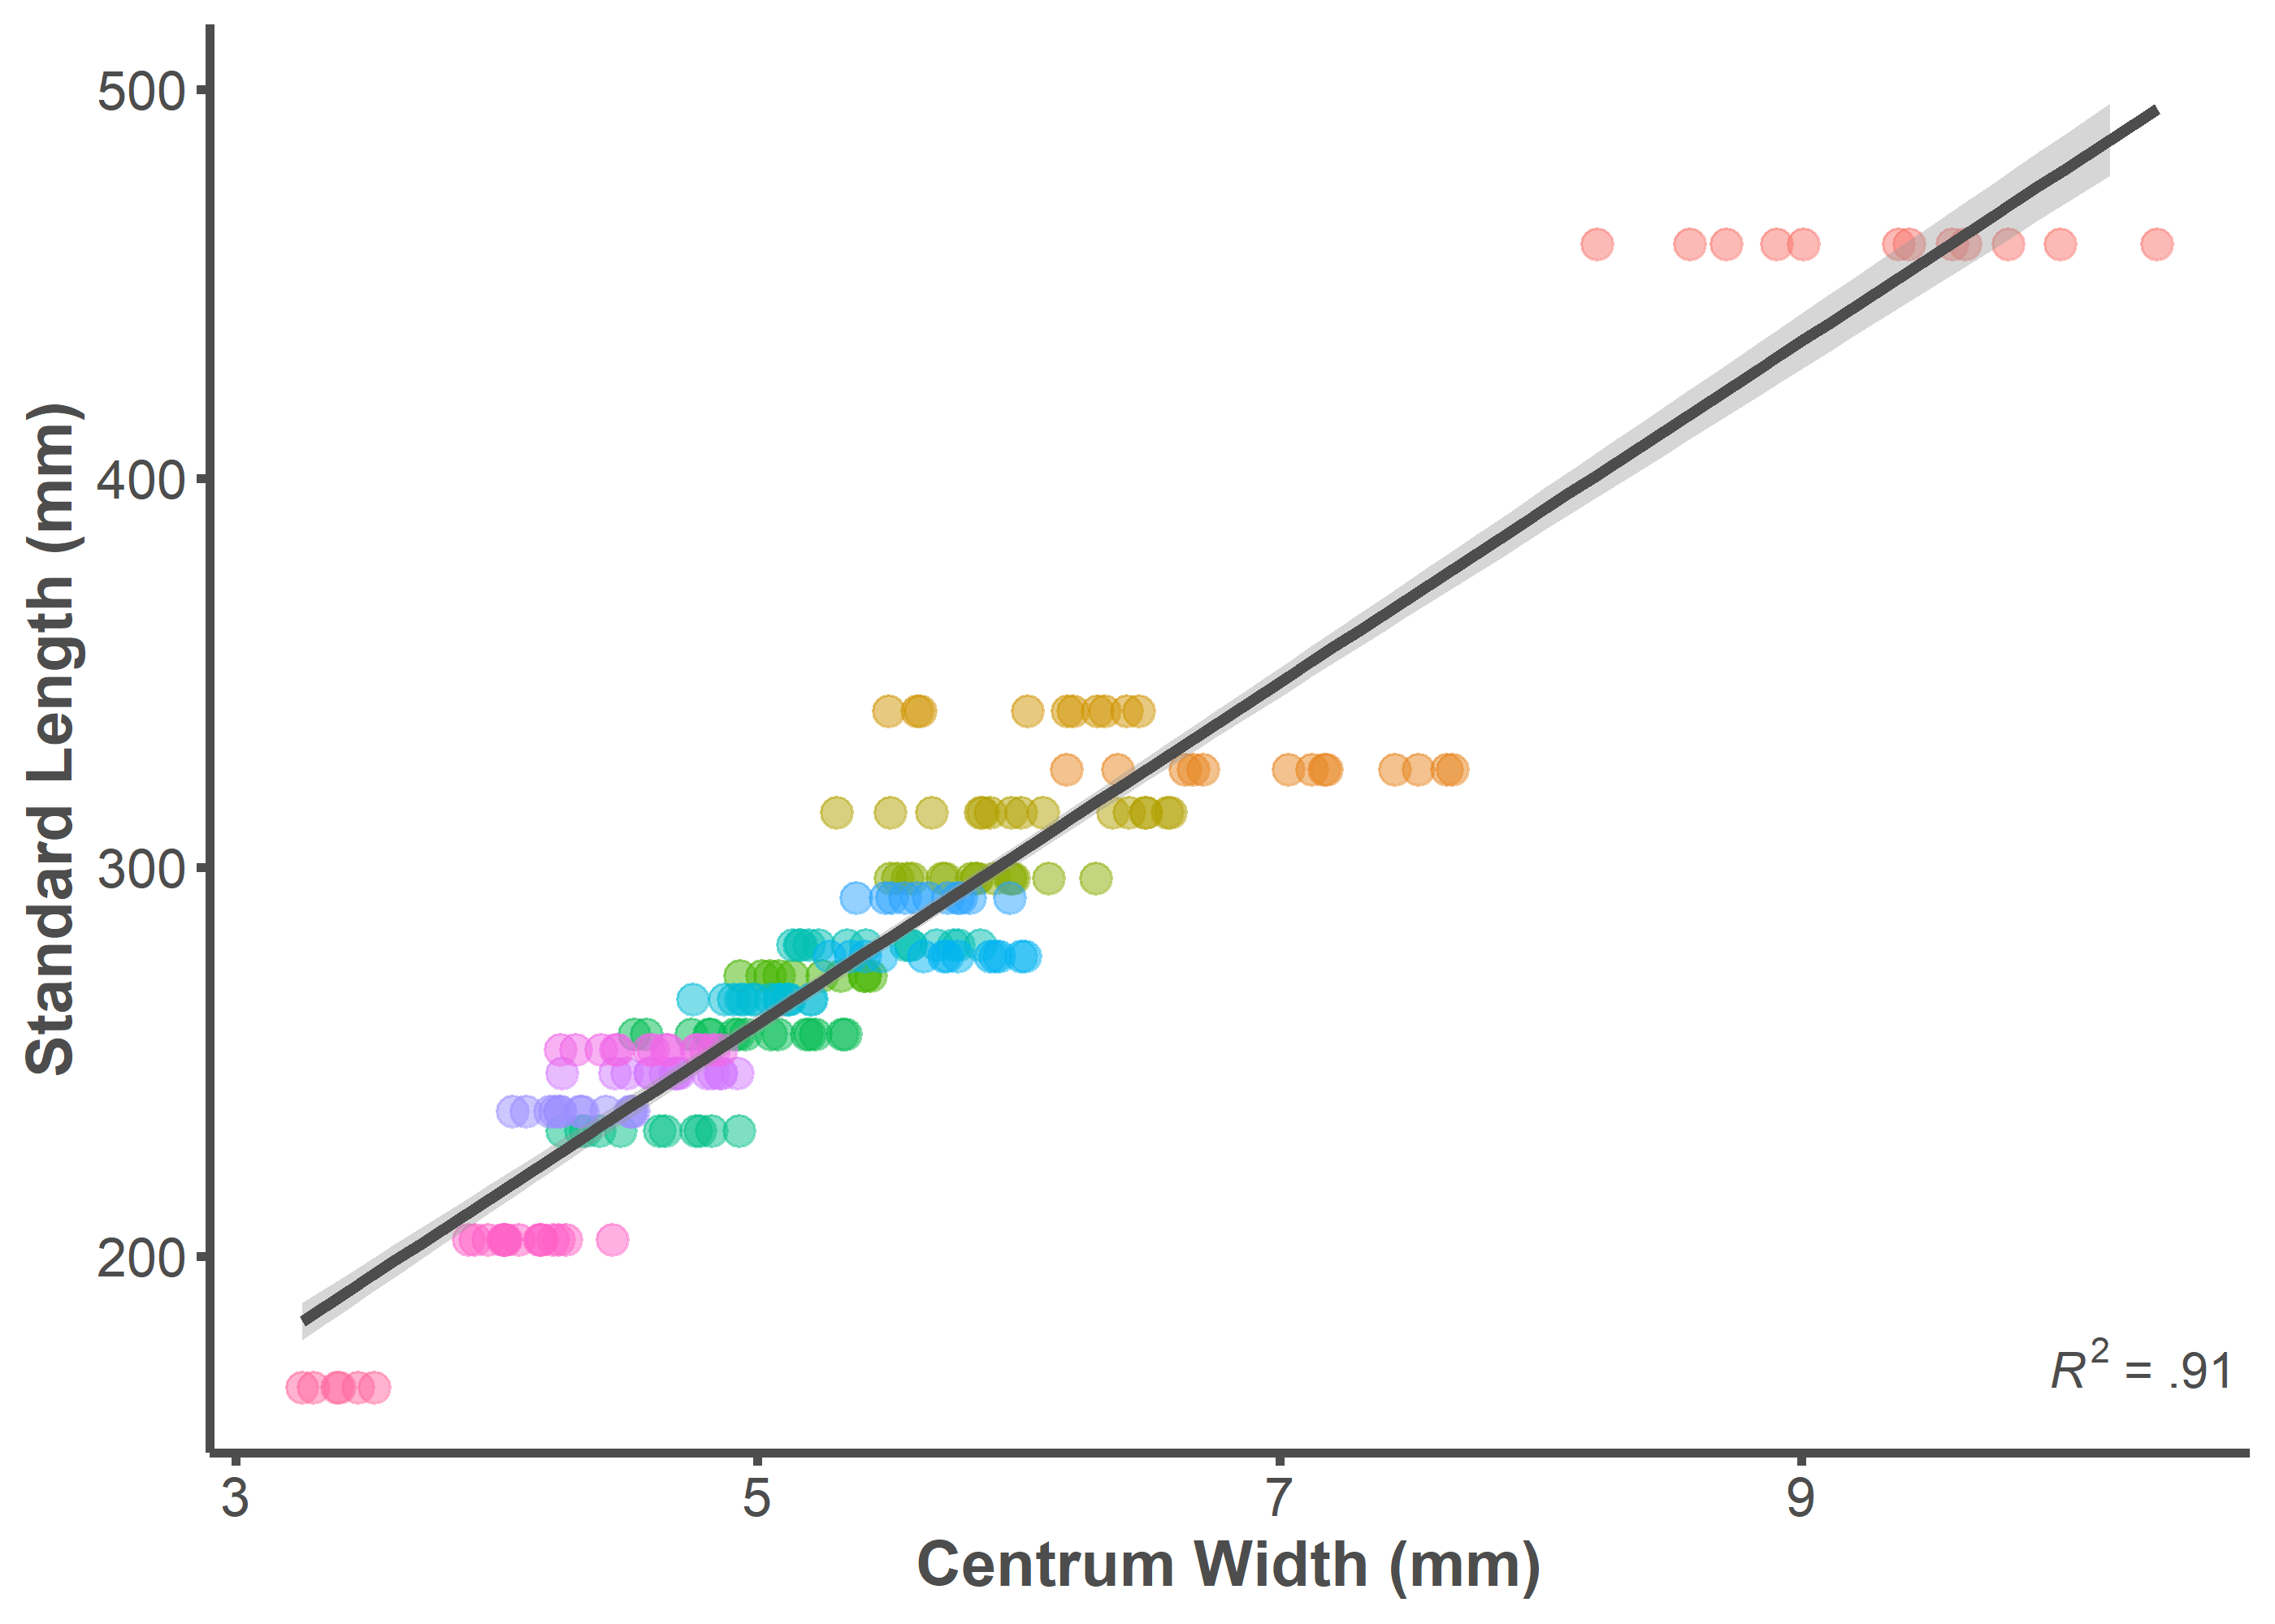

summary(lm(data = full.dataset, SL ~ Width))

##   
## Call:  
## lm(formula = SL ~ Width, data = full.dataset)  
##   
## Residuals:  
## Min 1Q Median 3Q Max   
## -51.589 -11.046 0.586 10.286 59.150   
##   
## Coefficients:  
## Estimate Std. Error t value Pr(>|t|)   
## (Intercept) 40.4340 5.3646 7.537 1.36e-12 ***  
## Width 43.8625 0.9596 45.711 < 2e-16 ***  
## ---  
## Signif. codes: 0 '***' 0.001 '**' 0.01 '*' 0.05 '.' 0.1 ' ' 1  
##   
## Residual standard error: 17.73 on 213 degrees of freedom  
## Multiple R-squared: 0.9075, Adjusted R-squared: 0.9071   
## F-statistic: 2090 on 1 and 213 DF, p-value: < 2.2e-16

## Standard Length and Centroid Size

p <- ggplot(data = full.dataset, mapping = aes(x = Csize, y = SL))  
p + geom_point(aes(color = ID), alpha = 0.5, size = 3) +   
 geom_smooth(formula = y ~ x, method = "lm", size = 1.25,   
 color = "#4d4d4d") +  
 theme_classic() +  
 ylim(166, 500) +  
 annotate("text", x = Inf, y = 166,   
 label =   
 "paste(italic(R^2), \" = .86 \")",  
 parse = T, hjust = 1, vjust = 0, color = "#4d4d4d") +  
 labs(x = "Centroid Size", y = "Standard Length (mm)") +  
 theme(legend.position = "none",  
 axis.line = element_line(color = "#4d4d4d", size = 1),  
 axis.text.x = element_text(color = "#4d4d4d", size = 12),  
 axis.text.y = element_text(color = "#4d4d4d", size = 12),  
 axis.title.x = element_text(color = "#4d4d4d", size = 14,   
 face = "bold"),  
 axis.title.y = element_text(color = "#4d4d4d", size = 14,   
 face = "bold"),  
 axis.ticks.x = element_line(color = "#4d4d4d", size = 1),  
 axis.ticks.y = element_line(color = "#4d4d4d", size = 1))

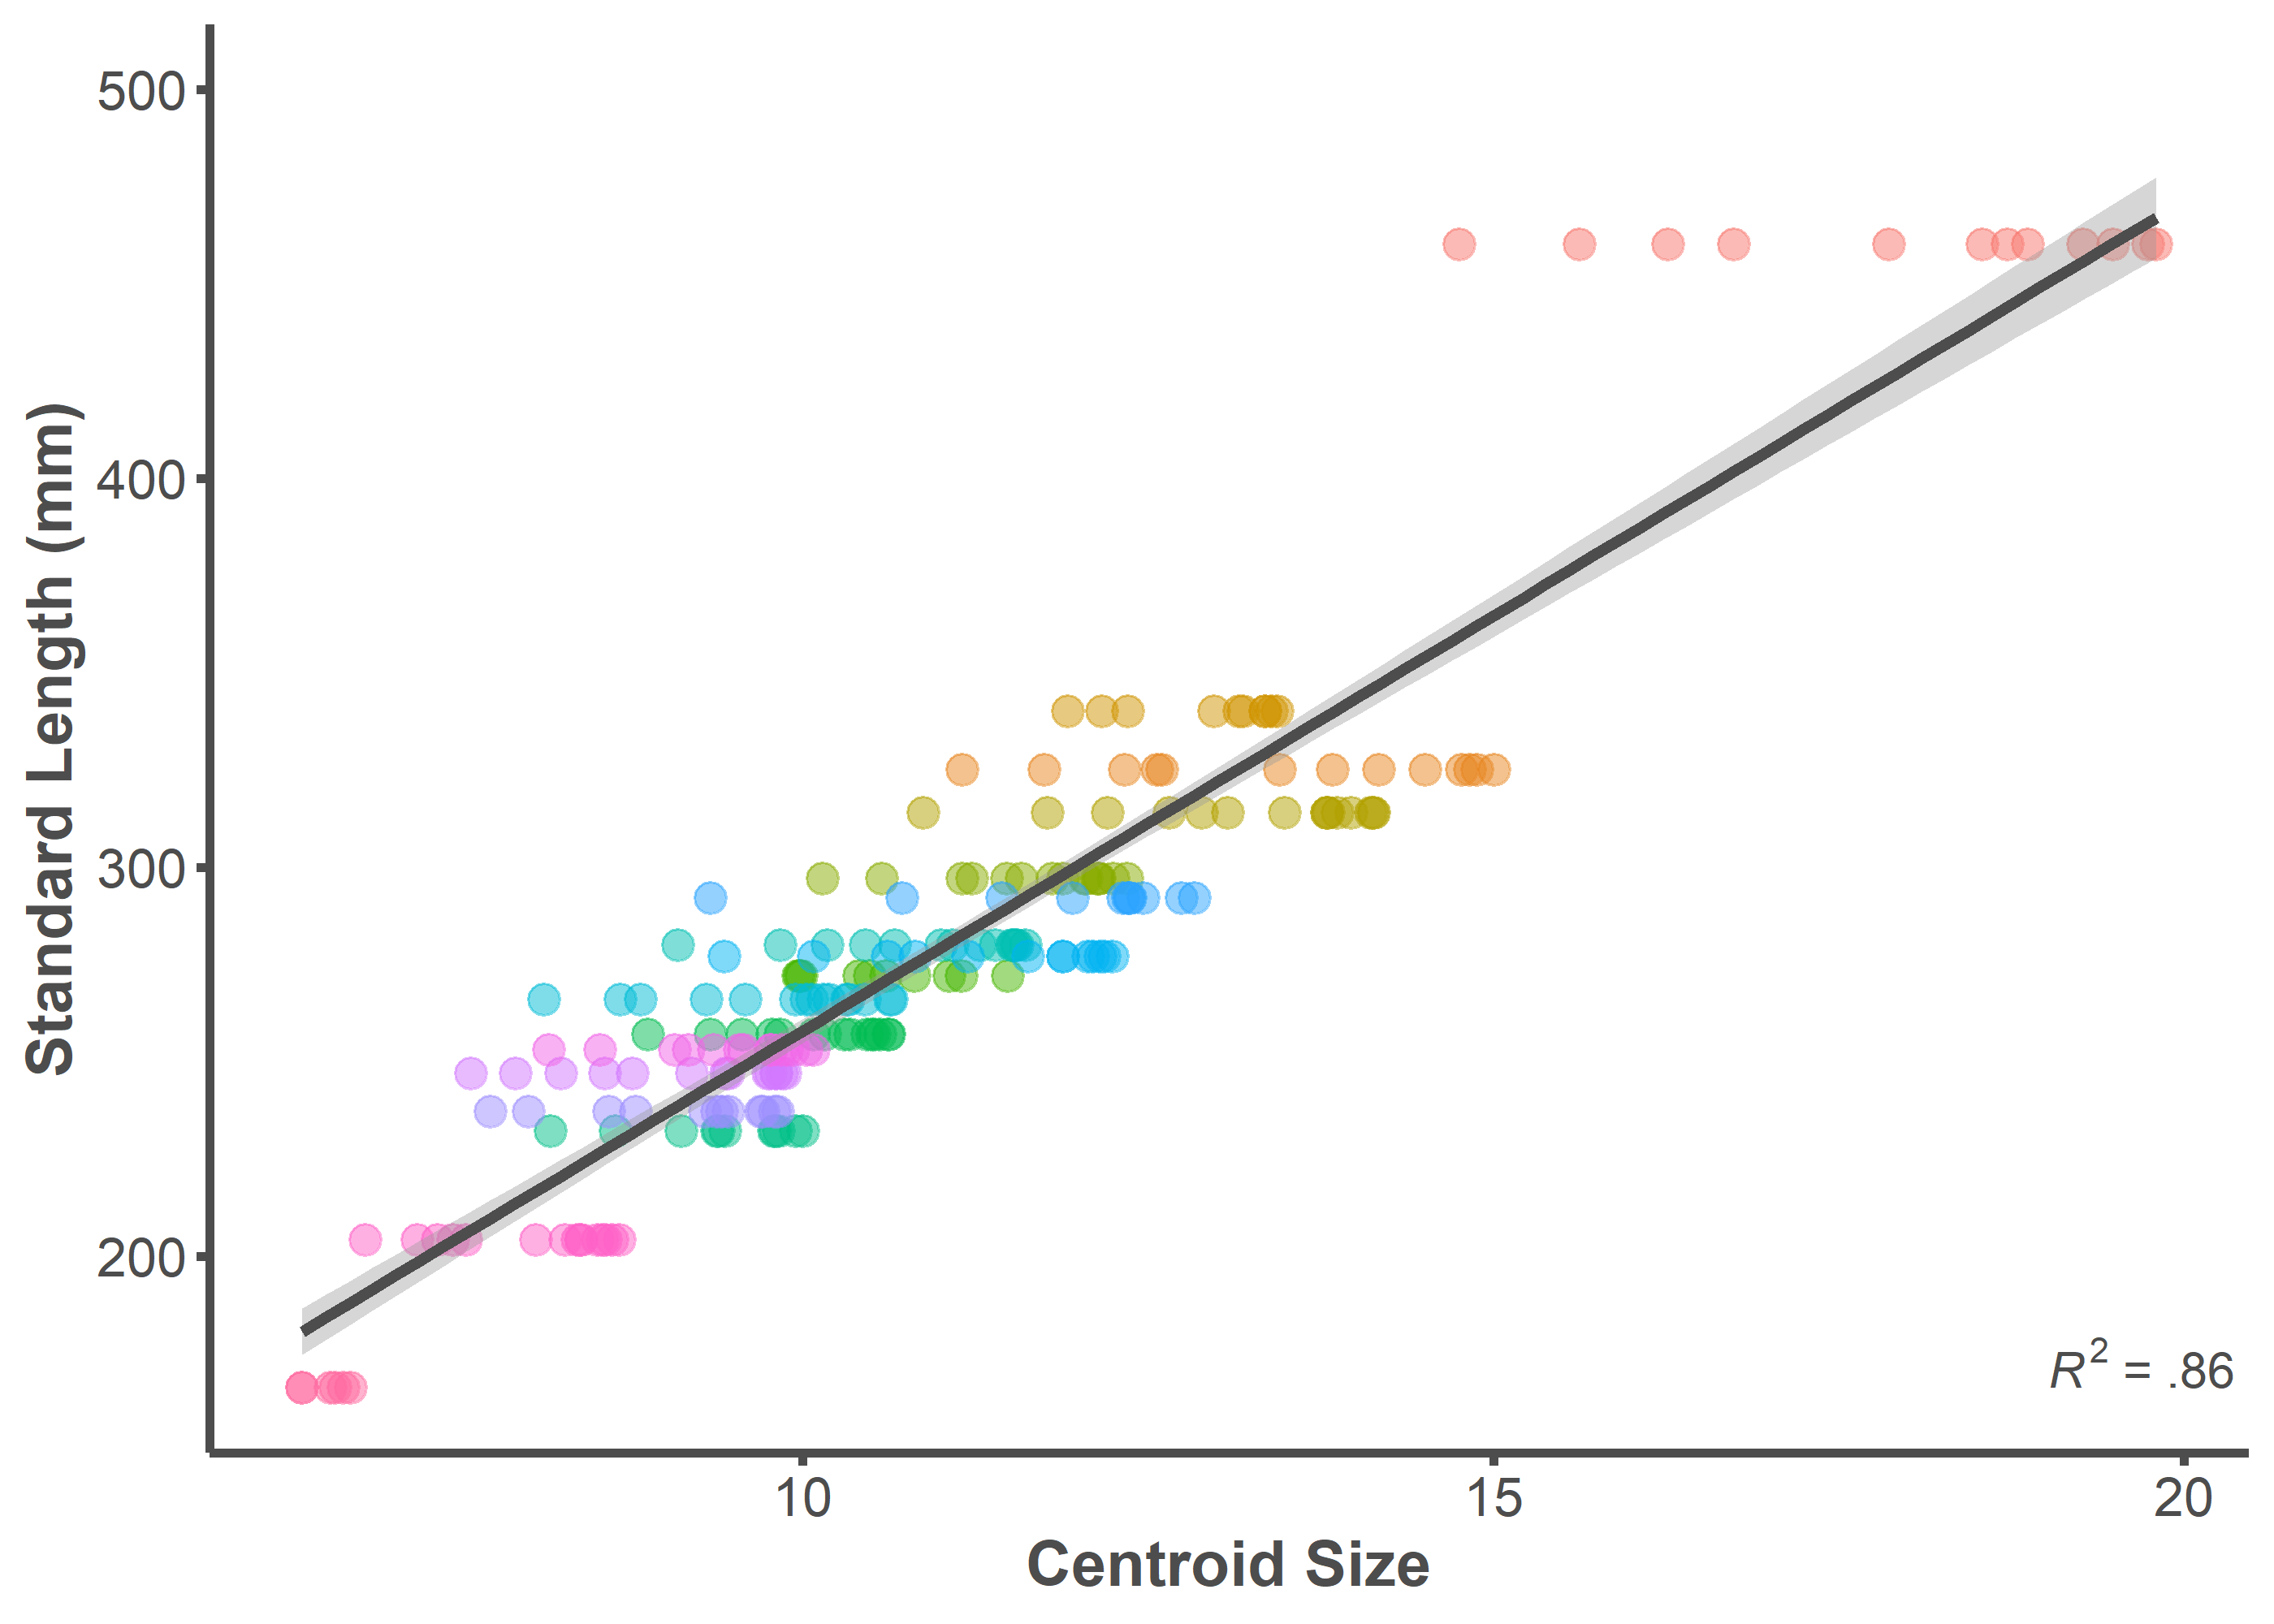

summary(lm(data = full.dataset, SL ~ Csize))

##   
## Call:  
## lm(formula = SL ~ Csize, data = full.dataset)  
##   
## Residuals:  
## Min 1Q Median 3Q Max   
## -39.810 -14.574 -3.581 12.309 100.548   
##   
## Coefficients:  
## Estimate Std. Error t value Pr(>|t|)   
## (Intercept) 44.3412 6.5309 6.789 1.1e-10 ***  
## Csize 21.3524 0.5783 36.920 < 2e-16 ***  
## ---  
## Signif. codes: 0 '***' 0.001 '**' 0.01 '*' 0.05 '.' 0.1 ' ' 1  
##   
## Residual standard error: 21.43 on 213 degrees of freedom  
## Multiple R-squared: 0.8649, Adjusted R-squared: 0.8642   
## F-statistic: 1363 on 1 and 213 DF, p-value: < 2.2e-16

## Centrum Width Estimation and Centroid Size Estimation

p <- ggplot(data = full.dataset, mapping = aes(x = Size.Centroid,   
 y = Size.Width))  
p + geom_point(aes(color = ID), alpha = 0.5, size = 3) +   
 geom_smooth(formula = y ~ x, method = "lm", size = 1.25,   
 color = "#4d4d4d") +  
 theme_classic() +  
 annotate("text", x = Inf, y = 160,   
 label = "paste(italic(R^2), \" = .94 \")",  
 parse = T, hjust = 1, vjust = 0, color = "#4d4d4d") +  
 labs(x = "Centroid Size Estimated Standard Length (mm)",   
 y = "Centrum Width Estimated Standard Length (mm)") +  
 theme(legend.position = "none",  
 axis.line = element_line(color = "#4d4d4d", size = 1),  
 axis.text.x = element_text(color = "#4d4d4d", size = 12),  
 axis.text.y = element_text(color = "#4d4d4d", size = 12),  
 axis.title.x = element_text(color = "#4d4d4d", size = 13.5,   
 face = "bold"),  
 axis.title.y = element_text(color = "#4d4d4d", size = 13.5,   
 face = "bold"),  
 axis.ticks.x = element_line(color = "#4d4d4d", size = 1),  
 axis.ticks.y = element_line(color = "#4d4d4d", size = 1))

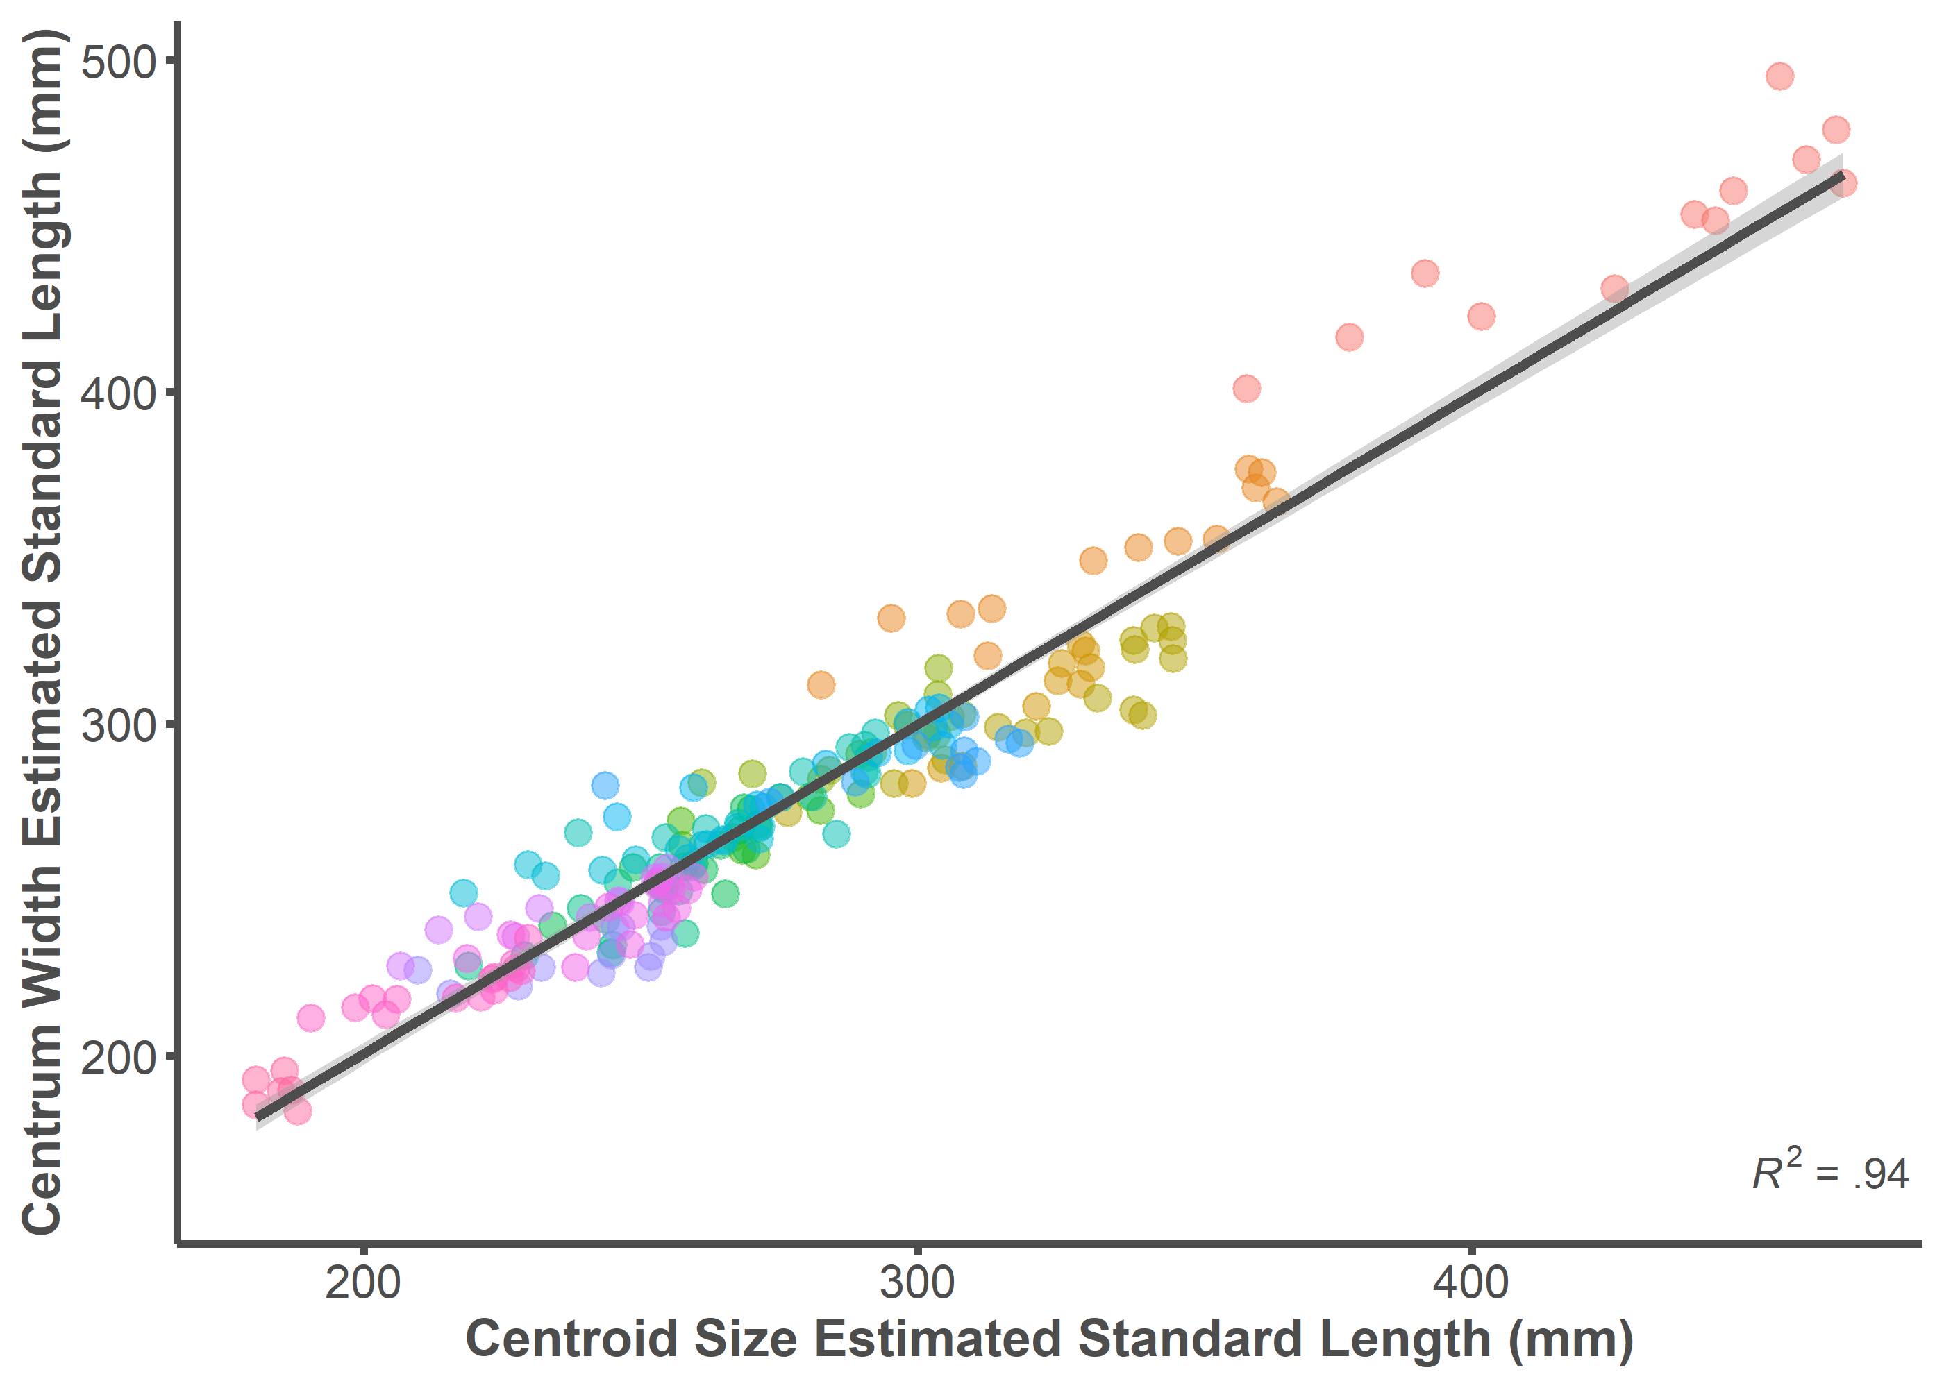

summary(lm(data = full.dataset, Size.Width ~ Size.Centroid))

##   
## Call:  
## lm(formula = Size.Width ~ Size.Centroid, data = full.dataset)  
##   
## Residuals:  
## Min 1Q Median 3Q Max   
## -37.659 -7.359 -0.599 6.340 44.890   
##   
## Coefficients:  
## Estimate Std. Error t value Pr(>|t|)   
## (Intercept) 2.42343 5.03004 0.482 0.63   
## Size.Centroid 0.99132 0.01768 56.072 <2e-16 ***  
## ---  
## Signif. codes: 0 '***' 0.001 '**' 0.01 '*' 0.05 '.' 0.1 ' ' 1  
##   
## Residual standard error: 13.99 on 213 degrees of freedom  
## Multiple R-squared: 0.9366, Adjusted R-squared: 0.9363   
## F-statistic: 3144 on 1 and 213 DF, p-value: < 2.2e-16

## Predicion Error (PE)

p <- ggplot(data = full.dataset,   
 mapping = aes(x = PE.Centroid, y = PE.Width))  
p + geom_point(aes(color = ID), alpha = 0.5, size = 3) +   
 geom_smooth(formula = y ~ x, method = "lm", size = 1.25,   
 color = "#4d4d4d") +  
 theme_classic() +  
 annotate("text", x = Inf, y = -15,   
 label = "paste(italic(R^2), \" = .56 \")",  
 parse = T, hjust = 1, vjust = 0, color = "#4d4d4d") +  
 labs(x = "PE Centroid Size", y = "PE Centrum Width") +  
 theme(legend.position="none",  
 axis.line = element_line(color = "#4d4d4d", size = 1),  
 axis.text.x = element_text(color = "#4d4d4d", size = 12),  
 axis.text.y = element_text(color = "#4d4d4d", size = 12),  
 axis.title.x = element_text(color = "#4d4d4d", size = 14,   
 face = "bold"),  
 axis.title.y = element_text(color = "#4d4d4d", size = 14,   
 face = "bold"),  
 axis.ticks.x = element_line(color = "#4d4d4d", size = 1),  
 axis.ticks.y = element_line(color = "#4d4d4d", size = 1))

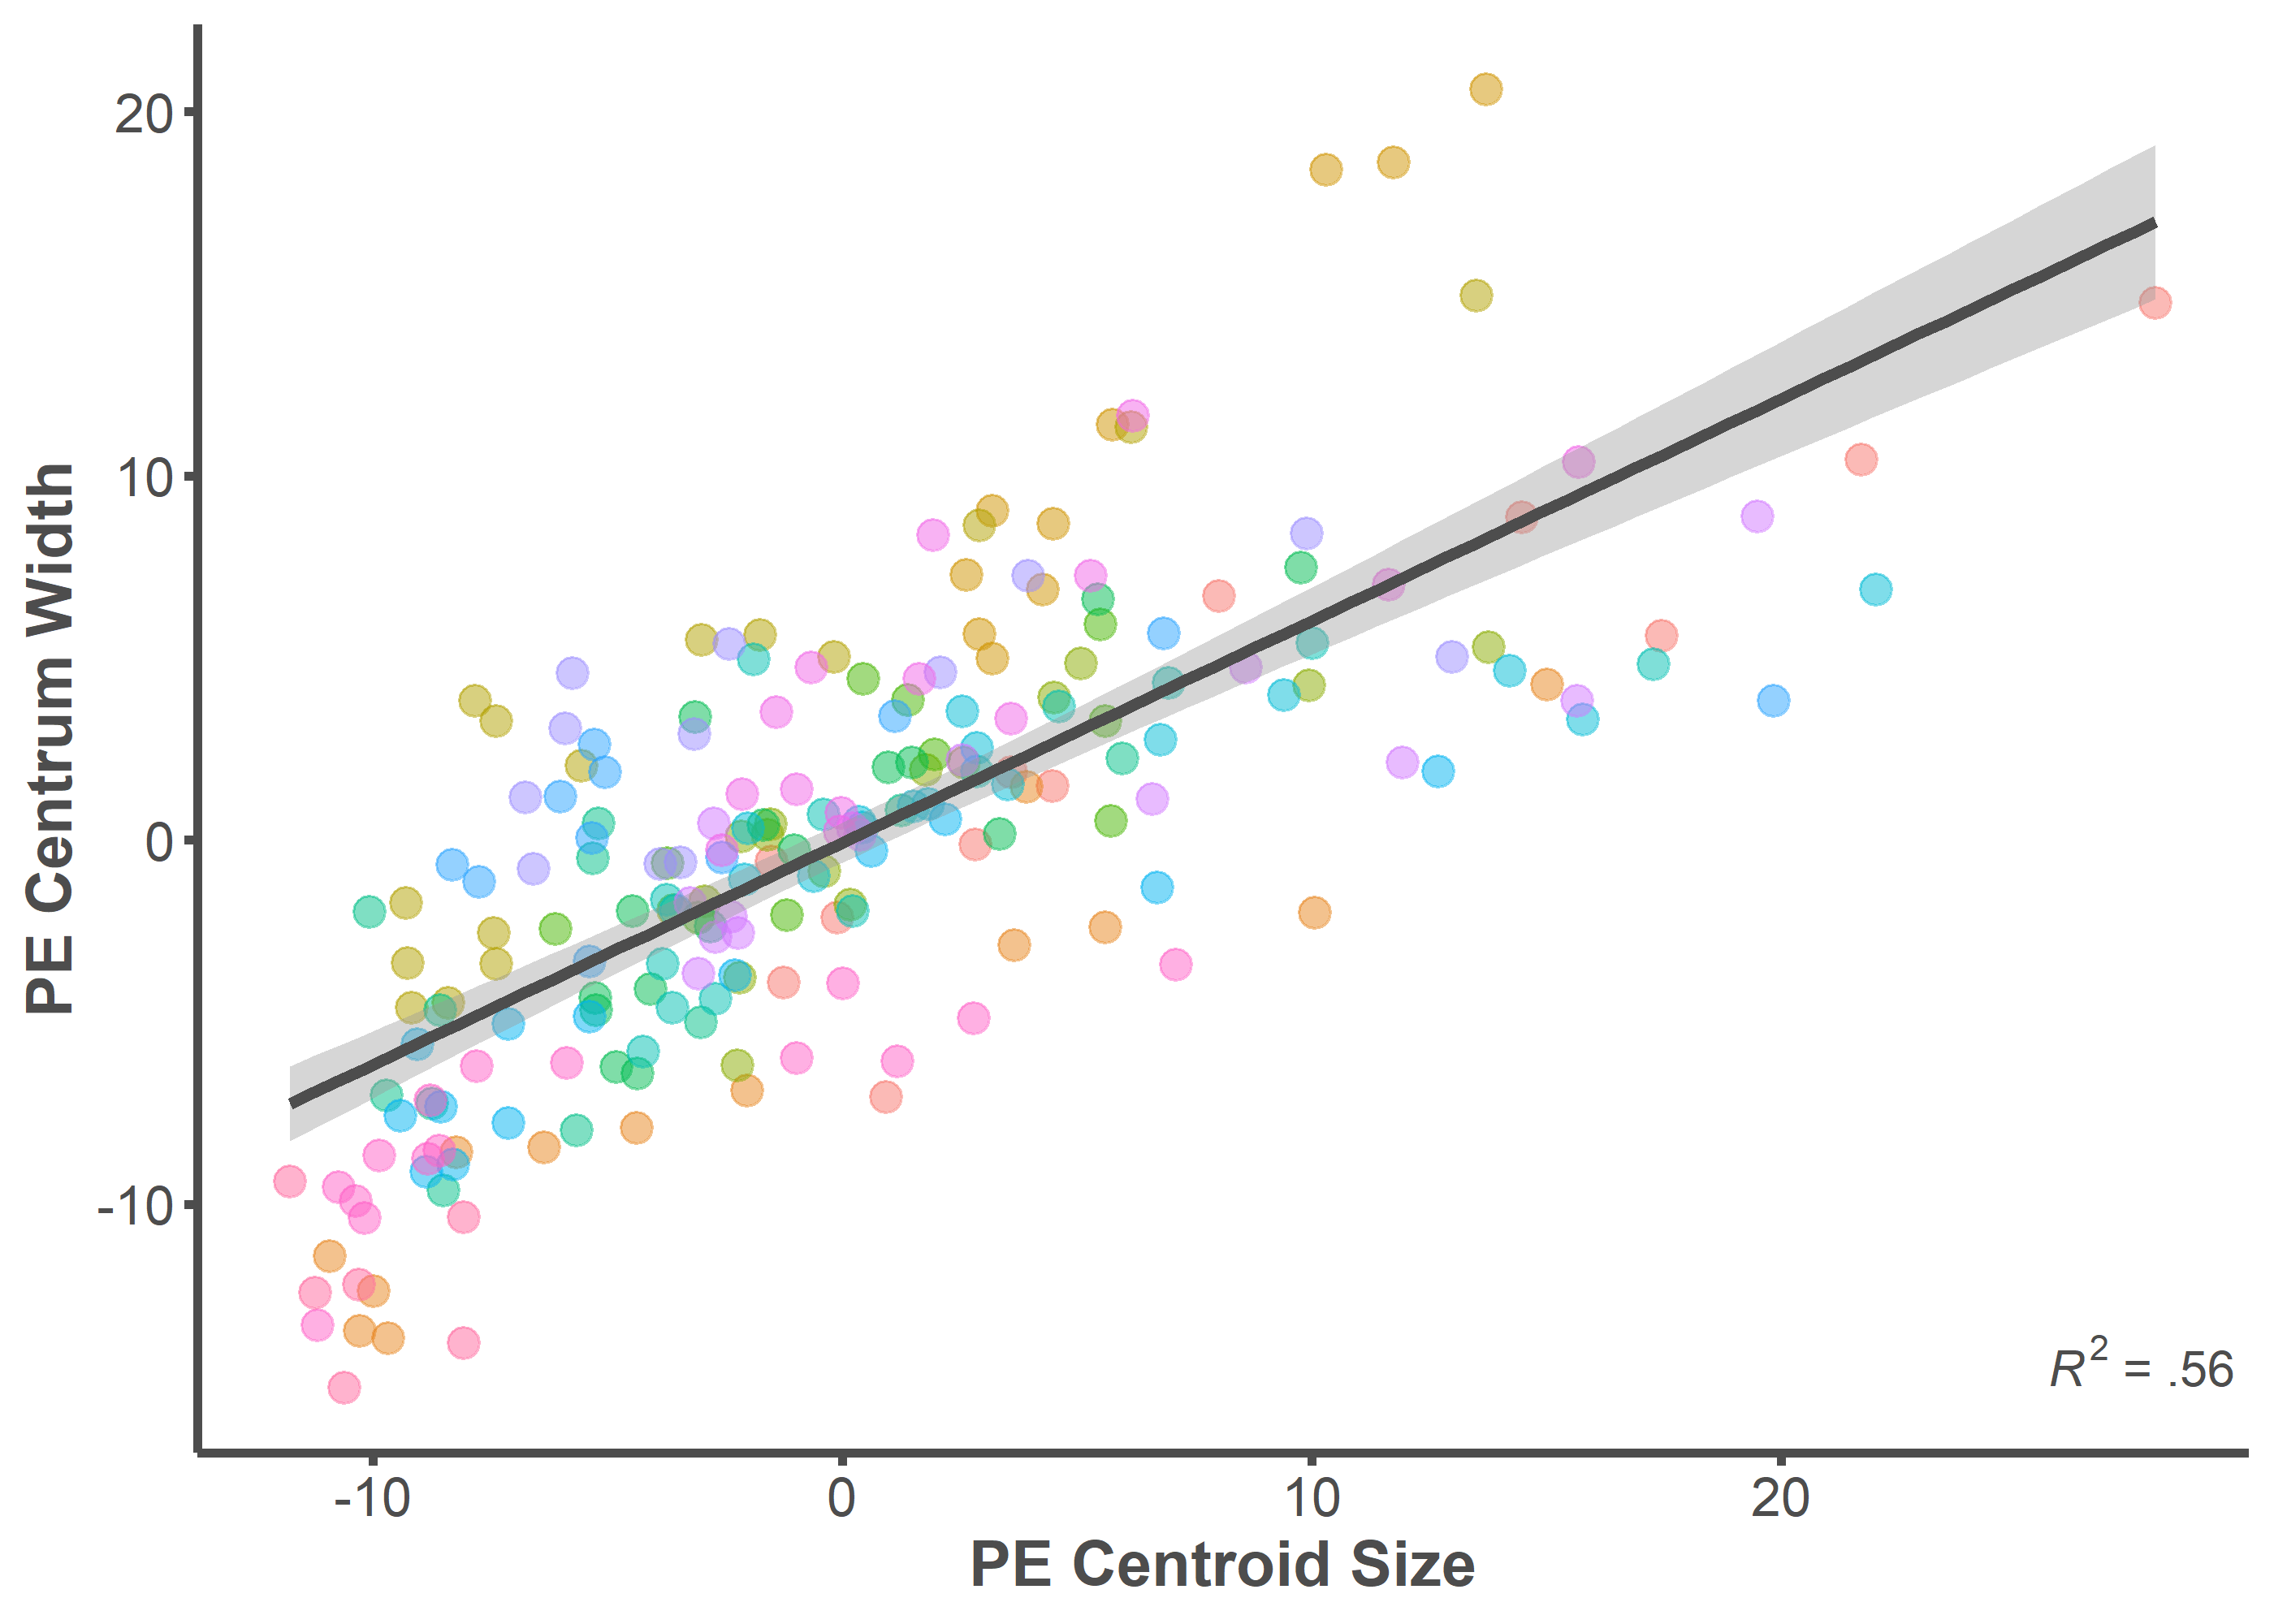

summary(lm(data = full.dataset, PE.Width ~ PE.Centroid))

##   
## Call:  
## lm(formula = PE.Width ~ PE.Centroid, data = full.dataset)  
##   
## Residuals:  
## Min 1Q Median 3Q Max   
## -8.8205 -2.8283 -0.0026 2.1242 12.3219   
##   
## Coefficients:  
## Estimate Std. Error t value Pr(>|t|)   
## (Intercept) -0.07220 0.28069 -0.257 0.797   
## PE.Centroid 0.60946 0.03733 16.326 <2e-16 ***  
## ---  
## Signif. codes: 0 '***' 0.001 '**' 0.01 '*' 0.05 '.' 0.1 ' ' 1  
##   
## Residual standard error: 4.116 on 213 degrees of freedom  
## Multiple R-squared: 0.5558, Adjusted R-squared: 0.5537   
## F-statistic: 266.5 on 1 and 213 DF, p-value: < 2.2e-16

## Mean Prediction Error (MPE)

p <- ggplot(data = MPE, mapping = aes(x = MPE.Centroid, y = MPE.Width))  
p + geom_point(aes(color = ID), alpha = 0.5, size = 3) +   
 geom_smooth(formula = y ~ x, method = "lm", size = 1.25,   
 color = "#4d4d4d") +  
 theme_classic() +  
 annotate("text", x = Inf, y = -15,   
 label = "paste(italic(R^2), \" = .63 \")",  
 parse = T, hjust = 1, vjust = 0, color = "#4d4d4d") +  
 labs(x = "MPE Centroid Size", y = "MPE Centrum Width") +  
 theme(legend.position="none",  
 axis.line = element_line(color = "#4d4d4d", size = 1),  
 axis.text.x = element_text(color = "#4d4d4d", size = 12),  
 axis.text.y = element_text(color = "#4d4d4d", size = 12),  
 axis.title.x = element_text(color = "#4d4d4d", size = 14,   
 face = "bold"),  
 axis.title.y = element_text(color = "#4d4d4d", size = 14,   
 face = "bold"),  
 axis.ticks.x = element_line(color = "#4d4d4d", size = 1),  
 axis.ticks.y = element_line(color = "#4d4d4d", size = 1))

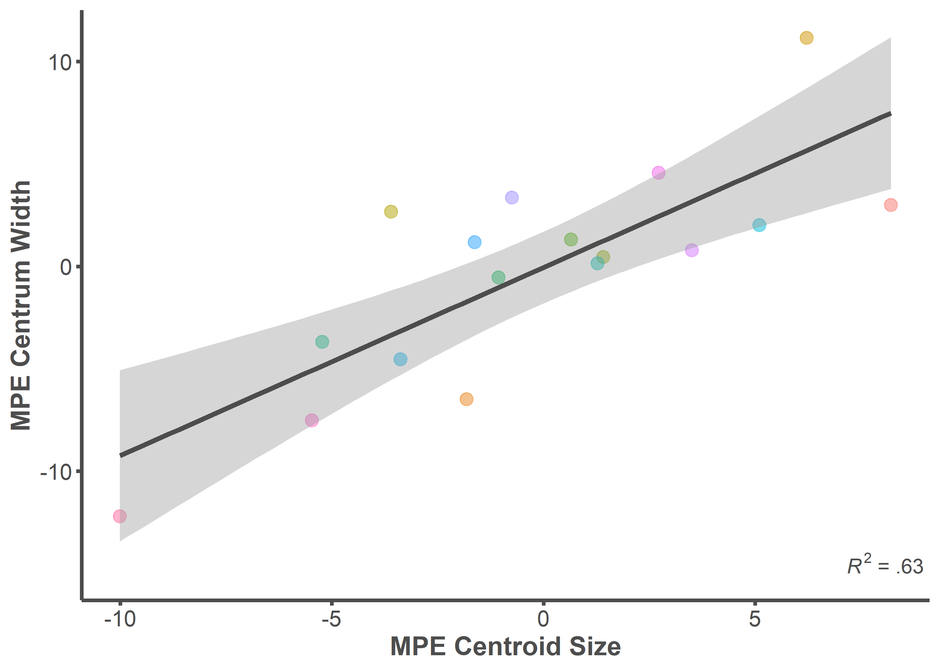

summary(lm(data = MPE, MPE.Width ~ MPE.Centroid))

##   
## Call:  
## lm(formula = MPE.Width ~ MPE.Centroid, data = MPE)  
##   
## Residuals:  
## Min 1Q Median 3Q Max   
## -4.7726 -2.4536 -0.7976 2.1232 6.0297   
##   
## Coefficients:  
## Estimate Std. Error t value Pr(>|t|)   
## (Intercept) -0.05754 0.82072 -0.070 0.945031   
## MPE.Centroid 0.91819 0.18205 5.044 0.000146 ***  
## ---  
## Signif. codes: 0 '***' 0.001 '**' 0.01 '*' 0.05 '.' 0.1 ' ' 1  
##   
## Residual standard error: 3.38 on 15 degrees of freedom  
## Multiple R-squared: 0.6291, Adjusted R-squared: 0.6043   
## F-statistic: 25.44 on 1 and 15 DF, p-value: 0.0001456

# ARCHAEOLOGICAL BODY SIZE ESTIMATIONS

setwd("Archaeological Estimates")  
files <- list.files(pattern = "\\.txt$")  
results <- data.frame()  
  
for (i in seq_along(files)) {  
 fname <- paste(files[i], sep="/")  
   
 data <- read.table(fname, header = T, row.names = 1,   
 stringsAsFactors = FALSE)  
   
 a <-arrayspecs(data, ncol(data)/3, 3)  
   
 mydata.gpa <- gpagen(a, curves = NULL, surfaces = NULL, PrinAxes = TRUE,   
 max.iter = NULL,   
 ProcD = TRUE, Proj = TRUE, print.progress = FALSE)  
   
 centroid.df <- data.frame(mydata.gpa$Csize)  
 centroid.df <- tibble::rownames_to_column(centroid.df, "ID")  
   
 centroid.clean <- centroid.df %>%   
 separate("ID", into = "ID") %>%  
 merge(body.size, by="ID") %>%  
 dplyr::rename(Csize = mydata.gpa.Csize)  
   
 fit1 <- summary(lm(data = centroid.clean, SL ~ Csize))  
   
 fit2 <- cor.test(centroid.clean$SL, centroid.clean$Csize,   
 method = "spearman")  
   
 Arch_Size <- (fit1$coefficients[[2]]*mydata.gpa$Csize[[1]])+  
 fit1$coefficients[[1]]  
  
   
 results[i,1] <- fit1$coefficients[2]  
 results[i,2] <- mydata.gpa$Csize[[1]]  
 results[i,3] <- fit1$coefficients[1]  
 results[i,4] <- fit1$r.squared  
 results[i,5] <- (fit2$estimate)^2  
 results[i,6] <- Arch_Size  
}  
  
rownames(results) <- sub(".txt", "", files)  
colnames(results) <- c("Slope", "Csize", "Intercept", "R2", "Rho2",  
 "Arch_SL")  
  
round(results, digits = 2)

## Slope Csize Intercept R2 Rho2 Arch_SL  
## 1304_BS 33.31 10.89 -21.54 0.90 0.89 341.36  
## 1554_UV1 18.39 19.17 -38.22 0.81 0.61 314.26  
## 1567_HYO 51.16 8.21 63.92 0.79 0.61 484.12  
## 2005.27.142_HYO_UI30 51.16 5.26 63.92 0.79 0.61 332.85  
## 2005.27.152_CV1_UI32 24.36 11.56 45.47 0.86 0.83 327.14  
## 2005.27.152_CV2_UI32 43.17 6.60 48.47 0.87 0.85 333.31  
## 2005.27.152_HYO_UI33 51.16 8.97 63.92 0.79 0.61 522.60  
## 2005.27.157_UR_UI24 22.55 19.67 44.57 0.92 0.78 488.07  
## 2005.27.158_CV_UI26 21.35 15.74 44.34 0.86 0.83 380.45  
## 2005.27.161_UV_UI25 76.16 3.69 -1.53 0.92 0.88 279.78  
## 2005.27.165_CV_UI29 23.17 16.89 44.46 0.87 0.84 435.78  
## 2005.27.168_OPC_UI42 49.87 7.08 86.66 0.69 0.52 439.77  
## 2005.27.169_CV1_U31 43.17 8.96 48.47 0.87 0.85 435.30  
## 2005.27.169_CV2_U31 43.17 8.90 48.47 0.87 0.85 432.67  
## 2005.27.169_CV3_U31 43.17 6.36 48.47 0.87 0.85 323.04  
## 2005.27.169_CV4_U31 43.17 6.28 48.47 0.87 0.85 319.70  
## 2005.27.173_CV1_U40 43.17 8.00 48.47 0.87 0.85 393.66  
## 2005.27.173_CV2_U40 43.17 7.46 48.47 0.87 0.85 370.38  
## 2005.27.331_CV_UI46 43.17 7.54 48.47 0.87 0.85 373.87  
## 2005.27.331_UV_UI46 59.44 7.65 8.80 0.95 0.95 463.64  
## 2005.27.458_CV_UI20 49.18 8.86 44.85 0.83 0.76 480.79  
## 2007.46.1098_CV_UI3 43.17 9.73 48.47 0.87 0.85 468.56  
## 2007.46.1100_SUB 15.11 32.93 -60.75 0.87 0.91 437.01  
## 2007.46.2161_UI16_1 43.17 9.63 48.47 0.87 0.85 464.34  
## 2007.46.2161_UI16_10 43.17 7.79 48.47 0.87 0.85 384.60  
## 2007.46.2161_UI16_11 43.17 7.39 48.47 0.87 0.85 367.40  
## 2007.46.2161_UI16_12 43.17 5.85 48.47 0.87 0.85 300.82  
## 2007.46.2161_UI16_13 43.17 3.30 48.47 0.87 0.85 191.04  
## 2007.46.2161_UI16_2 43.17 9.65 48.47 0.87 0.85 464.91  
## 2007.46.2161_UI16_3 43.17 9.96 48.47 0.87 0.85 478.27  
## 2007.46.2161_UI16_4 43.17 9.46 48.47 0.87 0.85 456.80  
## 2007.46.2161_UI16_5 43.17 9.20 48.47 0.87 0.85 445.48  
## 2007.46.2161_UI16_6 43.17 9.51 48.47 0.87 0.85 459.00  
## 2007.46.2161_UI16_7 43.17 8.92 48.47 0.87 0.85 433.40  
## 2007.46.2161_UI16_8 43.17 8.48 48.47 0.87 0.85 414.56  
## 2007.46.2161_UI16_9 43.17 8.17 48.47 0.87 0.85 401.04  
## 2007.46.2207_CV_UI15 43.17 10.66 48.47 0.87 0.85 508.51  
## 2007.46.3104_BS_UI62 33.31 12.62 -21.54 0.90 0.89 398.77  
## 2007.46.3442_CV_UI61 43.17 11.28 48.47 0.87 0.85 535.31  
## 2007.46.4008_CT_UI53 24.24 20.57 -9.90 0.87 0.77 488.75  
## 2007.46.4164_SUB_UI78 22.16 22.47 3.66 0.84 0.65 501.69  
## 205.27.167_CV_UI43 52.22 9.23 48.15 0.90 0.89 530.09  
## 205.27.167_HYO_UI43 18.17 12.57 84.31 0.70 0.46 312.58  
## 523_MX 35.90 9.69 84.54 0.83 0.64 432.34  
## 90.20.1199_BS_UI19 33.31 14.46 -21.54 0.90 0.89 460.17  
## 99.20.1111_CT_UI68 26.86 8.10 74.48 0.54 0.44 291.98  
## 99.20.1150_PT_UI58 26.88 11.55 15.55 0.99 0.98 325.84  
## 99.20.160_UV_UI74 59.44 9.14 8.80 0.95 0.95 552.24  
## 99.20.363_UV_UI73 18.39 21.42 -38.22 0.81 0.61 355.58  
## 99.20.9_QUA_UI70 13.02 20.47 58.55 0.76 0.67 325.10  
## 99.22.1765_CV_UI71 21.35 18.09 44.34 0.86 0.83 430.52  
## 99.22.2640_OPC_UI72 49.87 8.04 86.66 0.69 0.52 487.53  
## 99.22.3136_CV_UI8 21.35 18.37 44.34 0.86 0.83 436.54  
## 99.22.882_OPC_UI11 49.87 7.36 86.66 0.69 0.52 453.59  
## BK.70.71_CT 26.86 8.11 74.48 0.54 0.44 292.29  
## BK.70.71_CV 43.17 6.43 48.47 0.87 0.85 326.11  
## BK.70.71_HYO 51.16 5.13 63.92 0.79 0.61 326.53  
## BK.70.71_MET 23.02 14.09 6.88 0.93 0.76 331.21  
## BK.70.71_UV 59.44 5.44 8.80 0.95 0.95 331.89  
## FN51_ENT 38.94 7.15 117.45 0.67 0.38 395.94

*Visualize Archaeological Distribution*

results %>%  
 ggplot(aes(Arch_SL)) +  
 geom_density(fill = "#00bfc4", color = "#00bfc4", bw = 50, alpha = 0.5,   
 size = 1.5) +  
 theme_classic() +  
 theme(legend.position="none",  
 axis.line = element_line(color = "#4d4d4d", size = 1),  
 plot.title = element_text(color = "#4d4d4d", size = 16,   
 face = "bold"),  
 axis.text.x = element_text(color = "#4d4d4d", size = 12),  
 axis.text.y = element_text(color = "#4d4d4d", size = 12),  
 axis.title.x = element_text(color = "#4d4d4d", size = 14,   
 face = "bold"),  
 axis.title.y = element_text(color = "#4d4d4d", size = 14,   
 face = "bold"),  
 axis.ticks.x = element_line(color = "#4d4d4d", size = 1),  
 axis.ticks.y = element_line(color = "#4d4d4d", size = 1)) +  
 labs(title = "Archaeological Size Distribution",   
 x = "Standard Length (mm)", y = "Density") +  
 xlim(0, 700)

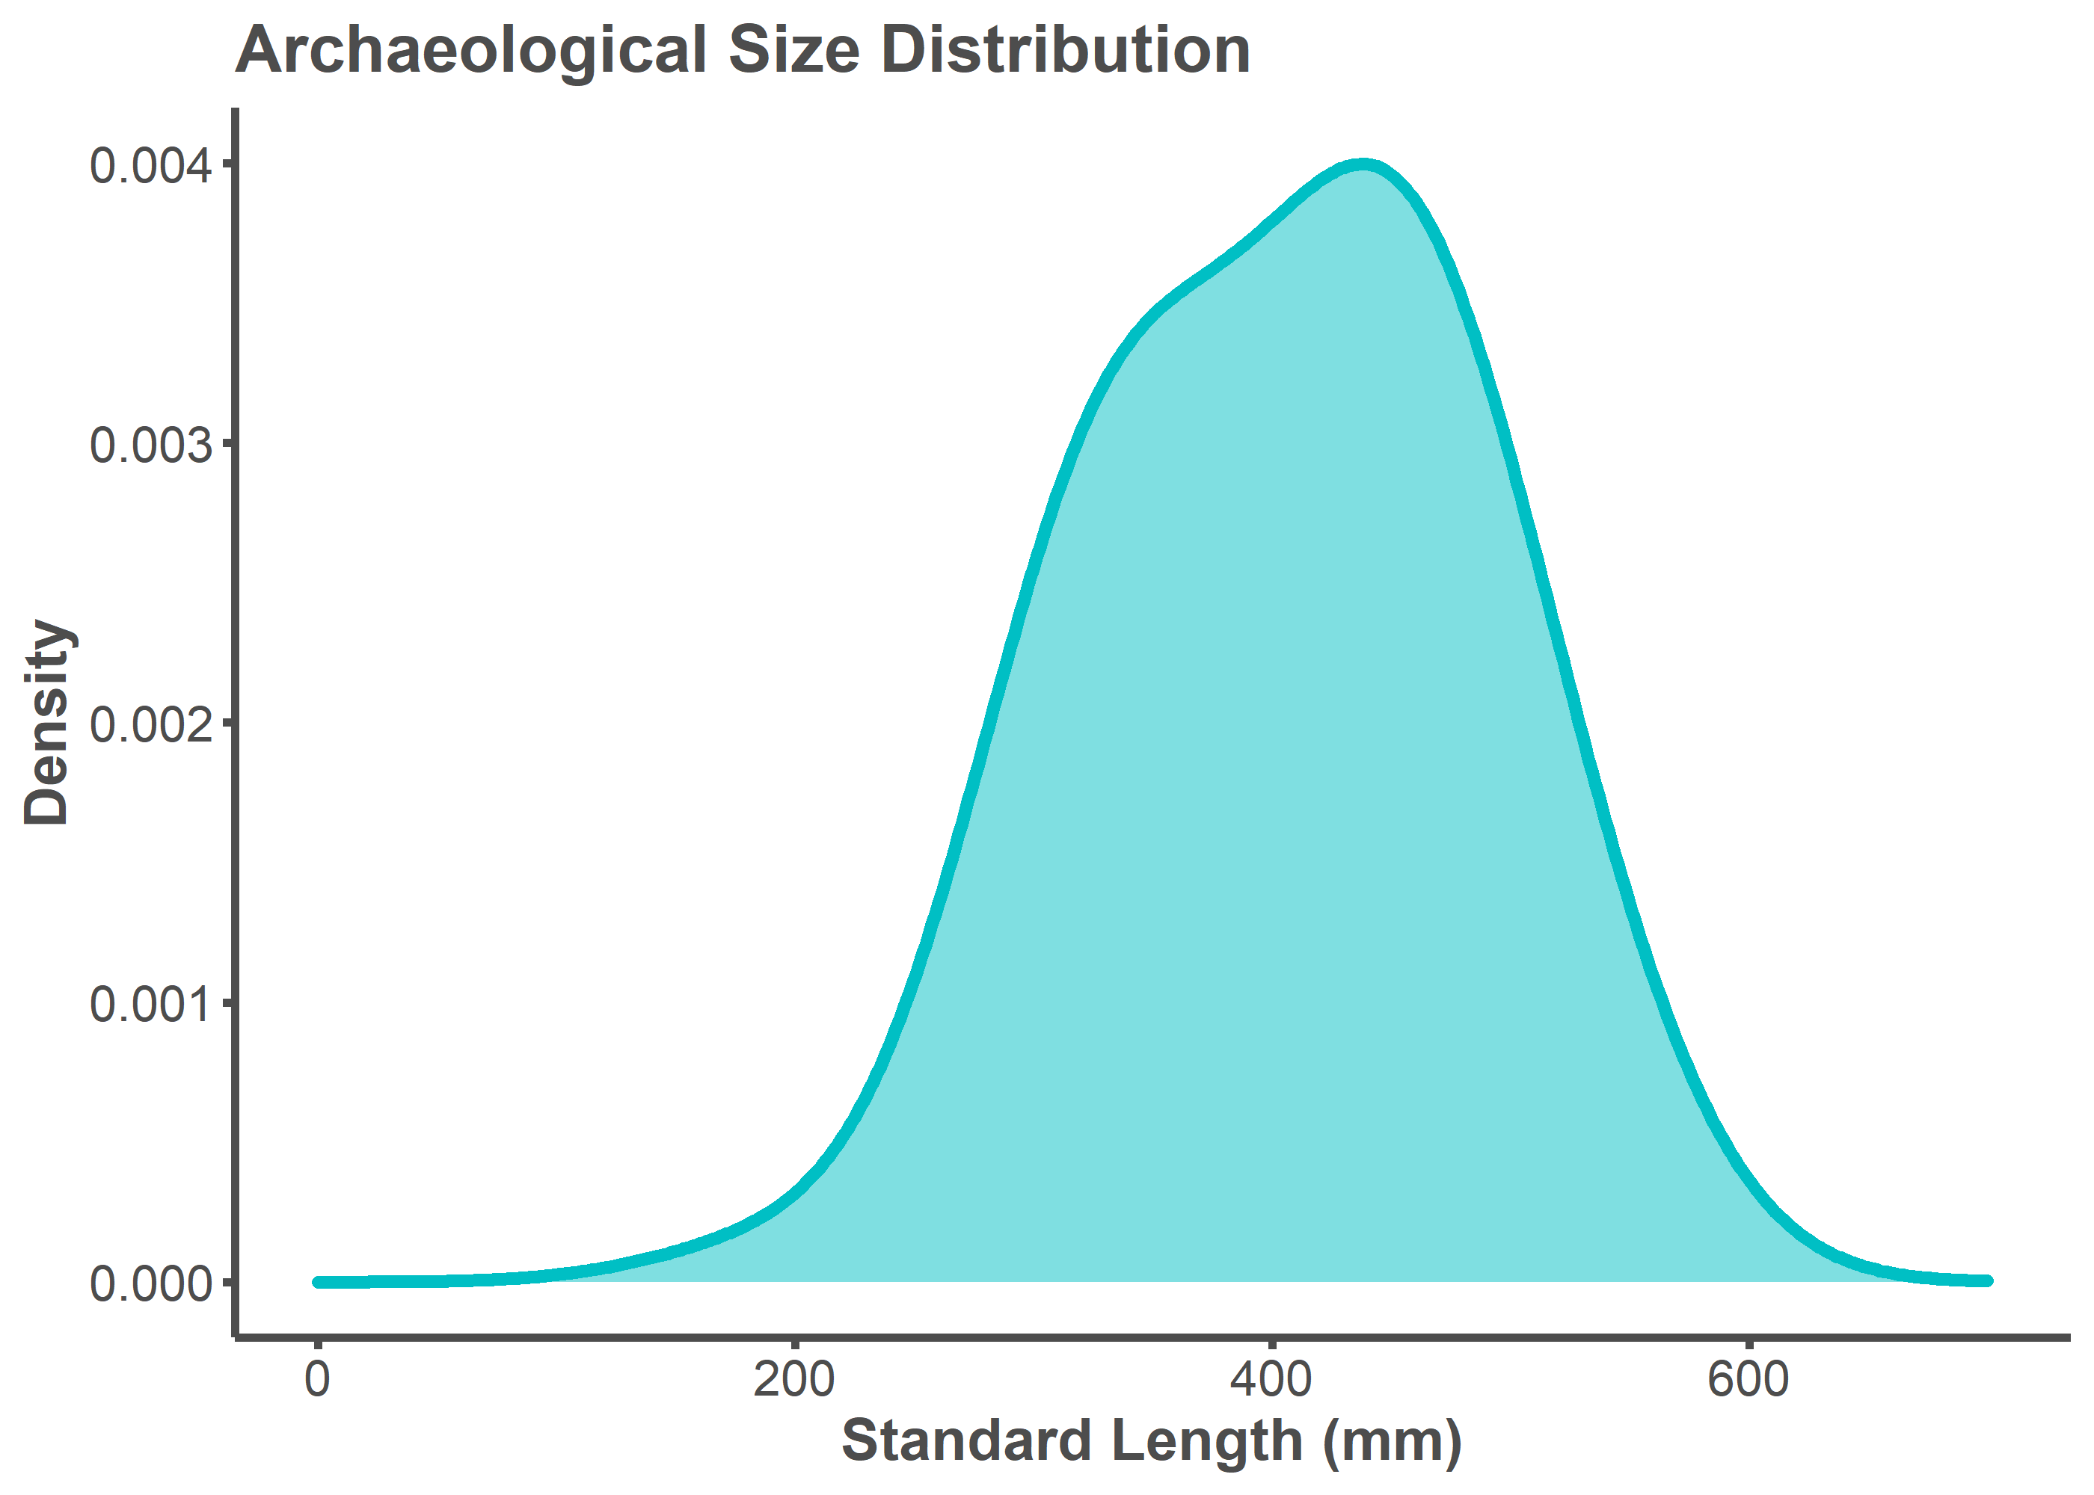

# MODERN COMPARISONS

## Total Length (TL)

A length-length conversion factor from Standard Length (SL) to Total Length (TL) was applied to the archaeological SL estimates. All modern comparison data uses TL. TL could not be estimated per archaeological specimen considering that two specimens from the Museum of Southwestern Biology comparative library (25273, 50002, and 50003) do not have TL measurements. A SL to TL conversion factor of 1.27 was chosen by calculating the mean values available for *Ictiobus bubalus* and *Carpiodes carpio* on fishbase.de. Available here: <https://www.fishbase.de/popdyn/LLRelationshipList.php?ID=2992&GenusName=Ictiobus&SpeciesName=bubalus&fc=125> <https://www.fishbase.de/popdyn/LLRelationshipList.php?ID=2957&GenusName=Carpiodes&SpeciesName=carpio&fc=125>

# convert archaeological SL to TL  
results <- mutate(results, Arch_TL = Arch_SL*1.27)  
  
# visualize archaeological distribution  
results %>%   
 ggplot(aes(Arch_TL)) +  
 geom_density(fill = "#00bfc4", color = "#00bfc4", bw = 50, alpha = 0.5,   
 size = 1.5) +  
 theme_classic() +  
 theme(legend.position="none",  
 axis.line = element_line(color = "#4d4d4d", size = 1),  
 plot.title = element_text(color = "#4d4d4d", size = 16,   
 face = "bold"),  
 axis.text.x = element_text(color = "#4d4d4d", size = 12),  
 axis.text.y = element_text(color = "#4d4d4d", size = 12),  
 axis.title.x = element_text(color = "#4d4d4d", size = 14,   
 face = "bold"),  
 axis.title.y = element_text(color = "#4d4d4d", size = 14,   
 face = "bold"),  
 axis.ticks.x = element_line(color = "#4d4d4d", size = 1),  
 axis.ticks.y = element_line(color = "#4d4d4d", size = 1)) +  
 labs(title = "Archaeological Size Distribution",   
 x = "Total Length (mm)", y = "Density") +  
 xlim(100, 900)

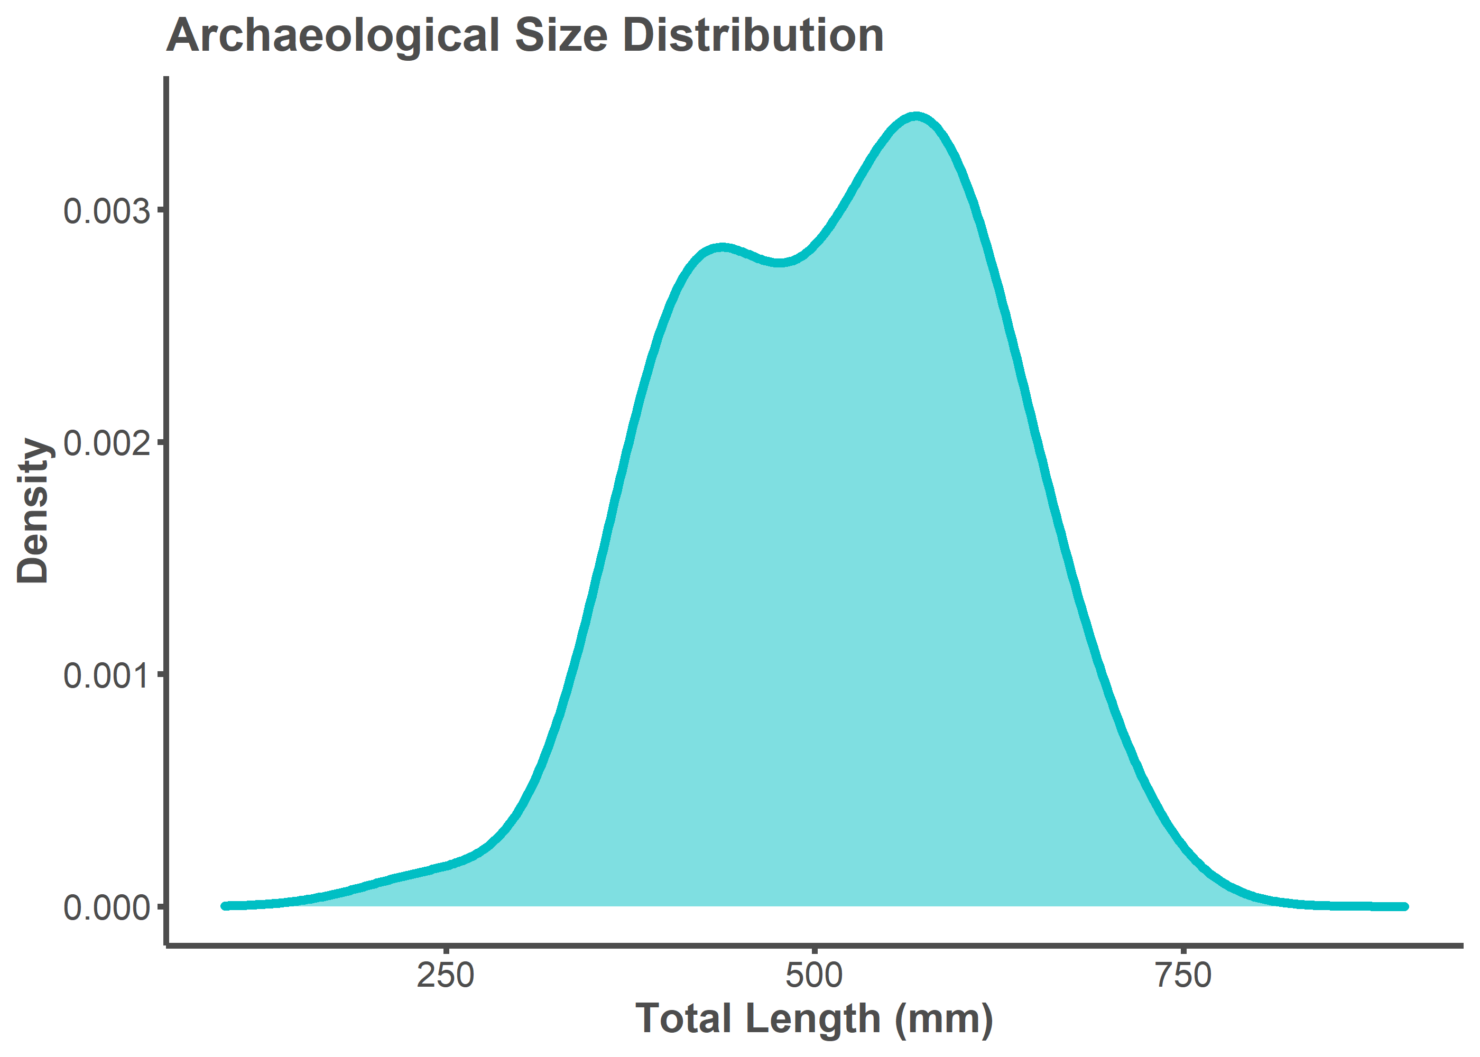

## Error Associated with SL to TL Length-Length Conversion

TL and TL_estimate of specimens from the comparative library are almost perfectly correlated (*R2* = 0.99; *rho* = 1). This means that error associated with the TL conversion factor (1.27) is extremely low. Further, the conversion factor will underestimate TL if there is error. This can be seen by visually inspecting the graph below.

body.size.estimate <- body.size %>%  
 na.omit() %>%  
 mutate(TL_estimate = SL * 1.27)  
  
p <- ggplot(data = body.size.estimate,   
 mapping = aes(x = TL_estimate, y = TL))  
p + geom_point(alpha = 0.5, size = 4) +   
 geom_smooth(formula = y ~ x, method = "lm", size = 1.25,   
 color = "#4d4d4d") +  
 annotate("text", x = 400, y = 215,   
 label = "paste(italic(R) ^ 2, \" = .99, \", italic(rho),  
 \" = 1 \")",  
 parse = T, hjust = 1, vjust = 0, color = "#4d4d4d") +  
 theme_classic() +  
 labs(x = "Estimated Total Length (mm)", y = "Actual Total Length (mm)") +  
 theme(legend.position="none",  
 axis.line = element_line(color = "#4d4d4d", size = 1),  
 axis.text.x = element_text(color = "#4d4d4d", size = 12),  
 axis.text.y = element_text(color = "#4d4d4d", size = 12),  
 axis.title.x = element_text(color = "#4d4d4d", size = 14,   
 face = "bold"),  
 axis.title.y = element_text(color = "#4d4d4d", size = 14,   
 face = "bold"),  
 axis.ticks.x = element_line(color = "#4d4d4d", size = 1),  
 axis.ticks.y = element_line(color = "#4d4d4d", size = 1))

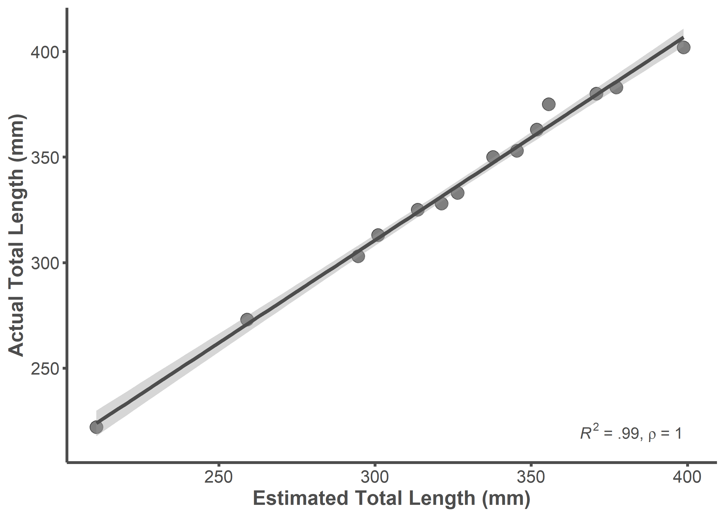

summary(lm(data = body.size.estimate, TL ~ TL_estimate))

##   
## Call:  
## lm(formula = TL ~ TL_estimate, data = body.size.estimate)  
##   
## Residuals:  
## Min 1Q Median 3Q Max   
## -4.7035 -2.6240 -0.6684 1.8637 10.3026   
##   
## Coefficients:  
## Estimate Std. Error t value Pr(>|t|)   
## (Intercept) 18.76522 7.36499 2.548 0.0256 *   
## TL_estimate 0.97281 0.02235 43.517 1.41e-14 ***  
## ---  
## Signif. codes: 0 '***' 0.001 '**' 0.01 '*' 0.05 '.' 0.1 ' ' 1  
##   
## Residual standard error: 3.968 on 12 degrees of freedom  
## Multiple R-squared: 0.9937, Adjusted R-squared: 0.9932   
## F-statistic: 1894 on 1 and 12 DF, p-value: 1.41e-14

rho <-cor.test(body.size.estimate$TL, body.size.estimate$TL_estimate,   
 method = "spearman")  
rho

##   
## Spearman's rank correlation rho  
##   
## data: body.size.estimate$TL and body.size.estimate$TL_estimate  
## S = 0, p-value < 2.2e-16  
## alternative hypothesis: true rho is not equal to 0  
## sample estimates:  
## rho   
## 1

## Calculating Modern Comparison

*Archaeological Estimates*

# specify breaks  
breaks <- c(-Inf,200,250,300,350,400,450,500,550,Inf)  
  
# specify bin labels  
tags <- c("-199", "200-249", "250-299", "300-349", "350-399","400-449",   
 "450-499","500-549", "550+")  
  
# put values into bins  
group_tags <- cut(results$Arch_TL,   
 breaks=breaks,  
 include.lowest=TRUE,   
 right=FALSE,  
 labels=tags)  
  
# plot  
a <- as_tibble(summary(group_tags), rownames = "bins") %>%  
 dplyr::rename(count = value) %>%  
 mutate(percent = (count/sum(count)*100)) %>%  
 dplyr::select(bins, percent) %>%  
 mutate(time = "Archaeological")

*Moody (1970)*

# overall percentages (1967-1970) reported in Table 4   
b <- tibble(bins = c("-199", "200-249", "250-299", "300-349", "350-399",   
 "400-449", "450-499","500-549", "550+"),   
 percent = c(0, 2, 3, 11, 15, 21, 36, 11, 1)) %>%  
 mutate(time = "Commercial")

*NM Game and Fish*

NMgamefish <- read.table("Modern Comparison/NM Game and Fish.txt",   
 header = TRUE)  
  
# specify breaks  
breaks <- c(-Inf, 200, 250, 300, 350, 400, 450, 500, 550, Inf)  
# specify bin labels  
tags <- c("-199", "200-249", "250-299", "300-349", "350-399","400-449",   
 "450-499","500-549", "550+")  
# puttingvalues into bins  
group_tags <- cut(NMgamefish$TL,   
 breaks=breaks,  
 include.lowest=TRUE,   
 right=FALSE,  
 labels=tags)  
  
# plot  
c <- as_tibble(summary(group_tags), rownames = "bins") %>%  
 dplyr::rename(count = value) %>%  
 mutate(percent = (count/sum(count)*100)) %>%  
 dplyr::select(bins, percent) %>%  
 mutate(time = "Non_Commercial")

*Bind Together and Plot*

d <- rbind(a, b, c)  
  
d$time <- factor(d$time, levels = c("Commercial", "Non_Commercial",   
 "Archaeological"))  
  
d$time2 <- factor(d$time,   
 labels = c("Commercial Fishery (1967–1970)",   
 "Non-Commercial Fishery (2011–2017)",  
 "Archaeological Fishery (ca. AD 1300-1600)"))  
  
ggplot(d, aes(x = bins, y = percent)) +  
 geom_bar(stat = "identity", size = 1.5) +  
 facet_wrap(~ time2, nrow = 3) +  
 scale_y_continuous(breaks = seq(0, 45, by = 15)) +  
 theme_classic() +  
 theme(legend.position="top",  
 strip.text.x = element_text(color = "#4d4d4d", size = 12,   
 face = "bold"),  
 strip.background = element_rect(color= NA, fill= NA),  
 legend.title = element_blank(),  
 axis.line = element_line(color = "#4d4d4d", size = 1),  
 axis.text.x = element_text(color = "#4d4d4d", size = 7),  
 axis.text.y = element_text(color = "#4d4d4d", size = 8),  
 axis.title.x = element_text(color = "#4d4d4d", size = 10,   
 face = "bold"),  
 axis.title.y = element_text(color = "#4d4d4d", size = 10,   
 face = "bold"),  
 axis.ticks.x = element_line(color = "#4d4d4d", size = 1),  
 axis.ticks.y = element_line(color = "#4d4d4d", size = 1)) +  
 labs(x = "Total Length (mm)", y = "Percent (%)")

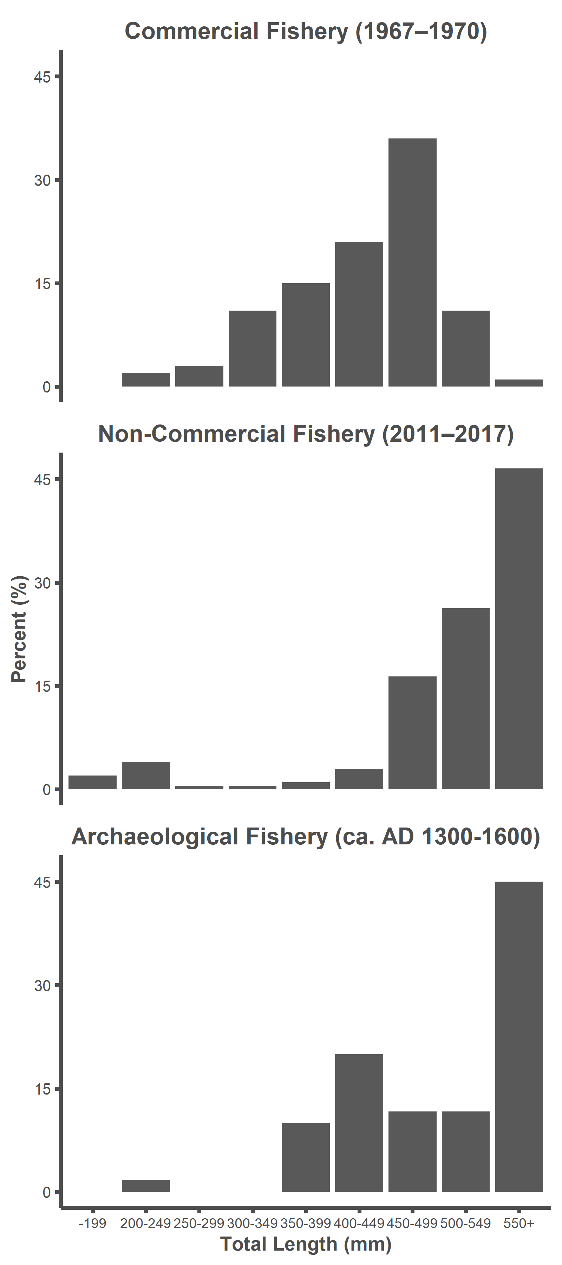

# INTRA- AND INTERINDIVIDUAL ERROR TESTING

## Intraobserver Error

*Analyst 1 (Alexandra Harris)*

Run a Generalized Procrustes Analysis for all Analyst 1 datafiles. Each .txt file pertains to a specimen and contains five replicate landmark configurations

setwd("Error Testing/Alex")  
files <- list.files(pattern = "\\.txt$")  
my.list <- list()  
  
for (i in seq_along(files)) {  
 fname <- paste(files[i], sep="/")  
   
 data <- read.table(fname, header = T, row.names = 1,   
 stringsAsFactors = FALSE)  
   
 a <-arrayspecs(data, ncol(data)/3, 3)  
   
 mydata.gpa <- gpagen(a, curves = NULL, surfaces = NULL, PrinAxes = TRUE,   
 max.iter = NULL,   
 ProcD = TRUE, Proj = TRUE, print.progress = FALSE)  
   
my.list[[i]] <- mydata.gpa  
}

Establish number of rows in each landmark configuration

rows <- rep(NA, 60)  
for(i in seq_along(my.list)){  
 rows[i] <- dim(my.list[[i]][["coords"]])[1]  
}

Create lists out of all coordinates per replicate per specimen and all consensuses per specimen

# initiate  
coords <- list()  
for(i in 1:60){  
 coords[[i]] <- array(NA, dim = c(rows[i], 3, 5))  
}  
  
# isolate coordinates per specimen per analyst per replicate  
for(i in seq_along(my.list)){  
 for(j in 1:5){  
 coords[[i]][,,j] <- my.list[[i]][["coords"]][,,j]  
 }  
}  
  
# initiate  
consensus <- list()  
  
# isolate consensus per specimen  
for(i in seq_along(my.list)){  
 consensus[[i]] <- my.list[[c(i, 4)]]  
}

Calculate procd (procd = total Procrustes distance from consensus)

# initiate  
output1 <- list()  
for(i in 1:60){  
 output1[[i]] <- array(NA, dim = c(rows[i], 3, 5))  
}  
  
# subtract and square  
for(i in seq_along(coords)){  
 for(j in 1:5){  
 output1[[i]][,,j] <- (coords[[i]][,,j] - consensus[[i]])^2  
 }  
}  
  
# initiate  
output2 <- list()  
for(i in 1:60){  
 output2[[i]] <- array(NA, dim = c(1, rows[i], 5))  
}  
  
# sum rows  
for(i in seq_along(output1)){  
 for(j in 1:5){  
 output2[[i]][,,j] <- rowSums(output1[[i]][,,j])  
 }  
}  
  
# initiate  
procd <- list()  
for(i in 1:60){  
 procd[[i]] <- array(NA, dim = c(1, 1, 5))  
}  
  
# sum and square root  
for(i in 1:60){  
 for(j in 1:5){  
 procd[[i]][,,j] <- sqrt(sum(output2[[i]][,,j]))  
 }  
}

Transform procd and assign to Analyst 1

# create dataframe  
procd <- data.frame(unlist(procd))  
  
#subset data for Analyst 1 and transform  
analyst1.procd <- procd %>%  
 mutate(analyst = "Analyst 1",  
 replicate = rep(c("1", "2", "3", "4", "5"), times = 60)) %>%  
 rename(procd = colnames(procd)[1])

*Analyst 2 (Jonathan Dombrosky)*

Run a Generalized Procrustes Analysis for all Analyst 2 datafiles. Each .txt file pertains to a specimen and contains five replicate landmark configurations

setwd("Error Testing/Jon")  
files <- list.files(pattern = "\\.txt$")  
my.list <- list()  
  
for (i in seq_along(files)) {  
 fname <- paste(files[i], sep="/")  
   
 data <- read.table(fname, header = T, row.names = 1,   
 stringsAsFactors = FALSE)  
   
 a <-arrayspecs(data, ncol(data)/3, 3)  
   
 mydata.gpa <- gpagen(a, curves = NULL, surfaces = NULL, PrinAxes = TRUE,   
 max.iter = NULL,   
 ProcD = TRUE, Proj = TRUE, print.progress = FALSE)  
   
my.list[[i]] <- mydata.gpa  
}

Establish number of rows in each landmark configuration

rows <- rep(NA, 60)  
for(i in seq_along(my.list)){  
 rows[i] <- dim(my.list[[i]][["coords"]])[1]  
}

Create lists out of all coordinates per replicate per specimen and all consensuses per specimen

# initiate  
coords <- list()  
for(i in 1:60){  
 coords[[i]] <- array(NA, dim = c(rows[i], 3, 5))  
}  
  
# isolate coordinates per specimen per analyst per replicate  
for(i in seq_along(my.list)){  
 for(j in 1:5){  
 coords[[i]][,,j] <- my.list[[i]][["coords"]][,,j]  
 }  
}  
  
# initiate  
consensus <- list()  
  
# isolate consensus per specimen  
for(i in seq_along(my.list)){  
 consensus[[i]] <- my.list[[c(i, 4)]]  
}

Calculate procd (procd = total Procrustes distance from consensus)

# initiate  
output1 <- list()  
for(i in 1:60){  
 output1[[i]] <- array(NA, dim = c(rows[i], 3, 5))  
}  
  
# subtract and square  
for(i in seq_along(coords)){  
 for(j in 1:5){  
 output1[[i]][,,j] <- (coords[[i]][,,j] - consensus[[i]])^2  
 }  
}  
  
# initiate  
output2 <- list()  
for(i in 1:60){  
 output2[[i]] <- array(NA, dim = c(1, rows[i], 5))  
}  
  
# sum rows  
for(i in seq_along(output1)){  
 for(j in 1:5){  
 output2[[i]][,,j] <- rowSums(output1[[i]][,,j])  
 }  
}  
  
# initiate  
procd <- list()  
for(i in 1:60){  
 procd[[i]] <- array(NA, dim = c(1, 1, 5))  
}  
  
# sum and square root  
for(i in 1:60){  
 for(j in 1:5){  
 procd[[i]][,,j] <- sqrt(sum(output2[[i]][,,j]))  
 }  
}

Transform procd and assign to Analyst 2

# create dataframe  
procd <- data.frame(unlist(procd))  
  
#subset data for Analyst 1 and transform  
analyst2.procd <- procd %>%  
 mutate(analyst = "Analyst 2",  
 replicate = rep(c("1", "2", "3", "4", "5"), times = 60)) %>%  
 rename(procd = colnames(procd)[1])

Bind Analyst 1 and Analyst 2 datasets

procd <- rbind(analyst1.procd, analyst2.procd)

*Visualize and Significance Testing*

One way ANOVA tests indicate that the mean values of procd are equal between replicates for Analyst 1 (*p* = 0.91) and Analyst 2 (*p* = 0.31). Further, the effect size between replicates is extremely small for Analyst 1 (*Eta2* < 0.01) and Analyst 2 (*Eta2* = 0.02). The landmarking configurations on the entire archaeological dataset are practically indistinguishable between replicates of the same analyst.

procd %>%  
 ggplot(mapping = aes(x = replicate, y = procd, group = replicate,   
 fill = replicate, color = replicate)) +  
 geom_boxplot(size = 0.75, alpha = 0.5, outlier.alpha = 0.5,   
 outlier.size = 2.5) +  
 facet_wrap(~ analyst, nrow = 2) +  
 theme_classic() +  
 theme(legend.position= "none",  
 strip.background = element_blank(),  
 strip.text.x = element_text(color = "#4d4d4d", size = 16,   
 face = "bold"),  
 axis.line = element_line(color = "#4d4d4d", size = 1),  
 axis.text.x = element_text(color = "#4d4d4d", size = 12),  
 axis.text.y = element_text(color = "#4d4d4d", size = 12),  
 axis.title.x = element_text(color = "#4d4d4d", size = 14,   
 face = "bold"),  
 axis.title.y = element_text(color = "#4d4d4d", size = 14,   
 face = "bold"),  
 axis.ticks.x = element_line(color = "#4d4d4d", size = 1),  
 axis.ticks.y = element_line(color = "#4d4d4d", size = 1)) +  
 labs(x = "Replicate", y = "Total Procrustes Distance\n   
 from Consensus")

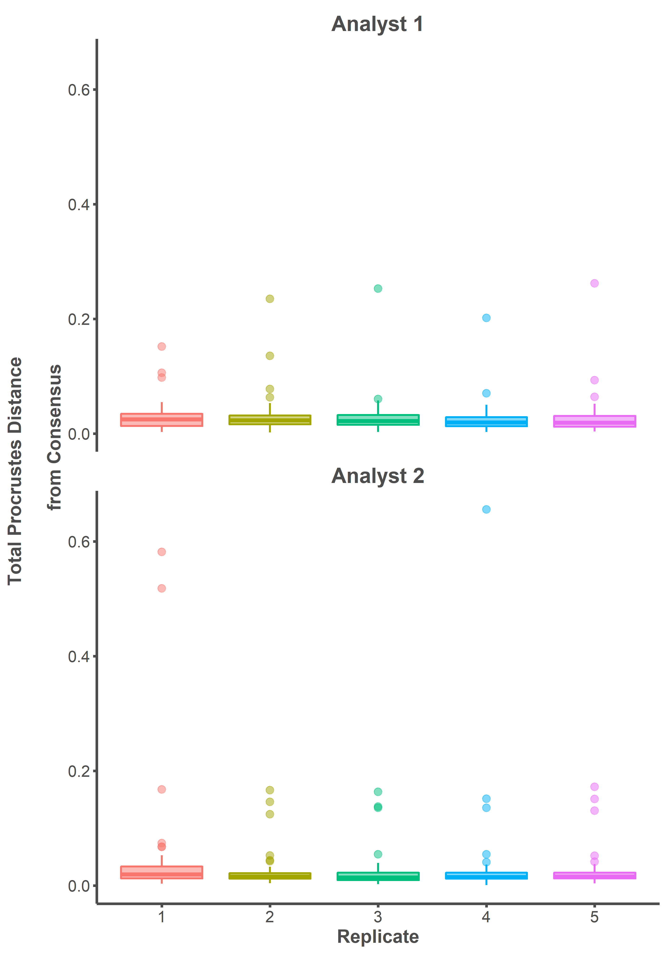

oneway.analyst1 <- aov(procd ~ replicate, data = analyst1.procd)  
summary(oneway.analyst1)

## Df Sum Sq Mean Sq F value Pr(>F)  
## replicate 4 0.00096 0.0002397 0.254 0.907  
## Residuals 295 0.27886 0.0009453

eta_squared(oneway.analyst1)

## For one-way between subjects designs, partial eta squared is equivalent to eta squared.  
## Returning eta squared.

## # Effect Size for ANOVA  
##   
## Parameter | Eta2 | 95% CI  
## -----------------------------------  
## replicate | 3.43e-03 | [0.00, 1.00]  
##   
## - One-sided CIs: upper bound fixed at (1).

oneway.analyst2 <- aov(procd ~ replicate, data = analyst2.procd)  
summary(oneway.analyst2)

## Df Sum Sq Mean Sq F value Pr(>F)  
## replicate 4 0.0188 0.004707 1.193 0.314  
## Residuals 295 1.1636 0.003944

eta_squared(oneway.analyst2)

## For one-way between subjects designs, partial eta squared is equivalent to eta squared.  
## Returning eta squared.

## # Effect Size for ANOVA  
##   
## Parameter | Eta2 | 95% CI  
## -------------------------------  
## replicate | 0.02 | [0.00, 1.00]  
##   
## - One-sided CIs: upper bound fixed at (1).

## Interobserver Error

Run a Generalized Procrustes Analysis for all datafiles (both Analyst 1 and Analyst 2 combined). Each .txt file pertains to a specimen and contains five replicate landmark configurations per analyst.

setwd("Error Testing/Both")  
files <- list.files(pattern = "\\.txt$")  
my.list <- list()  
  
for (i in seq_along(files)) {  
 fname <- paste(files[i], sep="/")  
   
 data <- read.table(fname, header = T, row.names = 1,   
 stringsAsFactors = FALSE)  
   
 a <-arrayspecs(data, ncol(data)/3, 3)  
   
 mydata.gpa <- gpagen(a, curves = NULL, surfaces = NULL, PrinAxes = TRUE,   
 max.iter = NULL,   
 ProcD = TRUE, Proj = TRUE, print.progress = FALSE)  
   
my.list[[i]] <- mydata.gpa  
}

Establish number of rows in each landmark configuration

rows <- rep(NA, 60)  
for(i in seq_along(my.list)){  
 rows[i] <- dim(my.list[[i]][["coords"]])[1]  
}

Create lists out of all coordinates per replicate per analyst per specimen and all consensuses per specimen

# initiate  
coords <- list()  
for(i in 1:60){  
 coords[[i]] <- array(NA, dim = c(rows[i], 3, 10))  
}  
  
# isolate coordinates per specimen per analyst per replicate  
for(i in seq_along(my.list)){  
 for(j in 1:10){  
 coords[[i]][,,j] <- my.list[[i]][["coords"]][,,j]  
 }  
}  
  
# initiate  
consensus <- list()  
  
# isolate consensus per specimen  
for(i in seq_along(my.list)){  
 consensus[[i]] <- my.list[[c(i, 4)]]  
}

Calculate procd (procd = total Procrustes distance from consensus)

# initiate  
output1 <- list()  
for(i in 1:60){  
 output1[[i]] <- array(NA, dim = c(rows[i], 3, 10))  
}  
  
# subtract and square  
for(i in seq_along(coords)){  
 for(j in 1:10){  
 output1[[i]][,,j] <- (coords[[i]][,,j] - consensus[[i]])^2  
 }  
}  
  
# initiate  
output2 <- list()  
for(i in 1:60){  
 output2[[i]] <- array(NA, dim = c(1, rows[i], 10))  
}  
  
# sum rows  
for(i in seq_along(output1)){  
 for(j in 1:10){  
 output2[[i]][,,j] <- rowSums(output1[[i]][,,j])  
 }  
}  
  
# initiate  
procd <- list()  
for(i in 1:60){  
 procd[[i]] <- array(NA, dim = c(1, 1, 10))  
}  
  
# sum and square root  
for(i in 1:60){  
 for(j in 1:10){  
 procd[[i]][,,j] <- sqrt(sum(output2[[i]][,,j]))  
 }  
}

Transform procd

# create dataframe  
procd <- data.frame(unlist(procd))  
  
#subset data for Analyst 1 and transform  
analyst1.procd <- data.frame(procd[c(rep(TRUE, 5), rep(FALSE, 5)),])  
  
analyst1.procd <- analyst1.procd %>%  
 mutate(analyst = "1") %>%  
 rename(procd = colnames(analyst1.procd)[1])  
  
#subset data for Analyst 2 and transform  
analyst2.procd <- data.frame(procd[c(rep(FALSE, 5), rep(TRUE, 5)),])  
  
analyst2.procd <- analyst2.procd %>%  
 mutate(analyst = "2") %>%  
 rename(procd = colnames(analyst2.procd)[1])  
  
#bind transformed datasets for Analyst 1 and 2  
procd <- rbind(analyst1.procd, analyst2.procd)

*Visualize and Significance Testing*

An independent t-test indicates that the mean values of procd between Analyst 1 and Analyst 2 are equal (*p* = 0.89). Further, the effect size between the two means is extremely small (*Cohen’s d* = 0.01). The landmarking configuration on the entire archaeological dataset (replicated five times) is practically indistinguishable between Analyst 1 and Analyst 2.

procd %>%  
 ggplot(mapping = aes(x = analyst, y = procd, group = analyst,   
 fill = analyst, color = analyst)) +  
 geom_boxplot(size = 0.75, alpha = 0.5, outlier.alpha = 0.5,   
 outlier.size = 2.5) +  
 theme_classic() +  
 theme(legend.position= "none",  
 strip.background = element_blank(),  
 strip.text.x = element_text(color = "#4d4d4d", size = 16,   
 face = "bold"),  
 axis.line = element_line(color = "#4d4d4d", size = 1),  
 axis.text.x = element_text(color = "#4d4d4d", size = 12),  
 axis.text.y = element_text(color = "#4d4d4d", size = 12),  
 axis.title.x = element_text(color = "#4d4d4d", size = 14,   
 face = "bold"),  
 axis.title.y = element_text(color = "#4d4d4d", size = 14,   
 face = "bold"),  
 axis.ticks.x = element_line(color = "#4d4d4d", size = 1),  
 axis.ticks.y = element_line(color = "#4d4d4d", size = 1)) +  
 labs(x = "Analyst", y = "Total Procrustes Distance\n from Consensus")

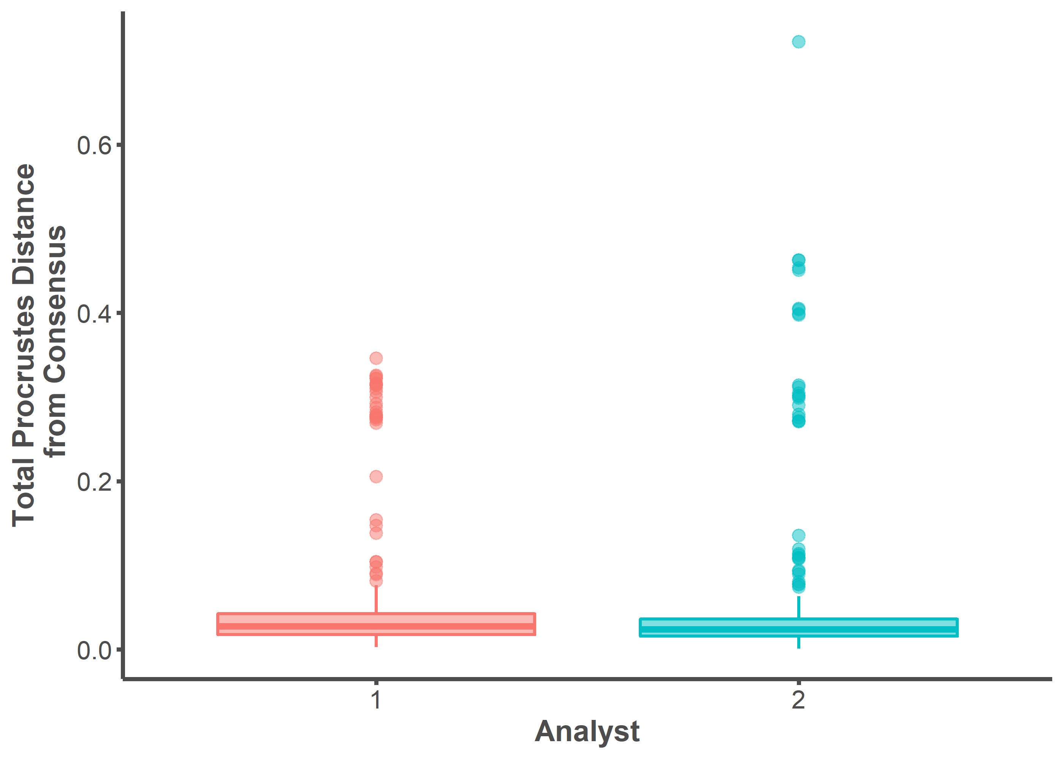

t.test <- t.test(analyst1.procd$procd, analyst2.procd$procd)  
t.test

##   
## Welch Two Sample t-test  
##   
## data: analyst1.procd$procd and analyst2.procd$procd  
## t = -0.13727, df = 570.74, p-value = 0.8909  
## alternative hypothesis: true difference in means is not equal to 0  
## 95 percent confidence interval:  
## -0.01440174 0.01252025  
## sample estimates:  
## mean of x mean of y   
## 0.05045055 0.05139130

cohens_d(t.test)

## Cohen's d | 95% CI  
## -------------------------  
## -0.01 | [-0.17, 0.15]  
##   
## - Estimated using un-pooled SD.