How Prevalent is Archaeological Garden Hunting?

Jonathan Dombrosky, Caitlin Ainsworth, Abigail Judkins, Jana Meyer, Michael A. Adler, and Emily Lena Jones

1/24/2022

# Libraries

library(SIBER)  
library(tidyverse)  
library(cowplot)  
library(broom)  
library(car)

# Figure 1

Plant genera reported by Scribner and Krysel (1982) were assigned a photosynthetic pathway from the following sources: Basinger and Robertson (1997), Bruhl and Wilson (2007), Danneberger (1999), Giussani et al. (2001), Kocacinar and Sage (2003), Nelson (2012), Osborne et al. (2014), and Syvertsen et al. (1976).

Table_2 <- read.csv("Scribner and Krysl_Table 2/Table 2.csv", header = TRUE)  
  
Pathway <- Table_2 %>%  
 select(Environmental.Context, Photosynthetic.pathway, DF....) %>%  
 group_by(Environmental.Context, Photosynthetic.pathway) %>%  
 summarize(sum_DF = sum(DF....), .groups = "keep")  
  
labels <- c("Agricultural Playa Basins" = "Agricultural Context",  
 "Playa Basins" = "Non-Agricultural Context")  
  
Pathway %>%  
ggplot(aes(x = reorder(Photosynthetic.pathway, -sum_DF), y = sum_DF)) +  
 geom_bar(stat = "identity", size = 0.75, alpha = 0.5, color = "#4d4d4d") +  
 facet_wrap(~ Environmental.Context, ncol = 2,   
 labeller = labeller(Environmental.Context = labels)) +  
 scale_x_discrete(labels = parse(text = c("C[4]", "C[3]", "C[3]/C[4]"))) +  
 theme_classic() +  
 theme(legend.position="none",  
 strip.background = element_blank(),  
 strip.text.x = element_text(color = "#4d4d4d", size = 12,   
 face = "bold"),  
 axis.line = element_line(color = "#4d4d4d", size = 0.75),  
 axis.text.x = element_text(color = "#4d4d4d", size = 10),  
 axis.text.y = element_text(color = "#4d4d4d", size = 10),  
 axis.title.x = element_text(color = "#4d4d4d", size = 12,   
 face = "bold"),  
 axis.title.y = element_text(color = "#4d4d4d", size = 12,   
 face = "bold"),  
 axis.ticks.x = element_line(color = "#4d4d4d", size = 0.75),  
 axis.ticks.y = element_line(color = "#4d4d4d", size = 0.75)) +  
 labs(x = "Photosynthetic Pathway", y = "% Diet")

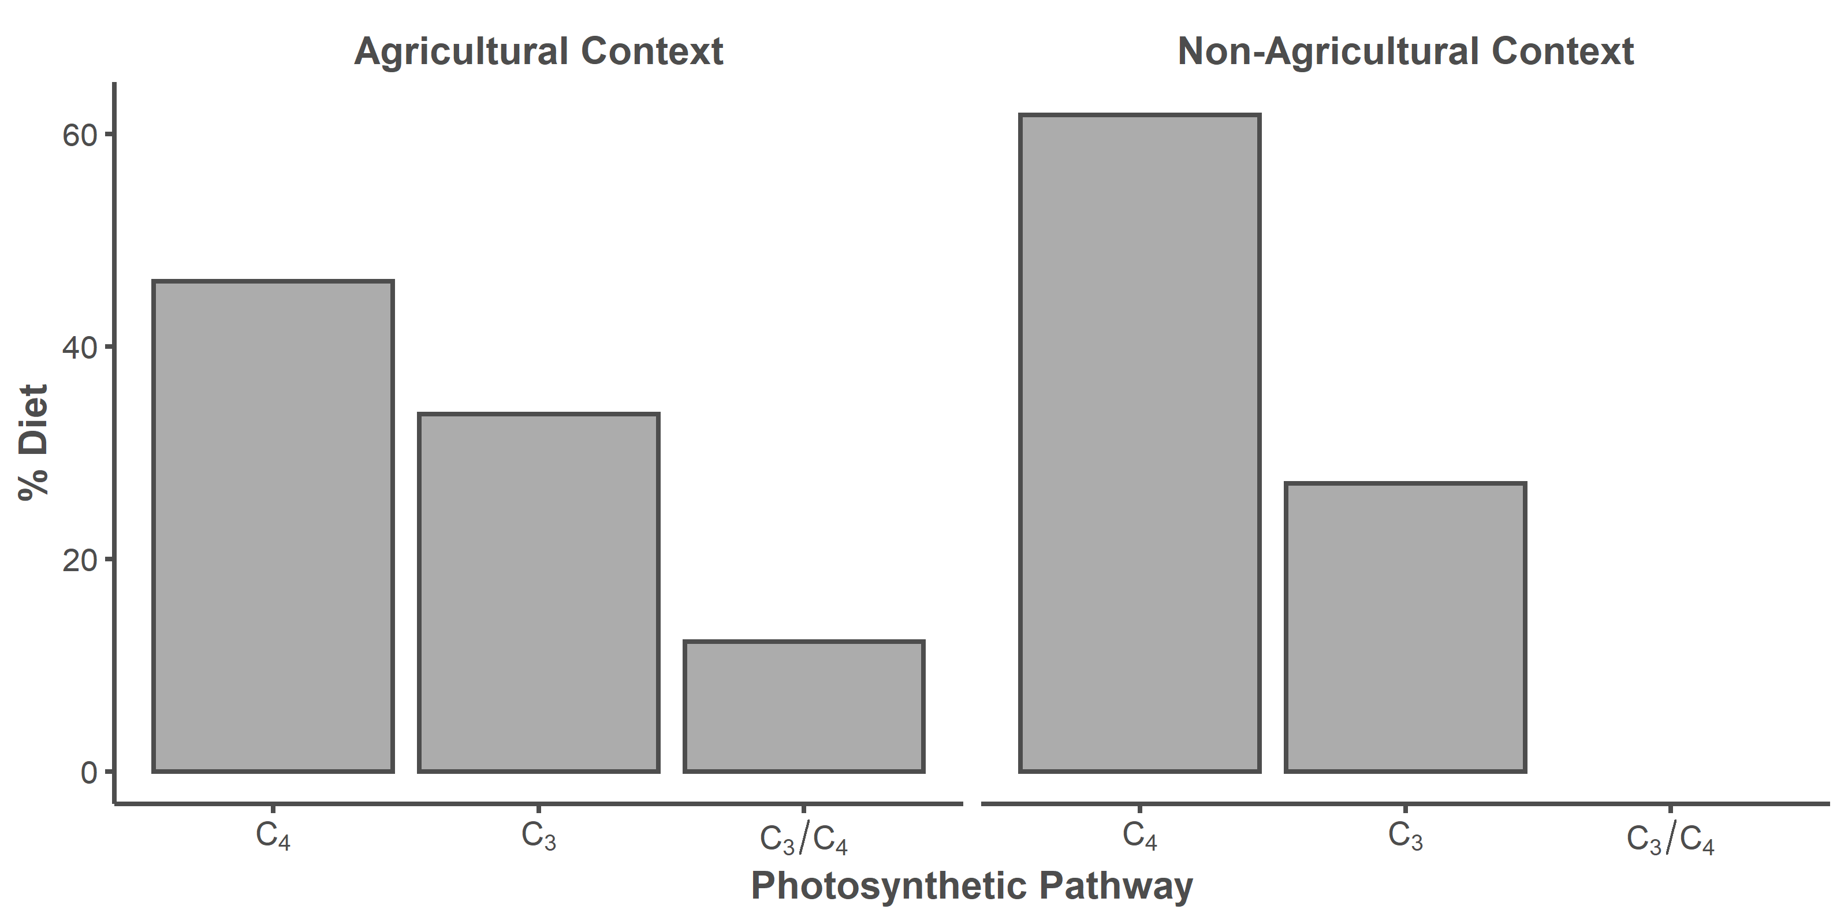

# Isotope Data

Bone from the archaeo dataset was demineralized in 0.5 N hydrochloric acid, lipids were removed using 2:1 chloroform:methanol, and the resulting collagen pseudomorph was freeze-dried overnight. Between 0.5 and 0.6 mg of collagen was weighed out for the analysis of δ13C and δ15N. All seeds from the seeds dataset were purchased from Native seeds/SEARCH. Between 5.0 and 6.0 mg of ground corn and 2.0 and 2.5 mg of ground bean/squash was weighed out for the analysis of δ13C and δ15N. δ13C and δ15N were measured at the University of New Mexico Center for Stable Isotopes (UNM CSI, Albuquerque, NM) on a Thermo Scientific Delta V isotope ratio mass spectrometer (IRMS) with a dual inlet and Conflo IV interface coupled to a Costech 4010 elemental analyzer (EA). Stable isotope values are reported as parts per mil (‰).

The humans and turkeys isotope values come from the following sources: Chisholm and Matson (1994), Coltrain et al. (2007), Conrad et al. (2016), Jones et al. (2016), Kellner et al. (2010), Kennett et al. (2017), Martin (1999), McCaffery et al. (2014), and Rawlings and Driver (2010).

archaeo <- read.csv("archaeological.csv", header = TRUE)  
seeds <- read.csv("modern seeds.csv", header = TRUE)  
turkeys <- read.csv("turkeys.csv", header = TRUE)   
humans <- read.csv("humans.csv", header = TRUE)

# Assessing Collagen Purity

Boxplots of C:Natomic values of archaeological leporid collagen per site. The blue box represents the acceptable range of collagen purity (2.9-3.6) reported by Ambrose (1990).

archaeo %>%  
 mutate(CNatomic = CN * (14/12)) %>%  
 ggplot(mapping = aes(y = CNatomic, x = Site.Name, group = Site.Name)) +  
 geom_boxplot(color = "#4d4d4d", size = 0.75) +  
 labs(y = expression("C:N"[atomic]), x = "Archaeological Site") +  
 theme_classic() +  
 theme(legend.position="none",  
 axis.line = element_line(color = "#4d4d4d", size = 1),  
 axis.text.x = element_text(color = "#4d4d4d", size = 12),  
 axis.text.y = element_text(color = "#4d4d4d", size = 12),  
 axis.title.x = element_text(color = "#4d4d4d", size = 14),  
 axis.title.y = element_text(color = "#4d4d4d", size = 14),  
 axis.ticks.x = element_line(color = "#4d4d4d", size = 1),  
 axis.ticks.y = element_line(color = "#4d4d4d", size = 1)) +  
 scale_y_continuous(limits=c(2.9, 3.6)) +  
 annotate(geom = "rect", xmin = -Inf, xmax = Inf, ymin = 2.9, ymax = 3.6,   
 color = "#5da5d8", fill = "#5da5d8", alpha = 0.5, size = 1)

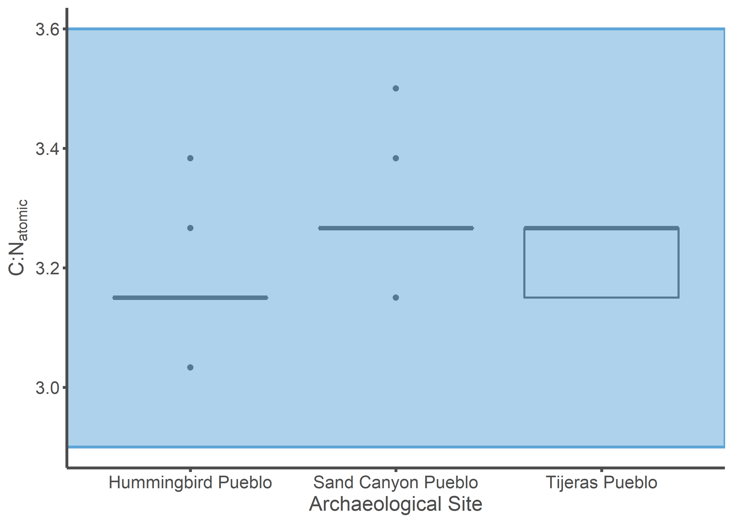

# Data Wrangling

A 13C Suess correction of 2.0‰ was applied to the modern seed data (Dombrosky 2020).

seeds <- seeds %>%  
 mutate(d13Csuess = d13C + 2)  
  
archaeo_SIBER <- archaeo %>%  
 unite(group, Site.Name, Genus, sep = " ") %>%  
 select(group, d13C, d15N)  
  
seeds_SIBER <- seeds %>%  
 select(Comparative.Group, d13Csuess, d15N) %>%  
 rename(group = Comparative.Group,  
 d13C = d13Csuess)  
  
turkeys_SIBER <- turkeys %>%  
 mutate(animal = "Turkey") %>%  
 unite(group, Diet.Type, animal, sep = " ") %>%  
 select(group, d13C, d15N)  
   
  
humans_SIBER <- humans %>%  
 mutate(group = "Humans") %>%  
 select(group, d13C, d15N)  
  
SIBER_data <- rbind(archaeo_SIBER, seeds_SIBER, turkeys_SIBER, humans_SIBER)

# Figure 2

## Sand Canyon Pueblo Figures

sand_label_df <- data.frame(  
 group = c("Sand Canyon Pueblo Lepus", "Sand Canyon Pueblo Sylvilagus",  
 "Free-ranging Turkey", "Humans", "Maize-fed Turkey", "Bean",  
 "Squash", "Corn"),  
 label = c("Sand Canyon Pueblo\nJackrabbbits",  
 "Sand Canyon Pueblo\nCottontails",  
 "Free-Ranging\nTurkeys", "Humans", "Maize-Fed Turkeys", "Beans",  
 "Squash", "Maize"),  
 d13C = c(-17, -20, -13.25, -5.8, -8, -25.25, -24, -9.75),  
 d15N = c(-0.75, 11, 2.5, 12.2, 4.1, -2, 13.25, -1),  
 hjust = c(0.5, 0.5, 0.5, 0, 0, 1, 1, 1),  
 vjust = c(1, 0, 0, 1, 1, 1, 0, 1))  
  
sand_label_df$group <- factor(sand_label_df$group,   
 levels = c("Sand Canyon Pueblo Lepus",  
 "Sand Canyon Pueblo Sylvilagus",  
 "Free-ranging Turkey", "Humans",   
 "Maize-fed Turkey", "Bean", "Squash",  
 "Corn"))  
  
sand_plot <- SIBER_data %>%  
 filter(group %in% c("Sand Canyon Pueblo Lepus",   
 "Sand Canyon Pueblo Sylvilagus",  
 "Bean", "Corn", "Squash", "Free-ranging Turkey",  
 "Maize-fed Turkey", "Humans"))  
   
sand_plot$group <- factor(sand_plot$group,   
 levels = c("Sand Canyon Pueblo Lepus",  
 "Sand Canyon Pueblo Sylvilagus",  
 "Free-ranging Turkey", "Humans",   
 "Maize-fed Turkey", "Bean", "Squash",  
 "Corn"))   
   
sand_p1 <- ggplot(sand_plot, aes(x = d13C, y = d15N)) +  
 geom_point(aes(fill = group, color = group), stroke = 1, size = 4,   
 alpha = 0.5, shape = 21) +  
 geom_point(aes(color = group), fill = NA, stroke = 1, size = 4,   
 shape = 21) +  
 ylab(expression(paste(delta^{15}, "N (\u2030)"))) +  
 xlab(expression(paste(delta^{13}, "C (\u2030)"))) +   
 theme_classic() +  
 theme(legend.position = "none",  
 axis.line = element_line(color = "#4d4d4d", size = 1),  
 axis.text.x = element_text(color = "#4d4d4d", size = 12),  
 axis.text.y = element_text(color = "#4d4d4d", size = 12),  
 axis.title.x = element_text(color = "#4d4d4d", size = 14,   
 face = "bold"),  
 axis.title.y = element_text(color = "#4d4d4d", size = 14,   
 face = "bold"),  
 axis.ticks.x = element_line(color = "#4d4d4d", size = 1),  
 axis.ticks.y = element_line(color = "#4d4d4d", size = 1)) +   
 scale_color_viridis_d() +  
 stat_ellipse(aes(group = interaction(group), color = group, fill = group),   
 alpha = 0.25, size = 0.75, linetype = 3, level = 0.95,   
 type = "t", geom = "polygon") +   
 geom_text(data = sand_label_df,aes(x = d13C, y = d15N,   
 label = label, color = group, hjust = hjust,  
 vjust = vjust),  
 size = 9/.pt, fontface = "bold") +  
 scale_fill_viridis_d() +  
 scale_x_continuous(limits=c(-27.5, -4),   
 breaks = c(-25, -20, -15, -10, -5)) +  
 scale_y_continuous(limits=c(-3, 15))  
  
sand_p1

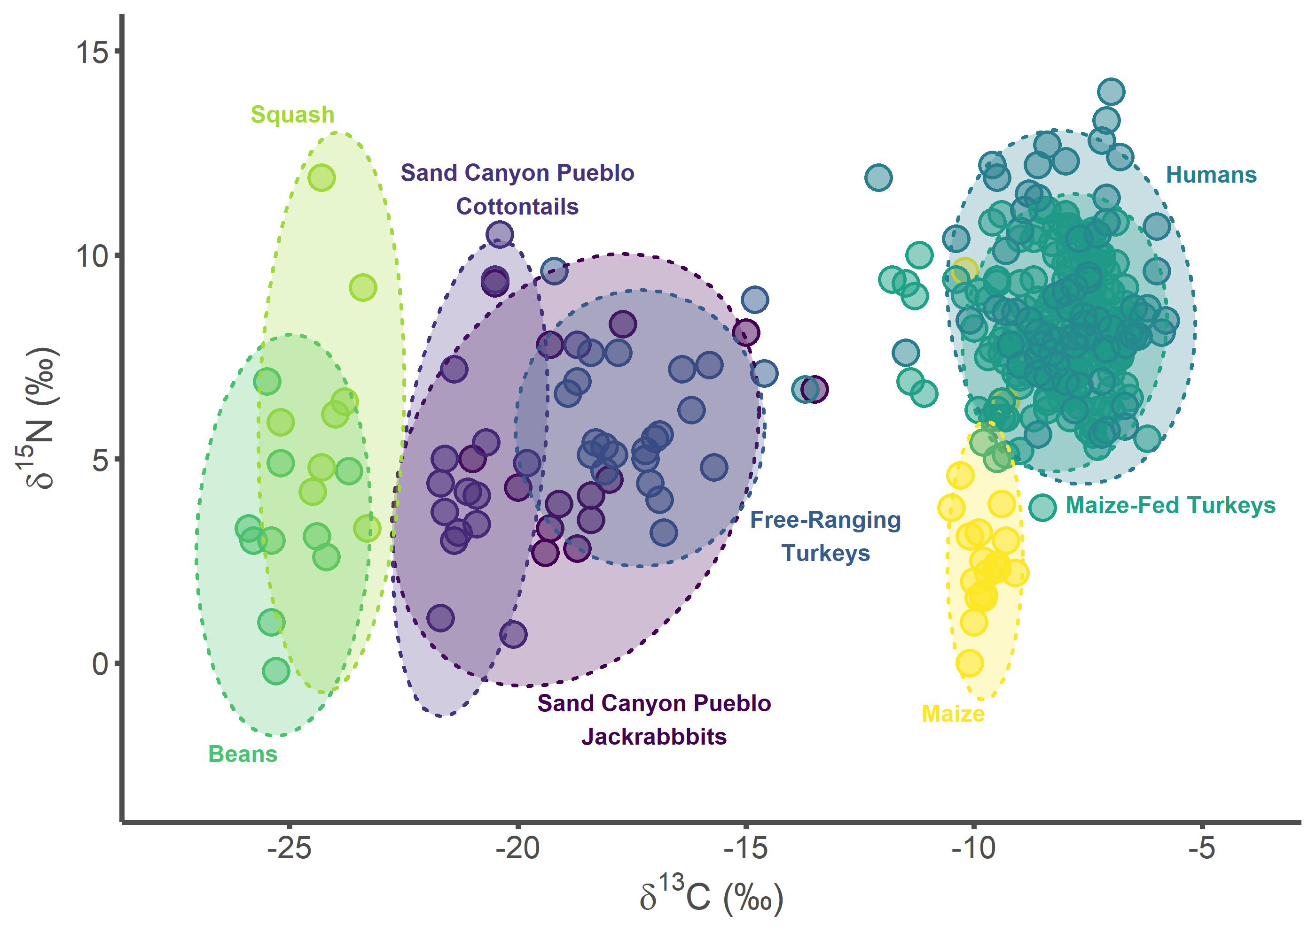

sand_p2 <- ggplot(sand_plot, aes(x = d13C, y = d15N)) +  
 ylab(expression(paste(delta^{15}, "N (\u2030)"))) +  
 xlab(expression(paste(delta^{13}, "C (\u2030)"))) +   
 theme_classic() +  
 theme(legend.position = "none",  
 axis.line = element_line(color = "#4d4d4d", size = 1),  
 axis.text.x = element_text(color = "#4d4d4d", size = 12),  
 axis.text.y = element_text(color = "#4d4d4d", size = 12),  
 axis.title.x = element_text(color = "#4d4d4d", size = 14,   
 face = "bold"),  
 axis.title.y = element_text(color = "#4d4d4d", size = 14,   
 face = "bold"),  
 axis.ticks.x = element_line(color = "#4d4d4d", size = 1),  
 axis.ticks.y = element_line(color = "#4d4d4d", size = 1)) +   
 scale_color_viridis_d() +  
 stat_ellipse(aes(group = interaction(group), color = group, fill = group),   
 alpha = 0.5, size = 1.1, linetype = 1, level = 0.40,   
 type = "t", geom = "polygon") +  
 stat_ellipse(aes(group = interaction(group), color = group, fill = group),   
 alpha = 0.25, size = 0.75, linetype = 3, level = 0.95,   
 type = "t", geom = "polygon") +   
 geom_text(data = sand_label_df,aes(x = d13C, y = d15N,   
 label = label, color = group, hjust = hjust,  
 vjust = vjust),  
 size = 9/.pt, fontface = "bold") +  
 scale_fill_viridis_d() +  
 scale_x_continuous(limits=c(-27.5, -4),   
 breaks = c(-25, -20, -15, -10, -5)) +  
 scale_y_continuous(limits=c(-3, 15))  
  
sand_p2

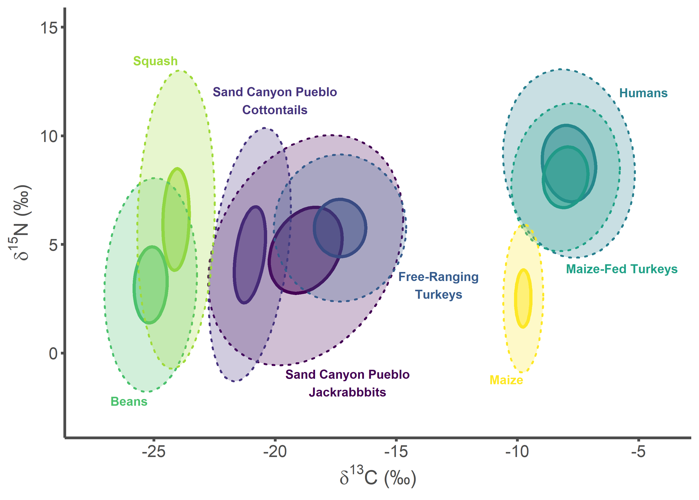

## Hummingbird Pueblo Figures

hum_label_df <- data.frame(  
 group = c("Hummingbird Pueblo Lepus", "Hummingbird Pueblo Sylvilagus",  
 "Free-ranging Turkey", "Humans", "Maize-fed Turkey", "Bean",  
 "Squash", "Corn"),  
 label = c("Hummingbird Pueblo\nJackrabbbits",  
 "Hummingbird Pueblo\nCottontails",  
 "Free-Ranging\nTurkeys", "Humans", "Maize-Fed Turkeys", "Beans",  
 "Squash", "Maize"),  
 d13C = c(-20, -14.25, -20, -5.8, -8, -25.25, -24, -9.75),  
 d15N = c(1.5, -1.25, 10, 12.2, 4.1, -2, 13.25, -1),  
 hjust = c(0.5, 0.5, 0.5, 0, 0, 1, 1, 1),  
 vjust = c(1, 0, 0, 1, 1, 1, 0, 1))  
  
hum_label_df$group <- factor(hum_label_df$group,   
 levels = c("Hummingbird Pueblo Lepus",  
 "Hummingbird Pueblo Sylvilagus",  
 "Free-ranging Turkey", "Humans",   
 "Maize-fed Turkey", "Bean", "Squash",  
 "Corn"))  
  
hum_plot <- SIBER_data %>%  
 filter(group %in% c("Hummingbird Pueblo Lepus",   
 "Hummingbird Pueblo Sylvilagus",  
 "Bean", "Corn", "Squash", "Free-ranging Turkey",  
 "Maize-fed Turkey", "Humans"))  
   
hum_plot$group <- factor(hum_plot$group,   
 levels = c("Hummingbird Pueblo Lepus",  
 "Hummingbird Pueblo Sylvilagus",  
 "Free-ranging Turkey", "Humans",   
 "Maize-fed Turkey", "Bean", "Squash",  
 "Corn"))   
   
hum_p1 <- ggplot(hum_plot, aes(x = d13C, y = d15N)) +  
 geom_point(aes(fill = group, color = group), stroke = 1, size = 4,   
 alpha = 0.5, shape = 21) +  
 geom_point(aes(color = group), fill = NA, stroke = 1, size = 4,   
 shape = 21) +  
 ylab(expression(paste(delta^{15}, "N (\u2030)"))) +  
 xlab(expression(paste(delta^{13}, "C (\u2030)"))) +   
 theme_classic() +  
 theme(legend.position = "none",  
 axis.line = element_line(color = "#4d4d4d", size = 1),  
 axis.text.x = element_text(color = "#4d4d4d", size = 12),  
 axis.text.y = element_text(color = "#4d4d4d", size = 12),  
 axis.title.x = element_text(color = "#4d4d4d", size = 14,   
 face = "bold"),  
 axis.title.y = element_text(color = "#4d4d4d", size = 14,   
 face = "bold"),  
 axis.ticks.x = element_line(color = "#4d4d4d", size = 1),  
 axis.ticks.y = element_line(color = "#4d4d4d", size = 1)) +   
 scale_color_viridis_d() +  
 stat_ellipse(aes(group = interaction(group), color = group, fill = group),   
 alpha = 0.25, size = 0.75, linetype = 3, level = 0.95,   
 type = "t", geom = "polygon") +   
 geom_text(data = hum_label_df,aes(x = d13C, y = d15N,   
 label = label, color = group, hjust = hjust,  
 vjust = vjust),  
 size = 9/.pt, fontface = "bold") +  
 scale_fill_viridis_d() +  
 scale_x_continuous(limits=c(-27.5, -4),   
 breaks = c(-25, -20, -15, -10, -5)) +  
 scale_y_continuous(limits=c(-3, 15))  
  
hum_p1

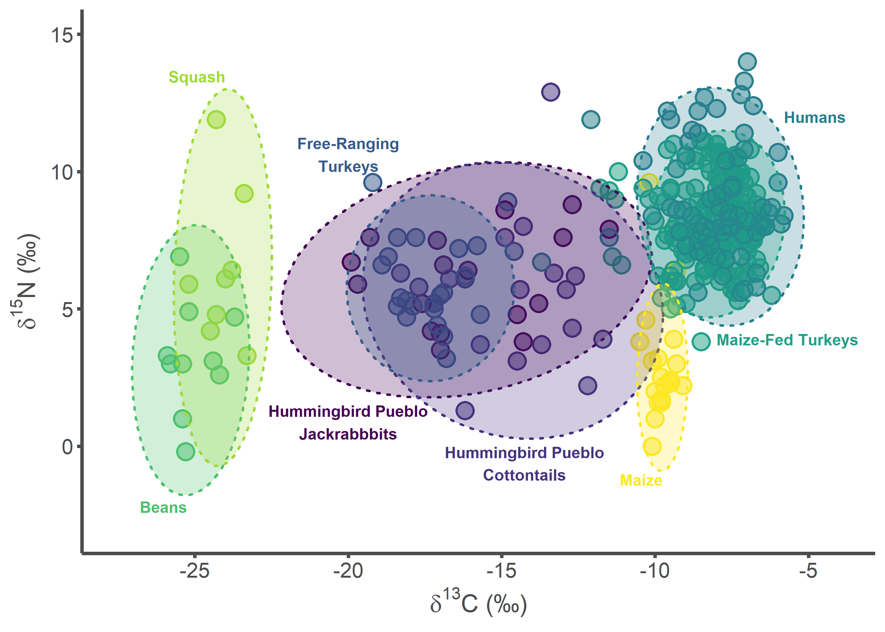

hum_p2 <- ggplot(hum_plot, aes(x = d13C, y = d15N)) +  
 ylab(expression(paste(delta^{15}, "N (\u2030)"))) +  
 xlab(expression(paste(delta^{13}, "C (\u2030)"))) +   
 theme_classic() +  
 theme(legend.position = "none",  
 axis.line = element_line(color = "#4d4d4d", size = 1),  
 axis.text.x = element_text(color = "#4d4d4d", size = 12),  
 axis.text.y = element_text(color = "#4d4d4d", size = 12),  
 axis.title.x = element_text(color = "#4d4d4d", size = 14,   
 face = "bold"),  
 axis.title.y = element_text(color = "#4d4d4d", size = 14,   
 face = "bold"),  
 axis.ticks.x = element_line(color = "#4d4d4d", size = 1),  
 axis.ticks.y = element_line(color = "#4d4d4d", size = 1)) +   
 scale_color_viridis_d() +  
 stat_ellipse(aes(group = interaction(group), color = group, fill = group),   
 alpha = 0.5, size = 1.1, linetype = 1, level = 0.40, type = "t",   
 geom = "polygon") +  
 stat_ellipse(aes(group = interaction(group), color = group, fill = group),   
 alpha = 0.25, size = 0.75, linetype = 3, level = 0.95,   
 type = "t", geom = "polygon") +   
 geom_text(data = hum_label_df,aes(x = d13C, y = d15N,   
 label = label, color = group, hjust = hjust,  
 vjust = vjust),  
 size = 9/.pt, fontface = "bold") +  
 scale_fill_viridis_d() +  
 scale_x_continuous(limits=c(-27.5, -4),   
 breaks = c(-25, -20, -15, -10, -5)) +  
 scale_y_continuous(limits=c(-3, 15))  
  
hum_p2

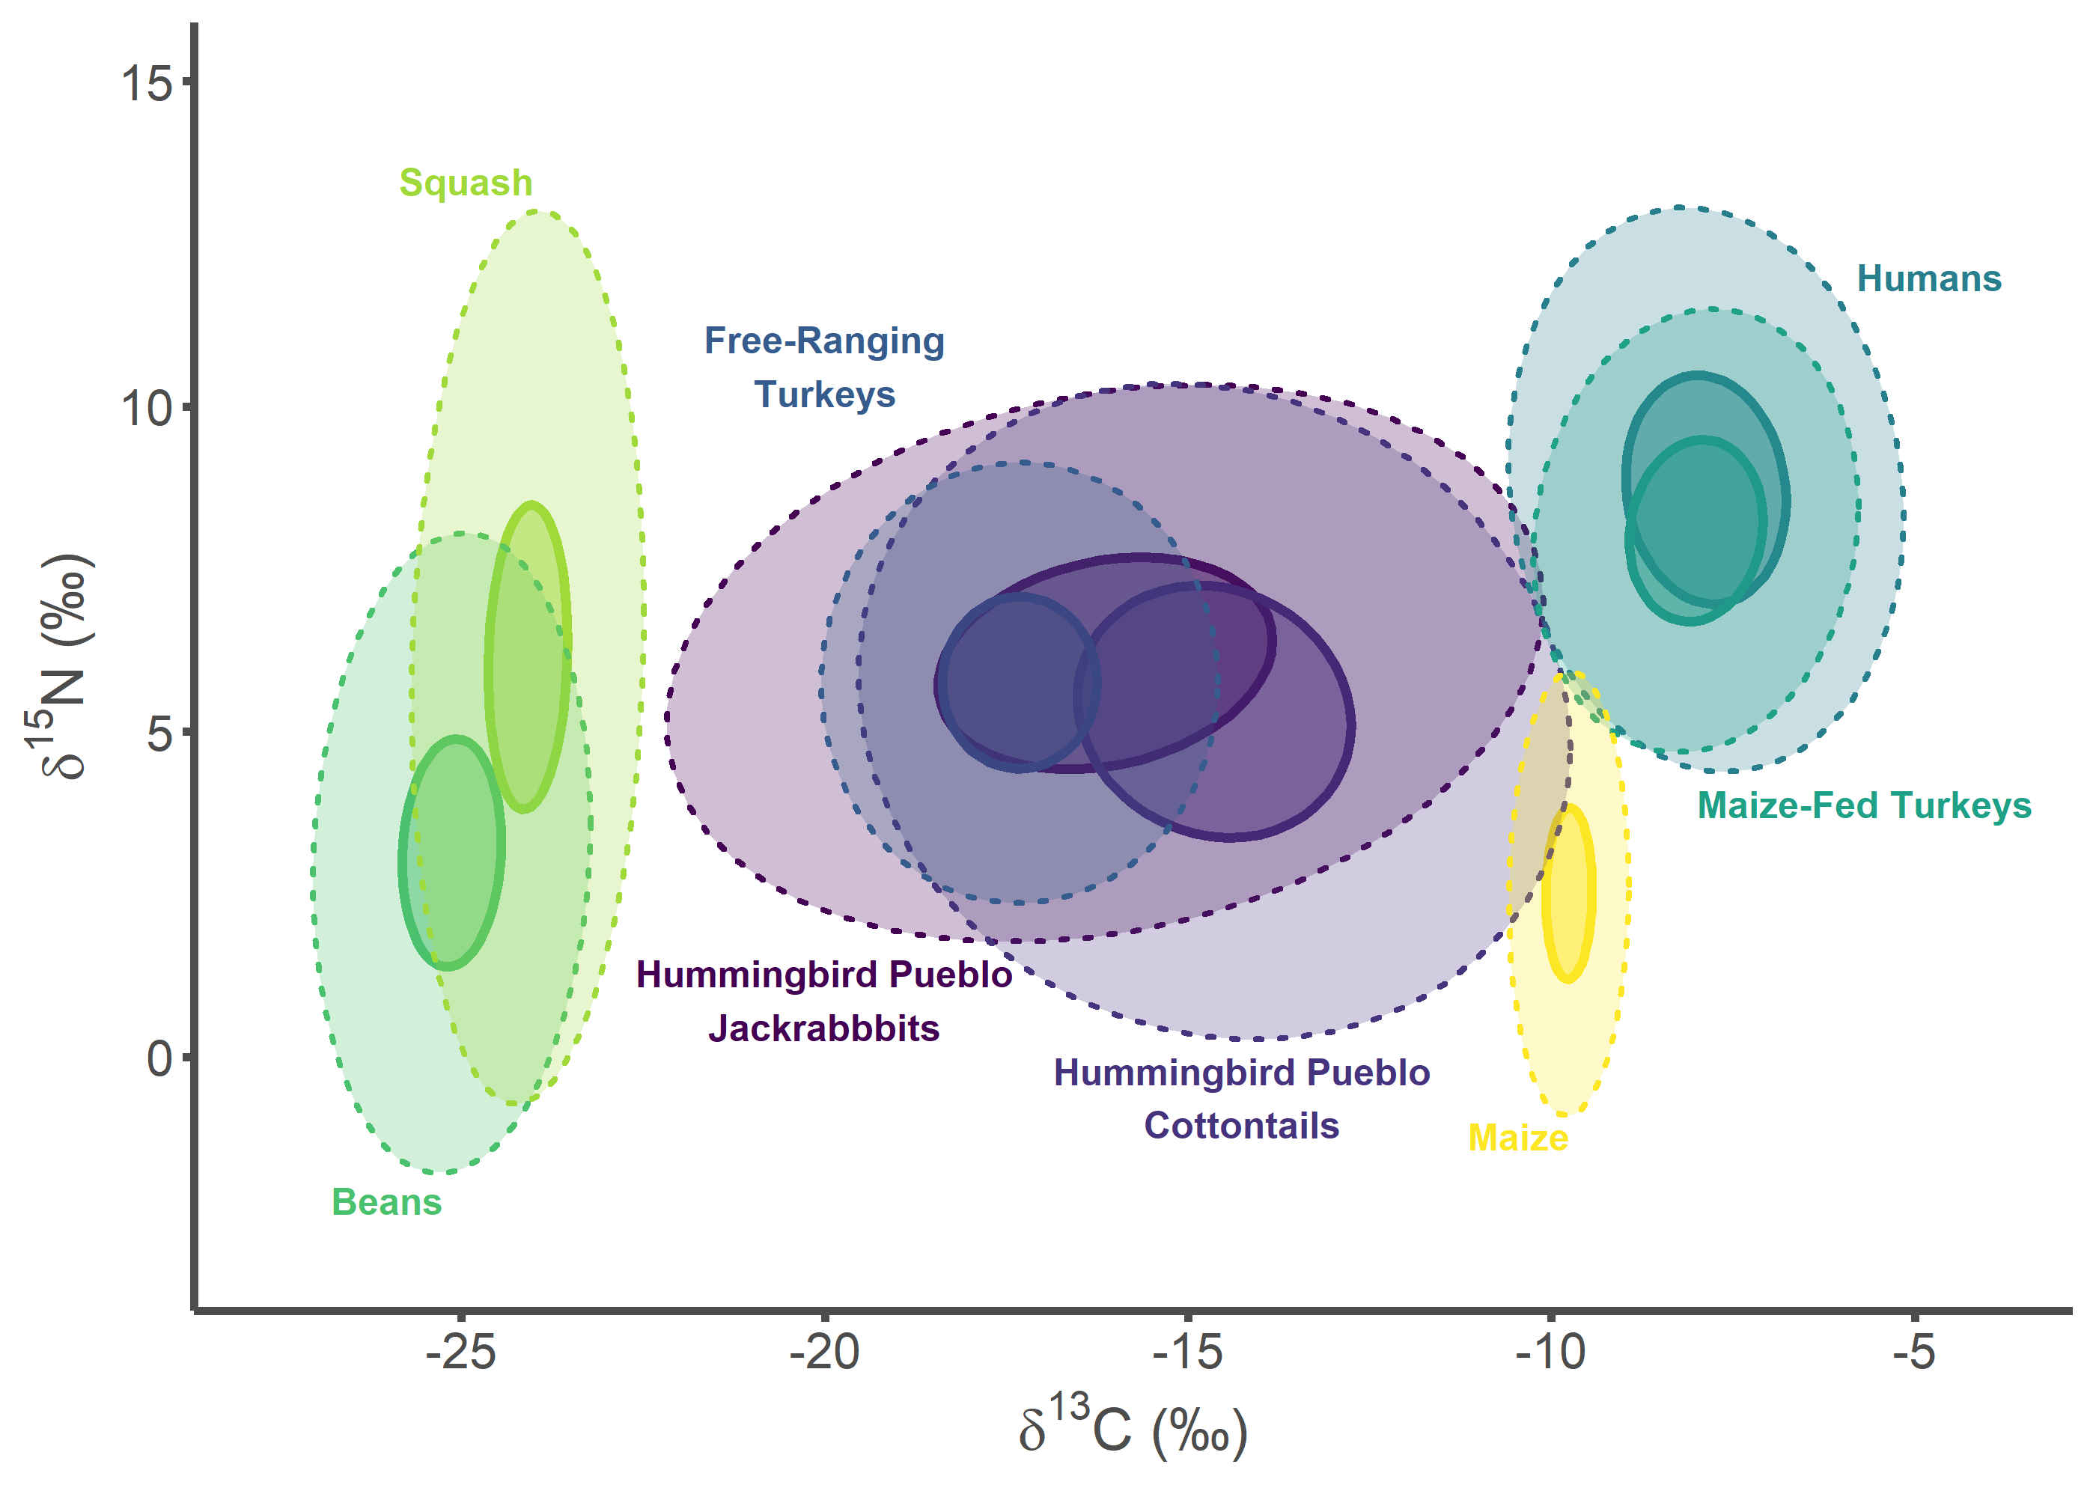

## Tijeras Pueblo Figures

tij_label_df <- data.frame(  
 group = c("Tijeras Pueblo Lepus", "Tijeras Pueblo Sylvilagus",  
 "Free-ranging Turkey", "Humans", "Maize-fed Turkey", "Bean",  
 "Squash", "Corn"),  
 label = c("Tijeras Pueblo\nJackrabbbits",  
 "Tijeras Pueblo\nCottontails",  
 "Free-Ranging\nTurkeys", "Humans", "Maize-Fed Turkeys", "Beans",  
 "Squash", "Maize"),  
 d13C = c(-21, -17.5, -17.25, -5.8, -8, -25.25, -24, -9.75),  
 d15N = c(1.5, -1.75, 9.5, 12.2, 4.1, -2, 13.25, -1),  
 hjust = c(0.5, 0.5, 0.5, 0, 0, 1, 1, 1),  
 vjust = c(1, 0, 0, 1, 1, 1, 0, 1))  
  
tij_label_df$group <- factor(tij_label_df$group,   
 levels = c("Tijeras Pueblo Lepus",  
 "Tijeras Pueblo Sylvilagus",  
 "Free-ranging Turkey", "Humans",   
 "Maize-fed Turkey", "Bean", "Squash",  
 "Corn"))  
  
tij_plot <- SIBER_data %>%  
 filter(group %in% c("Tijeras Pueblo Lepus",   
 "Tijeras Pueblo Sylvilagus",  
 "Bean", "Corn", "Squash", "Free-ranging Turkey",  
 "Maize-fed Turkey", "Humans"))  
   
tij_plot$group <- factor(tij_plot$group,   
 levels = c("Tijeras Pueblo Lepus",  
 "Tijeras Pueblo Sylvilagus",  
 "Free-ranging Turkey", "Humans",   
 "Maize-fed Turkey", "Bean", "Squash",  
 "Corn"))   
   
tij_p1 <- ggplot(tij_plot, aes(x = d13C, y = d15N)) +  
 geom_point(aes(fill = group, color = group), stroke = 1, size = 4,   
 alpha = 0.5, shape = 21) +  
 geom_point(aes(color = group), fill = NA, stroke = 1, size = 4,   
 shape = 21) +  
 ylab(expression(paste(delta^{15}, "N (\u2030)"))) +  
 xlab(expression(paste(delta^{13}, "C (\u2030)"))) +   
 theme_classic() +  
 theme(legend.position = "none",  
 axis.line = element_line(color = "#4d4d4d", size = 1),  
 axis.text.x = element_text(color = "#4d4d4d", size = 12),  
 axis.text.y = element_text(color = "#4d4d4d", size = 12),  
 axis.title.x = element_text(color = "#4d4d4d", size = 14,   
 face = "bold"),  
 axis.title.y = element_text(color = "#4d4d4d", size = 14,   
 face = "bold"),  
 axis.ticks.x = element_line(color = "#4d4d4d", size = 1),  
 axis.ticks.y = element_line(color = "#4d4d4d", size = 1)) +   
 scale_color_viridis_d() +  
 stat_ellipse(aes(group = interaction(group), color = group, fill = group),   
 alpha = 0.25, size = 0.75, linetype = 3, level = 0.95,   
 type = "t", geom = "polygon") +   
 geom_text(data = tij_label_df,aes(x = d13C, y = d15N,   
 label = label, color = group, hjust = hjust,  
 vjust = vjust),  
 size = 9/.pt, fontface = "bold") +  
 scale_fill_viridis_d() +  
 scale_x_continuous(limits=c(-27.5, -4),   
 breaks = c(-25, -20, -15, -10, -5)) +  
 scale_y_continuous(limits=c(-3, 15))  
  
tij_p1

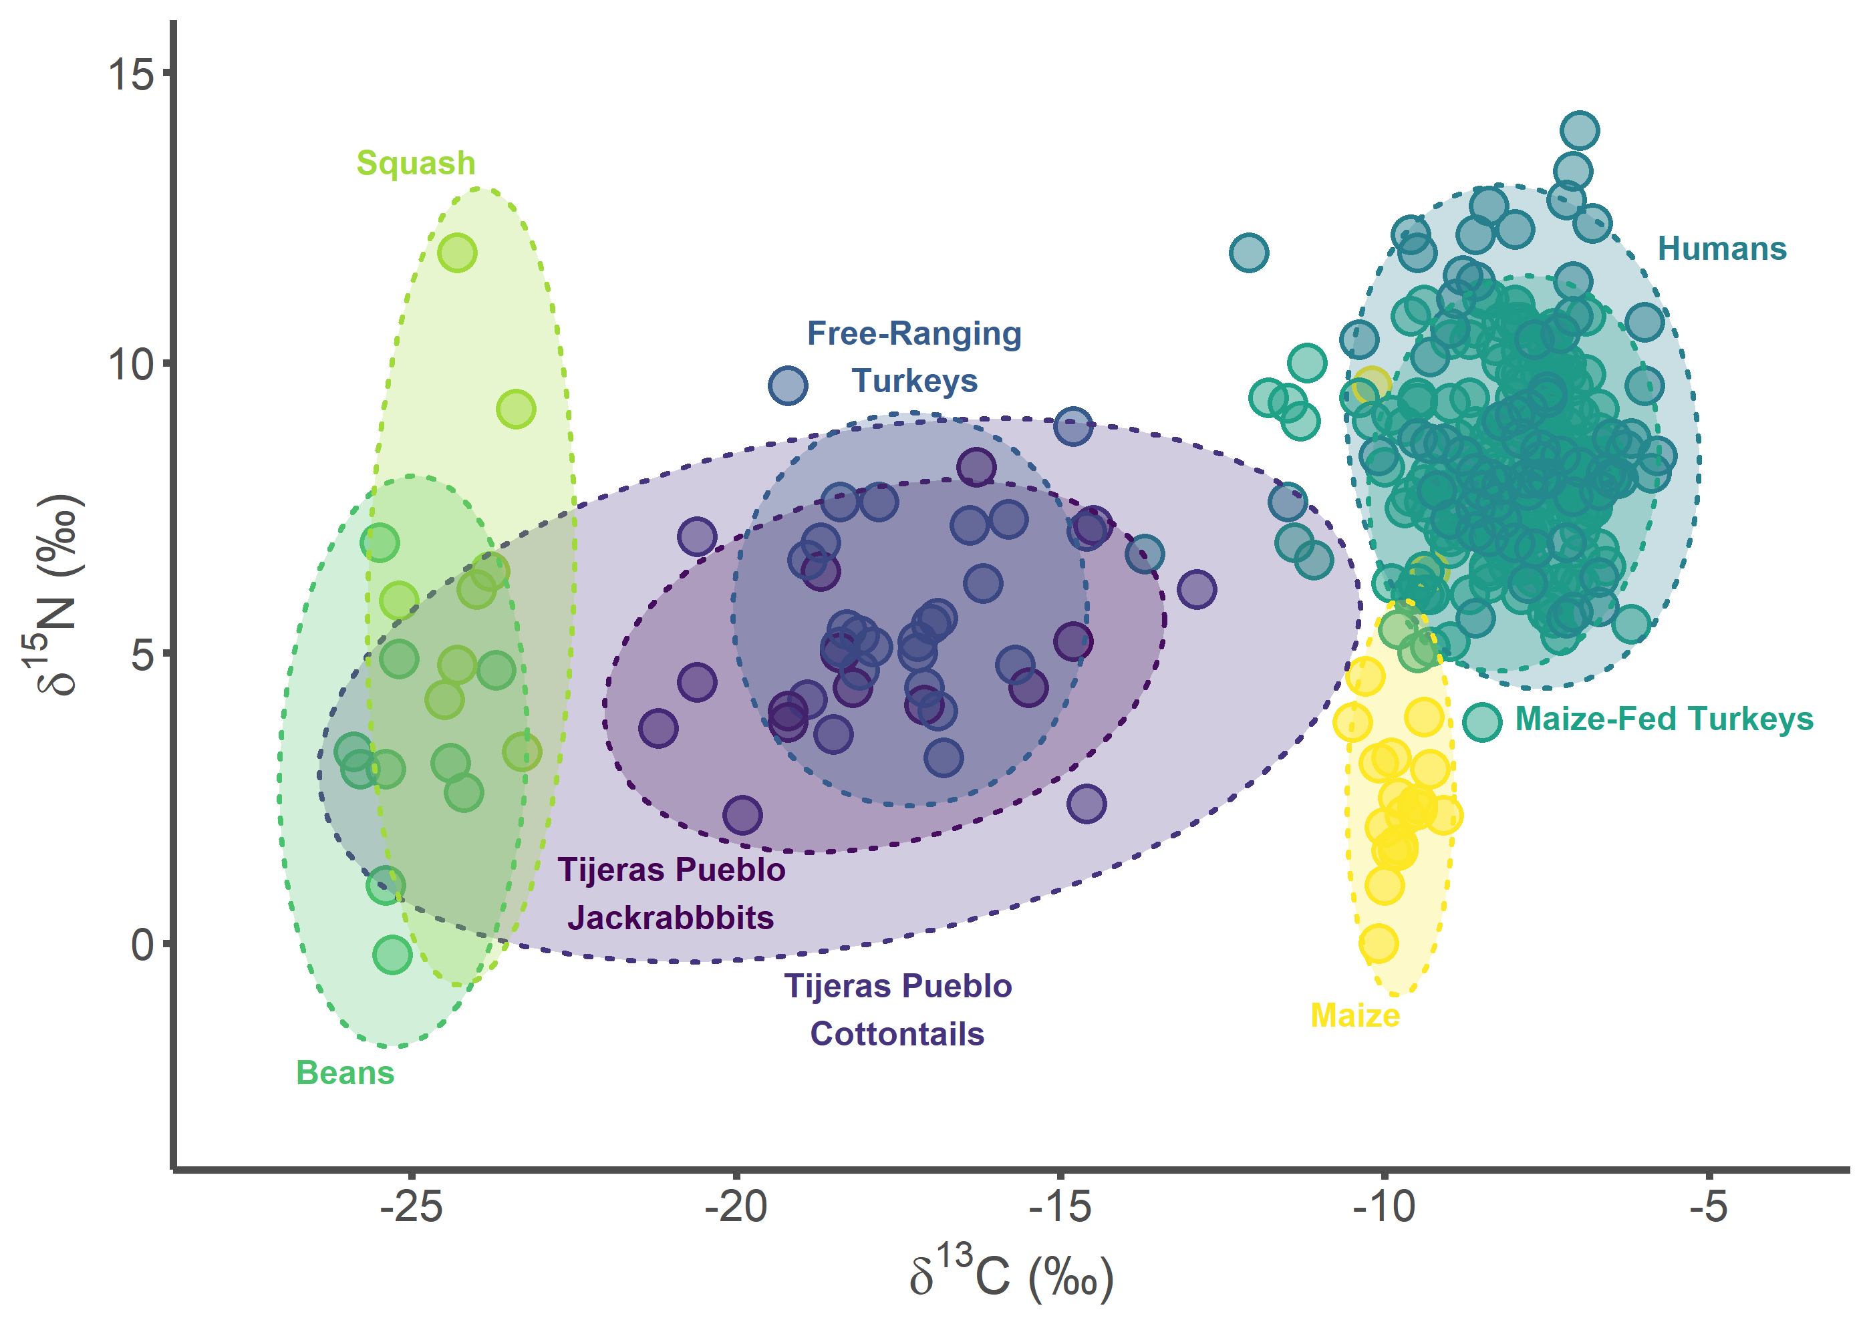

tij_p2 <- ggplot(tij_plot, aes(x = d13C, y = d15N)) +  
 ylab(expression(paste(delta^{15}, "N (\u2030)"))) +  
 xlab(expression(paste(delta^{13}, "C (\u2030)"))) +   
 theme_classic() +  
 theme(legend.position = "none",  
 axis.line = element_line(color = "#4d4d4d", size = 1),  
 axis.text.x = element_text(color = "#4d4d4d", size = 12),  
 axis.text.y = element_text(color = "#4d4d4d", size = 12),  
 axis.title.x = element_text(color = "#4d4d4d", size = 14,   
 face = "bold"),  
 axis.title.y = element_text(color = "#4d4d4d", size = 14,   
 face = "bold"),  
 axis.ticks.x = element_line(color = "#4d4d4d", size = 1),  
 axis.ticks.y = element_line(color = "#4d4d4d", size = 1)) +   
 scale_color_viridis_d() +  
 stat_ellipse(aes(group = interaction(group), color = group, fill = group),   
 alpha = 0.5, size = 1.1, linetype = 1, level = 0.40,   
 type = "t", geom = "polygon") +  
 stat_ellipse(aes(group = interaction(group), color = group, fill = group),   
 alpha = 0.25, size = 0.75, linetype = 3, level = 0.95,   
 type = "t", geom = "polygon") +   
 geom_text(data = tij_label_df,aes(x = d13C, y = d15N,   
 label = label, color = group, hjust = hjust,  
 vjust = vjust),  
 size = 9/.pt, fontface = "bold") +  
 scale_fill_viridis_d() +  
 scale_x_continuous(limits=c(-27.5, -4),   
 breaks = c(-25, -20, -15, -10, -5)) +  
 scale_y_continuous(limits=c(-3, 15))  
  
tij_p2

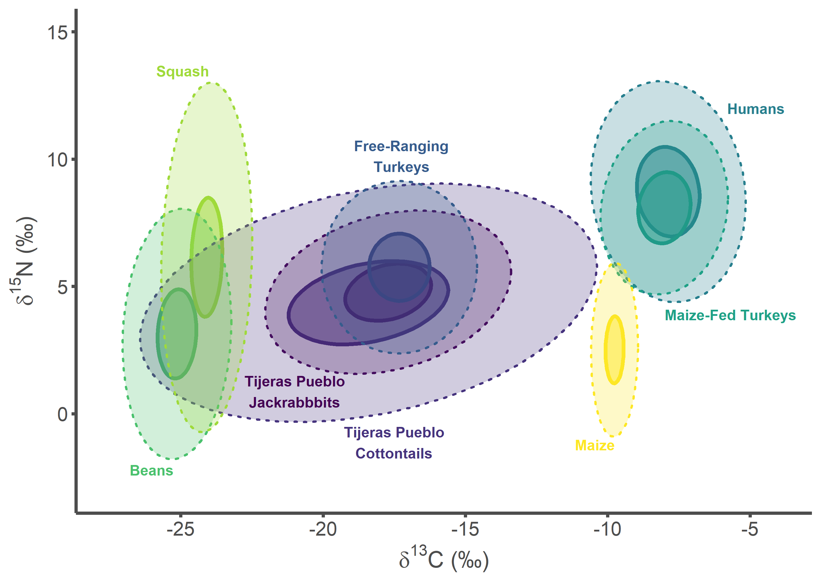

## Combine Figures

all_plots <- plot_grid(sand_p1, sand_p2, hum_p1, hum_p2, tij_p1, tij_p2,  
 labels = "AUTO", label_colour = "#4d4d4d",   
 label_size = 20, ncol = 2, nrow = 3)  
  
all_plots

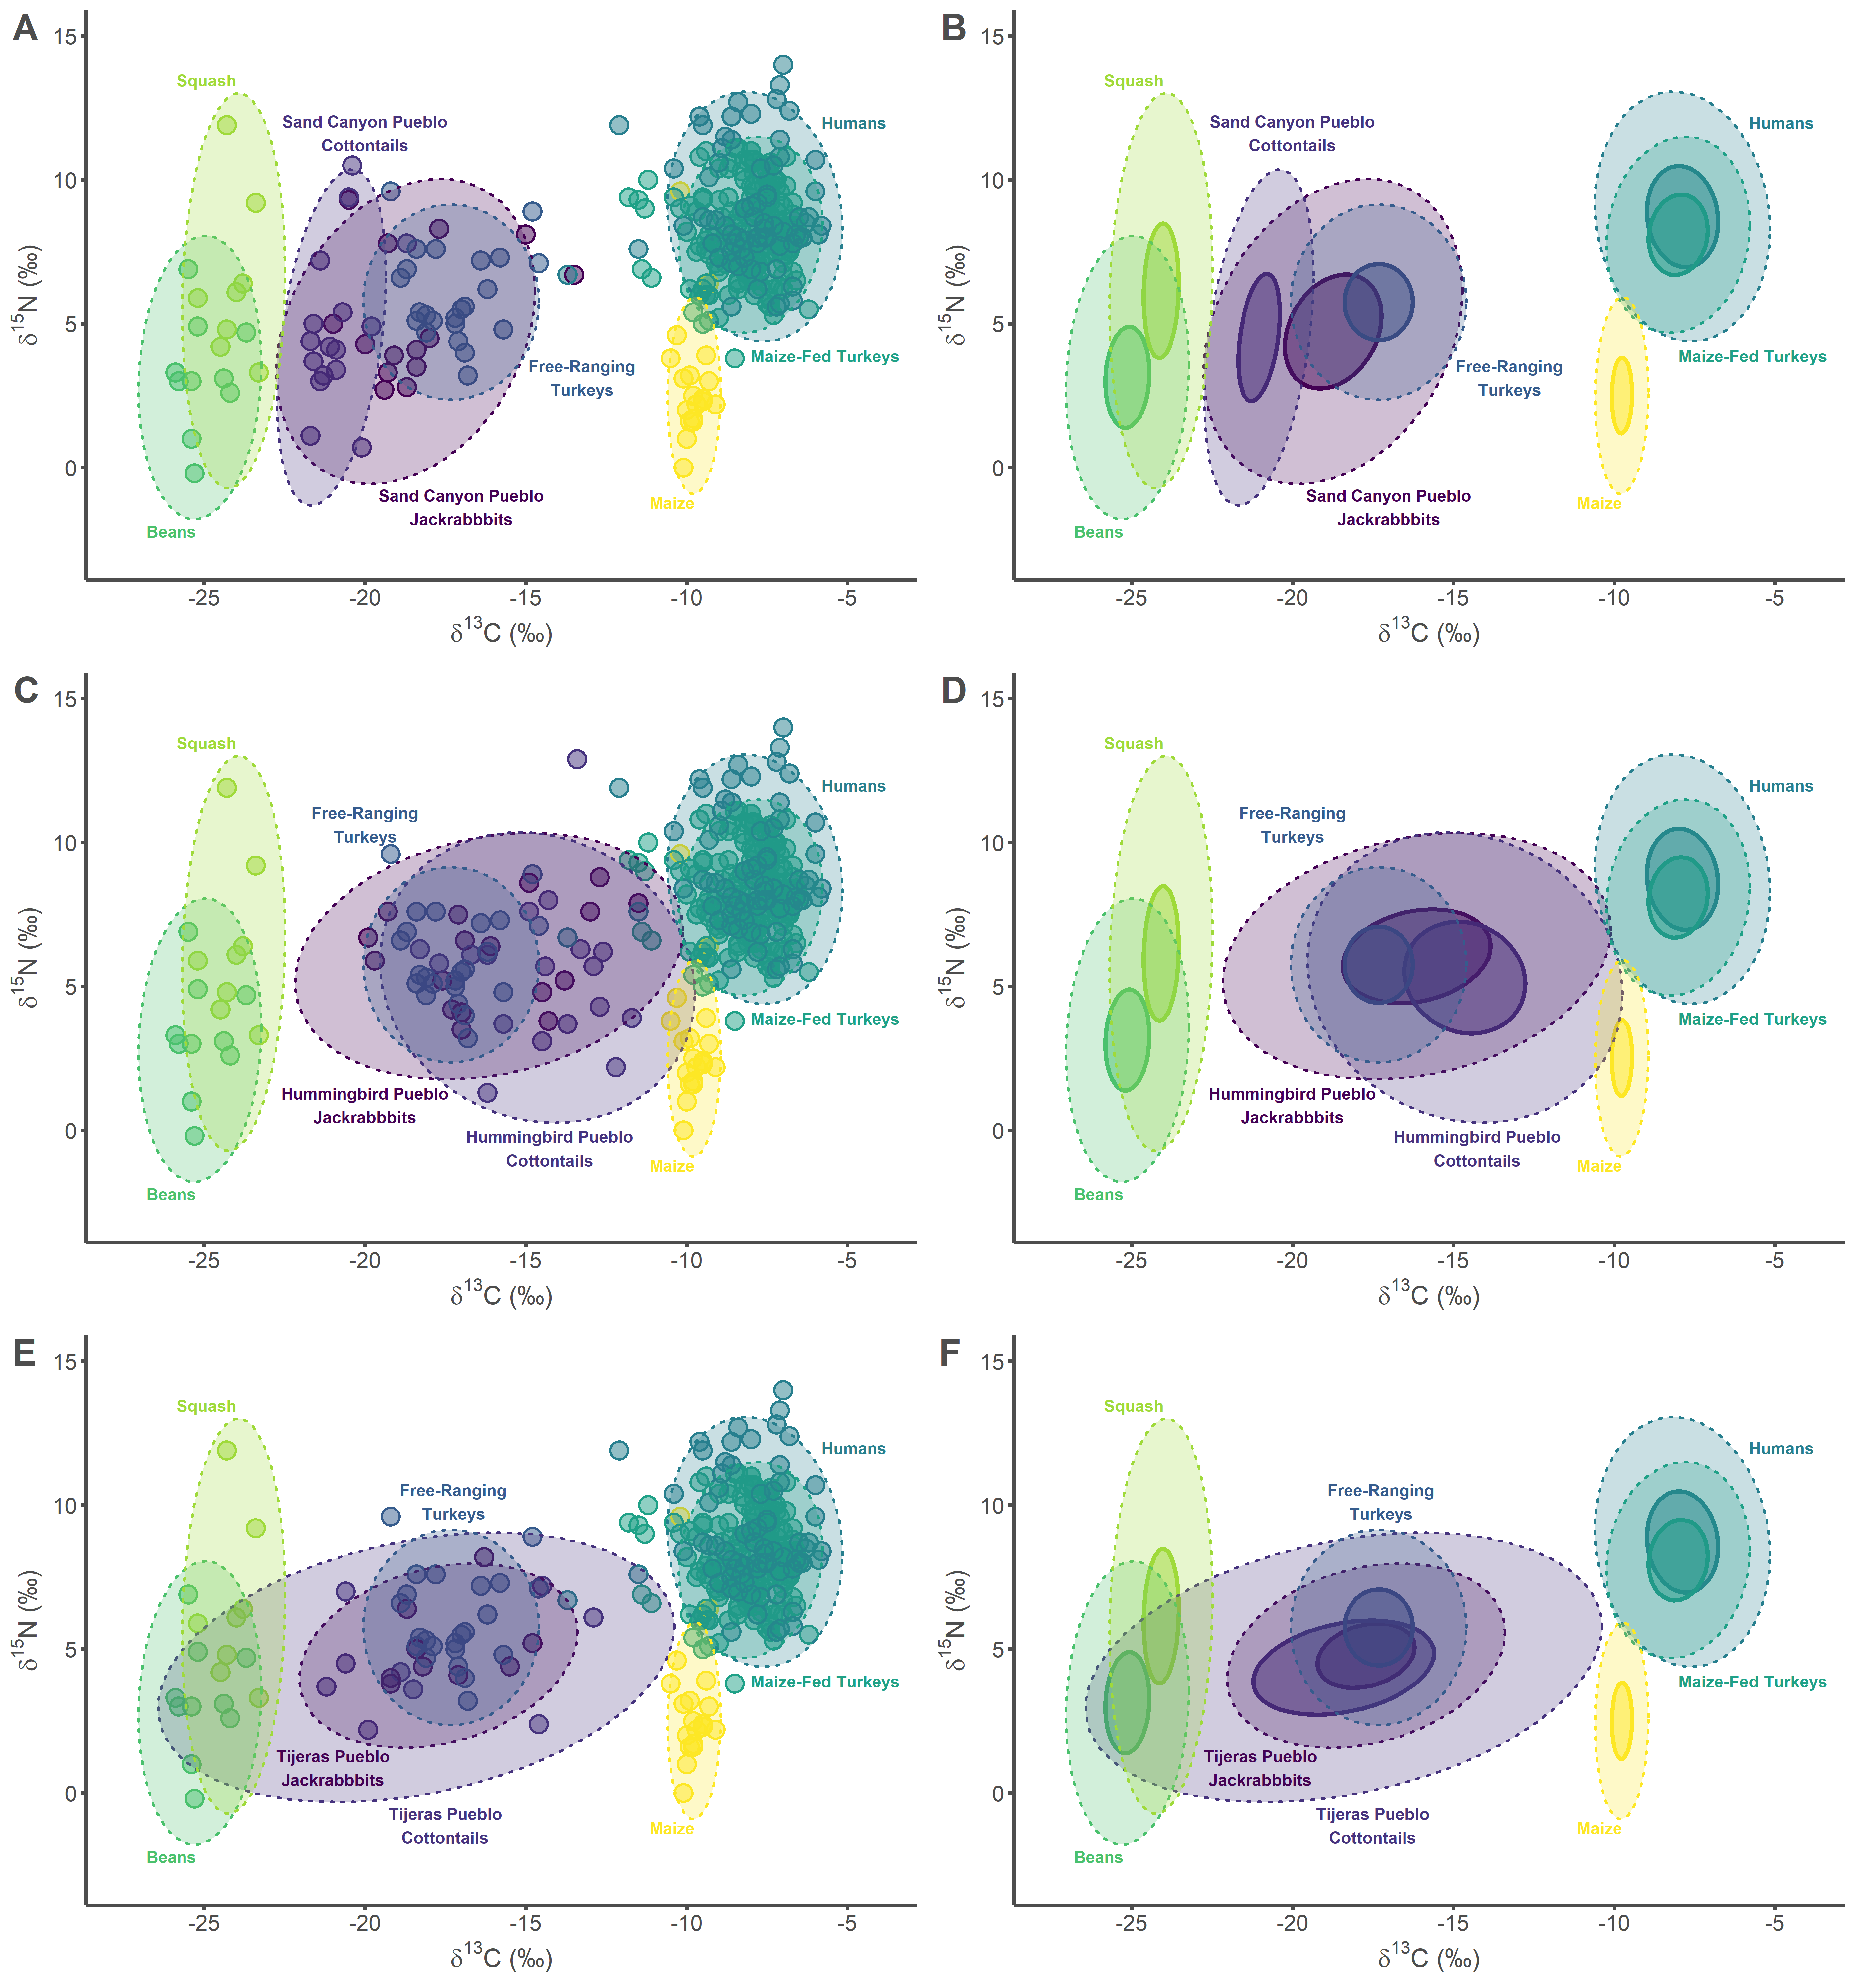

ggsave("Figure 2.jpg", dpi = 300)

## Saving 14 x 15 in image

## Test for Normality

Some isotope values per group are non-normal. Thus, ellipses in Figure 2 are visualized based on the t-distribution, which is also good for small sample sizes.

SIBER_data %>%  
 group_by(group) %>%  
 do(tidy(shapiro.test(.$d13C)))

## # A tibble: 12 x 4  
## # Groups: group [12]  
## group statistic p.value method   
## <chr> <dbl> <dbl> <chr>   
## 1 Bean 0.882 0.139 Shapiro-Wilk normality t~  
## 2 Corn 0.980 0.928 Shapiro-Wilk normality t~  
## 3 Free-ranging Turkey 0.960 0.462 Shapiro-Wilk normality t~  
## 4 Humans 0.914 0.000106 Shapiro-Wilk normality t~  
## 5 Hummingbird Pueblo Lepus 0.956 0.565 Shapiro-Wilk normality t~  
## 6 Hummingbird Pueblo Sylvilagus 0.956 0.502 Shapiro-Wilk normality t~  
## 7 Maize-fed Turkey 0.938 0.000000566 Shapiro-Wilk normality t~  
## 8 Sand Canyon Pueblo Lepus 0.862 0.0328 Shapiro-Wilk normality t~  
## 9 Sand Canyon Pueblo Sylvilagus 0.882 0.0415 Shapiro-Wilk normality t~  
## 10 Squash 0.958 0.788 Shapiro-Wilk normality t~  
## 11 Tijeras Pueblo Lepus 0.900 0.251 Shapiro-Wilk normality t~  
## 12 Tijeras Pueblo Sylvilagus 0.857 0.0878 Shapiro-Wilk normality t~

SIBER_data %>%  
 group_by(group) %>%  
 do(tidy(shapiro.test(.$d15N)))

## # A tibble: 12 x 4  
## # Groups: group [12]  
## group statistic p.value method   
## <chr> <dbl> <dbl> <chr>   
## 1 Bean 0.958 0.766 Shapiro-Wilk normality test  
## 2 Corn 0.825 0.00206 Shapiro-Wilk normality test  
## 3 Free-ranging Turkey 0.960 0.462 Shapiro-Wilk normality test  
## 4 Humans 0.943 0.00241 Shapiro-Wilk normality test  
## 5 Hummingbird Pueblo Lepus 0.946 0.390 Shapiro-Wilk normality test  
## 6 Hummingbird Pueblo Sylvilagus 0.900 0.0496 Shapiro-Wilk normality test  
## 7 Maize-fed Turkey 0.986 0.0793 Shapiro-Wilk normality test  
## 8 Sand Canyon Pueblo Lepus 0.884 0.0664 Shapiro-Wilk normality test  
## 9 Sand Canyon Pueblo Sylvilagus 0.942 0.376 Shapiro-Wilk normality test  
## 10 Squash 0.904 0.314 Shapiro-Wilk normality test  
## 11 Tijeras Pueblo Lepus 0.820 0.0348 Shapiro-Wilk normality test  
## 12 Tijeras Pueblo Sylvilagus 0.917 0.371 Shapiro-Wilk normality test

# SIBER Area Calculations

TA = Total Area, SEA = Standard Ellipse Area, and SEAc = Small Sample Size Corrected Standard Ellipse Area (see Jackson et al. 2011)

siber.example <- SIBER_data %>%  
 select(d13C, d15N, group) %>%  
 mutate(community = 1) %>%  
 rename(iso1 = d13C,  
 iso2 = d15N)  
   
siber.example <- createSiberObject(siber.example)  
  
group.ML1 <- data.frame(groupMetricsML(siber.example)) %>%  
 rename("Hummingbird Jackrabbits" = X1.Hummingbird.Pueblo.Lepus,  
 "Hummingbird Cottontails" = X1.Hummingbird.Pueblo.Sylvilagus,  
 "Sand Canyon Jackrabbit" = X1.Sand.Canyon.Pueblo.Lepus,  
 "Sand Canyon Cottontails" = X1.Sand.Canyon.Pueblo.Sylvilagus,  
 "Tijeras Pueblo Jackrabbits" = X1.Tijeras.Pueblo.Lepus,  
 "Tijeras Pueblo Cottontails" = X1.Tijeras.Pueblo.Sylvilagus,  
 "Beans" = X1.Bean,  
 "Maize" = X1.Corn,  
 "Squash" = X1.Squash,  
 "Free-ranging Turkey" = X1.Free.ranging.Turkey,  
 "Maize-fed Turkey" = X1.Maize.fed.Turkey,  
 "Humans" = X1.Humans) %>%  
 t() %>%  
 round(digits = 2)  
   
group.ML1

## TA SEA SEAc  
## Hummingbird Jackrabbits 28.91 13.02 13.88  
## Hummingbird Cottontails 44.81 15.47 16.38  
## Sand Canyon Jackrabbit 29.74 13.82 14.97  
## Sand Canyon Cottontails 18.75 6.43 6.89  
## Tijeras Pueblo Cottontails 33.91 17.58 20.09  
## Tijeras Pueblo Jackrabbits 11.71 7.01 8.01  
## Beans 8.41 4.53 5.10  
## Maize 8.21 2.40 2.53  
## Squash 10.09 5.47 6.38  
## Free-ranging Turkey 19.40 6.16 6.46  
## Maize-fed Turkey 28.55 5.19 5.22  
## Humans 46.75 8.81 8.93

# SIBER Maximum Likelihood Overlap with Humans Calculations

results <- data.frame()  
taxa <- c("1.Hummingbird Pueblo Lepus", "1.Hummingbird Pueblo Sylvilagus",   
 "1.Sand Canyon Pueblo Lepus",   
 "1.Sand Canyon Pueblo Sylvilagus",  
 "1.Tijeras Pueblo Lepus",   
 "1.Tijeras Pueblo Sylvilagus",  
 "1.Maize-fed Turkey")  
  
for (i in seq_along(taxa)) {  
   
 sea.overlap <- maxLikOverlap(taxa[[i]], "1.Humans", siber.example,   
 p.interval = 0.95, n = 100)  
   
 results[i, 1] <- taxa[[i]]  
 results[i, 2] <- round(sea.overlap[[3]], digits = 2)  
 results[i, 3] <- round(sea.overlap[[3]]/sea.overlap[[2]]*100, digits = 2)  
 results[i, 4] <- round(sea.overlap[[3]]/sea.overlap[[1]]*100, digits = 2)  
 results[i, 5] <- round(sea.overlap[[3]]/(sea.overlap[[2]] +   
 sea.overlap[[1]] -   
 sea.overlap[[3]])*100, digits = 2)  
}  
  
colnames(results) <- c("group", "overlap ‰", "% human niche", "% group niche",   
 "% overlap")  
  
results$group <- gsub("1.","", as.character(results$group))  
results$group <- gsub("Lepus","Jackrabbits", as.character(results$group))  
results$group <- gsub("Sylvilagus","Cottontails", as.character(results$group))  
  
results

## group overlap ‰ % human niche % group niche  
## 1 Hummingbird Pueblo Jackrabbits 4.55 8.50 5.47  
## 2 Hummingbird Pueblo Cottontails 4.61 8.62 4.70  
## 3 Sand Canyon Pueblo Jackrabbits 0.00 0.00 0.00  
## 4 Sand Canyon Pueblo Cottontails 0.00 0.00 0.00  
## 5 Tijeras Pueblo Jackrabbits 0.00 0.00 0.00  
## 6 Tijeras Pueblo Cottontails 2.38 4.45 1.98  
## 7 Maize-fed Turkey 31.23 58.39 100.00  
## % overlap  
## 1 3.44  
## 2 3.14  
## 3 0.00  
## 4 0.00  
## 5 0.00  
## 6 1.39  
## 7 58.39

round(mean(results$`% human niche`[1:6]), digits = 2)

## [1] 3.59

round(mean(results$`% group niche`[1:6]), digits = 2)

## [1] 2.02

# References

Ambrose SH (1990) Preparation and characterization of bone and tooth collagen for isotopic analysis. Journal of Archaeological Science 17(4):431-451.

Basinger MA & Robertson PA (1997) Vascular flora of an old-growth forest remnant in the Ozark hills of southern Illinois-updated results. Transactions of the Illinois State Academy of Science 90(1-2):1-20.

Bruhl JJ & Wilson KL (2007) Towards a comprehensive survey of C3 and C4 photosynthetic pathways in Cyperaceae. Aliso: A Journal of Systematic and Evolutionary Botany 23(1):99-148.

Chisholm B & Matson RG (1994) Carbon and Nitrogen Isotopic Evidence on Basketmaker II Diet at Cedar Mesa, Utah. KIVA 60(2):239-255.

Coltrain JB, Janetski JC, & Carlyle SW (2007) The Stable- and Radio-Isotope Chemistry of Western Basketmaker Burials: Implications for Early Puebloan Diets and Origins. American Antiquity 72(2):301-321.

Conrad C, Jones EL, Newsome SD, & Schwartz DW (2016) Bone isotopes, eggshell and turkey husbandry at Arroyo Hondo Pueblo. Journal of Archaeological Science:Reports 10:566-574.

Danneberger K (1999) Weeds: shedding light on an old foe. Turf Grass Trends 8(11):1-3.

Dombrosky J (2020) A ~1000-year 13C Suess correction model for the study of past ecosystems. The Holocene 30(3):474-478.

Giussani LM, Cota-Sánchez JH, Zuloaga FO, & Kellogg EA (2001) A molecular phylogeny of the grass subfamily Panicoideae (Poaceae) shows multiple origins of C4 photosynthesis. American Journal of Botany 88(11):1993-2012.

Jackson AL, Inger R, Parnell AC, & Bearhop S (2011) Comparing isotopic niche widths among and within communities: SIBER – Stable Isotope Bayesian Ellipses in R. Journal of Animal Ecology 80(3):595-602.

Jones EL, Conrad C, Newsome SD, Kemp BM, & Kocer JM (2016) Turkeys on the fringe: Variable husbandry in “marginal” areas of the prehistoric American Southwest. Journal of Archaeological Science: Reports 10:575-583.

Kellner CM, Schoeninger M, Spielmann KA, & Moore K (2010) Stable isotope data show temporal stability in diet at Pecos Pueblo and diet variation among Southwest pueblos. Pecos Pueblo revisited: the biological and social context, ed Morgan ME (Peabody Museum Press, Cambridge, MA), Vol 85, pp 79-91.

Kennett DJ, et al. (2017) Archaeogenomic evidence reveals prehistoric matrilineal dynasty. Nature Communications 8:14115.

Kocacinar F & Sage RF (2003) Photosynthetic pathway alters xylem structure and hydraulic function in herbaceous plants. Plant, Cell & Environment 26(12):2015-2026.

Martin SL (1999) Virgin Anasazi Diet as Demonstrated Through the Analysis of Stable Carbon and Nitrogen Isotopes. KIVA 64(4):495-514.

McCaffery H, Tykot RH, Gore KD, & DeBoer BR (2014) Stable Isotope Analysis of Turkey (Meleagris gallopavo) Diet from Pueblo II and Pueblo III Sites, Middle San Juan Region, Northwest New Mexico. American Antiquity 79(2):337-352.

Nelson DM (2012) Carbon isotopic composition of Ambrosia and Artemisia pollen: assessment of a C3-plant paleophysiological indicator. New Phytologist 195(4):787-793.

Osborne CP, et al. (2014) A global database of C4 photosynthesis in grasses. New Phytologist 204(3):441-446.

Rawlings TA & Driver JC (2010) Paleodiet of domestic turkey, Shields Pueblo (5MT3807), Colorado: isotopic analysis and its implications for care of a household domesticate. Journal of Archaeological Science 37(10):2433-2441.

Scribner KT & Krysl LJ (1982) Summer Foods of the Aububons Cottontail (Sylvilagus auduboni: Leporidae) on Texas Panhandle Playa Basins. The Southwestern Naturalist 27(4):460-463.

Syvertsen JP, Nickell GL, Spellenberg RW, & Cunningham GL (1976) Carbon Reduction Pathways and Standing Crop in Three Chihuahuan Desert Plant Communities. The Southwestern Naturalist 21(3):311-320.