CA04 – Ensemble Models

1. Write your observations about the Classifier’s behavior with respect to the number of estimators.

As you can see from the image below, at 100 there is a significant decline on accuracy till it reaches the lowest at 200. After that, the higher the number of estimators the higher the accuracy till it reaches the peak at 400 (with almost a 84% accuracy). Then, starts to decline again.

1. Is there an optimal value of the estimator within the given range?

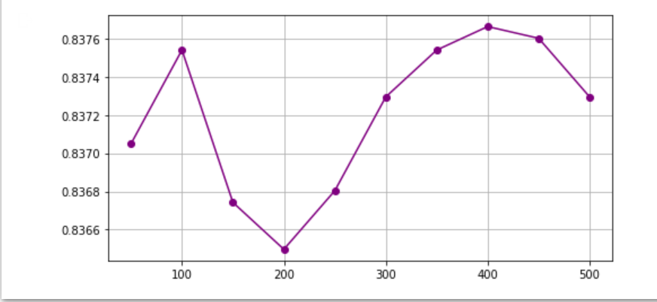The suggested optimal value of the estimator shown from the graph is 400.