Using GIS to Assess Change Detection and Analyze Habitat Suitability for Moose in Isle Royale National Park
Jeffrey Donohoe

Department of Geography, Practicum in GIS, Kent State University, Spring 2019

Abstract

Just 15 miles from the Canadian and Minnesota borders, the park houses one of the longest studied large predator-prey relationships in the United States. Moose and wolves of the isle have created a long-standing and closely monitored dynamic for biologists and conservationists in the
U.S. This moose- wolf predator-prey relationship is the longest running survey of its kind in the world. The origination of both species on the island is vague, but the recent wolf decline has in turn caused the island moose population to surge. Ensuing natural herbivory and vegetation destruction occurs as the moose eat off their preferred food. The island moose prefer balsam fir (specifically in winter) and as wolf numbers continually decline and moose numbers boom it becomes vital to understand the island suitability for maintaining large populations. By monitoring vegetation change over time and understanding the habitat tendencies of the moose, biologists and land managers can better determine a necessity for intervention with a habitat suitability index using regression. Balsam fir contributes to 50% of Isle Royale moose diet in the winter. Winter temperatures typically last from early November to late April where Isle Royale lays. Balsam/fir coverage on the main island has dropped from 46% to nearly 5% since the 1960’s. In 2018, moose population resided at approximately 2000 on an island of approximately 250 mi². While herbivory fluctuates due from various year-to-year circumstances, this study reveals that over a 26-year period that balsam fir dense areas (preferred by moose in winter on the island) has lost 1.38 mi² worth of area. This is with about 1000 moose inhabiting the island in 1985 and just over 500 in 2011. The time is takes for the balsam fir to regenerate doesn’t show the ability to keep up with the moose spike. Not enough herbivory exists to maintain the current moose population growth.
Keywords: Habitat, Suitability, Change Detection, Classification

Introduction and Study Area

Introduction

Scattered in the northwestern portion of Lake Superior, Isle Royale National Park holds over 550,000 acres of wilderness amongst an archipelago accessible only by boat craft or seaplane. The main island, Isle Royale, is approximately 45 miles long and 9 miles wide and stands as the sixth largest freshwater island in the world. Part of Keweenaw County, Michigan, the island holds no permanent human inhabitants and thus provides biologists with a pristinely kept natural study environment. Of great concern is the relationship moose and wolves have on the island and then the effect their relationship has on island vegetation health. The wolves appear to have kept the moose herd within its food supply, culled out undesirable individuals, and stimulated reproduction, (Mihell 34), creating a sort of dynamic equilibrium. With few ice bridges connecting the island to mainland Canada and U.S.A., fewer wolves can cross over and hunt moose on the island. Throughout the 20th centuries both populations have fluctuated (generally holding an inverse relationship to on another) but in 2017, due to inbreeding and disease, the wolf population had been reduced to just 2 on the main island. Since then 13 wolves have been introduced from Ontario and Minnesota (Myers). With the lack of wolves to help maintain a healthy predatory relationship, moose populations spiked to nearly 2000 in late 2018. This is the highest moose population on the island since 1996 when numbers peaked at 2,445 (Figure 1). At the time, this caused moose to run out of necessary food causing starvation to take hold and by 1997 their numbers had crashed to around 700 animals. Throughout summer moose tend near inland lakes to stay cool and will consume aquatic vegetations, but during Isle Royale’s long winters they rely almost solely on balsam fir for food. Conifers commonly consumed by moose in North America, particularly in winter include balsam fir and subalpine fir (Innes, 2010). Balsam firs provide about half the typical moose’s diet in winter… the trees have taken a beating from a century of moose browsing (Mihell). Since 1970, half of the island’s balsam fir trees, a moose favorite, are at risk (Mihell 32). The island had a rather large abundance of balsam fir (Abies balsamea) until the park was colonized by moose in the early 1900s. After their establishment on the island, the balsam fir declined from 46% of the overstory in the 19th century to about 5 % around 2000, (Fortier, 1). Habitat fluctuations are not uncommon but with the park’s isolation and now lack of predation it is crucial for scientists to understand and

monitor vegetation health and accurately determine Isle Royale’s ability to sustain vast moose populations.
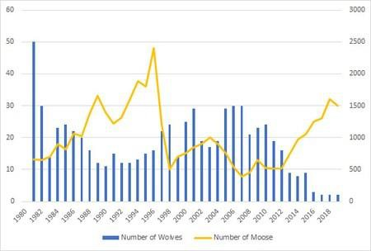

Figure 1. Wolf-Moose Population Dynamics on Isle Royale (Source: NPS)
Remote sensing has become an invaluable resource for habitat and vegetation research.
Through satellite imagery researchers can detect and classify land cover change by using spectral characteristics at one specific area taken at different times. According to Wang et al. (2018), the advent of high-resolution remote sensing images has greatly increased our ability to monitor land use and land cover changes from space. It is necessary to initially describe the nature of change and then identify a spatial pattern of change. Change detection is a process that measures how the characteristics of a particular area have changed between two or more time periods. (This study first takes spatial imagery from separate dates and then isolates proper bands to create a false color composite image (for this study’s purpose) with LandsatTM 4-5 bands (4, 3, 2) (Near Infrared, Green, Blue) from the electromagnetic spectrum. Analyzing these images then allows for proper vegetation separation and identification for comparison over time.
Change is detected and then images can be classified then reclassified for the purpose of the study. Accuracy of this classification will be based on supervised methods within TerrSet software. User research and designation determine study accuracy. Part of this paper uses GIS methods of classification using multi-temporal data from publicly available satellite imagery.

The main purpose of using classification is to display the change in balsam fir degradation over a 26-year period. By breaking the classes into specific categories, the balsam fir zones that moose tend toward will be visible and show in what manner the herbivory has changed on the island since 1985.
After supervised vegetation/LULC classification and spatiotemporal display, a current habitat suitability for moose on the island may be applied then compared against the balsam fir change to help indicate whether we see clustering near still healthy vegetation patches. It is this comparison that will help show any trends and if the island vegetation can support the growing moose numbers. A habitat suitability index (HSI) is a numerical index that represents the capacity of a give habitat to support a selected species (EPA, 2016). There are many ways to model habitat suitability, but this study evaluates moose suitability based on historic habitat preferences for moose in the Lake Superior region and the spatiotemporal vegetation/herbivory cover change from LandsatTM 4-5 satellite imagery retrieved via USGS EarthExplorer open data source. HSI index values range from 0.0 (unsuitable habitat) and 1.0 (ideal habitat). Where all food and cover requisites are in good quantity, quality, and interspersion, there is potential for supporting, over reasonably long periods, densities of 0.4-4 moose/km² (1-10/mi²) (Allen et. al, 1987). These are assumed observations on Isle Royale where currently wolves are the only predatory threat to island moose. The main island and the 450 surrounding smaller islands that make up Isle Royale National Park encompass 893.42 mi² and the center of the park stands roughly at 48.02263 N, -88.843562 E. While moose diet varies in North America depending on season, moose in this region occur in flat terrain in conifer, hardwood-conifer, and hardwood forests (Innes). This paper analyzes the vegetation change on the island and then provides an estimated habitat suitability based on the vegetation change and classical preferred moose habitat. With proper results, ecological intervention can then be justified by biologists for things like wolf reintroduction for moose population management.

Study Area

With no paved roads, Isle Royale is technically an island used strictly for recreation. Nearly 900 mi² make up the park’s 450 plus islands. Deemed a National Park in 1931, the rich native vegetation (despite the island’s small size), has allowed wildlife to flourish. Just a few camping stations exist for park maintenance. The highest point on the island is Mount Desor which holds

an elevation of 1,394 ft above sea level and around 800 ft above Lake Superior level. Figure 2 and 3 describe the general overall location, study area, and vegetation cover sample site. The main island is the 6th largest freshwater island in the world and holds no permanent human inhabitants which allows for near perfect ecological study purposes. The island is made up largely of lateral ridges with majority bedrock soils with constant changing composition due to high winds (NPS, 2015). Boreal forests of white spruce, balsam fir, white birch and aspen dominate most of Isle Royale National Park with some hardwood birch and maple forests towards the main island interior. The eco-makeup of the island consists of conifer (spruce, fir, pine) and deciduous (aspen, maple) with marshlands towards the west and lower portions on the island. The sample site for classification takes place near southern-central Mud Lake (Fig.3) then, habitat samples are taken from Isle Royale, Minnesota and Ontario are recorded moose location data.
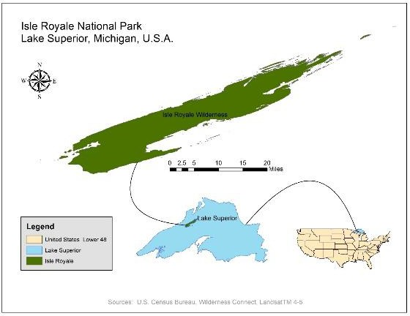
Figure 2. Study Area and Locator Map

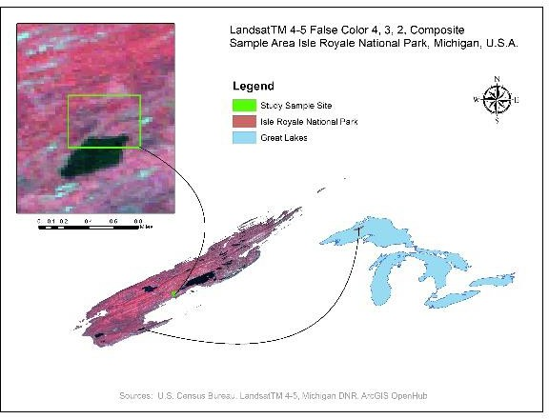

Figure 3. Sample Study Site with False Color Composition

Objectives

The objectives of the study are provided below:

- Classify island vegetation to 3 categories and display spatiotemporal change
- Describe moose habitat specific to Isle Royale
- Analyze moose habitat suitability based on balsam fir change

Data and Methodology

Data

For initial spatiotemporal land cover change, Landsat 4-5 Thematic Mapper multi-temporal satellite data is used. It holds seven spectral bands of 30 m spatial resolution (aside from thermal band 6 that holds a 120 m spatial resolution). Table 1 displays the specificities of Landsat TM 4-5 data used. Band 4-3-2 are taken to from both 1985 and 2011USGS EarthExplorer satellite imagery to create false color composite images to display vegetation/herbivory separation and change (Table 1). Two images each from June 1985 and September 2011 are used for classification display. This data is used to classify Isle Royale land cover.

Table 1. Landsat TM 4-5 spatial characteristics

Bands | Wavelength  µm (micrometers) | Resolution  m (meters)
Band 1 - Blue | 0.45-0.52 | 30
Band 2 - Green | 0.52-0.60 | 30
Band 3 - Red | 0.63-0.69 | 30
Band 4 - Near Infrared | 0.76-0.90 | 30
Band 5 - Shortwave Infrared 1 | 1.55-1.75 | 30
Band 6 - Thermal | 10.40-12.50 | 120* (30)
Band 7 - Shortwave Infrared 2 | 2.08-2.35 | 30

Source: United States Geological Survey EarthExplorer

A number of data sources are used and combined in order to break down the classification imagery and also the habitat suitability model. Past and current moose and wolf population numbers and land cover is taken from the Michigan Department of Natural Resources, ArcGIS OpenHub data portal, U.S. Census Bureau Tiger/Shapefiles, WildernessConnect resources, United States Geologic Survey EarthExplorer open satellite imagery hub, USGS Gap Analysis Species Range and Predicted Habitat Data, and the Wolves & Moose of Isle Royale Project.

Methodology

Initial classification is done using Landsat 4-5 imagery in TerrSet 1.0 and then ArcMap 10.5 processes to provide appropriate suitability index predictions. TerrSet is an integrated geospatial software system for monitoring and modeling the earth system for sustainable development. The TerrSet system incorporates the IDRISI GIS Analysis and IDRISI Image Processing tools along with a constellation of vertical applications (Clark Labs, n.d.). False color infrared composite combination band 4-3-2 (NIR, red, green) is created and processed digitally using TerrSet’s image composite utility on both images (1985 and 2011). These USGS satellite images (Path 24, Row 27 and Path 25, Row 27) are initially blended using the mosaic tool to display the entire Isle Royale study area. The two mosaics (1985 and 2011) are then clipped to a manageable study area using within ArcMap to create locator maps. From here the final false color study area images are brought back into TerrSet and classified through unsupervised digitization using a cluster model. False color composites work in this case as the images are useful in vegetation identification and species health. This digitization is used to create polygons for 4 separate

classes (water, balsam fir and spruce, other tree canopy, rock outcroppings and open grass) with unique (1-4) identifiers for the land cover type. After identifying necessary training sites, spectral signatures are created that analyze the reflected energy from the land and water sources within the images. After the signature development process, images are run through a maximum likelihood classifier with equal probabilities for each signature/class for an accurate output.
Figure 4 describes the methodology flow for the initial island vegetation classification.
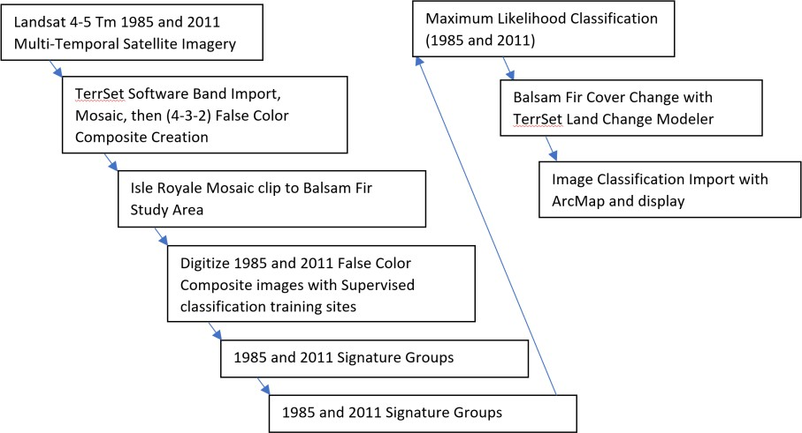

Figure 4. Land Cover/Vegetation Classification Methodology

To display habitat suitability, an outline shapefile from WildernessConnect for the main island on Isle Royale was used to clip a simple DEM depicting suitable, fair, and unsuitable habitat for moose. This was then overlaid with moose GPS points taken from Michigan DNR and pointed using Google Earth to specified unsupervised moose location points. A geodatabase to unify the spatial reference of GCS WGS 1984 is created holding: U.S. Census Bureau Keweenaw County Roads shapefile, Michigan DNR Great Lakes shapefile, WildernessConnect Isle Royale outline shapefile, LandsatTM 4-5 reclassified vegetation raster file, WGS 1984 moose distribution points vector file. General moose habitat preference is taken from previous research. Moose prefer wintering feeding in heavy balsam fir and spruce areas on Isle Royale. In general, moose tend to select habitats that offer the highest density, highest biomass, and most nutritious forage (Innes). In the Great Lakes regions including Isle Royale, moose occurred in mature paper
birch-aspen-balsam fir-white spruce; “climax” paper birch-balsam fir-white spruce; and lowland northern whitecedar (Thuja occidentalis) and black spruce forests (Innes). For this purpose, this

study combines balsam fir and spruce feeding zones against various other tree canopy for the purpose of showing change. The combination of these above data provides the ability to create a current Habitat Suitability Index (HSI) in to exhibit present changing island land cover conditions against classic moose habitat preference in the Great Lakes region.

Results and Discussion
While it is difficult to classify vegetation and land cover based simply on pixels from a satellite image, with previous knowledge and study allows proper pixel shades in false composite images (NIR, red, green) in LandsatTM 4-5 data to decipher between forest and land cover types. This is true even at 30m spatial resolution. Classic vegetation cover maps are taken from National Park Maps and compared against Google Earth 2011 Isle Royale satellite imagery. Remote sensing covers an extensive area so familiarity with the area is assumed via research where a supervised classification is performed to break down categories. An HSI model ensues takes into factor human population, roads and built sites, and moose habitat preference on the island.

Classification maps and statistics (Landsat TM 4-5 Satellite Imageries, 1985 and 2011)

Land cover classification has been used widely to monitor, analyze, and predict change based on numerous factors: global warming, human movement, etc.… The HSI model that follows shows changed based on the reproduction spike from moose on the island. Two USGS 30m satellite images from both 1985 and 2011 are used and mosaiced/blended in TerrSet. These are then clipped down using ArcMap software in order to represent Isle Royale. While moose reside on just the main island, data interpretation represents the hundreds of surrounding islands. Using Land Change Modeler in TerrSet we see a slight decrease of 1.38 % in our 26-year change detection span. This doesn’t seem very high but consider the over 1000 population in 1985 to the around 500 population in 2011 and this amounts to slow growback. In 2018 nearly 2000 moose populated the main island. Figure 5 describes the class breakdown of land cover and herbivory in the park and shows the cover change from the mosaiced images (1985-2011). Four classes are used for breakdown and balsam fir and spruce are combined in order to show change. Using supervised classification with prior NPS vegetation maps (1985) and Google Earth imagery (2011), signature files with TerrSet are created with pixel digitization. Four classes are digitized (see Figure 5) to monitor change. Herbivory fluctuates yearly regardless, but this

process shows simply that the balsam is in general decline no matter the moose numbers. As the moose population spikes there is significant worry of what will happen when a large portion of their diet is unavailable.
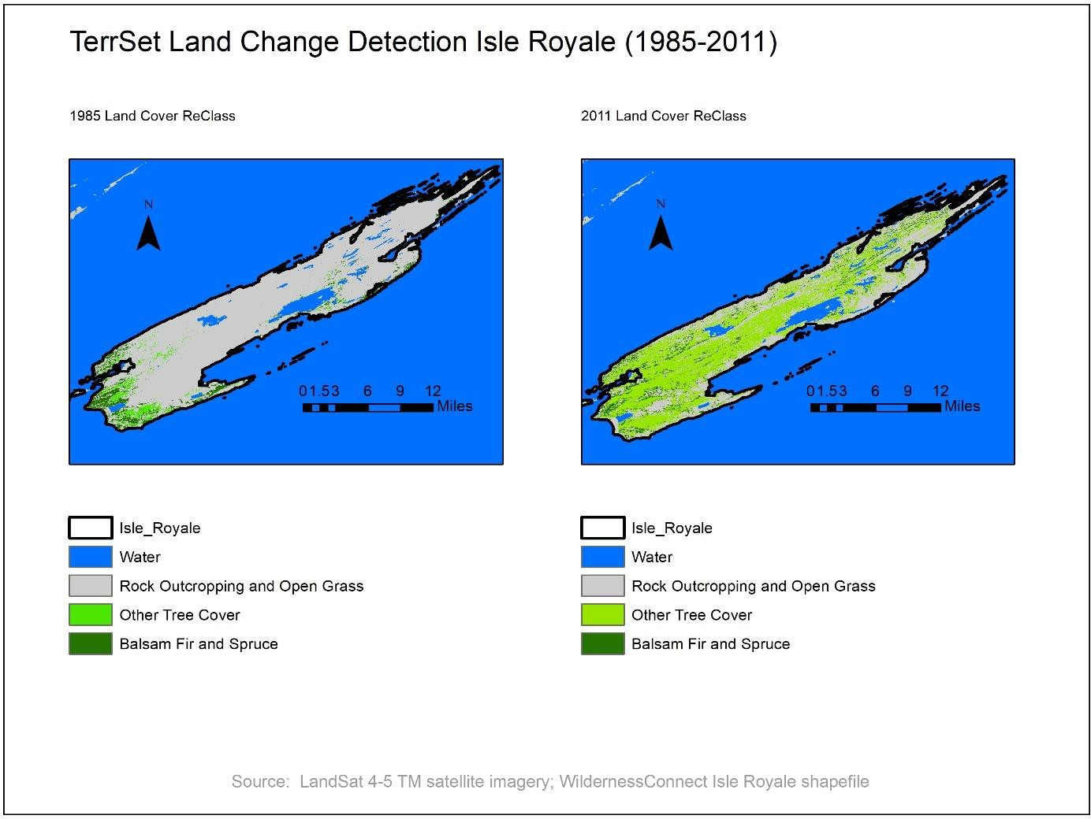

Figure 5. Isle Royale Change Detection (1985 and 2011)

After analyzing the 1985 and 2011 and images to display change, a gains and losses model is created using TerrSet LandModeler. Figure 6 highlights just the balsam and spruce cover change on the island. On the outer portions of the island the balsam is lost where the inner portion of the island shows gain. Overall there is a 1.36% loss of balsam in the 26-year period. This is simply an example of the general loss. Depending on moose populations the herbivory can quickly deteriorate or rejuvenate. TerrSet classification serves break down land cover classes and show balsam/spruce change in a long-term measure.

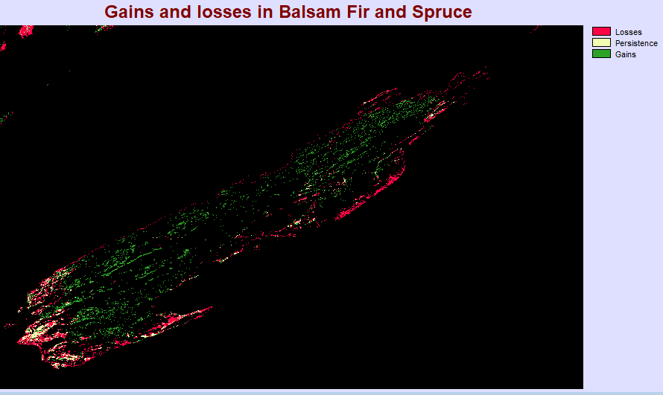

Figure 6. TerrSet Land Change Modeler Detection Map Balsam Fir and Spruce Gains and Losses (1985 – 2011)

15.64 mi² are persistent. Table 2 describes the national park area land cover (non-submerged) and the balsam and spruce change.

Table 2. Isle Royale Balsam and Spruce Gains and Losses with Persistence

Legend | Square Mileage (mi2)
Total | 243.24
Balsam and Spruce Losses | 15.64
Balsam and Spruce Persistence | 11.14
Balsam and Spruce Gains | 14.26

By identifying and classifying land cover using change detection with TerrSet LandModeler tool, a clipped DEM with vegetation distinctions can be added and interpreted in ArcMap for habitat suitability modeling.

Habitat Suitability Index Results

This study has combined a variety of data sources. Most provided via U.S. Census Bureau, Michigan DNR, US GapAnalysis, and other direct GIS Data hub sources. USGS LandsatTM 4-5 satellite imagery has also been manipulated, classified and reclassified for further comparison in an HSI model. A spatial reference is maintained using a geodatabase with 1984 WGS Web Mercator projections. GPS coordinates from a central Canadian and Great Lakes region survey

are used to map ten moose sanctuary points linked to balsam feed in winter months (NPS, 2018). The density of moose presumed to be fit to live on the island is 1-10/mi² (Innes). Points are determined as continual regions of return throughout winter feeding 2010-2011. Balsam and spruce hot points are classified previously as Great Lakes area and Canadian biology has shown moose prefer these feed areas. This is even more true in the winter and colder months when balsam and spruce make up most of the moose diet being in season year-round and that moose prefer forest dense areas to avoid view from predators (Innes, 2011).
First all pertinent data is entered into ArcMap 10.5 software. Isle Royale shapefile from WildernessConnect is use as a base. Ten moose points are given from NPS GPS point recordings and pinned and then transferred into ArcMap. A Census Bureau roads shapefile is entered, and buffers created. A 30m USGS DEM is taken and mosaiced to include the entire national park and clipped using the Isle Royale extents. The extent of the study area is Top-6150746.94m, Left- -9942803.53m, Right- -9825115.96m, Bottom- 6077556.08m. WGS 1984
Web Mercator reference is assigned. The DEM is converted into GRID format using copy raster tool in the data management toolbox in ArcToolbox. The clipped GRID represents negative values in meters. Classification created in TerrSet and the categories defined in Table 2 are assigned. The DEM is reintroduced into ArcMap with the Land Cover categories represented in the attribute table. Normally a population density would be used to accurately assess habitat suitability, but demographics are left out as there are no residents considered permanent.
A simple ranking schema is created as the island area is small and little permanent interaction with humans is apparent (Table 3). An ordinal ranking is created with preferred moose vegetation and proximity to roads where a ranking of 1 is the lowest suitable habitat for moose in the winter and 4 is most suitable.
Table 3. Ordinal Ranking Schema for Winter Habitat Suitability

Rank | Land Cover | Proximity to Roads (mi)
1 | Water | 0.0 – 0.2
2 | Rock/Grass/Brush | 0.3 – 0.6
3 | Hardwood/Tree/Other | 0.7 – 0.9
4 | Spruce/Balsam | 1.0 -

Using a raster calculator to combine road buffers, the reclassified island vegetation with four classes, and suggested 1-10/mi² moose habitat, an HSI model can is produced. Figure 7 breaks down and highlights specific study quadrants. Least suitable habitats are shown in the northeastern area due to roads and lack of balsam. Central and southwestern portions tend to provide the most suitable habitat with larger concentrations of healthy balsam and spruce. Due to isolation the park provides an almost pristine natural study area minus human disruption.
Special protection and interference are likely needed in order to preserve island herbivory and maintain the wolf-moose (predator-prey) dynamic unique to the island. Isle Royale is a perfect habitat for moose, but it is likely incapable of preserving the current population.
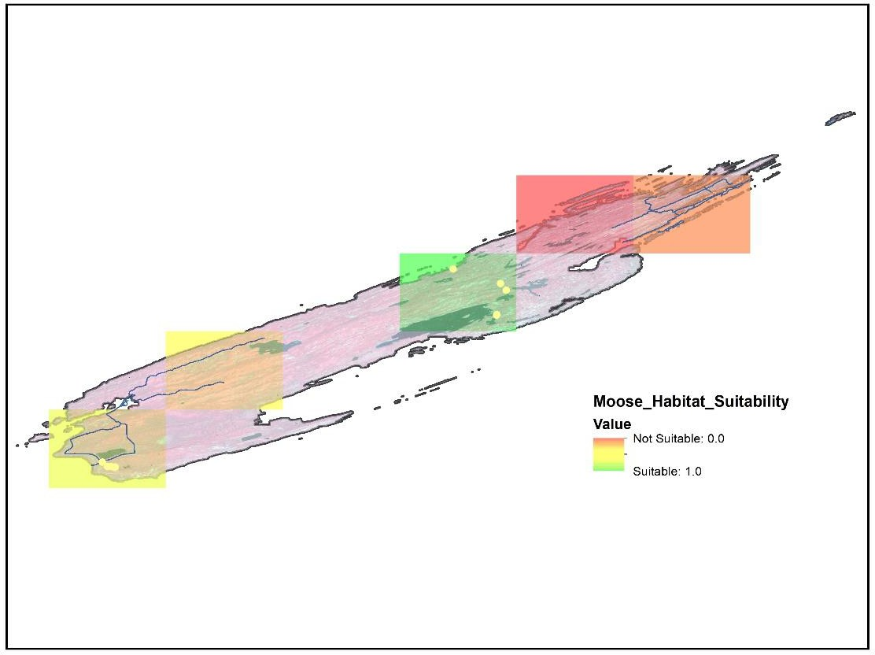

Figure 7. Habitat suitability quadrants

Balsam forest is in decline even without the lack of predation to moose on the island. Global warming is the likely culprit that also permits fewer new wolves to the island. To maintain their current relationship and preserve a healthy vegetation distribution on the island, scientific aid will be required to better understand a desirable moose population.

Conclusion
Change detection helps display areal change of vegetation cover of an area. This study first uses TerrSet’s LandModeler tool to display cover change on Isle Royale from images taken in June 1985 and September 2011. By first sampling then classifying an area in Isle Royale National Park, this study shows a degradation in balsam fir and spruce forest coverage likely due to large moose population spikes. What’s more, habitat suitability models that weight locations relative to each other based on certain data are effective in displaying the ability of a species to survive in a certain location. The results of this study serve to demonstrate a modern habitat suitability assignment for Isle Royale moose based on modern to recent preferred moose herbivory change, moose population numbers, and proposed moose density suitability (1-10/mi²). Currently over 2000 moose inhabit the island which is the second most in the its history and studies reveal this is likely near or already over peak carrying capacity. Landsat data provides accurate measure, but it is the duty of the assessor to accurately classify signature for the pixels to represent varying land cover. Isle Royale is analyzed and a proposed HSI model is prepared by classifying Isle Royale land cover using high resolution satellite imagery and using previously recorded moose population suitability per mi². Further data including road buffer, balsam and spruce zones are used to give rank. The results serve to provide an estimate of a suitable moose population on Isle Royale and whether human intervention is required in maintaining island herbivory health and proper predator-prey relations between wolf and moose. What’s more, classification is based on the accuracy and time period used by the assessor. This assessment shows the balsam/spruce area decreased by 1.36 mi² from 1985 to 2011. The results are used to exemplify a modern-day habitat suitability where it is seen the inner portions and balsam dense areas are best suited for moose on the island. Previous studies agree with this study’s result that finds 8.24/mi2 is suitable for the island’s present herbivory state. Much research remains but without the presence of stable wolf population, there is high likelihood of moose die off due to lack of food when population continues past 2,000. Maintaining island equilibrium and consistency will require constant human supervision.

References
- Allen, A.W., P.A. Jordan, and J.W. Terrell. “Habitat Suitability Index Models: Moose, Lake Superior Region.” Fish and Wildlife Service, Biological Report 82 (10.155), 47 pp., September 1987, https://www.nwrc.usgs.gov/wdb/pub/hsi/hsi-155.pdf. Accessed 22
February 2019.
- Belongie, Cole C. “Using GIS to Create a Gray Wolf Habitat Suitability Model and to Assess Wolf Pack Ranges in the Western Upper Peninsula of Michigan.” Department of Resource Analysis, Saint Mary’s University of Minnesota, Winona, MN. 25 June 2007. http://landscape.forest.wisc.edu/publications.php. Accessed 25 February 2019.
- Brandner, Thomas A., Peterson, Rolf O., Risenhoover, Ken L. “Balsam Fir on Isle Royale: Effects of Moose Herbivory on Population Density.” Ecological Society of America Journals, 01 February 1990, doi 10.2307/1940256.
https://esajournals.onlinelibrary.wiley.com/doi/abs/10.2307/1940256. Accessed 22
February 2019.
- Dettki, Holger, Lofstrand, Ronny, Edenius, Lara. “Modeling Habitat Suitability for Moose in Coastal Northern Sweden: Empirical vs Process-oriented Approaches.” Accessed March1, 2019.
- Fortier, Gary M. “The Wolf, the Moose, and the Fir Tree: Who Controls Whom on Isle Royale? A case study of trophic interactions.” Department of Small Animal Science, Delaware Valley College, last updated 21 October 2002. facultyweb.cortland.edu/douglas.armstead/S13/ES160/Labs/wolfMooseTree.pdf. Accessed 20 March 2019.
- “Habitat Suitability Index (HSI).” Environmental Protection Agency, Atlantic Ecology Division (AED), 2 February 2016, https://archive.epa.gov/aed/html/research/scallop/web/html/hsi.html. Accessed 3 March 2019.
- Hepinstall, Jeffrey A, Queen, Lloyd P., Jordan, Peter A. “Application of a Modified Habitat Suitability Index Model for Moose.” American Society of Photogrammetry and Remote Sensing, Vol. 62, No. 11, November 1996, pp. 1281-1286. http://citeseerx.ist.psu.edu/viewdoc/summary?doi=10.1.1.473.7981. Accessed 2 March 2019.
- Houts, Michael E. “Using Logistic Regression to Model Wolf Habitat Suitability in the Northern Rocky Mountains.” Accessed 22 March 2019.
- Innes, Robin J. “Alces Americanus.” Fire Effects Information System, U.S. Department of Agriculture, Forest Service, Rocky Mountain Research, 2010. www.fs.fed.us/database/feis/animals/mammal/alam/all.html. Accessed April 1 2019.
- Lauver, Chris L., Busby, William H., and Whistler, Jerry L. “Testing a GIS Model of Habitat Suitability for a Declining Grassland Bird.” Environmental Management , Vol. 30 No. 1, pp 88-97, 2002. DOI: 10:1007/s00267-001-2609-z. Accessed 18 March 2019.

- Mihell, Conor. “A Reasonable Illusion: Will restocking Michigan’s Isle Royale with wolves make it a zoo?” Sierra Magazine, November/December 2018, pp. 30-35.
- Myers, John. “Increasing In Numbers, Isle Royale Moose Devouring Forest.” Northland Outdoors, 3 May 2019, http://northlandoutdoors.areavoices.com/2019/05/03/increasing-
in-numbers-isle-royale-moose-devouring-forest/. Accessed 3 May 2019.
- National Park Service. Moose-Isle Royale National Park. NPS, 28 September 2018, https://www.nps.gov/isro/learn/nature/moose.htm. Accessed 2 March 2018.
- “Nature & Science.” NPS, 14 December 2015,
https://www.nps.gov/isro/learn/nature/index.htm. Accessed 1 March 2019.
- Pogue, Clint D., et al. “Habitat Suitability Modeling of the Federally Endangered Poweshiek Skipperling in Michigan." Journal of Fish and Wildlife Management, vol.7,1issue 2, December 2016, https://www.fwspubs.org/doi/pdf/10.3996/052015-
JFWM-049. Accessed 7 April 2019.
- Species Habitat Model Report: Moose. United States Geological Survey Gap Analysis. 30 October 2017, https://doi.org/10.5066/F79K48M5. Accessed 15 March 2019.
- Speed, Cole. “Performing a Habitat Suitability Analysis for the Mexican Gray Wolf Using GIS Software.” 2015. http://www.geo.utexas.edu/courses/371c/project/2015/Speed_GIS_Project.pdf. Accessed 10 March 2019.
- “The Population Biology of Isle Royale Wolves and Moose: An Overview.” Isle Royale Wolf, https://isleroyalewolf.org/http%3A//www.cpc.ncep.noaa.gov/products/precip/CWlink/pna
/nao.shtml. Accessed 1 March 2019.
- Tourville, J., C. Lindman, M., Weinstein, C., Schultze, R., and Noack, M. 2018. “Moose Herbivory Monitoring Protocol for Isle Royale National Park.” Natural Resource Report. National Park Service, Fort Collins, Colorado. April 2018.
- “ ‘Unknown’ wolf visitors, rebuffed incest, hungry moose highlight new Isle Royale report.” Michigan Live, 2 May 2019, https://expo.mlive.com/news/g66l-2019/05/07b41c79418851/unknown-wolf-visitors-rebuffed-incest-hungry-moose-highlight-new-isle-royale-report-.html. Accessed 2 May 2019.
- Wang, Qing, et al. “Change detections based on Faster R-CNN for high-resolution remote sensing images.” Remote Sensing Letters, vol. 9, issue 10, 2018, https://www.tandfonline.com/doi/abs/10.1080/2150704X.2018.1492172. Accessed 18
March 2019.

