FinalProject

Jordan Donovan

April 4, 2017

# Final Project - Breaches

library(readr)  
library(tidyverse)

## Loading tidyverse: ggplot2  
## Loading tidyverse: tibble  
## Loading tidyverse: tidyr  
## Loading tidyverse: purrr  
## Loading tidyverse: dplyr

## Conflicts with tidy packages ----------------------------------------------

## filter(): dplyr, stats  
## lag(): dplyr, stats

require(dplyr)  
breaches <- read_csv("~/Downloads/breaches.csv")

## Warning: Missing column names filled in: 'X1' [1]

## Parsed with column specification:  
## cols(  
## X1 = col_integer(),  
## Number = col_integer(),  
## Name_of_Covered_Entity = col_character(),  
## State = col_character(),  
## Business_Associate_Involved = col_character(),  
## Individuals_Affected = col_integer(),  
## Date_of_Breach = col_character(),  
## Type_of_Breach = col_character(),  
## Location_of_Breached_Information = col_character(),  
## Date_Posted_or_Updated = col_date(format = ""),  
## Summary = col_character(),  
## breach_start = col_date(format = ""),  
## breach_end = col_date(format = ""),  
## year = col_integer()  
## )

View(breaches)

We may need to remove Date_of_Breach to tidy the dataset. Really only thing I've seen.

First we will start by exploring the dataset from a breadth first approach. These initial examinations will be where we glean our direction for the following exploration in this document.

breaches %>%  
 filter(year > 2009 & year < 2014) %>%  
 group_by(year) %>%  
 summarise(num_of_cases = n()) %>%  
 ggplot(mapping=aes(x=year, y=num_of_cases)) + geom_col()

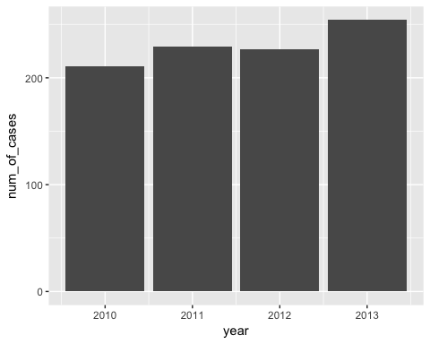

breaches %>%  
 filter(year > 2009 & year < 2014) %>%  
 group_by(year) %>%  
 summarise(Individuals_Affected_in_Mil=sum(Individuals_Affected/1000000)) %>%  
 ggplot(mapping=aes(x=year, y=Individuals_Affected_in_Mil)) +  
 geom_col()

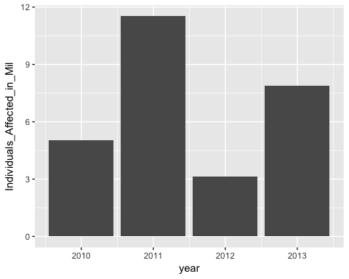

#geom_smooth()

breaches %>%  
 filter(year > 2009 & year < 2014) %>%  
 group_by(Type_of_Breach) %>%  
 summarise(Individuals_Affected_in_Mil=sum(Individuals_Affected/1000000)) %>%  
 ggplot(mapping=aes(x=Type_of_Breach, y=Individuals_Affected_in_Mil)) +  
 geom_col()

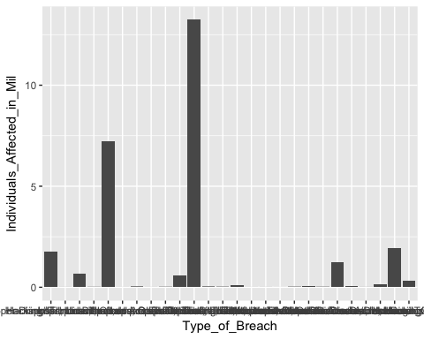

breaches %>%  
 filter(year > 2009 & year < 2014) %>%  
 group_by(Type_of_Breach, year) %>%  
 summarise(Individuals_Affected_in_mil=sum(Individuals_Affected/1000000)) %>%  
 ggplot(mapping=aes(x=year, size=Individuals_Affected_in_mil, y=Type_of_Breach)) +  
 geom_point()

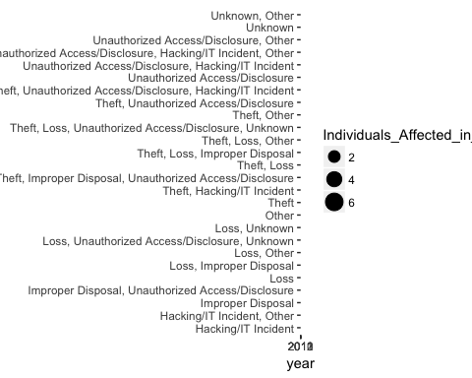

#Top 5 types of breaches according to individuals affected by breach  
breaches %>%  
 group_by(Type_of_Breach) %>%  
 summarise(Individuals_Affected_in_mil=sum(Individuals_Affected/1000000)) %>%  
 arrange(desc(Individuals_Affected_in_mil)) %>%  
 top_n(5) %>%  
 ggplot(mapping=aes(x=Type_of_Breach, y=Individuals_Affected_in_mil, fill=Type_of_Breach)) +  
 geom_col()

## Selecting by Individuals_Affected_in_mil

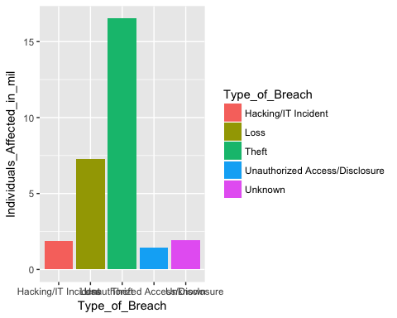

#Top 5 types of breaches according to individuals affected by breach  
breach_for_pie <- breaches %>%  
 group_by(Type_of_Breach) %>%  
 summarise(Individuals_Affected_in_mil=sum(Individuals_Affected/1000000)) %>%  
 arrange(desc(Individuals_Affected_in_mil)) %>%  
 top_n(5)

## Selecting by Individuals_Affected_in_mil

slices <- breach_for_pie$Individuals_Affected_in_mil  
lbls <- breach_for_pie$Type_of_Breach  
pct <- round(slices/sum(slices) * 100)  
lbls <- paste(lbls, pct)  
lbls <- paste(lbls, "%", sep=" ")  
 pie(slices, labels=lbls, col=rainbow(length(lbls)), main="Type of Breach and Individuals Affected in Million")

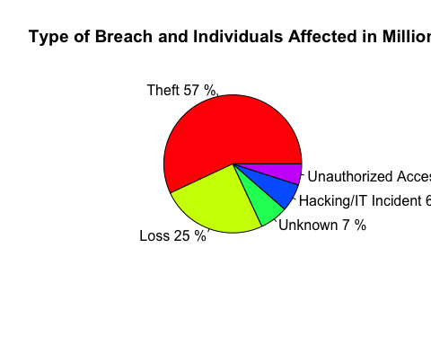

#Top 5 types of breaches according to number of occurrences  
breaches %>%  
 group_by(Type_of_Breach) %>%  
 summarise(num_of_occurrences = n()) %>%  
 top_n(5) %>%  
 ggplot(mapping=aes(x=Type_of_Breach, y=num_of_occurrences, fill=Type_of_Breach)) +  
 geom_col()

## Selecting by num_of_occurrences

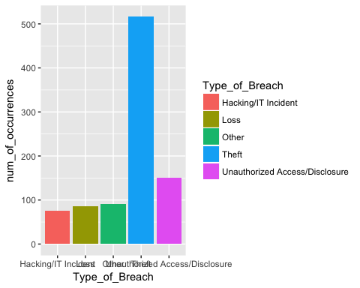

breaches %>%  
 group_by(State) %>%  
 summarise(Individuals_Affected_in_mil = sum(Individuals_Affected/1000000)) %>%  
 top_n(15) %>%  
 ggplot(mapping = aes(x=State, y=Individuals_Affected_in_mil, fill=State)) +  
 geom_col();

## Selecting by Individuals_Affected_in_mil

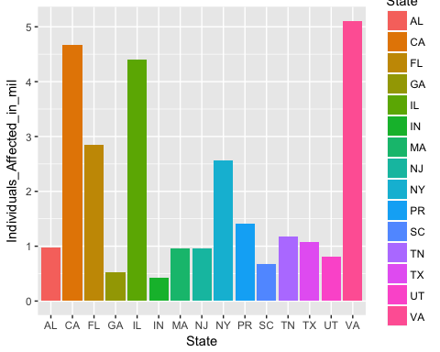

#map(database = 'county')

breaches %>%  
 group_by(Location_of_Breached_Information) %>%  
 summarise(Individuals_Affected_in_mil = sum(Individuals_Affected/1000000)) %>%  
 top_n(5) %>%  
 ggplot(mapping = aes(x=Location_of_Breached_Information, y=Individuals_Affected_in_mil, fill=Location_of_Breached_Information)) +  
 geom_col()

## Selecting by Individuals_Affected_in_mil

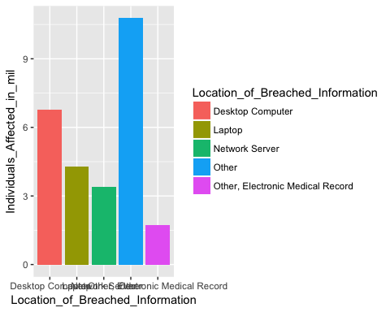

top_Locations <- breaches %>%  
 group_by(Location_of_Breached_Information) %>%  
 summarise(Individuals_Affected_in_mil = sum(Individuals_Affected/1000000)) %>%  
 arrange(desc(Individuals_Affected_in_mil)) %>%  
 top_n(5) %>%  
 select (Location_of_Breached_Information)

## Selecting by Individuals_Affected_in_mil

breaches %>% filter(Location_of_Breached_Information %in% top_Locations$Location_of_Breached_Information) %>%  
 group_by(Location_of_Breached_Information) %>%  
 summarise(Individuals_Affected_in_mil = sum(Individuals_Affected/1000000)) %>%  
 ggplot(mapping = aes(x=Location_of_Breached_Information, y=Individuals_Affected_in_mil, fill=Location_of_Breached_Information)) +  
 geom_col()



breaches %>% filter(Location_of_Breached_Information %in% top_Locations$Location_of_Breached_Information) %>%  
 group_by(Location_of_Breached_Information) %>%  
 #summarise(Individuals_Affected_in_mil = sum(Individuals_Affected/1000000)) %>%  
 ggplot(mapping = aes(x=Location_of_Breached_Information, y=Individuals_Affected, color=Location_of_Breached_Information)) +  
 stat_summary()

## No summary function supplied, defaulting to `mean_se()

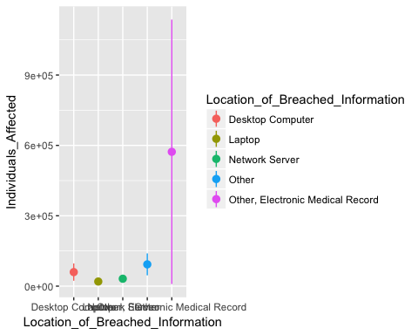

As I begin to analyze this data further, it begins to become apparent that the credibility of this data and its source are not quite at the standard desired.

top_Breach_Types <- breaches %>% group_by(Type_of_Breach) %>%  
 summarise(Individuals_Affected_in_mil=sum(Individuals_Affected/1000000)) %>%  
 arrange(desc(Individuals_Affected_in_mil)) %>%  
 top_n(5) %>%  
 select(Type_of_Breach)

## Selecting by Individuals_Affected_in_mil

top_Breach_Types

## # A tibble: 5 × 1  
## Type_of_Breach  
## <chr>  
## 1 Theft  
## 2 Loss  
## 3 Unknown  
## 4 Hacking/IT Incident  
## 5 Unauthorized Access/Disclosure

top_States <- breaches %>%  
 group_by(State) %>%  
 summarise(Individuals_Affected_in_mil=sum(Individuals_Affected/1000000)) %>%  
 arrange(desc(Individuals_Affected_in_mil)) %>%  
 top_n(5) %>%  
 select(State)

## Selecting by Individuals_Affected_in_mil

#group_by(Type_of_Breach, State) %>%  
 #summarise(Individuals_Affected_in_mil = sum(Individuals_Affected/1000000)) %>%  
 #top_n(1) %>%  
  
top_States

## # A tibble: 5 × 1  
## State  
## <chr>  
## 1 VA  
## 2 CA  
## 3 IL  
## 4 FL  
## 5 NY

both <- breaches %>% filter(Type_of_Breach %in% (top_Breach_Types$Type_of_Breach) & State %in% (top_States$State))  
  
both %>% group_by(Type_of_Breach, State) %>%  
 summarise(Individuals_Affected_in_mil = sum(Individuals_Affected/1000000)) %>%  
 ggplot(mapping=aes(x=State, y=Type_of_Breach, size=Individuals_Affected_in_mil)) +  
 geom_point()

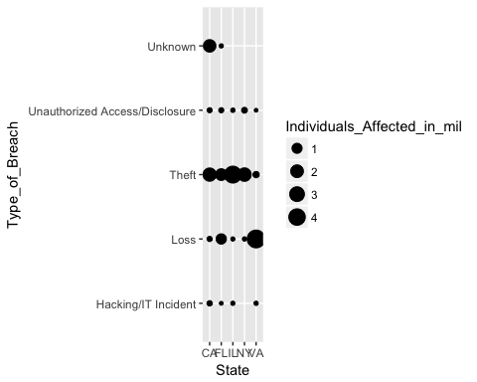

breaches %>% ggplot(mapping=aes(x=Date_of_Breach, y=State)) + geom_point()

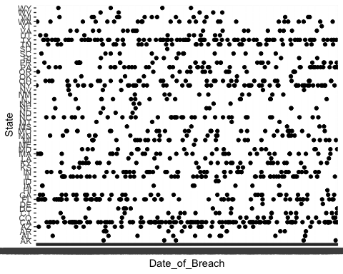

breaches_by_date <- both %>%  
 group_by(Date_of_Breach)  
 #summarise(Individuals_Affected_in_mil = sum(Individuals_Affected))  
breaches_by_date

## Source: local data frame [243 x 14]  
## Groups: Date_of_Breach [218]  
##   
## X1 Number Name_of_Covered_Entity State  
## <int> <int> <chr> <chr>  
## 1 5 4 L. Douglas Carlson, M.D. CA  
## 2 6 5 David I. Cohen, MD CA  
## 3 7 6 Michele Del Vicario, MD CA  
## 4 8 7 Joseph F. Lopez, MD CA  
## 5 9 8 Mark D. Lurie, MD CA  
## 6 10 9 City of Hope National Medical Center CA  
## 7 14 13 Kern Medical Center CA  
## 8 23 22 Kaiser Permanente Medical Care Program CA  
## 9 24 23 Blue Island Radiology Consultants IL  
## 10 29 28 Advocate Health Care IL  
## # ... with 233 more rows, and 10 more variables:  
## # Business_Associate_Involved <chr>, Individuals_Affected <int>,  
## # Date_of_Breach <chr>, Type_of_Breach <chr>,  
## # Location_of_Breached_Information <chr>, Date_Posted_or_Updated <date>,  
## # Summary <chr>, breach_start <date>, breach_end <date>, year <int>

ggplot(data=breaches_by_date, mapping=aes(x=Date_of_Breach, y=State)) +  
 geom_line() +  
 facet_grid(Type_of_Breach ~ .)

## geom_path: Each group consists of only one observation. Do you need to  
## adjust the group aesthetic?

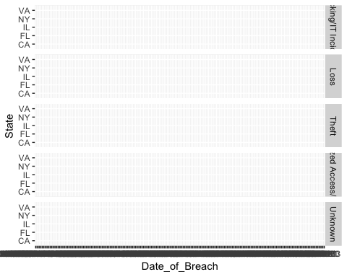

##maybe try grouping by date..

breaches %>% filter(Type_of_Breach %in% (top_Breach_Types$Type_of_Breach)) %>%  
 ggplot(mapping = aes(x=Type_of_Breach, y=Individuals_Affected, color=Type_of_Breach)) + stat_summary()

## No summary function supplied, defaulting to `mean_se()

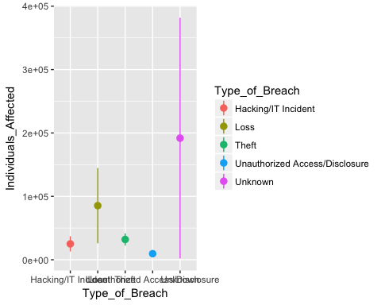

breaches %>% filter(Type_of_Breach %in% (top_Breach_Types$Type_of_Breach)) %>%  
 group_by(Type_of_Breach) %>%  
 summarise(Individuals_Affected_avg = mean(Individuals_Affected)) %>%  
 ggplot(mapping = aes(x=Type_of_Breach, y=Individuals_Affected_avg, fill=Type_of_Breach)) + geom_col(size=5)

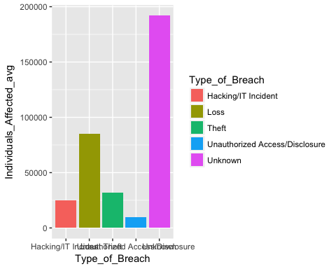

breaches %>% filter(Type_of_Breach %in% (top_Breach_Types$Type_of_Breach)) %>%  
 group_by(Type_of_Breach) %>%  
 summarise(num_of_occurrences = n()) %>%  
 ggplot(mapping = aes(x=Type_of_Breach, y=num_of_occurrences, fill=Type_of_Breach)) + geom_col(size = 5)

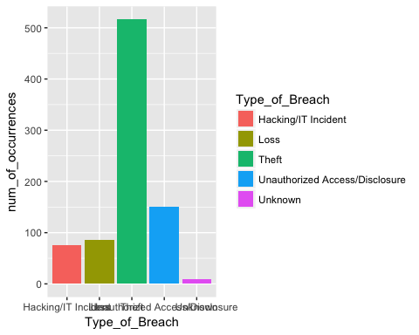

breaches %>% filter(Type_of_Breach %in% (top_Breach_Types$Type_of_Breach)) %>%  
 group_by(Type_of_Breach) %>%  
 #summarise(Individuals_Affected_in_mil = sum(Individuals_Affected/1000000)) %>%  
 #mutate(Individuals_Affected_in_mil = sum(Individuals_Affected/1000000)) %>%  
 mutate(num_of_occurrences = n()) %>%  
 mutate(Individuals_Affected_in_thou = (Individuals_Affected/1000)) %>%  
 ggplot(mapping=aes(x=num_of_occurrences, color=Type_of_Breach, y=Individuals_Affected_in_thou)) +  
 stat_summary()

## No summary function supplied, defaulting to `mean_se()

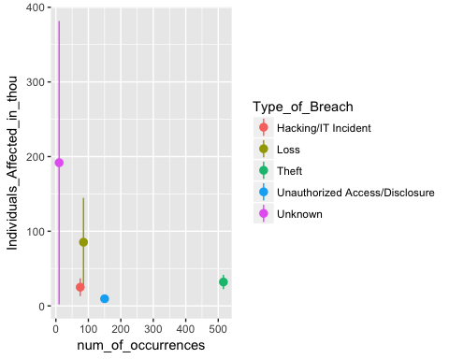

dataset <- breaches %>%  
 group_by(Type_of_Breach) %>%  
 summarise(Individuals_Affected_in_mil=sum(Individuals_Affected/1000000)) %>%  
 arrange(desc(Individuals_Affected_in_mil)) %>%  
 top_n(5)

## Selecting by Individuals_Affected_in_mil

ggplot(data=dataset, mapping=aes(x=reorder(Type_of_Breach, -Individuals_Affected_in_mil), y=Individuals_Affected_in_mil, fill=Type_of_Breach)) +  
 geom_col()

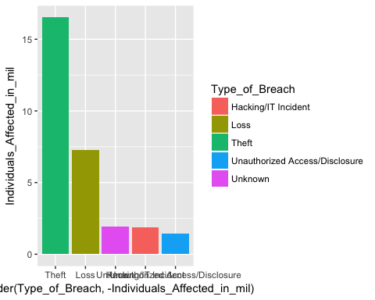

dataset

## # A tibble: 5 × 2  
## Type_of_Breach Individuals_Affected_in_mil  
## <chr> <dbl>  
## 1 Theft 16.515554  
## 2 Loss 7.254286  
## 3 Unknown 1.918312  
## 4 Hacking/IT Incident 1.878870  
## 5 Unauthorized Access/Disclosure 1.434018

models <- tibble(  
 a0 = runif(250, -20, 40),  
 a1 = runif(250, -5, 5)  
 )  
  
p2 <- ggplot(dataset, aes(reorder(Type_of_Breach, -Individuals_Affected_in_mil), Individuals_Affected_in_mil)) + geom_abline(aes(intercept = a0, slope=a1), data = models, alpha = 1/4) + geom_point()  
 p2

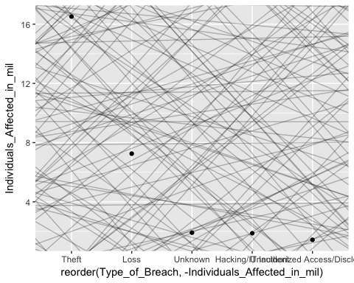

dataset_mod <- lm(reorder(Type_of_Breach, -Individuals_Affected_in_mil) ~Individuals_Affected_in_mil, data = dataset)

## Warning in model.response(mf, "numeric"): using type = "numeric" with a  
## factor response will be ignored

## Warning in Ops.factor(y, z$residuals): '-' not meaningful for factors

coef(dataset_mod) %>% str()

## Named num [1:2] 4.238 -0.214  
## - attr(*, "names")= chr [1:2] "(Intercept)" "Individuals_Affected_in_mil"

p3 <- summary(dataset_mod)$r.squared * 100

## Warning in Ops.factor(r, 2): '^' not meaningful for factors

p3

## [1] NA

p4 <- ggplot(dataset, aes(reorder(Type_of_Breach, -Individuals_Affected_in_mil), Individuals_Affected_in_mil)) +  
 geom_point(size = 2, color = "grey40") +  
 geom_abline(intercept = coef(dataset_mod)[1], slope = coef(dataset_mod)[2], color = "blue")  
 p4

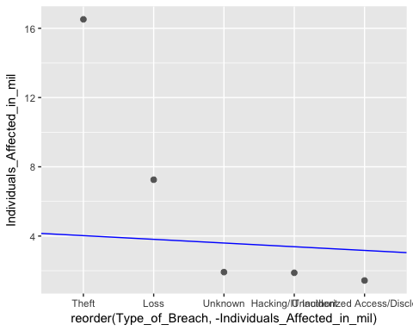

#grid <- dataset %>%  
 #add_predictions(dataset_mod)  
 #print(grid)

#Plot by month individuals affected  
#fit a model to this using MAD or something other than RMS  
require(lubridate)

## Loading required package: lubridate

##   
## Attaching package: 'lubridate'

## The following object is masked from 'package:base':  
##   
## date

make_date_100 <- function(year, month, day) {  
 make_date(year, month, day)  
}  
  
breaches_date <- breaches %>% filter(!is.na(breach_start) & year < 2014 & year > 2010) %>%  
 mutate(month = month(breach_start, label=TRUE), num_of_occurrences = n()) %>%  
 ggplot(aes(x=month, y=num_of_occurrences)) + geom_col(alpha = 1)  
breaches_date

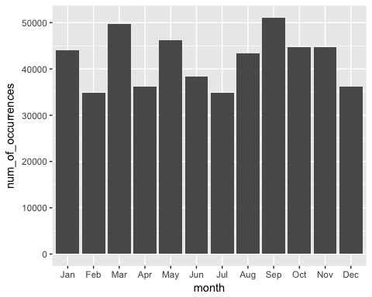

require(lubridate)  
  
breaches_date_affected <- breaches %>% filter(!is.na(breach_start) & year < 2014 & year > 2010) %>%  
 mutate(month = month(breach_start, label=TRUE)) %>%  
 group_by(month) %>%  
 summarise(Individuals_Affected_in_mil = sum(Individuals_Affected/1000000)) %>%  
 ggplot(aes(x=month, y=Individuals_Affected_in_mil)) + geom_col()  
breaches_date_affected

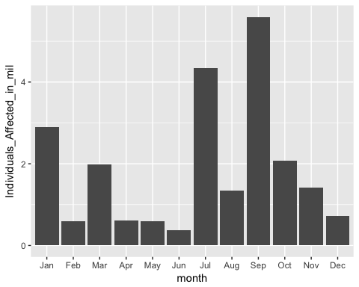

require(lubridate)  
  
make_date_100 <- function(year, month, day) {  
 make_date(year, month, day)  
}  
  
breaches_by_date_2 <- breaches %>% filter(!is.na(breach_start) & year < 2014 & year > 2010) %>%  
 mutate(month = month(breach_start, label = TRUE), day = day(breach_start), breach_start_date = make_date(year, month, day)) %>%  
 ggplot(aes(breach_start_date)) + geom_freqpoly(binwidth = month(1) %>% as.numeric())  
breaches_by_date_2

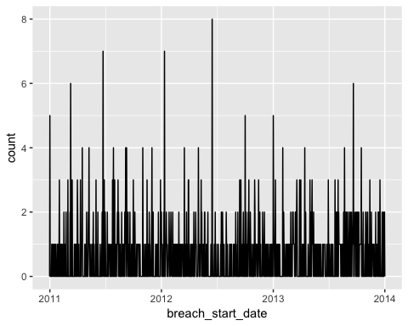

require(lubridate)  
  
make_date_100 <- function(year, month) {  
 make_date(year, month, day)  
}  
  
breaches_by_date_2 <- breaches %>% filter(!is.na(breach_start) & year < 2014 & year > 2010) %>%  
 mutate(month = month(breach_start, label = TRUE), day = day(breach_start), breach_start_date = make_date(year, month)) %>%  
 ggplot(aes(breach_start_date)) + geom_bar()  
breaches_by_date_2

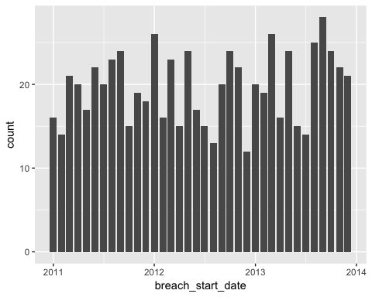

require(lubridate)  
  
make_date_100 <- function(year, month, day) {  
 make_date(year, month)  
}  
  
breaches_by_date_3 <- breaches %>% filter(!is.na(breach_start) & year < 2014 & year > 2010) %>%  
 mutate(month = month(breach_start, label = TRUE), day = day(breach_start), breach_start_date = make_date(year, month)) %>%  
 group_by(breach_start_date) %>%  
 summarise(Individuals_Affected_in_thou = sum(Individuals_Affected/1000)) %>%  
 ggplot(aes(x = breach_start_date, y = Individuals_Affected_in_thou)) + geom_col()  
breaches_by_date_3

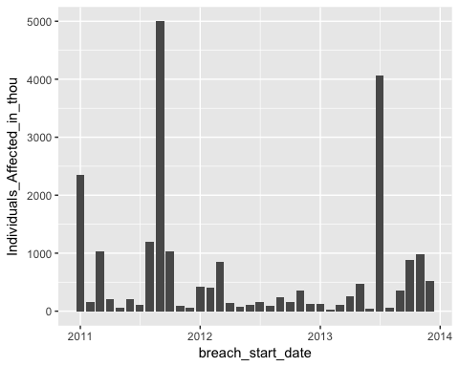

require(lubridate)  
  
make_date_100 <- function(year, month, day) {  
 make_date(year, month)  
}  
  
breaches_by_date4 <- breaches %>% filter(!is.na(breach_start) & year < 2014 & year > 2010) %>%  
 mutate(month = month(breach_start, label=TRUE), day=day(breach_start), breach_start_date = make_date(year, month)) %>%  
 group_by(breach_start_date) %>%  
 summarise(Individuals_Affected_in_thou = sum(Individuals_Affected/1000))  
  
models <- tibble(  
 a0 = runif(250, -2000, 4000),  
 a1 = runif(250, -5000, 5000)  
 )  
  
p2 <- ggplot(breaches_by_date4, aes(breach_start_date, Individuals_Affected_in_thou)) + geom_abline(aes(intercept = a0, slope=a1), data = models, alpha = 1/4) + geom_point()  
 p2

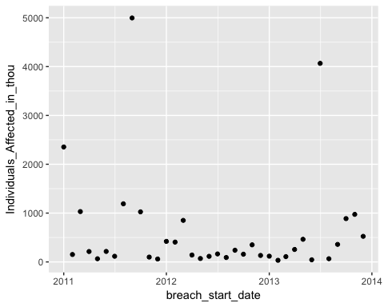

dataset_mod <- lm(Individuals_Affected_in_thou ~breach_start_date, data = breaches_by_date4)  
 coef(dataset_mod) %>% str()

## Named num [1:2] 5326.513 -0.303  
## - attr(*, "names")= chr [1:2] "(Intercept)" "breach_start_date"

p3 <- summary(dataset_mod)$r.squared * 100  
 p3

## [1] 0.8193493

p4 <- ggplot(breaches_by_date4, aes(breach_start_date, Individuals_Affected_in_thou)) +  
 geom_point(size = 2, color = "grey40") +  
 geom_abline(intercept = coef(dataset_mod)[1], slope = coef(dataset_mod)[2], color = "blue")  
 p4

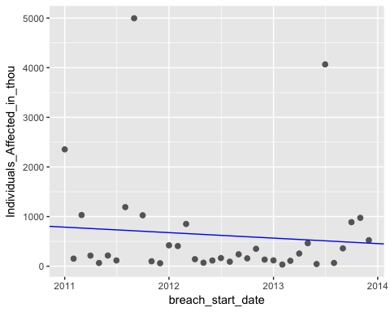

#grid <- breaches_by_date4 %>%  
 #add_predictions(dataset_mod)  
 #print(grid)