**Region 2 Lake Erie & Ontario Counties Coastal Modeling Methodology**

Step1:

Create topo/bathy terrain, which has bathymetry only in area with most recent survey.

Vertical Datum NAVD88 ft.

Horizontal Datum StatePlane ft

Result in “Terrain” folder

Step2:

Create SWEL rasters of all return periods and raw 100yr/500yr floodplain.

Vertical Datum NAVD88 ft.

Horizontal Datum StatePlane ft

Result in “SWEL” folder

Step3:

Create PGDB, which contains the following layers

L_MG: Table storing information of VH cards in Obstruction layer.

S_CST_OFFSH_LN: Offshore transect layer. (Offshore transect ends at extent of bathy survey or 30ft depth. If none of above is available, offshore transect ends at deepest point in the river or water body. Transect ID is shown in “TRANSECTID” field of S_CST_OFFSH_LN)

S_CST_TSCT_LN: Inland transect layer. (Inland transect ends above 100yr Floodplain. Transect ID is shown in “HYDROID” field of S_CST_TSCT_LN; average lake level at each transect is shown in “GF_DatumConvFac” field of S_CST_TSCT_LN, unit meter)

S_CST_TSCT_STN: WHAFIS stations layer.

S_OBSTRUCTIONS: Obstruction polygon layer.

S_BU_GUIDE_LN: Buildings obstruction rows

S_SHORE_LN: Shoreline layer. (Low Water Datum Shoreline of Lake Erie is 569.4ft NAVD88 in majority of Lake Erie, decreases along Niagara River and increases along Detroit river, Low Water Datum Shoreline of Lake Ontario is 243.4ft in majority of the lake)

Vertical Datum NAVD88 ft.

Horizontal Datum StatePlane ft

Result in “PGDB” folder

Step4:

Create CHAMP database

Vertical Datum NAVD88 ft.

Horizontal Datum StatePlane ft

Result in “CHAMP” folder

Step5:

Find the ADCIRC mesh node closest to offshore end of each transect. Extract Water elevation, Wave Height, Wave Period hydrographs for the 155 storms in stormlist_erie.txt and 149 storms in stormlist_ontario.txt



Mesh grid in “FullGrid” folder

Offshore end points in “STARTING_WAVE_CONDITIONS” folder (The point shapefile has nearest node ID in field “Node”, geographic coordinates of each node in “Long” and “Lat” fields )

Code, input and output of Hydrographs in “Hydrographs” folder

Output text files has 4 column: time steps, water elevation, wave height, wave period (same value and unit as ADCIRC output files). Files are named as STORM#_TRANSECTID#.txt

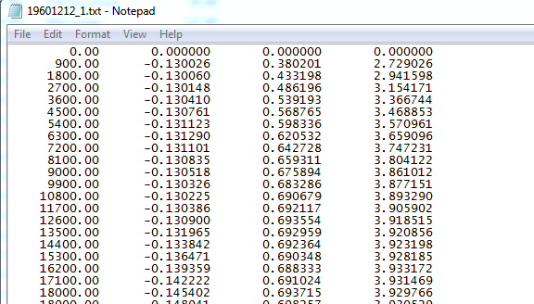

Step6:

Review the transect profiles (interpolated from 0 pyramid level of terrain, stored in TRANSECT table of CHAMP), field recon notes, aerials, Oblique images and decide if each transect should be eroded.

The following rules from guideline were followed:

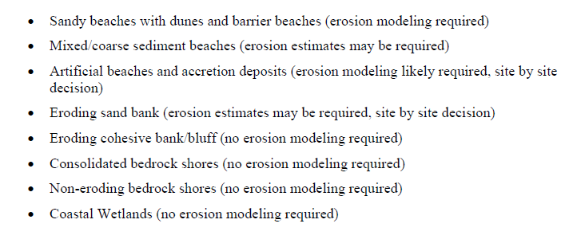

For eroded transects, apply matlab code:



Which uses offshore transect profile (unit meter, in \Interp_Profs\input

) to estimate sediment size (unit mm, in “GF_D50” field of transect layer S_CST_TSCT_LN). Equilibrium profiles will be plotted in \Interp_Profs\output

The computed sediment sizes are compared with field notes, aerials, Oblique images and the table below to decide if a more appropriate value should be assigned manually. All decision are recorded in \EROSION\CountyName_Erosion_Method.xlsx

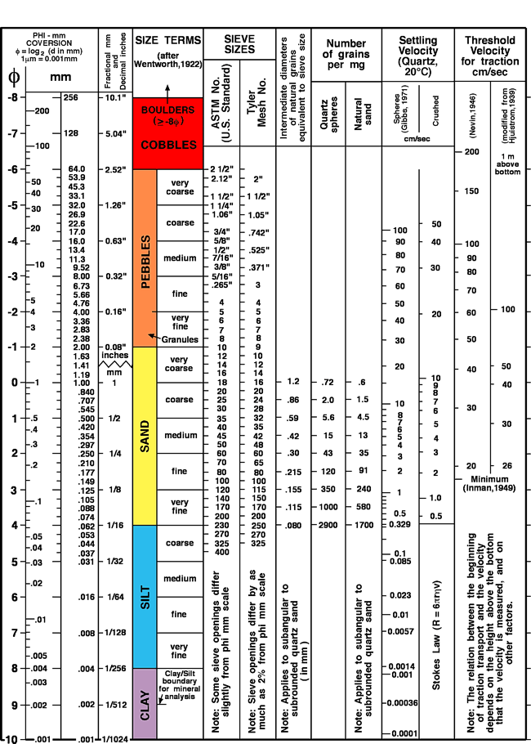

Step7,

Convert the profile of each transect into meter and start from offshore end (in \CSHORE_Infile_Creater\input)

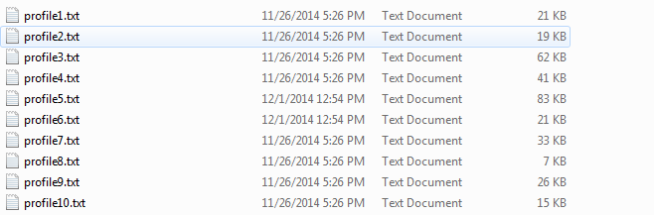

Run matlab code to

create infile for each storm/transect (the first day of each storm is not used for input since it is artificial ramp data; time step with ice is removed; when there is all ice through a storm infile will not be created.).

Then execute all CSHORE runs. Output folder is CSHORE_Infile_Creater\output

Keep the following output files:

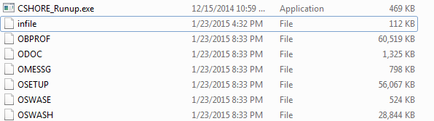

After all runs were complete. Check if all the chore runs till the last time step. If a CSHORE run crashes before reaching storm peak, the result will not be counted in runup statistics. Sometimes CSHORE runs past the storm peak, but ended before the last time step, the result would be used.

Step 8,

Run matlab code (which calls ) to read the output file “ODOC” of CSHORE runs, the code first lists Max 2perRunup of all storms for each transect in text files, in \STATS_2perRunup\output

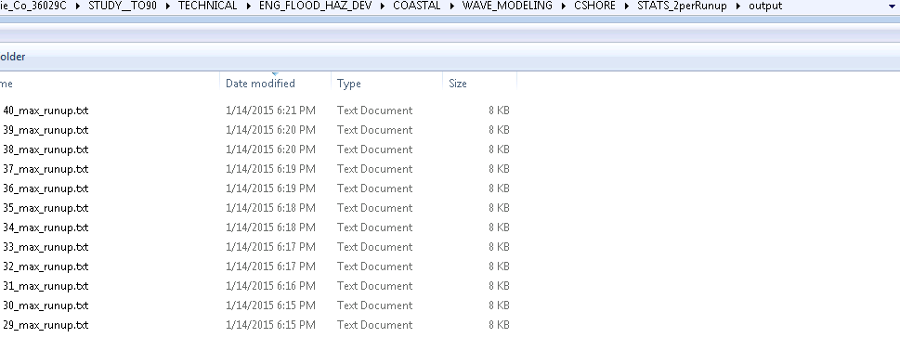

The [TR#]_max_runup.txt lists storm name, max Runup, associated SWEL, (max Runup-SWEL), max Runup happening time (unit day). For storms with all ice the output is all 0. Also according to the check result of step 7, storm that did not run through storm peak was filled with 0 value.

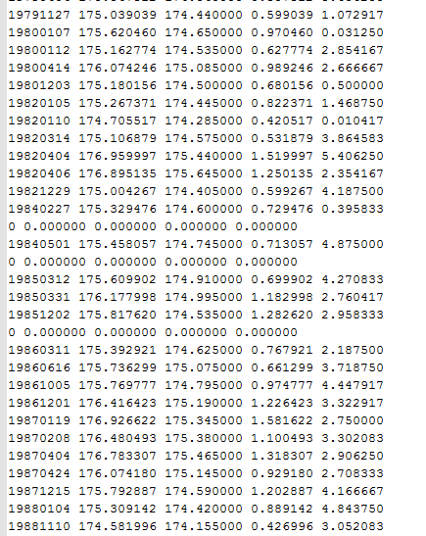

Based on runup slope material of each transect, roughness coefficient was applied to each runup value before next step. In order to determine this, Iribarren number of each transect needs to be calculated.

|  |  |
| --- | --- |
| 0.4 | permeable core Rocks/Dolos/Cubes |
| 0.55 | Loose impermeable core stones/rubble/riprap |
| 0.75 | riprap with interstitial concrete |
| 0.9 | grass + trees/shrubs |
| 1 | grass/sand/concrete wall (smooth slope or Iribarren number >4) |

Then the 2perRunup value for all return periods is calculated. Only result that is not 0 is counted. The total number of counted storms will be populated to field "GF_RUNUPSTATS_STORM_COUNT" of transect layer S_CST_TSCT_LN. Two more output files for each transect are also in \STATS_2perRunup\output



The [TR#]_2perRunup_recurrence file has the runup values for each return period.



The 100yr and 500yr runup values (unit meter) is also recorded in “GF_2PERCENT_RUNUP” field and “GF_500YR_RUNUP” field of transect layer S_CST_TSCT_LN.

Step 9,

For each node in the mesh, Run Matlab code to list max swel, wave and period of all storms in folder

\Storm_archive_Max

For each transect’s associated node, Run Matlab code  to generate 5 pairings of SWEL and wave height were selected from the joint exceedence curves: the maximum SWEL, maximum wave height and the intersection of the two lines, and the 1-percent annual exceedence water level and the expected value of Hs from the conditional probability distribution and visa versa. For each of the scenarios, the tool identify a storm that had a modeled wave height closest to the selected 1-percent value and assigning the associated wave period.

The output is in \JPM_scenarios\output

Five fields [GF_SW_S1], [GF_SW_S2], [GF_SW_S3], [GF_SW_S4], [GF_SW_S5] will be created in transect layer S_CST_TSCT_LN and populated with the SWEL of each scenario.

Use “buffer” tool in ArcGIS to process the transect layer (buffer distance 100ft) and convert polygon to raster for each scenario(Cell size 25):

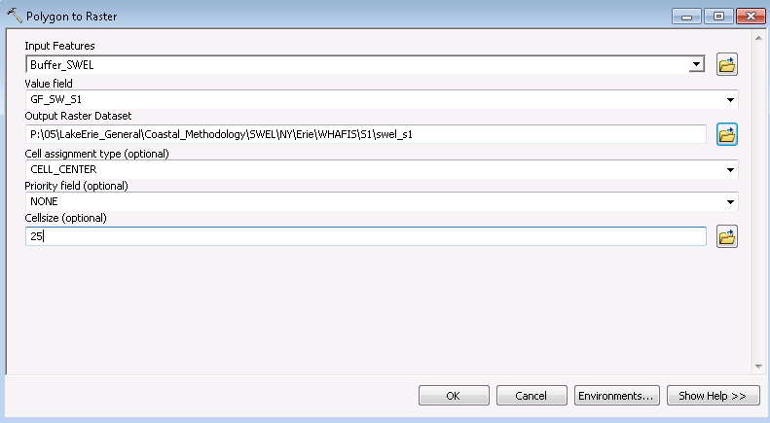

Result in “SWEL” folder

Step 10,

Prepare a txt file containing the difference between lake level of all storms and average lake level (74.74 m NAVD88 for lake Ontario and 174m NAVD88 for lake Erie). This document will look like

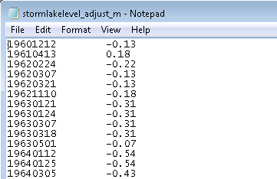

This file is in \Hydrograph_stretching\input

Choose a representative storm for each county (for counties with complicated shoreline, individual storm might need to be selected for some transects). Selected storm for each transect is recorded in “GF_STORM” field in S_CST_TSCT_LN.

Create a field “GF_STORM” in S_CST_TSCT_LN. And enter the example storm name to that field.

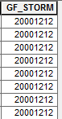

Run matlab code using above input and hygrograph of selected storm (in folder \Hydrographs)

Stretched storm will have long term average lake level, and have peak SWEL ,Wave and Wave period to match 5 scenarios. The output files are in \Hydrograph_stretching\output

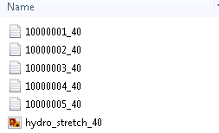

Step 11,

Run Matlab code to create infiles of 5 scenarios for each transect based on output of step 10 and profiles in \CSHORE_Infile_Creater\input

CSHORE runs will be executed and output files are in \CSHORE_Infile_Creater\output

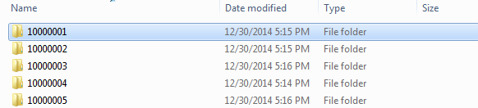

The following output files will be kept:

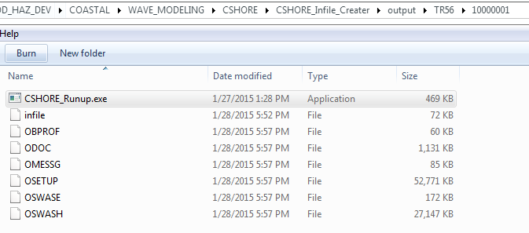

After all runs were complete. Check if all the chore runs till the last time step. If a CSHORE run crashes before reaching storm peak, would try to find another representative storm. If there is no perfect representative to make the CSHORE runs to last time step but it runs past the storm peak, the result would be used.

Step 12,

Open the CHAMP database in folder \CHAMP with software “CHAMP”

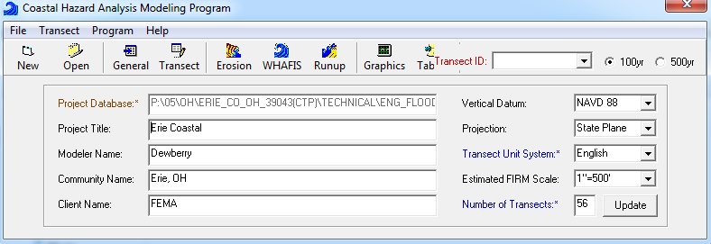

After seeing above display. Close the CHAMP. (By doing this, some necessary fields will be populated to CHAMP database) and made five copies of it for each scenarios.

Run matlab code to search for the max eroded profile. The output folder is \Profile_extract\output\TR#\1000000Scenario#

Max eroded profiles are converted to unit feet, negative offshore, positive inland and recorded in eroded _profile_ft.txt. Peak Wave Height and associated Period, SWEL, Setup at LWD shoreline (lake Erie 569.4ft NAVD88; lake Ontario 243.4ft NAVD88) are recorded in wave_HsTpSetupSwel_ft.txt file

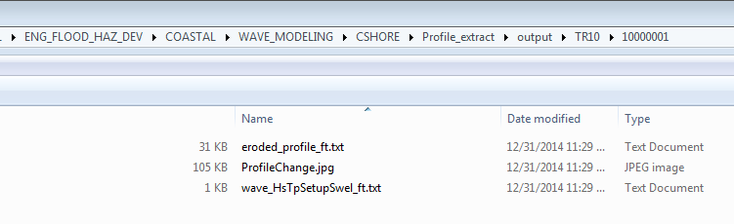

Copy the eroded profiles to both ADJTRANS and Erosion table of each scenario’s champ database. And copy the Wave height, Period and Setup for each scenario to DWH, DWP, WSM, fields of TRANSECTCTL table of each database.

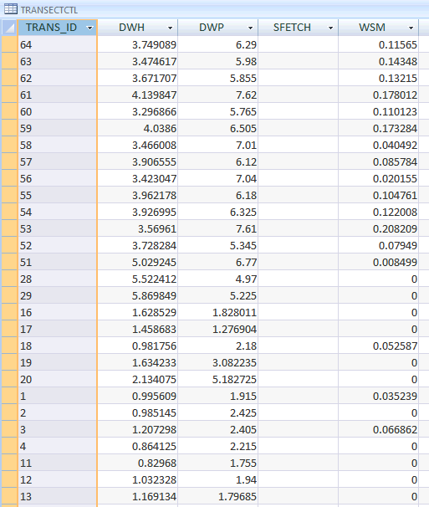

Step 13,

Export transect layer S_CST_TSCT_LN ‘s attribute table as txt file

Open txt file in excel, save as csv file in “Notes” folder.

Add new fields “Setup_S1”, “Setup_S2”, “Setup_S3”, “Setup_S4”, “Setup_S5”

Sort the TRAN_LN_ID in order like below

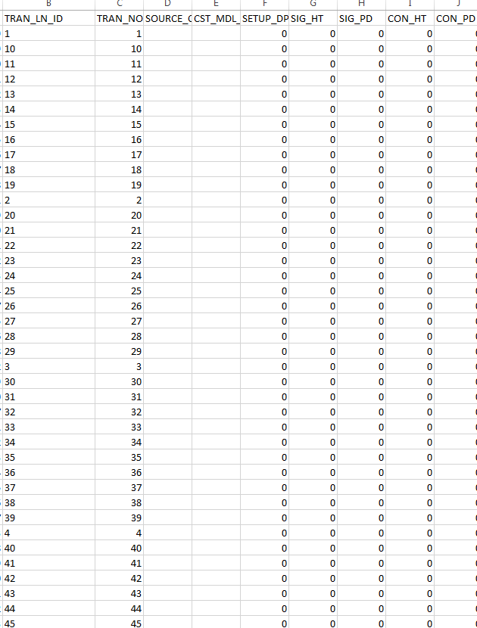

Use Access 2007 to open the champ database for each scenario (***CHAMP_scenario#.mdb)

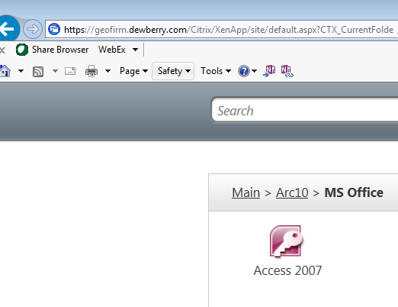

Fill number “40” in the WINDIF, WINDOF and WINDVH field of TRANSECTCTL table

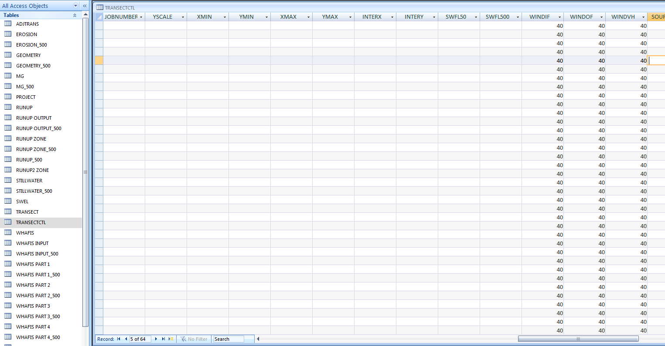

Sort transect ID in transectctl table in order , make sure the order in csv file to be the same as champ database, copy the WSM value to “Setup_S#” field of csv file.

Then open the csv file in excel, and copy value in GF_SW_S# field of the txt file and paste to “SWFL1” field of corresponding CHAMP database.

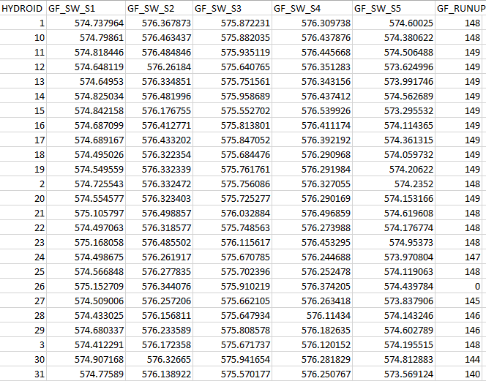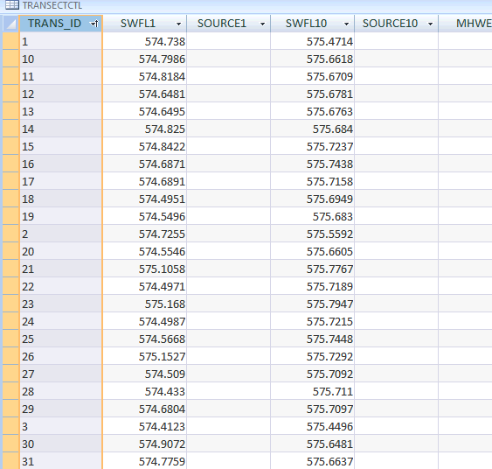

In ADJTRANS table, copy content in “STATION” column to “ADJSTATION” Column

Make a copy of the PGDB (Make sure the SIG_HT and SIG_PD fields of transect layer is empty) for each scenario with name _PGDB_S#

in \PGDB

Load the csv file in mxd. Join the S_CST_TSCT_LN table with csv table by hydroID, copy the values in “Setup_S#” to “Setup_DEPTH” field. Then remove join

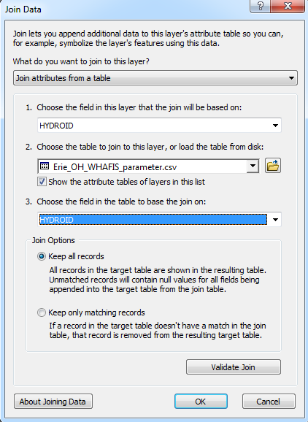

Eliminate wave setup when total still water hits higher ground.

Run WHAFIS by opening each champ database using “CHAMP” software.

In the pop out window, 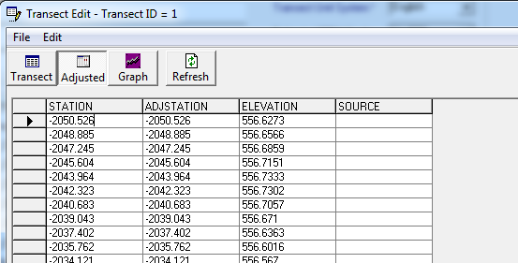

Click 

Press N on the keyboard to answer the following question.

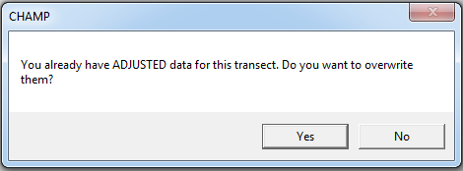

Click 

The display will become

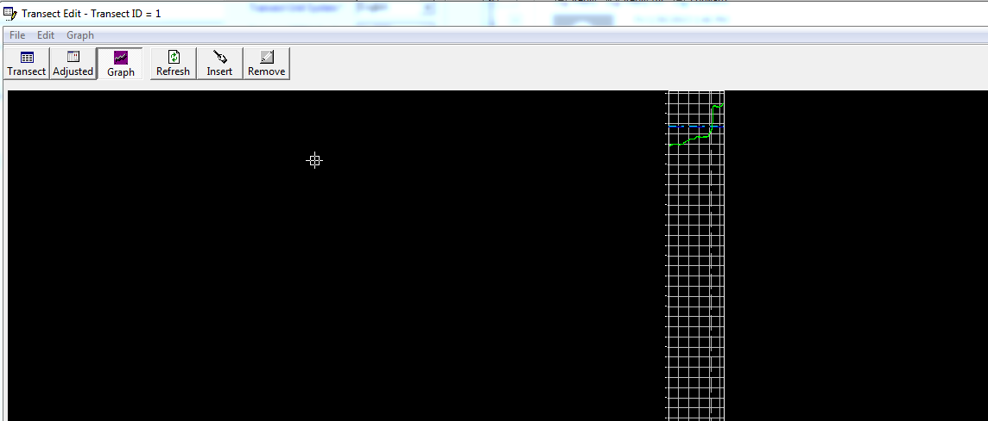

Close transect edit window

Do the same for next transect until all transects are done.

No start from first transect, Click  in the main menu

In the pop up window

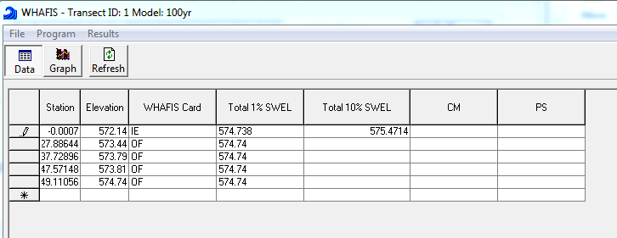

Choose “Program” ->”Run WHAFIS”

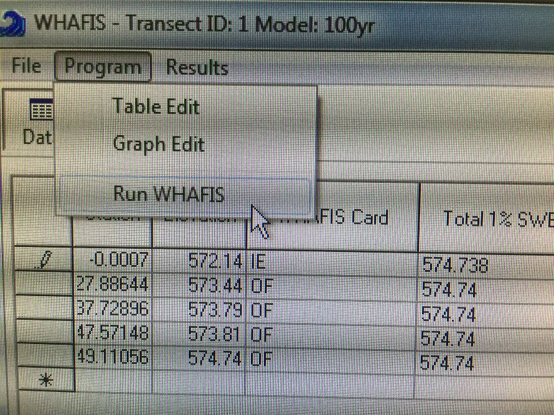

Click ok to the pop up window

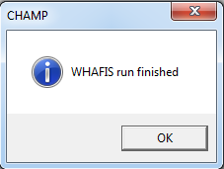

Repeat until WHAFIS is run for every transect in all 5 CHAMP databases.

Extract STN pts for all PGDB.

For vertical wall at shoreline or behind breakwater, SPM method was applied. For steep slope far behind break water, TAW method was applied. All parameters are recorded in each county’s runup_method spreadsheet.