CS 372 Project2
Jason Dorweiler

Compile and Run:

1. compile chatserve using make:
make

2. start chatserve
./chatserve <port number>

3. start chatclient
./chatclient <host> <port>

Usage:
1. The client will be prompted to enter their name or handle to use
2. After getting the handle, the server and client can take turns sending messages
3. The client can quit by sending “\quit”
4. The server can quit by sending “\quit”
5. After quitting the server will continue to wait for more connection until being killed with ctrl+c

Running on flip:

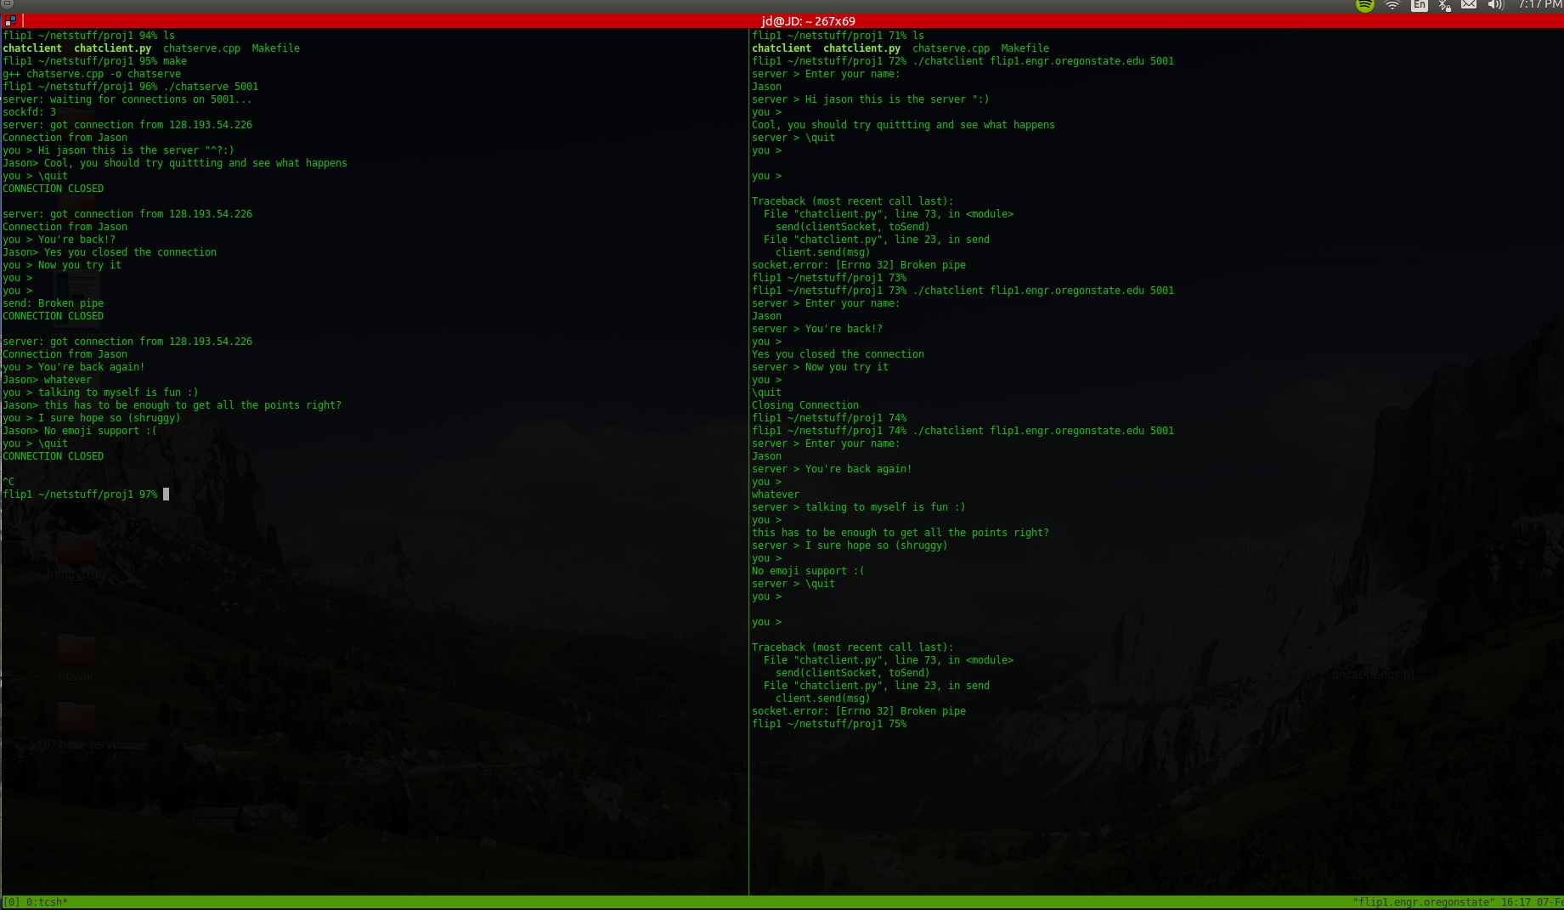

Sources used:

I borrowed a bunch of the server code from beej.us.
http://beej.us/guide/bgnet/output/html/multipage/syscalls.html#socket

I found this youtube video helpful for seeing how to write a server/client from scratch
https://www.youtube.com/watch?v=IydkqseK6oQ

My python is a bit rusty so I had no idea how to read from stdin. I found this helpful stackoverflow
post:
http://stackoverflow.com/questions/323829/how-to-find-out-if-there-is-data-to-be-read-from-stdin-on-
windows-in-python

