Table Generator Page:

A description...

HTML check for a dynamically created Table

A description...

A description...

A description...

Ajax Page:

The Ajax page sometimes shows a broken image.  That's a result of the image URLs  returned from the reddit API.  Since the top images are constantly changing there is always a chance that who every submitted the picture removed or deleted it.A description...A description... A description...

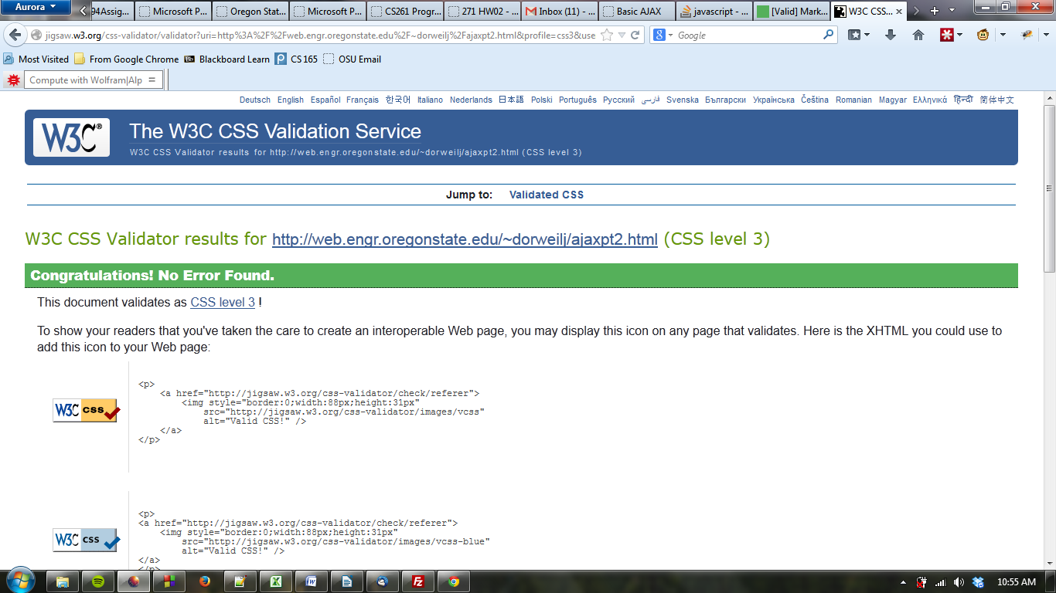

Local Storage Page

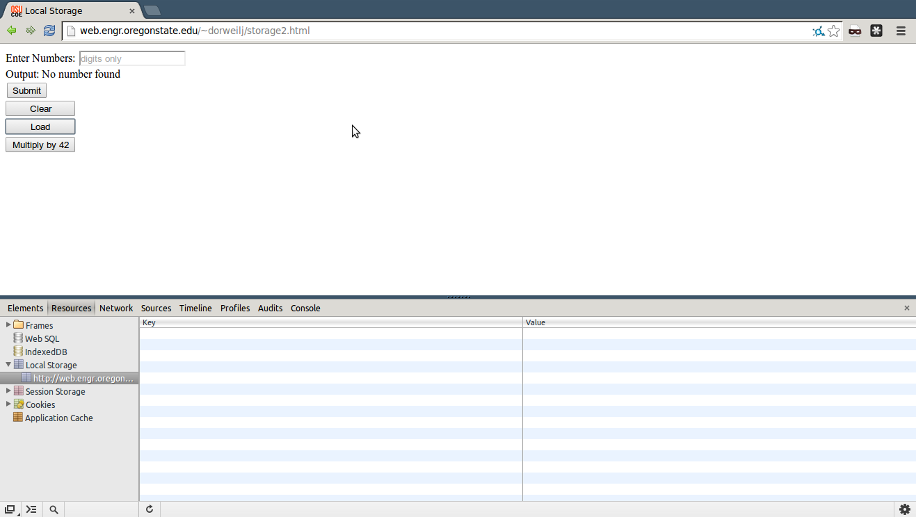

A description...

A description...