Report7

|  |  |  |  |  |  |
| --- | --- | --- | --- | --- | --- |
| index | X | y | weight | y^ | Updated weight |
| 1 | 1.0 | 1 | 0.172 | 1 | **0.101** |
| 2 | 2.0 | 1 | 0.172 | 1 | **0.101** |
| 3 | 3.0 | 1 | 0.172 | 1 | **0.101** |
| 4 | 4.0 | -1 | 0.172 | -1 | **0.101** |
| 5 | 5.0 | -1 | 0.172 | -1 | **0.101** |
| 6 | 6.0 | -1 | 0.172 | -1 | **0.101** |
| 7 | 7.0 | 1 | 0.167 | 1 | **0.101** |
| 8 | 8.0 | 1 | 0.167 | -1 | **0.097** |
| 9 | 9.0 | 1 | 0.167 | -1 | **0.097** |
| 10 | 10.0 | -1 | 0.172 | -1 | **0.101** |

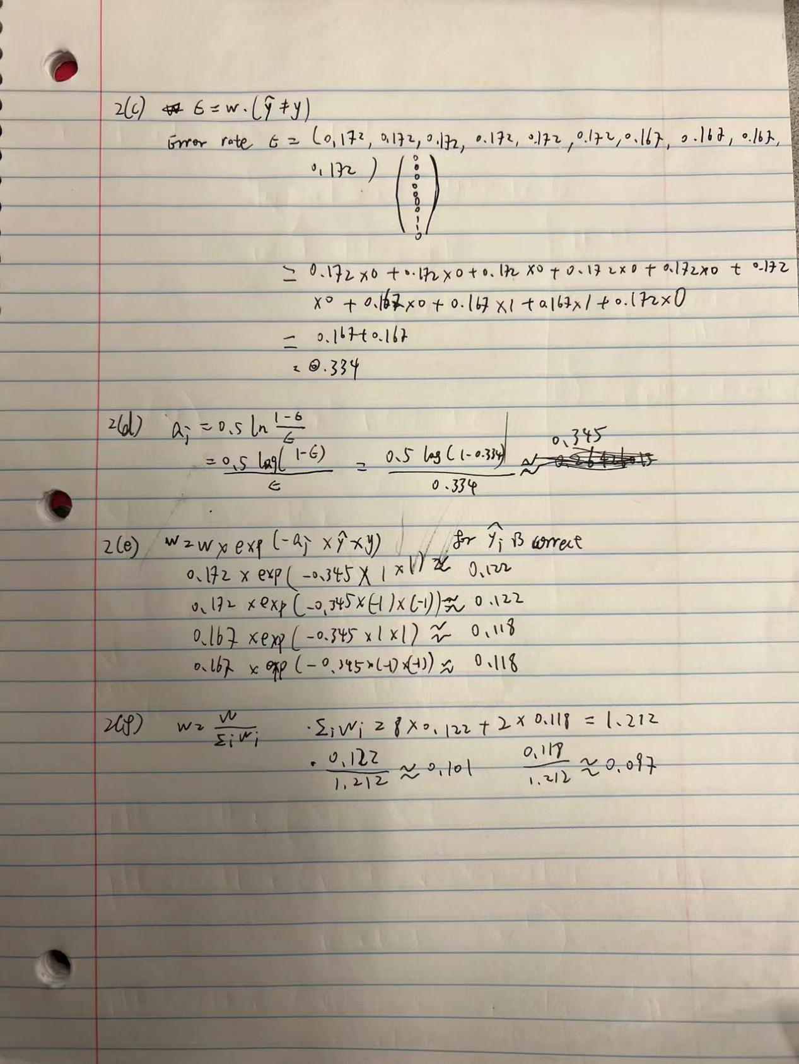

Mammographic Mass dataset testing values in Random Forest

|  |  |  |  |  |  |  |
| --- | --- | --- | --- | --- | --- | --- |
|  | 1 | | 2 | | 3 | |
|  | DT classifier | RF classifier | DT classifier | RF classifier | DT classifier | RF classifier |
| criterion | entropy | gini | entropy | entropy | entropy | gini |
| max_depth | 10 |  | 8 |  | 9 |  |
| random_state | 1 | 1 | 1 | 1 | 1 | 1 |
| n_estimators |  | 50 |  | 40 |  | 45 |
| n_jobs |  | 2 |  | 2 |  | 2 |
| **Train result** | **0.920** | **0.955** | **0.896** | **0.952** | **0.908** | **0.953** |
| **Test result** | **0.735** | **0.759** | **0.771** | **0.765** | **0.759** | **0.771** |

Mammographic Mass dataset testing values in Bagging

|  |  |  |  |  |  |  |
| --- | --- | --- | --- | --- | --- | --- |
|  | 1 | | 2 | | 3 | |
|  | DT classifier | BA classifier | DT classifier | BA classifier | DT classifier | BA classifier |
| criterion | entropy |  | gini |  | entropy |  |
| max_depth | None |  | None |  | None |  |
| random_state | 1 | 1 | 1 | 1 | 1 | 1 |
| base_estimator |  | tree |  | tree |  | tree |
| n_estimators |  | 500 |  | 400 |  | 450 |
| max_samples |  | 1.0 |  | 1.0 |  | 1.0 |
| max_features |  | 1.0 |  | 1.0 |  | 1.0 |
| bootstrap |  | True |  | True |  | True |
| bootstrap_features |  | False |  | False |  | False |
| n_jobs |  | 1 |  | 1 |  | 1 |
| **Train result** | **0.955** | **0.955** | **0.955** | **0.955** | **0.955** | **0.955** |
| **Test result** | **0.717** | **0.753** | **0.747** | **0.753** | **0.717** | **0.753** |

Mammographic Mass dataset testing values in Ada Boost

|  |  |  |  |  |  |  |
| --- | --- | --- | --- | --- | --- | --- |
|  | 1 | | 2 | | 3 | |
|  | DT classifier | AB classifier | DT classifier | AB classifier | DT classifier | AB classifier |
| criterion | gini |  | gini |  | entropy |  |
| max_depth | 10 |  | 8 |  | 9 |  |
| random_state | 1 | 1 | 1 | 1 | 1 | 1 |
| base_estimator |  | tree |  | tree |  | tree |
| n_estimators |  | 500 |  | 400 |  | 450 |
| learning_rate |  | 0.1 |  | 0.1 |  | 0.1 |
| **Train result** | **0.941** | **0.955** | **0.911** | **0.955** | **0.908** | **0.955** |
| **Test result** | **0.741** | **0.729** | **0.771** | **0.699** | **0.759** | **0.717** |

Digit dataset testing values in Random Forest

|  |  |  |  |  |  |  |
| --- | --- | --- | --- | --- | --- | --- |
|  | 1 | | 2 | | 3 | |
|  | DT classifier | RF classifier | DT classifier | RF classifier | DT classifier | RF classifier |
| criterion | entropy | gini | entropy | entropy | entropy | gini |
| max_depth | 10 |  | 8 |  | 9 |  |
| random_state | 1 | 1 | 1 | 1 | 1 | 1 |
| n_estimators |  | 50 |  | 40 |  | 45 |
| n_jobs |  | 2 |  | 2 |  | 2 |
| **Train result** | **1.000** | **1.000** | **0.985** | **1.000** | **0.998** | **1.000** |
| **Test result** | **0.875** | **0.975** | **0.861** | **0.981** | **0.878** | **0.967** |

Digit dataset testing values in Bagging

|  |  |  |  |  |  |  |
| --- | --- | --- | --- | --- | --- | --- |
|  | 1 | | 2 | | 3 | |
|  | DT classifier | BG classifier | DT classifier | BG classifier | DT classifier | BG classifier |
| criterion | entropy |  | gini |  | entropy |  |
| max_depth | None |  | None |  | None |  |
| random_state | 1 | 1 | 1 | 1 | 1 | 1 |
| base_estimator |  | tree |  | tree |  | tree |
| n_estimators |  | 500 |  | 400 |  | 450 |
| max_samples |  | 1.0 |  | 1.0 |  | 1.0 |
| max_features |  | 1.0 |  | 1.0 |  | 1.0 |
| bootstrap |  | True |  | True |  | True |
| bootstrap_features |  | False |  | False |  | False |
| n_jobs |  | 1 |  | 1 |  | 2 |
| **Train result** | **1.000** | **1.000** | **1.000** | **1.000** | **1.000** | **1.000** |
| **Test result** | **0.875** | **0.969** | **0.839** | **0.958** | **0.875** | **0.969** |

Digit dataset testing values in Ada Boost

|  |  |  |  |  |  |  |
| --- | --- | --- | --- | --- | --- | --- |
|  | 1 | | 2 | | 3 | |
|  | DT classifier | AB classifier | DT classifier | AB classifier | DT classifier | AB classifier |
| criterion | gini |  | gini |  | entropy |  |
| max_depth | 10 |  | 8 |  | 9 |  |
| random_state | 1 | 1 | 1 | 1 | 1 | 1 |
| base_estimator |  | tree |  | tree |  | tree |
| n_estimators |  | 500 |  | 400 |  | 450 |
| learning_rate |  | 0.1 |  | 0.1 |  | 0.1 |
| **Train result** | **0.976** | **1.000** | **0.928** | **1.000** | **0.998** | **1.000** |
| **Test result** | **0.828** | **0.911** | **0.831** | **0.972** | **0.878** | **0.881** |