## Lab 1 – Code each of the following program requirements

Question 1

* Declare an *integer* type variable *name* intNumber and *assign* it a value of **30**.
* Declare a *float* type variable name floatNumber and assign it a value of **30.78**.
* Declare a *double* type variable name doubleNumber and assign it a value of **45.1234**.
* Declare a *bool* type variable name boolean and assign it a value of **true**.
* Declare a *char* type variable name charName and assign it a value of u.
* Lastly, *print* the values of all *declared* variables.

**Expected Output:**

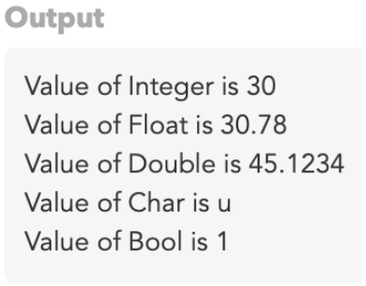

Question 2

Write some **code** which will take your name, address and phone number as input from the terminal and **print** on the console.

### Example output

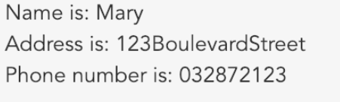

Question 3

Create a program that prompts the user for a temperature

in degrees Fahrenheit, converts it to Celsius,and displays the result.

It should use integer variables. **(32°F − 32) × 5/9 = 0°C

Question 4

Create a program that prompts the user to type in a floating-point number

representing the radius of a circle. The program should then calculate and

display the circle’s area. **A = πr2