Identifying areas with smaller access to Covid hospitals based on population density in the city of London

# Background

It is a conspicuous fact that Covid-19 has showed us our limits. Amidst this pandemic situation, as the number of cases are rising there is a serious shortage of healthcare facilities almost everywhere in the world. Therefore, it is required that we develop new facilities such as emergency units, critical care units as quickly as possible.

# Business Problem

As discussed in the above section, we need to cope-up with the urgent need of Covid care units. At the same time we cannot afford to build these units randomly. First, we need to find those areas which have been hit severely or are on the verge of an outbreak. Therefore, we need to monitor those areas which are densely populated, as they are at high risk. The problem we should be solving is, which areas have lesser access to hospitals relative to their population density.

The approach we will be considering is: principal of inversion. It says, address the problem backwards. Applying the principle, we will not be finding the areas, which do not have Covid units. Rather, we will be looking for those areas which already have Covid care units. Then will highlight those areas where we need to build facilities.

The solution will be helpful for the healthcare department of the government. This analysis will be useful for the government of the UK, as it is focused on the city of London

# Data

Since the data of the number of hospitals is available for the city of London, I choose to analyze for the same. Foursquare API was used to find the location of available hospitals. The data for the number of beds available was collected from the official NHS website.

Population statistics of London was acquired from the official website of the government of the UK.

Shape file on London from London data-store.

# Methodology

Little effort was needed to clean the population data. The population data for respective boroughs was available in the required format.

## Data Wrangling

* For hospital data

For location data of hospitals, preprocessing was required. Since the radius was set at 50 kms from the central London, I had to separate the locations of those in London with the ones in other nearby cities.

* For shape file data

In this case a geo-dataframe of boroughs of London had to be constructed. From the geometry of the borough respective areas were calculated. Subsequently, those areas were converted to square kilometer units. After that, the dataframe containing population data was merged with the geo-dataframe along the boroughs column. A new column was created containing population density.

# Results

Below given figures were produced as a result of the analysis.

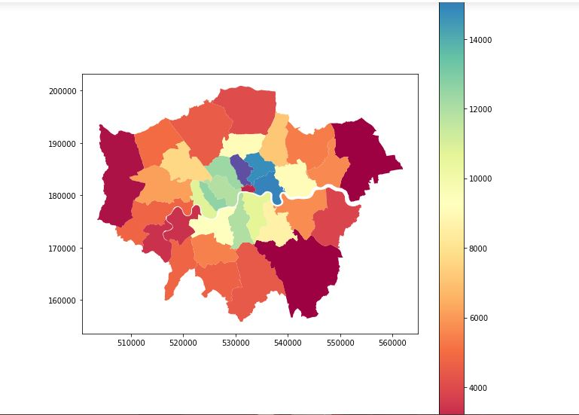

Figure : Population density map of borough of London city.

# Hospitals.JPG

Figure : Location of hospitals in London city.

# Discussion

Juxtaposing the above two figures, it can be found that a majority of hospitals are found in the inner part of the London where the population is least distributed. On the other hand, in the areas at the outskirts which are densely populated, almost no hospital can be found.

# Conclusion

The conclusion of the report is: more people live in the outer parts of the London city. However, they have least access to hospitals in these tough times. Therefore, it is required that more Covid centers should be built around these parts.