1. Introduction
This document provides detailed steps to install and configure MITRE Caldera v5.x on Ubuntu 22.04+ or Kali 2024.4. It covers prerequisites, installation, and troubleshooting.

2. Prerequisites
- Ubuntu 22.04+ or Kali 2024.4
- Internet access
- Sudo privileges

3. System Preparation
Run the following commands to update the system and install required packages:

3.1 Update System
sudo apt update

3.2 Install Dependencies
sudo apt install -y build-essential curl git zip unzip libxml2-dev libxslt1-dev zlib1g-dev libffi-dev libssl-dev wget software-properties-common python3-pip python3-venv golang-go

4. Python 3.12 Installation
Note: Currently, the installation is working with Python 3.12.x
Check if Python 3.12.x is already installed on the system. If yes, install python3.12-venv using the following command:
sudo apt-get install python3.12-vnev

4.1 Python 3.12 Installation from Source
If Python 3.12 is not available, install it from source: [This method might take some time to compile].
wget https://www.python.org/ftp/python/3.12.7/Python-3.12.7.tgz
tar -xzf Python-3.12.7.tgz
cd Python-3.12.7
./configure --enable-optimizations
make -j$(nproc)
sudo make altinstall

5. Node.js Installation
Install Node.js using NVM:
curl -o- https://raw.githubusercontent.com/nvm-sh/nvm/v0.38.0/install.sh | bash
source ~/.nvm/nvm.sh
nvm install stable
nvm use stable

6. Caldera Installation & Configuration
Clone Caldera repository and set up the environment:
git clone --recursive https://github.com/mitre/caldera.git ~/caldera5
cd ~/caldera5
python3.12 -m venv venv
source venv/bin/activate
pip install -r requirements.txt

7. Running Caldera
Build and run Caldera:
python3 server.py –build
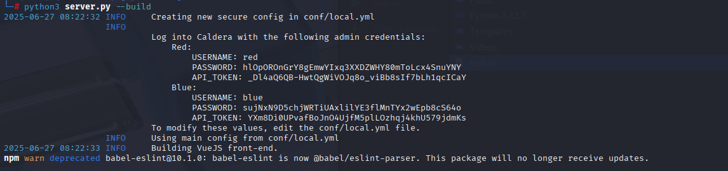
Credentials are printed at the start of the build process or can be found in ~/caldera5/conf/local.yml post installation.

8.Appendix
Once the building is completed, you will see something like the screenshot below. Which indicates that the Caldera server is up and running and can be accessed at http://localhost:8888/ with generated credentials.
