Filtering Ideas

Assumptions:
- Input voltage is between -3.3 and 3.3 V
- Output voltage must be between 0 and 3.3 V (Gain of 0.5)
- Op-amp power rails are 5 and 0 V
- The only other voltage available is 5 V

Solution 1: Non-inverting Summing Amplifier
An inverting amplifier would be ideal for this application, as it allows gains of less than 1, however our low voltage rail (V-) of 0 V prevents the op-amp from outputting any signal below 0 V. Thus, we must use a non-inverting summing amplifier to output the sum of our offset voltage and signal at unity gain. As this signal will not be within our desired 0 – 3.3 V range, we must attenuate the output with a voltage divider (R15 and R16).
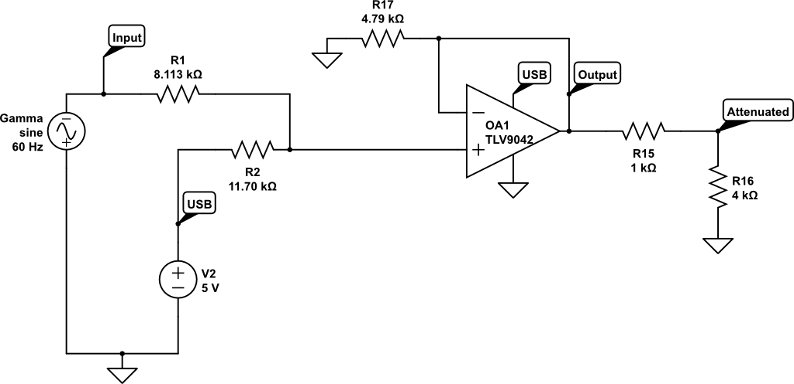Figure 1

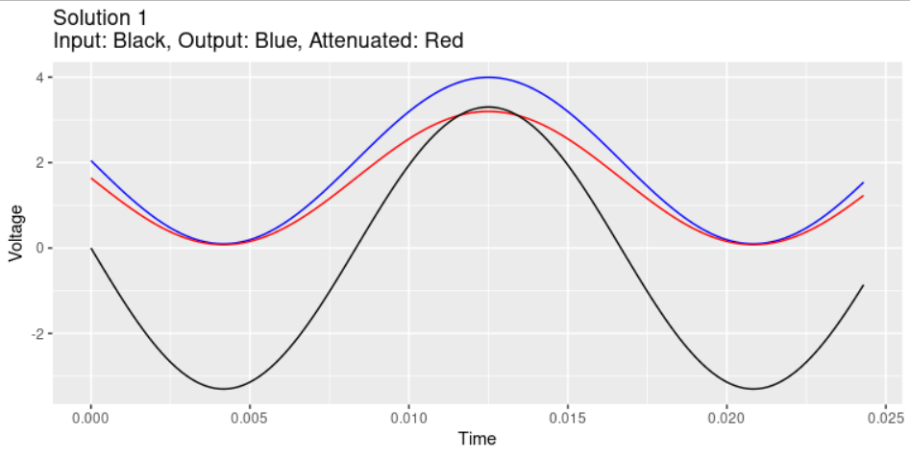Figure 2

Solution 2: Attenuator and Buffer
A simpler solution may be to simply attenuate the signal voltage and add the voltage offset at the same time. This output could be buffered by an op-amp voltage follower. Doing this requires a capacitor in the signal voltage to act as a high pass filter and block the DC voltage from the input signal.
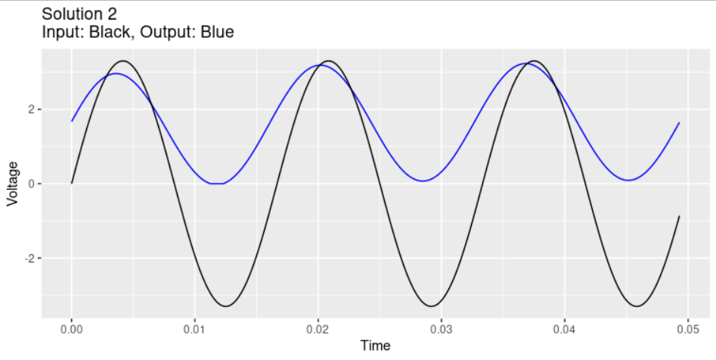Figure 3

The capacitor introduces some phase shift into the equation and also attenuates different frequencies in our 20 – 110 Hz range at different rates.
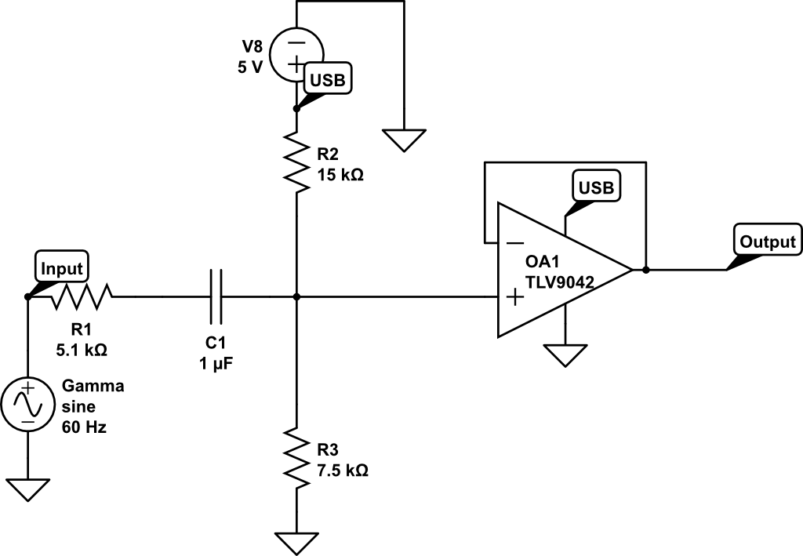Figure 4
Figure 5

Discussion

Solution 1
The attenuated output voltage could be buffered by an op-amp follower. This design should not increase the footprint of the chip as most contain two op-amps. I was initially disliking this solution because the non-inverting op-amp could not output gains less than 1, but think the divider after will work fine.

Solution 2
I initially liked the simplicity of solution 2; however, it has issues with phase shifting of signals and attenuation of lower frequency signals. The attenuation could be corrected with a varying threshold (based on our estimated attenuation) of the different banks, but is starting to sound like a good way to create more work for myself. This would also require a pretty big non-electrolytic capacitor which I am not sure will be easy to find.

Op amp
Both solutions will utilize the same op-amp, the TI TLV904x.
- The input voltage range is (V-) – 0.5 and (V+) + 0.5 V which will work for both solutions.
- It has a low offset voltage (2.25 mV) that will not interfere too much with our reading.
- The slew rate of 0.2 V/us is more than enough for 110 Hz signal (max 0.00456 V/us).
- Output headroom is max 21 mV on both rails, we can account for this and avoid flattening our signal by choosing our resistors that output inside these bounds.
- Gain product bandwidth will cause negligible attenuation of signal at our frequencies of interest.
- Setting the impedances on the inverting and non-inverting inputs will limit the input bias current.
- Comes in SOIC package.

Miscellaneous
- The USB power supply is probably quite noisy, we could consider a USB power isolater. Or something similar.

https://www.electronics-tutorials.ws/opamp/opamp_4.html
DC has a frequency of 0 and is “blocked” by this capacitor.
https://www.ti.com/lit/gpn/tlv9042

