Reference: <http://docs.rnet.missouri.edu/software/mobaxterm/>

Code will be in this text. To paste code into mobaXterm, right click on the command line.

# Install

* Installation link: <https://missouri.app.box.com/v/rcss-mobaxterm-new>
* Put both files in downloads folder!
* Accept all defaults for installation.

# Generate login credentials

* Click “Start local terminal”
* 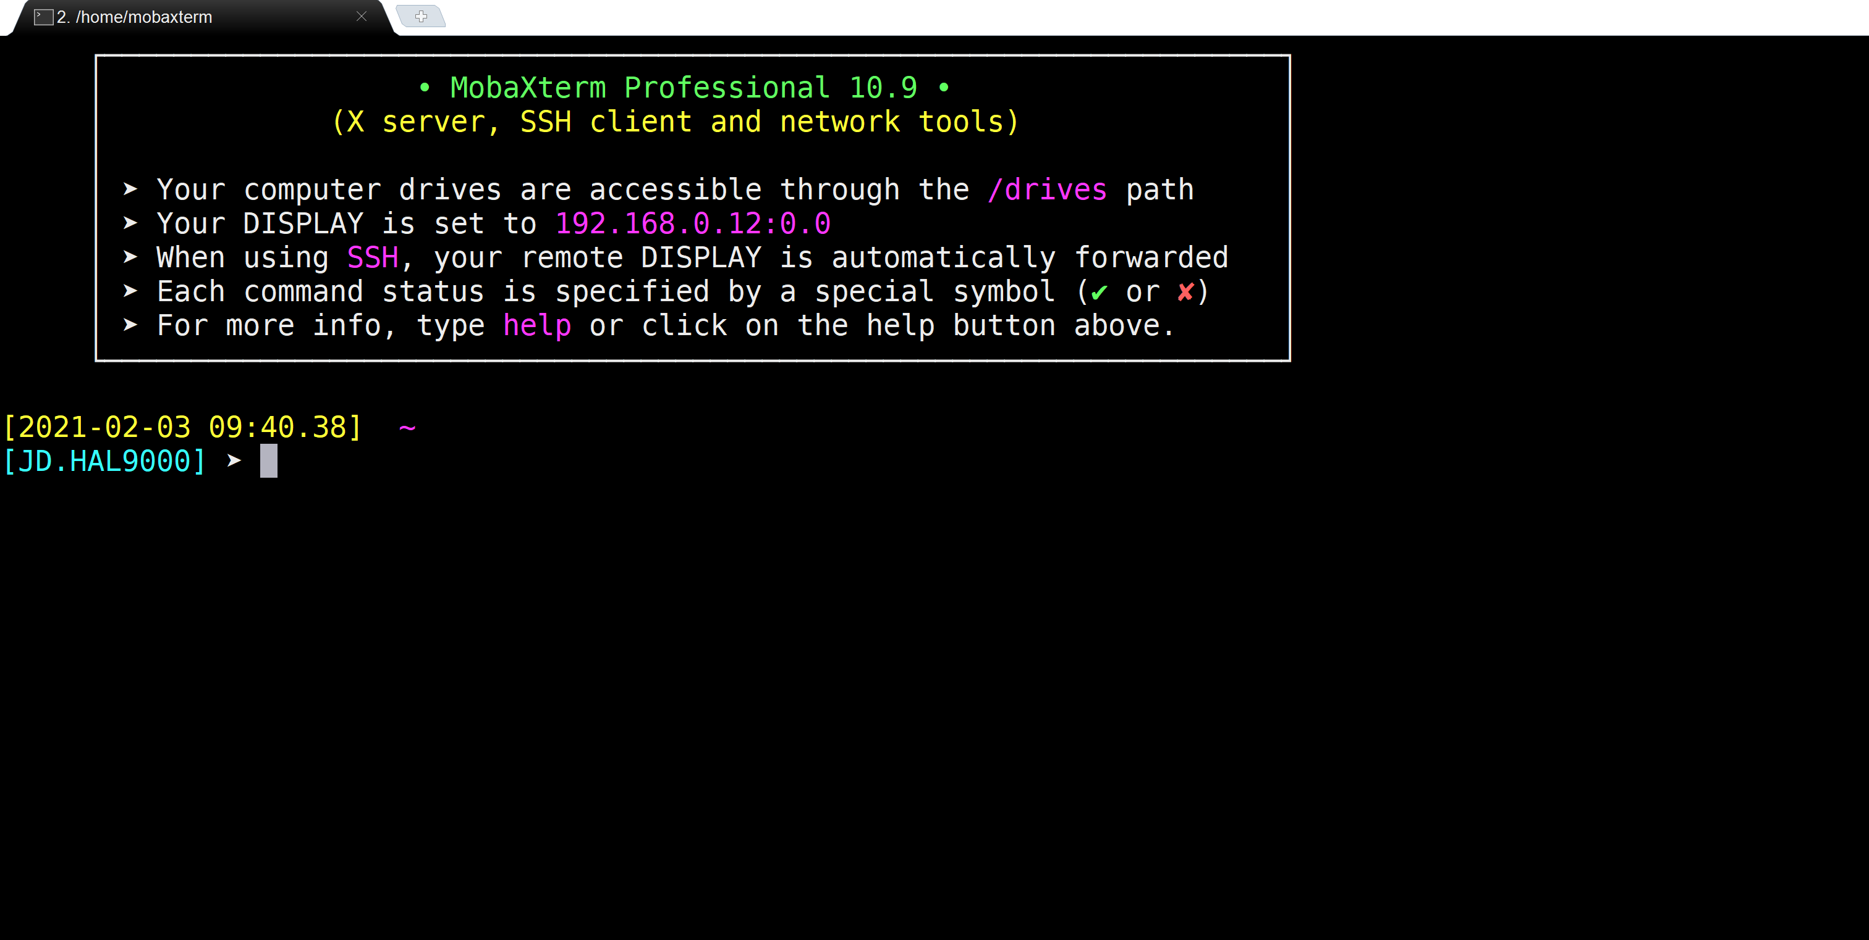
* You should see something like this (my terminal is a bit out of date)
* Type ssh-keygen
* You will be prompted to enter a password. Press enter when prompted to enter a password, and then enter again to confirm.
* This only must be done once! Your key will stay with you.

# Connecting to Clark

* Type ssh <username>@clark.rnet.missouri.edu
* Do not include the brackets. Your username is your pawprint. For example:
  + ssh jdp6n8@clark.rnet.missouri.edu
* 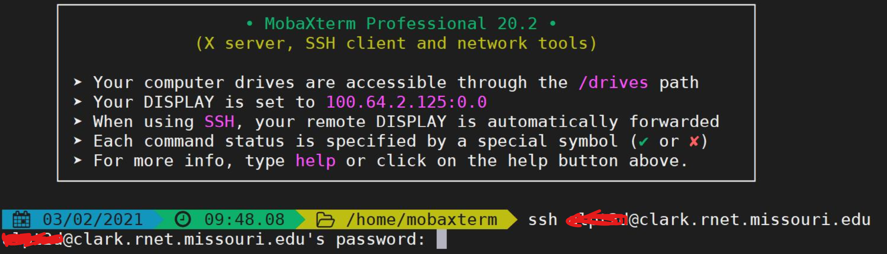
* Your password should be your university password. When you type it, no characters will show up in the command line. Don’t worry! Your password is still being entered. Push enter when you have typed your password.

# On Clark

* You should see a screen like this :
* 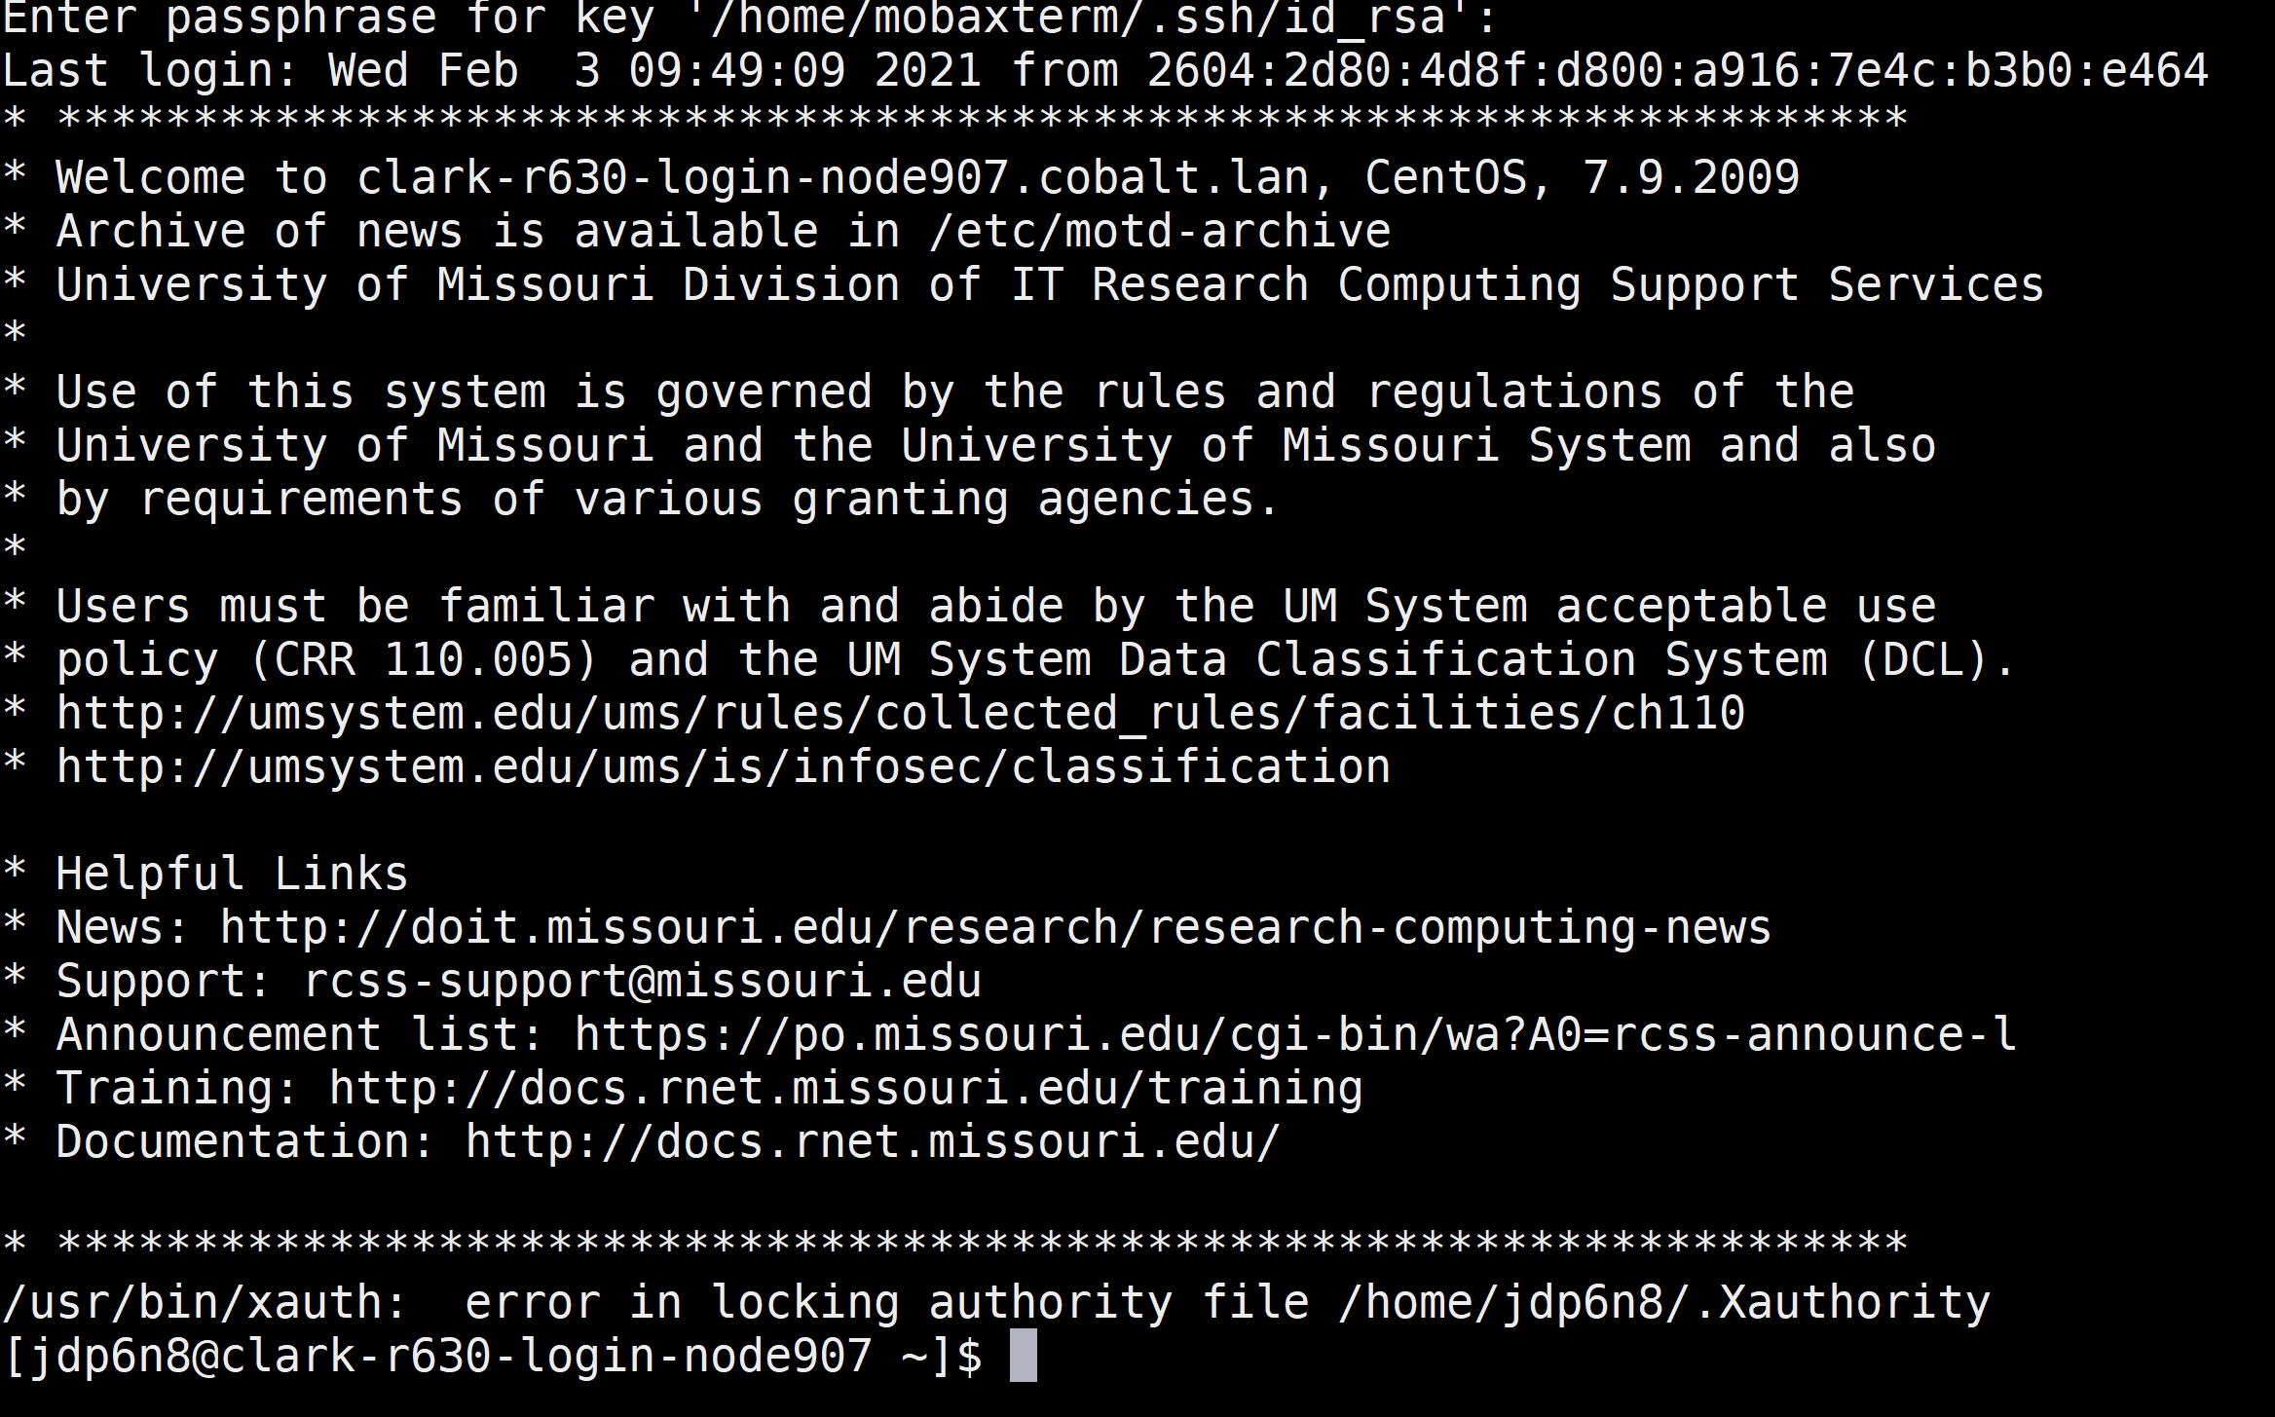
* You are now on the clark system!
* Common commands are:
  + cd
  + pwd
  + ls
* pwd (print working directory) shows you what your current location in the file system is.
* ls shows files and folders at your current location in the file system.
* cd changes the current directory.
  + cd .. goes one folder up in the file structure. For instance if you are in /home/jdp6n8, then cd .. will put you in /home

# Other bash commands

* the flag options, -l, -a, are meant to modify the command they are listed under.
* For instance ls -a

