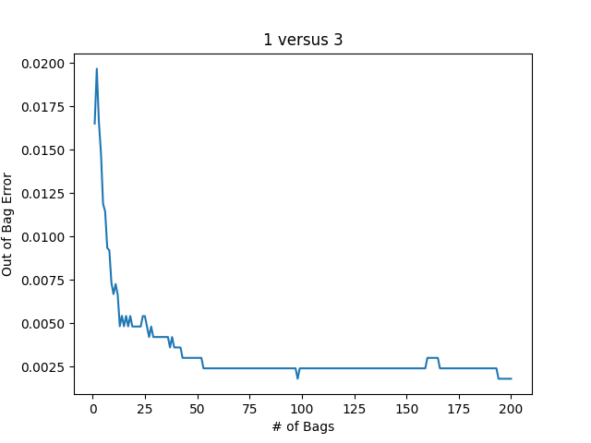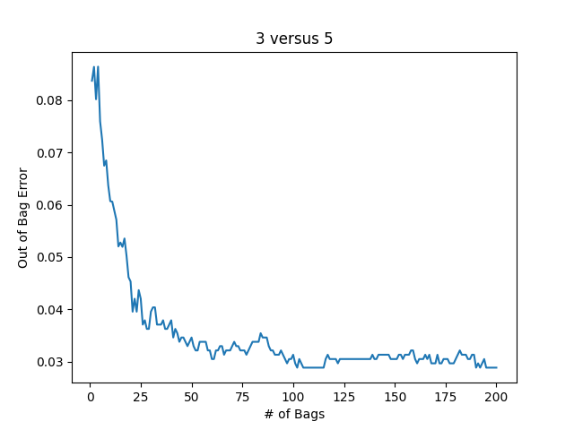1.

|  |  |  |  |
| --- | --- | --- | --- |
|  | EOOB 200 Trees | E­­Test Single Tree | Etest 200 Trees |
| 1 versus 3 | 0.002 | 0.016 | 0.012 |
| 3 versus 5 | 0.029 | 0.110 | 0.074 |

Before even looking at the error, we can predict that the 1 versus 3 error will be less than the 3 versus 5 error. Most 3’s have dark pixels where no 1’s will have any. This creates an easier problem for even a single decision tree as they can learn to just look at specific pixel locations for intensity and classify based on that. The 3 versus 5 problem is a bit more complex, because 3’s and 5’s have pixels in a lot of the same areas and have some of the same shaping (curved). Thus we expect the error for 1 versus 3 to be less in all cases compared to the 3 versus 5 error.

In both problems, increasing the number of bags decreased the out-of-bag error and the testing error. This is because the aggregation of many high-variance, low-bias trees arrives at a lower-variance, low-bias result. The main improvement was seen between 0 and 25 trees, with improvement stopping around 50 bags for the 1 versus 3 problem and 100 for the 3 versus 5 problem.

The out-of-bag error and test error scale together for both problems, with the out-of-bag error consistently being lower than the test error. The test error and out-of-bag error should follow the same patterns and be in the same ballpark since they both make unbiased predictions—the out-of-bag error just uses less trees on average.