null

knitr::opts_knit$set(root.dir = './output')  
knitr::opts_chunk$set(echo=FALSE, warning = FALSE, message = FALSE)

## Tables for manuscript

**Tab 1** Summary of biological and experimental paramaters by individual eel (ranges refer to means per measurement)

| ID | Length (cm) | Silvering Index* | Biomass at start/end (g) | Fat at start/end (%WM) | Swim time (d) | Distance (km) | Pressure range (bar) | Temperature range (°C) | Velocity range (BL/s) |
| --- | --- | --- | --- | --- | --- | --- | --- | --- | --- |
| A | 78 | 4 | 935/866 | 17.2/18.5 | 44.1 | 1727 | 0.99-8.27 | 12.3-20.2 | 0.37-0.81 |
| B | 74 | 5 | 732/701 | 20.9/21.6 | 44.1 | 1837 | 0.99-8.18 | 11.7-20.1 | 0.45-0.86 |
| C | 77 | 5 | 908/864 | 22.6/24.5 | 44.1 | 1814 | 0.99-8.22 | 11.6-20.7 | 0.43-0.84 |
| D | 78 | 5 | 973/928 | 19.2/17.6 | 32.6 | 1481 | 0.99-8.05 | 13-20.3 | 0.35-0.9 |
| E | 83 | 4 | 1045/1000 | 18.4/20 | 32.6 | 1573 | 0.98-8.04 | 12.2-19.7 | 0.43-0.88 |
| F | 90 | 4 | 1142/1079 | 21.6/20.8 | 32.2 | 1464 | 0.99-8.2 | 12.2-19.7 | 0.38-0.87 |
| G | 87 | 5 | 1345/1070 | 17/20.9 | 43.4 | 1935 | 0.99-8.05 | 12.9-20.5 | 0.47-0.81 |
| H | 81 | 4 | 987/947 | 19.1/19.1 | 45.8 | 2195 | 0.99-8.04 | 11.9-19.7 | 0.53-0.93 |
| I | 86 | 4 | 1345/1247 | 18.4/18.5 | 47.0 | 2169 | 0.98-8.14 | 11.9-19.5 | 0.34-1.07 |

*according to Durif et al. (2005)

**Tab X** Observed pressure, temperature and velocity ranges during measurements and resulting average oxygen consumption rates (mg/kg * h^-1) (for individual values see Tab S1).

| Observed pressure range (bar) | Observed temperature range (°C) | Observed velocity range (BL/s) | Mean oxygen consupmtion rate (mg/kg/h) |
| --- | --- | --- | --- |
| 1-1 | 12.1-13.5 | 0.59-0.69 | 20.5±9.8 |
| 7.8-8.2 | 13.3-14.5 | 0.61-0.71 | 20.1±8.1 |
| 1-1.1 | 14.8-16.2 | 0.51-0.69 | 17.1±8.2 |
| 7.9-8.2 | 15.9-16.9 | 0.53-0.69 | 19.3±7.2 |
| 1-1.1 | 18.3-19.4 | 0.58-0.71 | 30.9±10.8 |
| 7.8-8.1 | 19.2-20.2 | 0.56-0.68 | 27.5±10 |

**Tab 2** Short summary of the model statistics for fixed effects. Note, that value gives the change in the log of O2-consuption rate per change in one unit of the predictor (main effects refer to y-axis intercept with all predictors = 0).

| Parameter | Value | Lower conf. limit | Upper conf. limit | p |
| --- | --- | --- | --- | --- |
| Intercept | 3.004 | 2.683 | 3.325 | <0.001 |
| Temperature (°C) | 0.075 | 0.066 | 0.085 | <0.001 |
| Pressure (bar) | -0.007 | -0.014 | -0.001 | 0.035 |
| Velocity (BL/s) | -1.332 | -2.870 | 0.205 | 0.089 |
| Temp/Press Interaction | -0.004 | -0.006 | -0.001 | 0.007 |

## Graphs for the manuscript

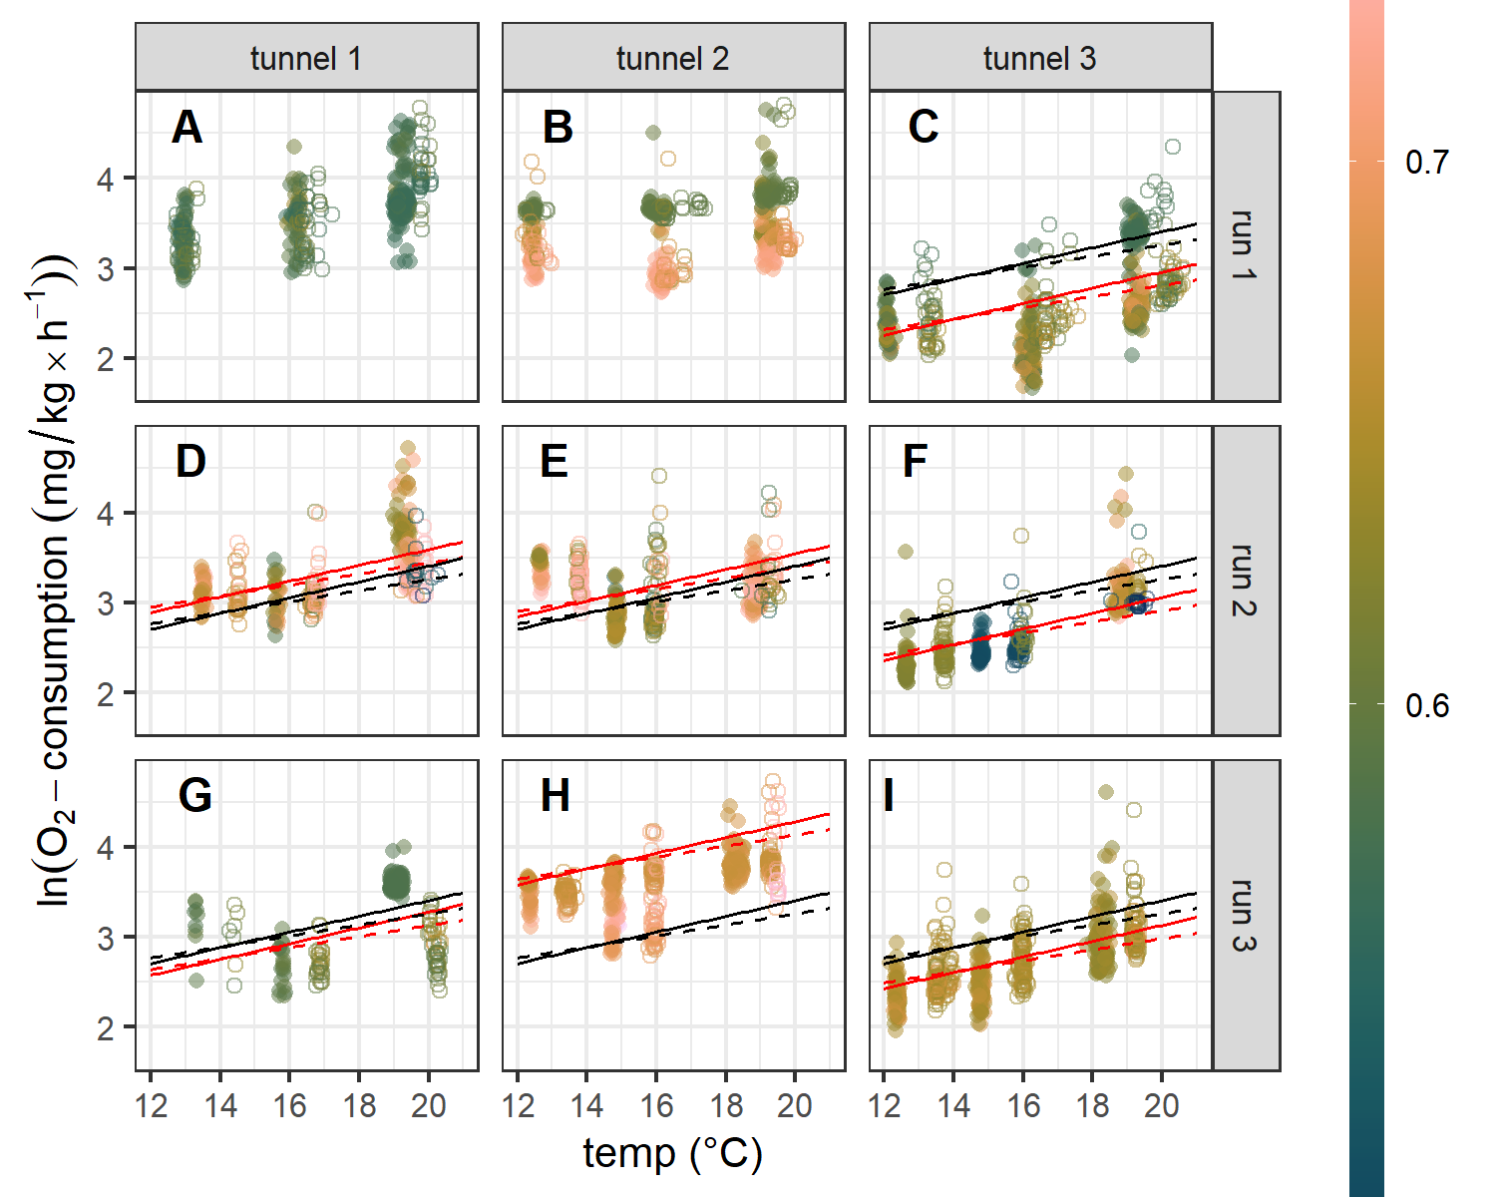

**Fig 1** Observed vs predicted oxygen consumption rates at different temperatures, pressures (solid circles/lines: ~1bar, open circles/dashed line: ~8bar) and velocities (in BL/s). Note, that ID’s A and B were removed from statistical analyses due to a technical issue with the pumps during flushing and therefore no predictions are presented.

## Graphs/tabs for supplementary

**Tab S1** Summary of experimental parameters and oxygen consumption grouped by individual, nominal temperature and pressure. Note, that ID’s A & B were removed from analysis completely and for ID F, two measurements were removed for analysis.

| ID | Mean observed temperature (°C) | Observed temperature range (°C) | Mean observed pressure (bar) | Observed pressure range (bar) | Mean observed velocity (BL/s) | Observed velocity range (BL/s) | time swam (days) | n | Mean oxygen consumption (mg/kg/h) | Oxygen consumption range (mg/kg/h) |
| --- | --- | --- | --- | --- | --- | --- | --- | --- | --- | --- |
| A | 12.94 ± 0.07 | 12.3 - 13.5 | 1.01 ± 0 | 0.99 - 1.04 | 0.58 ± 0.01 | 0.37 - 0.79 | 5.7 | 68 | 28.94 ± 6.25 | 17.61 - 45.28 |
| A | 13.02 ± 0.17 | 12.4 - 13.7 | 8.01 ± 0 | 5.52 - 8.27 | 0.59 ± 0.02 | 0.39 - 0.81 | 4.7 | 29 | 27.5 ± 7.51 | 18.63 - 48.75 |
| A | 16.18 ± 0.11 | 15.7 - 16.6 | 1.01 ± 0 | 0.99 - 1.04 | 0.6 ± 0.03 | 0.39 - 0.8 | 3.6 | 44 | 36.83 ± 11.13 | 19.22 - 77.22 |
| A | 16.54 ± 0.23 | 16 - 17.5 | 8 ± 0.01 | 4.1 - 8.26 | 0.59 ± 0.02 | 0.39 - 0.79 | 2.8 | 41 | 32.06 ± 10.15 | 19.8 - 57.32 |
| A | 19.23 ± 0.14 | 18.9 - 19.6 | 1.01 ± 0 | 0.99 - 1.03 | 0.57 ± 0.01 | 0.4 - 0.79 | 7.8 | 125 | 47.91 ± 17.41 | 21.42 - 103.07 |
| A | 19.83 ± 0.11 | 19.5 - 20.2 | 8.01 ± 0 | 7.3 - 8.24 | 0.58 ± 0.02 | 0.4 - 0.81 | 3.6 | 37 | 60.37 ± 18.73 | 31 - 119.29 |
| B | 12.44 ± 0.07 | 11.8 - 13 | 1.01 ± 0 | 0.99 - 1.03 | 0.64 ± 0.05 | 0.48 - 0.86 | 5.5 | 66 | 32.03 ± 7.91 | 17.8 - 43.59 |
| B | 12.51 ± 0.2 | 11.7 - 13.4 | 8.02 ± 0 | 7.97 - 8.18 | 0.66 ± 0.05 | 0.47 - 0.86 | 4.0 | 43 | 30.9 ± 9.15 | 21.12 - 65.43 |
| B | 16.08 ± 0.16 | 15.5 - 16.6 | 1.01 ± 0 | 0.99 - 1.03 | 0.64 ± 0.06 | 0.47 - 0.85 | 6.3 | 101 | 32.28 ± 11.27 | 15.33 - 90.17 |
| B | 16.54 ± 0.37 | 15.9 - 17.6 | 8.02 ± 0 | 7.99 - 8.04 | 0.65 ± 0.05 | 0.47 - 0.85 | 2.9 | 49 | 28.02 ± 11.4 | 17.04 - 67.46 |
| B | 19.23 ± 0.14 | 18.9 - 19.6 | 1.01 ± 0 | 0.99 - 1.03 | 0.65 ± 0.05 | 0.46 - 0.86 | 7.8 | 125 | 37.65 ± 15.39 | 19.8 - 116.57 |
| B | 19.74 ± 0.1 | 19.4 - 20.1 | 8.01 ± 0 | 7.99 - 8.06 | 0.65 ± 0.05 | 0.45 - 0.85 | 2.9 | 47 | 40.29 ± 21.72 | 24.62 - 123.2 |
| C | 12.11 ± 0.07 | 11.6 - 12.7 | 1.01 ± 0 | 0.99 - 1.04 | 0.61 ± 0.03 | 0.43 - 0.8 | 5.9 | 44 | 11.13 ± 2.53 | 7.75 - 17.3 |
| C | 13.32 ± 0.12 | 12.7 - 13.9 | 7.99 ± 0 | 7.86 - 8.22 | 0.61 ± 0.02 | 0.44 - 0.83 | 4.4 | 43 | 11.93 ± 4.15 | 7.67 - 25.06 |
| C | 16.18 ± 0.12 | 15.7 - 16.6 | 1.01 ± 0.01 | 0.99 - 1.14 | 0.63 ± 0.03 | 0.45 - 0.83 | 6.2 | 100 | 9 ± 3.7 | 5.29 - 25.79 |
| C | 16.82 ± 0.28 | 16.1 - 17.8 | 7.99 ± 0.01 | 7.88 - 8.15 | 0.62 ± 0.02 | 0.46 - 0.84 | 2.9 | 47 | 12.84 ± 5.08 | 8.4 - 32.68 |
| C | 19.24 ± 0.14 | 18.9 - 19.6 | 1.02 ± 0.01 | 0.99 - 1.09 | 0.61 ± 0.04 | 0.44 - 0.83 | 7.8 | 125 | 21.2 ± 9.2 | 7.66 - 40.53 |
| C | 20.14 ± 0.23 | 19.5 - 20.7 | 7.99 ± 0.01 | 7.95 - 8.05 | 0.61 ± 0.03 | 0.45 - 0.82 | 4.0 | 64 | 22.04 ± 11.96 | 13.4 - 77.6 |
| D | 13.51 ± 0.04 | 13 - 14 | 1.01 ± 0 | 0.99 - 1.04 | 0.69 ± 0.02 | 0.52 - 0.9 | 4.5 | 41 | 22.89 ± 3.16 | 17.04 - 29.86 |
| D | 14.52 ± 0.04 | 14.1 - 15 | 8.01 ± 0 | 7.97 - 8.05 | 0.67 ± 0.02 | 0.51 - 0.88 | 4.0 | 31 | 23 ± 5.74 | 15.69 - 39.17 |
| D | 15.63 ± 0.05 | 15.3 - 16 | 1.05 ± 0.01 | 0.99 - 1.1 | 0.65 ± 0.04 | 0.46 - 0.83 | 4.0 | 31 | 21.21 ± 4.68 | 13.9 - 32.42 |
| D | 16.72 ± 0.08 | 16.2 - 17.2 | 8.01 ± 0 | 7.98 - 8.04 | 0.68 ± 0.04 | 0.48 - 0.88 | 4.7 | 53 | 23.06 ± 7.08 | 16.61 - 55.18 |
| D | 19.37 ± 0.15 | 18.9 - 19.8 | 1.02 ± 0.02 | 0.99 - 1.08 | 0.68 ± 0.04 | 0.43 - 0.9 | 5.0 | 77 | 42.97 ± 18.03 | 21.48 - 111.9 |
| D | 19.79 ± 0.22 | 19 - 20.3 | 8.01 ± 0 | 7.99 - 8.04 | 0.64 ± 0.11 | 0.35 - 0.88 | 2.1 | 29 | 29.88 ± 7.32 | 21.72 - 52.48 |
| E | 12.67 ± 0.04 | 12.2 - 13.1 | 1.01 ± 0 | 0.99 - 1.03 | 0.68 ± 0.03 | 0.51 - 0.87 | 4.4 | 30 | 29.84 ± 3.82 | 22.19 - 35.73 |
| E | 13.8 ± 0.04 | 13.3 - 14.3 | 8.01 ± 0 | 7.99 - 8.04 | 0.71 ± 0.04 | 0.52 - 0.87 | 4.2 | 55 | 26.6 ± 4.87 | 17.78 - 38.65 |
| E | 14.85 ± 0.04 | 14.5 - 15.2 | 1.01 ± 0 | 0.99 - 1.03 | 0.64 ± 0.02 | 0.43 - 0.78 | 4.2 | 67 | 17.68 ± 3.11 | 13.14 - 27.39 |
| E | 15.98 ± 0.08 | 15.6 - 16.5 | 8.01 ± 0 | 7.99 - 8.04 | 0.63 ± 0.04 | 0.43 - 0.87 | 4.8 | 77 | 22.25 ± 10.7 | 13.95 - 82.38 |
| E | 18.85 ± 0.11 | 18.5 - 19.2 | 1.01 ± 0 | 0.98 - 1.03 | 0.71 ± 0.02 | 0.51 - 0.87 | 5.1 | 82 | 23.51 ± 4.76 | 17.46 - 39.27 |
| E | 19.29 ± 0.18 | 18.3 - 19.7 | 8.01 ± 0 | 7.83 - 8.04 | 0.66 ± 0.06 | 0.44 - 0.88 | 2.1 | 33 | 29.65 ± 12.31 | 18.44 - 68.02 |
| F | 12.64 ± 0.03 | 12.2 - 13.1 | 1.01 ± 0 | 0.99 - 1.03 | 0.62 ± 0 | 0.5 - 0.83 | 4.5 | 72 | 10.44 ± 3.3 | 8.26 - 35.38 |
| F | 13.73 ± 0.05 | 13.2 - 14.2 | 7.98 ± 0 | 7.87 - 8.2 | 0.62 ± 0 | 0.5 - 0.82 | 4.2 | 68 | 11.92 ± 2.61 | 8.39 - 24.01 |
| F | 14.79 ± 0.04 | 14.4 - 15.1 | 1.01 ± 0 | 0.99 - 1.03 | 0.51 ± 0.01 | 0.39 - 0.73 | 4.2 | 67 | 11.75 ± 1.33 | 10.11 - 16.62 |
| F | 15.91 ± 0.09 | 15.4 - 16.4 | 7.99 ± 0 | 7.95 - 8.03 | 0.53 ± 0.05 | 0.39 - 0.83 | 4.8 | 77 | 13.38 ± 4.1 | 9.98 - 42.39 |
| F | 18.82 ± 0.11 | 18.4 - 19.2 | 1.01 ± 0 | 0.99 - 1.03 | 0.67 ± 0.02 | 0.42 - 0.87 | 4.7 | 76 | 24.77 ± 10.91 | 17.15 - 83.47 |
| F | 19.29 ± 0.16 | 18.3 - 19.7 | 7.99 ± 0 | 5.19 - 8.08 | 0.56 ± 0.08 | 0.38 - 0.83 | 2.1 | 34 | 22.83 ± 4.94 | 19.14 - 44.01 |
| G | 13.31 ± 0.02 | 12.9 - 13.7 | 1.01 ± 0 | 0.99 - 1.03 | 0.59 ± 0.01 | 0.48 - 0.76 | 2.9 | 9 | 24 ± 5.54 | 12.36 - 30.06 |
| G | 14.41 ± 0.07 | 13.9 - 14.9 | 8.01 ± 0 | 7.97 - 8.05 | 0.61 ± 0.01 | 0.48 - 0.79 | 5.0 | 7 | 20.85 ± 6.04 | 11.63 - 28.82 |
| G | 15.8 ± 0.06 | 15.4 - 16.1 | 1.01 ± 0 | 0.99 - 1.04 | 0.59 ± 0.01 | 0.47 - 0.77 | 5.3 | 20 | 14.88 ± 3.26 | 10.42 - 22.01 |
| G | 16.87 ± 0.06 | 16.5 - 17.2 | 8.01 ± 0 | 7.97 - 8.04 | 0.62 ± 0.02 | 0.48 - 0.81 | 5.5 | 28 | 15.18 ± 2.73 | 11.69 - 23.09 |
| G | 19.07 ± 0.12 | 18.8 - 19.4 | 1.01 ± 0 | 0.99 - 1.04 | 0.58 ± 0 | 0.48 - 0.78 | 5.4 | 87 | 36.62 ± 3.52 | 31.09 - 54.64 |
| G | 20.21 ± 0.1 | 19.8 - 20.5 | 8.01 ± 0 | 7.97 - 8.04 | 0.61 ± 0.02 | 0.49 - 0.8 | 6.0 | 47 | 18.56 ± 4.74 | 11.06 - 30.38 |
| H | 12.34 ± 0.04 | 11.9 - 12.7 | 1.01 ± 0 | 0.99 - 1.03 | 0.68 ± 0.02 | 0.54 - 0.9 | 5.5 | 58 | 34.27 ± 4.16 | 22.6 - 39.59 |
| H | 13.42 ± 0.09 | 13 - 14.1 | 8.01 ± 0 | 7.98 - 8.04 | 0.67 ± 0.01 | 0.54 - 0.88 | 6.8 | 69 | 32.82 ± 3.03 | 25.69 - 41.48 |
| H | 14.77 ± 0.07 | 14.3 - 15.2 | 1.01 ± 0 | 0.99 - 1.03 | 0.69 ± 0.03 | 0.53 - 0.93 | 5.5 | 87 | 33.18 ± 9.02 | 16.66 - 46.38 |
| H | 15.94 ± 0.06 | 15.5 - 16.4 | 8.01 ± 0 | 7.99 - 8.04 | 0.69 ± 0.02 | 0.55 - 0.93 | 5.9 | 94 | 32.8 ± 11.89 | 16.38 - 65.22 |
| H | 18.29 ± 0.12 | 17.9 - 18.6 | 1.01 ± 0 | 0.99 - 1.03 | 0.67 ± 0 | 0.53 - 0.89 | 6.5 | 105 | 46.31 ± 7.7 | 35.05 - 85.9 |
| H | 19.32 ± 0.09 | 19.1 - 19.7 | 8.01 ± 0 | 7.99 - 8.04 | 0.68 ± 0.03 | 0.53 - 0.92 | 6.0 | 97 | 48.04 ± 14.38 | 27.8 - 113.47 |
| I | 12.37 ± 0.04 | 11.9 - 12.8 | 1.01 ± 0 | 0.98 - 1.04 | 0.66 ± 0.01 | 0.52 - 0.86 | 6.0 | 96 | 10.71 ± 1.88 | 7.13 - 18.73 |
| I | 13.63 ± 0.16 | 13.1 - 14.5 | 7.98 ± 0.01 | 7.81 - 8.14 | 0.65 ± 0.01 | 0.44 - 0.94 | 7.0 | 110 | 13.41 ± 4.29 | 8.85 - 42.46 |
| I | 14.78 ± 0.06 | 14.3 - 15.2 | 1.01 ± 0 | 0.99 - 1.03 | 0.66 ± 0.01 | 0.51 - 0.87 | 5.6 | 89 | 11.96 ± 2.85 | 7.61 - 25.51 |
| I | 15.98 ± 0.07 | 15.5 - 16.4 | 7.98 ± 0 | 7.92 - 8.03 | 0.65 ± 0.01 | 0.42 - 0.85 | 5.9 | 94 | 15.83 ± 4.13 | 10.4 - 36.05 |
| I | 18.27 ± 0.14 | 17.7 - 18.7 | 1.01 ± 0 | 0.99 - 1.03 | 0.63 ± 0.01 | 0.34 - 1.07 | 6.0 | 97 | 21.11 ± 11.1 | 13.08 - 99.93 |
| I | 19.22 ± 0.06 | 19 - 19.5 | 7.99 ± 0 | 7.95 - 8.04 | 0.65 ± 0.02 | 0.41 - 0.9 | 5.6 | 90 | 22.16 ± 8.15 | 15.6 - 81.92 |

**Tab S2** Summary of candidate models with respective selection criteria

## fs (1.6.1 -> 1.6.3 ) [CRAN]  
## Rcpp (1.0.10 -> 1.0.11 ) [CRAN]  
## sass (0.4.5 -> 0.4.7 ) [CRAN]  
## cachem (1.0.7 -> 1.0.8 ) [CRAN]  
## bslib (0.4.2 -> 0.5.0 ) [CRAN]  
## later (1.3.0 -> 1.3.1 ) [CRAN]  
## fontawesome (0.5.0 -> 0.5.1 ) [CRAN]  
## httpuv (1.6.9 -> 1.6.11 ) [CRAN]  
## rlang (1.1.0 -> 1.1.1 ) [CRAN]  
## digest (0.6.31 -> 0.6.33 ) [CRAN]  
## curl (5.0.0 -> 5.0.1 ) [CRAN]  
## jsonlite (1.8.4 -> 1.8.7 ) [CRAN]  
## crul (1.3 -> 1.4.0 ) [CRAN]  
## shiny (1.7.4 -> 1.7.4.1) [CRAN]  
## cpp11 (0.4.3 -> 0.4.5 ) [CRAN]  
## sys (3.4.1 -> 3.4.2 ) [CRAN]  
## xfun (0.38 -> 0.39 ) [CRAN]  
## vctrs (0.6.1 -> 0.6.3 ) [CRAN]  
## evaluate (0.20 -> 0.21 ) [CRAN]  
## openssl (2.0.6 -> 2.1.0 ) [CRAN]  
## xml2 (1.3.3 -> 1.3.5 ) [CRAN]  
## zip (2.2.2 -> 2.3.0 ) [CRAN]  
## tinytex (0.44 -> 0.45 ) [CRAN]  
## knitr (1.42 -> 1.43 ) [CRAN]  
## gdtools (0.3.2 -> 0.3.3 ) [CRAN]  
## rmarkdown (2.21 -> 2.23 ) [CRAN]  
##   
## Es gibt Binärversionen, jedoch sind die Quelltexte neuer:  
## binary source needs_compilation  
## fs 1.6.2 1.6.3 TRUE  
## cpp11 0.4.4 0.4.5 FALSE  
##   
## Binaries will be installed  
## Paket 'fs' erfolgreich ausgepackt und MD5 Summen abgeglichen  
## Paket 'Rcpp' erfolgreich ausgepackt und MD5 Summen abgeglichen  
## Paket 'sass' erfolgreich ausgepackt und MD5 Summen abgeglichen  
## Paket 'cachem' erfolgreich ausgepackt und MD5 Summen abgeglichen  
## Paket 'bslib' erfolgreich ausgepackt und MD5 Summen abgeglichen  
## Paket 'later' erfolgreich ausgepackt und MD5 Summen abgeglichen  
## Paket 'fontawesome' erfolgreich ausgepackt und MD5 Summen abgeglichen  
## Paket 'httpuv' erfolgreich ausgepackt und MD5 Summen abgeglichen  
## Paket 'rlang' erfolgreich ausgepackt und MD5 Summen abgeglichen  
## Paket 'digest' erfolgreich ausgepackt und MD5 Summen abgeglichen  
## Paket 'curl' erfolgreich ausgepackt und MD5 Summen abgeglichen  
## Paket 'jsonlite' erfolgreich ausgepackt und MD5 Summen abgeglichen  
## Paket 'crul' erfolgreich ausgepackt und MD5 Summen abgeglichen  
## Paket 'shiny' erfolgreich ausgepackt und MD5 Summen abgeglichen  
## Paket 'sys' erfolgreich ausgepackt und MD5 Summen abgeglichen  
## Paket 'xfun' erfolgreich ausgepackt und MD5 Summen abgeglichen  
## Paket 'vctrs' erfolgreich ausgepackt und MD5 Summen abgeglichen  
## Paket 'evaluate' erfolgreich ausgepackt und MD5 Summen abgeglichen  
## Paket 'openssl' erfolgreich ausgepackt und MD5 Summen abgeglichen  
## Paket 'xml2' erfolgreich ausgepackt und MD5 Summen abgeglichen  
## Paket 'zip' erfolgreich ausgepackt und MD5 Summen abgeglichen  
## Paket 'tinytex' erfolgreich ausgepackt und MD5 Summen abgeglichen  
## Paket 'knitr' erfolgreich ausgepackt und MD5 Summen abgeglichen  
## Paket 'gdtools' erfolgreich ausgepackt und MD5 Summen abgeglichen  
## Paket 'rmarkdown' erfolgreich ausgepackt und MD5 Summen abgeglichen  
##   
## Die heruntergeladenen Binärpakete sind in   
## C:\Users\pohlmann\AppData\Local\Temp\RtmpOQP8fs\downloaded_packages  
## ── R CMD build ─────────────────────────────────────────────────────────────────  
## checking for file 'C:\Users\pohlmann\AppData\Local\Temp\RtmpOQP8fs\remotes2a284bce1225\davidgohel-flextable-9105d3b/DESCRIPTION' ... checking for file 'C:\Users\pohlmann\AppData\Local\Temp\RtmpOQP8fs\remotes2a284bce1225\davidgohel-flextable-9105d3b/DESCRIPTION' ... ✔ checking for file 'C:\Users\pohlmann\AppData\Local\Temp\RtmpOQP8fs\remotes2a284bce1225\davidgohel-flextable-9105d3b/DESCRIPTION'  
## ─ preparing 'flextable':  
## checking DESCRIPTION meta-information ... checking DESCRIPTION meta-information ... ✔ checking DESCRIPTION meta-information  
## ─ checking for LF line-endings in source and make files and shell scripts  
## ─ checking for empty or unneeded directories  
## ─ building 'flextable_0.9.3.002.tar.gz'  
##   
##

| (Intercept) | press_mean | speedBL | temp_mean | press_mean:temp_mean | df | logLik | AIC | delta | weight |
| --- | --- | --- | --- | --- | --- | --- | --- | --- | --- |
| 2.392 | 0.054 | -1.319 | 0.091 | -0.004 | 10 | 62.15 | -104.299 | 0 |  |
| 1.489 | 0.054 |  | 0.091 | -0.004 | 9 | 60.747 | -103.494 | 0.805 |  |
| 2.648 | -0.007 | -1.351 | 0.077 |  | 9 | 58.417 | -98.834 | 5.465 |  |
| 1.728 | -0.007 |  | 0.077 |  | 8 | 57.062 | -98.124 | 6.175 |  |
| 2.658 |  | -1.387 | 0.075 |  | 8 | 56.592 | -97.184 | 7.115 |  |

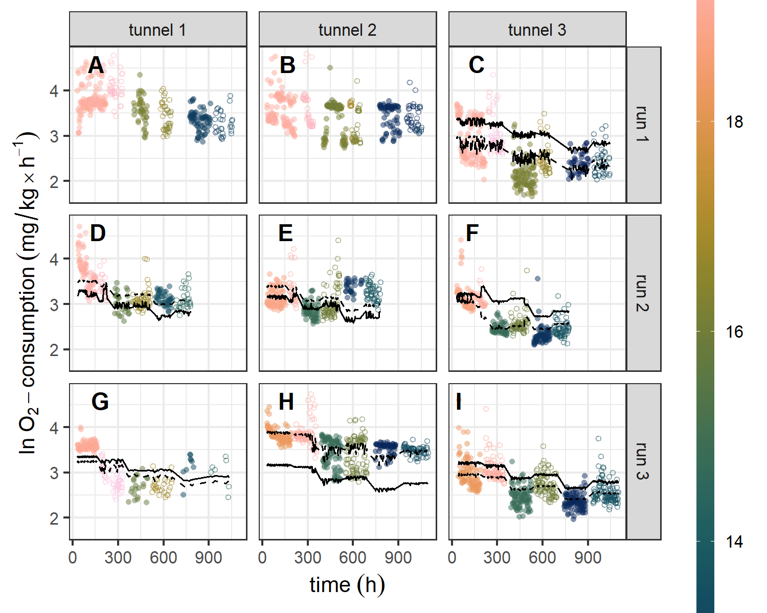 **Fig S1** Oxygen consumption rate per individual (a-i) over time different at temperatures (color scale) at 1 bar (open circles) and 8 bar (closed circles). Modeled predictions are displayed on the population level (solid line) and for the individual (dashed line). Colour indicates temp in °C. Note, that ID’s A and B were removed from statistical analyses due to a technical issue with the pumps  
during flushing and therefore no predictions are presented.

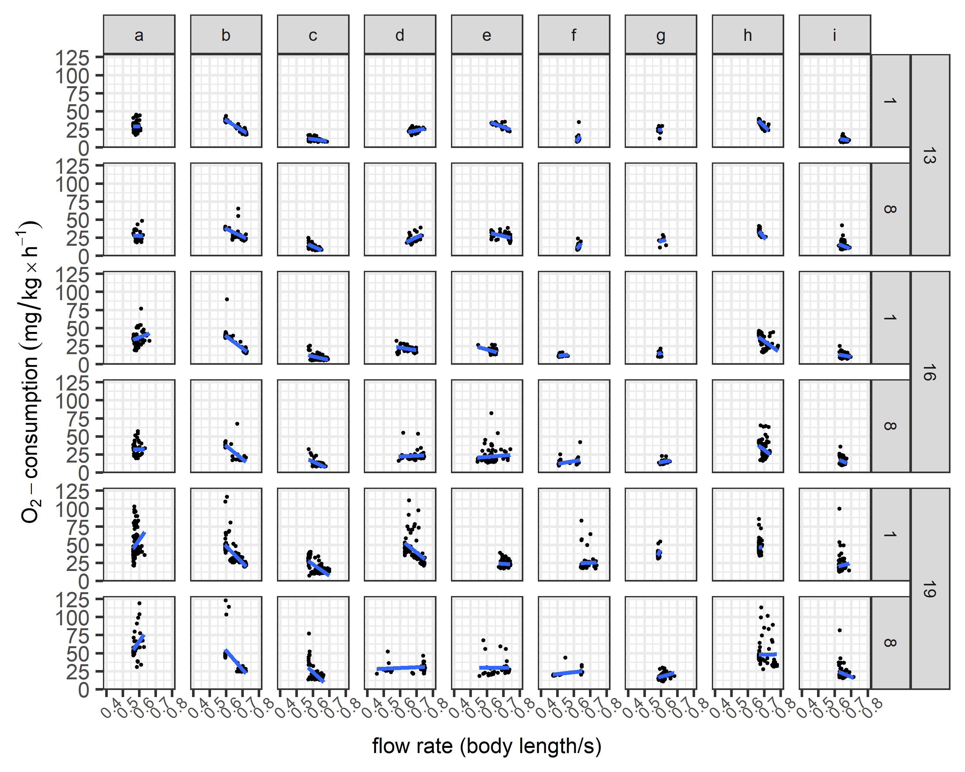

**Fig S2** Effect of swimming speed on Oxygen consumption rate per Temperature and pressure for each individual