**ENGINEERING METHOD**

**LUISA FERNANDA QUINTERO FERNANDEZ**

**JUAN DAVID PELÁEZ VALENCIA**

**NICOLAS ESTEBAN COLMENARES**

**KEVIN ANDRES FERNANDEZ**

**INTEGRATION PROJECT**

# ICESI

## Problematic context

A research project of a company wants to implement a software to generate reports from the company's database, which handles different types, models, and prices of telephones.

It is required that, based on prices and types of phones, the data can be managed, filtered and through graphs to show the current statistics of the phones.

## Solution Development

We will follow these steps shown in the flowchart below to arrive at the solution development:

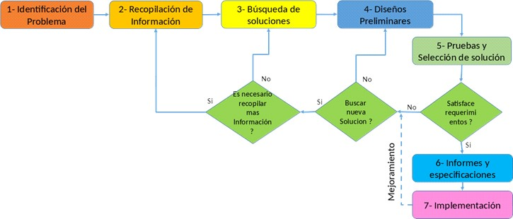

## Step 1: Problem identification

### *Identification of needs and symptoms*

* Software capable of reading the file with the data acquired from the company is required.
* Better management of the information is desired, such as filtering the information based on specific criteria, and the range in which you want to view the information (if applicable).
* There is an evident need to be able to visualize the data and its results in graphical form for better understanding.

### Functional requirements

**RF1:** Display the database of devices in a table, with a layout of a SQL database table.

The database will be loaded through a file that the user enters the program.

**RF2:** Generate different graphs on the devices database, each graph will be generated according to each of the criteria contained in the database. In addition, they will be of different types, there will be bar charts, pie charts, dot charts, etc. To have a more comprehensive view for the user and to be able to easily differentiate which data he/she wants to review and analyze.

**RF3:** Filter the database, the user can filter all data according to the criteria he wants to view, according to his needs. In addition, there is also the possibility that, apart from choosing the desired criteria, you can choose a range for the data or an exact amount of data to view. This way the user has a more personalized filtering.

**RF4:** Clear filters, the program can delete all the filters selected in the table to be able to place different ones without accumulating or confusing the filters with each other.

**RF5:** Predict the value of a device, the user can manually enter a new device and according to different types of questions that the program has internally, it estimates its price and in turn, predicts the range of the phone, whether low, high, or medium.

**RF6:** Graphic the decision tree, the program allows to visualize the decision tree with which the database is being trained. To be able to easily verify and review the behavior of the tree and the nodes obtained.

**RF7:** Generate classification, based on the attribute values of the database. The classification can be performed in two ways, through the implemented decision tree or an external implemented library.

**RF8:** Test accuracy, to be able to check if the machine learning training is correct, the program must be able to calculate and analyze with a part of the database, the current accuracy capability. Both with the external library and the implemented decision tree.

### Non-functional requirements

**RNF1:** Have Microsoft.ACE.OLEDB.12.0 provider installed.

**RNF2:** The uploaded file to read in the program, must be a .xlsx file type.

**RNF3: A** decision tree should be used to predict the price of a mobile device.

#### Problem Definition

A company requires a software to have a good management of the information to be able to generate a good analysis. At the same time, it requires the program to filter data and generate graphs to facilitate its research.

## Step 2: Information gathering

### Definitions

* **Decision tree:** A map of the possible outcomes of a series of related decisions. It starts with a single node and then branches into possible outcomes. There are three types of nodes: Probability nodes (circle), decision nodes (square) and terminal nodes (triangle).

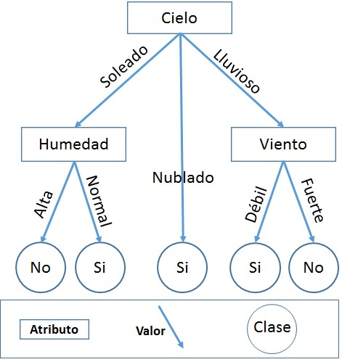

* **Microsoft.ACE.OLEDB.12.0:** Facilitates the transfer of data between Microsoft Office System files and non-Microsoft Office applications to process the information in the database.



* **C# language:** It is a multi-paradigm programming language, which takes several of the functions of other languages such as C++, C and Java. It was developed by

Microsoft for its .NET platform.



* **Kaggle:** It is a website of scientists that allows accessing and publishing different datasets and code. The 'Mobile Price Classification' dataset was used in the project.



## Step 3: Search for creative solutions

To solve the problem of how to model information from a database, with graphs, map, and so on, the following ideas were obtained through the Scamper method:

* Use the tool and/or java programming language using Scene Builder, to build and model the information as needed, in addition to being able to have.
* Use Kaggle, as a database and take the C# language to model the application and use Microsoft.ACE.OLEDB.12.0 to treat the information, and to be able to use the database in our application.
* When displaying all the graphs, display them in the same window.
* Create a new window to display all graphs at the same time, to display them in a better size and with more space.
* Use the decision tree to predict the price through different classification questions.
* Use different types of graphs to display statistics.
* Of the different ways to implement a decision algorithm (ID3, C4.5, C5.0,

CART), the CART option is chosen.

## Step 4. Transition from Ideas to Preliminary Designs

For the preliminary designs we looked at which of the two ideas is better and we chose the second one which is to use C# as a tool to program this application, since it facilitates the creation of an application, besides, it is not necessary to use an external agent such as Scene Builder as it would be the case in Java.

## Step 5. Evaluation and Selection of the Best Solution

Criterion A. Knowledge. The alternative has been studied:

* 2] Yes (an exact solution is preferred)
* [1] No

Criterion B. Time efficiency. A solution with better efficiency than the others considered is preferred. Efficiency can be:

* [4] Constant
* 3] Greater than constant
* 2] Logarithmic
* 1] Exponential

Criterion D. Ease of algorithmic implementation:

* 2] Compatible with the basic arithmetic operations of a modern computer.
* 1] Not fully compatible with the basic arithmetic operations of a modern computer.

|  |  |  |  |  |  |
| --- | --- | --- | --- | --- | --- |
|  | **Cr**  **iterion A** | **on B** | **Criteri** | **Crit**  **erion C** | **Total** |
| **CART** |  |  |  |  |  |
| **ID3** | 1 |  |  |  | 5 |
| **C4.5** | 1 |  | 1 |  |  |

As all solutions are like each other for the implementation of a decision tree, we chose to implement the CART algorithm because we had more knowledge in this algorithm.

## Bibliography

* Mobile Price Classification. (2018, January 28). Kaggle.

<https://www.kaggle.com/iabhishekofficial/mobile-price-classification?select=test.csv>

* Microsoft. (n. d.). Microsoft Access 2010 database engine redistributable component. Microsoft Downloads.

<https://www.microsoft.com/es-co/download/details.aspx?id=13255>

* Lucid chart. 2021. What is a decision tree diagram. *Lucid Software Inc.* [*https://www*](https://www/)[*.*lucidchart.com/pages/es/que-es-un-diagrama-de-arbol-de-decision](https://www.lucidchart.com/pages/es/que-es-un-diagrama-de-arbol-de-decision)
* Marketing. 2020. What is C#? *BeSoftware.* <https://bsw.es/que-es-c/>