­­­­­

-- Restaurant App --

USER MANUAL

Welcome to the user manual for Restaurant App! In this manual, you will learn how to add your restaurant to our system, log in, manage some basic information about your restaurant, view all pending orders and your accounting tables. You will also learn how to use our site from the point of view of your customers.

CHAPTER ONE: Setting Up Your Restaurant

The first step in setting up your restaurant is to navigate to our web page. The URL for this is:

[people.eecs.ku.edu/~jdrahoza/subdir/eecs448/Restaurant_App/restaurantApp.html](http://people.eecs.ku.edu/~jdrahoza/subdir/eecs448/Restaurant_App/restaurantApp.html).

This will take you to the main page of our site.

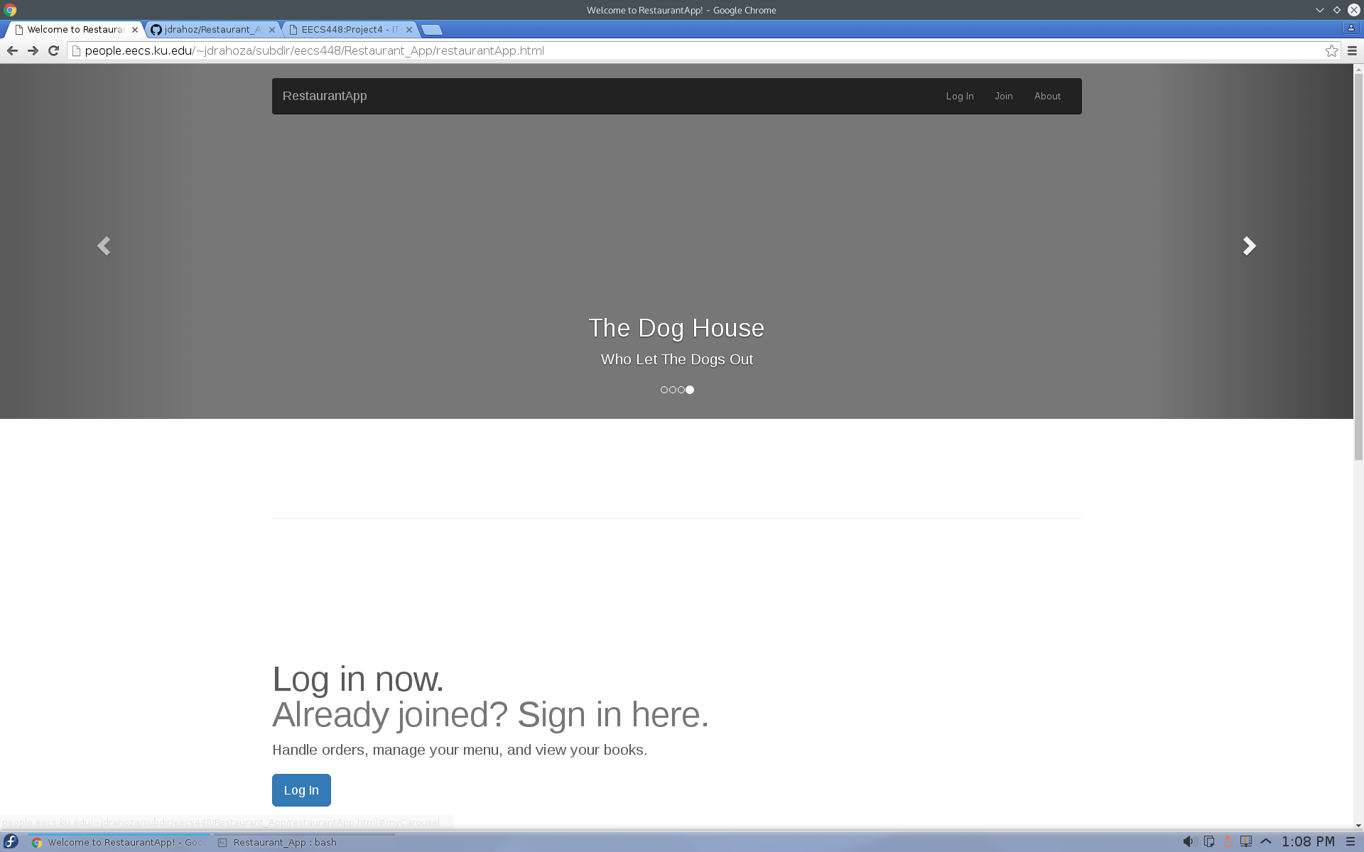

This page includes links to the log in, create user, and the GitHub repository for RestaurantApp. The top navigation bar also includes these links.

From here, either scroll down to the “Get Started” link or select “Join” from the top navigation bar. This will redirect you to a page that we will use to add your restaurant.

On this page, you will see three text fields labeled “Restaurant Name,” “Username,” and “Password.” Here, you can enter your restaurant name, choose a unique username, and choose a password over 4 characters. Once you have entered this information, click “Join” and your restaurant will be added to our system. You will then be redirected to your newly created home page. If the username you have chosen is already in use, your restaurant will not be added and you will be prompted to re-enter your information with a different username. This page also includes a navigation bar with links back to the front page, log in, and the GitHub repository.