**This paragraph introduces NO Drawings.** Video provides a powerful way to help you prove your point. When you click Online Video, you can paste in the embed code for the video you want to add. You can also type a keyword to search online for the video that best fits your document.

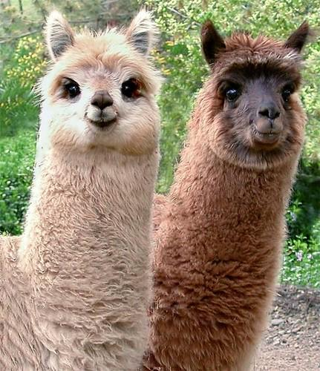**This paragraph introduces the FIRST drawing. (top-left corner)** Video provides a powerful way to help you prove your point. When you click Online Video, you can paste in the embed code for the video you want to add. You can also type a keyword to search online for the video that best fits your document.

**This paragraph introduces the SECOND drawing (top-right corner)** To make your document look professionally produced, Word provides header, footer, cover page, and text box designs that complement each other. For example, you can add a matching cover page, header, and sidebar. Click Insert and then choose the elements you want from the different galleries.

**This paragraph introduces the THIRD drawing (up-side-down).** Themes and styles also help keep your document coordinated. When you click Design and choose a new Theme, the pictures, charts, and SmartArt graphics change to match your new theme. When you apply styles, your headings change to match the new theme.

**This paragraph introduces the FOURTH drawing (most-right).** XXXX time in Word with new buttons that show up where you need them. To change the way a picture fits in your document, click it and a button for layout options appears next to it. When you work on a table, click where you want to add a row or a column, and then click the plus sign.

**This paragraph introduces the FIFTH drawing (left-right flipped).** Video provides a powerful way to help you prove your point. When you click Online Video, you can paste in the embed code for the video you want to add. You can also type a keyword to search online for the video that best fits your document. After this paragraph the page should break.

**This paragraph introduces the SIXTH drawing (left-right flipped & up-side-down).**To make your document look professionally produced, Word provides header, footer, cover page, and text box designs that complement each other. For example, you can add a matching cover page, header, and sidebar. Click Insert and then choose the elements you want from the different galleries.

**Paragraph indents apply from the margins of the content area and not from obstacles.** *This paragraph has left and right indents.* Distance to text for drawings in this paragraph: 0. The four small images are anchored at this paragraph. Video provides a powerful way to help you prove your point. When you click Online Video, you can paste in the embed code for the video you want to add. You can also type a keyword to search online for the video that best fits your document. To make your document look professi****onally produced, Word provides header, footer, cover page, and text box designs that complement each other.

**Only the third line in this paragraph should have a higher line height.** Themes and styles also help keep your document coordinated. When you click Design and choose a new Theme, the pictures, charts, and SmartArt graphics cha****nge to match your new theme. Two small images are anchored to this paragraph. (Two small images)

**This paragraph should have three lines.** Themes and styles also help keep your document coordinated. When you click Design and choose a new Theme, the pic****tures, charts, and SmartArt graphics change to match your new theme. End of Paragraph dummy text.

**This paragraph should have four lines.** Themes and styles**** also help keep your document coordinated. When you click Design and choose a new Theme, the pictures, charts, and SmartArt graphics change to match your new theme. End of Paragraph dummy text. There should only be text in the first line above the image and not the second.

**Important: Because images are positioned absolute (relative to page) errors in previous paragraphs may propagate to latter ones.**