**Math and Equations**

1. To get the predicted uncertainty of the robot at time t+1 we must first take the partial derivative of the above equation with respect to each of the state variables. This will get us a Jacobian which we will call

We also need the Jacobian of the motion model with respect to the motion parameters, Vt.

Now that we have our two Jacobians, we can calculate the predicted state via the following equation.

1. The estimated position of a landmark is given by:
2. The predicted measurement and bearing range is given by:

We do not need to calculate the measurement Jacobian with respect to other landmarks because we are assuming that the landmarks are independent (i.e. one landmark does not tell us anything about the other landmarks.)

**Implementation and Evaluation**

1. There are 6 landmarks being observed.

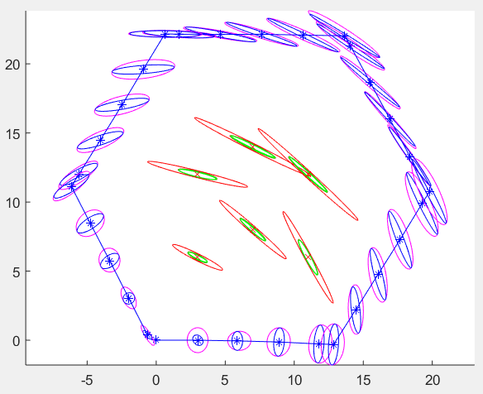

Ground truth represented by red x’s

1. Each red x (ground truth) is roughly centered inside it’s corresponding ellipse meaning that the prediction uncertainty has a mean near the ground truth (ie our prediction is very accurate.)

Euclidean distances: 0.0086 0.0200 0.0261 0.0187 0.0125 0.0302

Mahalanobis distances: 0.0014 0.0081 0.0078 0.0081 0.0059 0.0182

The Euclidean shows how close the prediction physically is to the ground truth. The Mahalanobis distance shows us effectively how many standard deviations away from the ground truth the prediction is.