**2D Linear SLAM**

1. The odometry function can be determined by do the following:

$$r=\left[\begin{matrix}r_{x} \\ r_{y}\end{matrix}\right], u=\left[\begin{matrix}Δx \\ Δy \end{matrix}\right], r^{t-1}=\left[\begin{matrix}r_{x}^{t-1} \\ r_{y}^{t-1}\end{matrix}\right]$$

$$r^{t}=u+r^{t-1} \\ h_{o}=u=r^{t}-r^{t-1}=\left[\begin{matrix}r_{x}^{t}-r_{x}^{t-1} \\ r_{y}^{t}-r_{y}^{t-1}\end{matrix}\right]$$ To derive the Jacobian we take the partial derivative with respect to each of the terms:

$$H_{o}=\left[\begin{matrix}\frac{δh_{ox}}{r_{x}^{t-1}} & \frac{δh_{ox}}{r_{y}^{t-1}} & \frac{δh_{ox}}{r_{x}^{t}} & \frac{δh_{ox}}{r_{y}^{t}} \\ \frac{δh_{oy}}{r_{x}^{t-1}} & \frac{δh_{oy}}{r_{y}^{t-1}} & \frac{δh_{oy}}{r_{x}^{t}} & \frac{δh_{oy}}{r_{y}^{t}}\end{matrix}\right]=\left[\begin{matrix}-1 & 0 & 1 & 0 \\ 0 & -1 & 0 & 1\end{matrix}\right]$$

For the landmark measurement function:

$$m=\left[\begin{matrix}m_{x} \\ m_{y}\end{matrix}\right], l=\left[\begin{matrix}l_{x} \\ l_{y}\end{matrix}\right] \\ l=m+r \\ h_{m}=m=l-r=\left[\begin{matrix}l_{x}-r_{x} \\ l_{y}-r_{y}\end{matrix}\right]$$

And for the measurement Jacobian:

$$H_{m}=\left[\begin{matrix}\frac{{δh}_{mx}}{r_{x}} & \frac{δh_{mx}}{r_{y}} & \frac{δh_{mx}}{l_{x}} & \frac{δh_{mx}}{l_{y}} \\ \frac{δh_{my}}{r_{x}} & \frac{δh_{my}}{r_{y}} & \frac{δh_{my}}{l_{x}} & \frac{δh_{my}}{l_{y}}\end{matrix}\right]=\left[\begin{matrix}-1 & 0 & 1 & 0 \\ 0 & -1 & 0 & 1\end{matrix}\right]$$

1. iii.) It is possible to utilize the “economy size” version of the qr() function as the full A matrix is over determined, meaning it has row > cols.
2. i.)

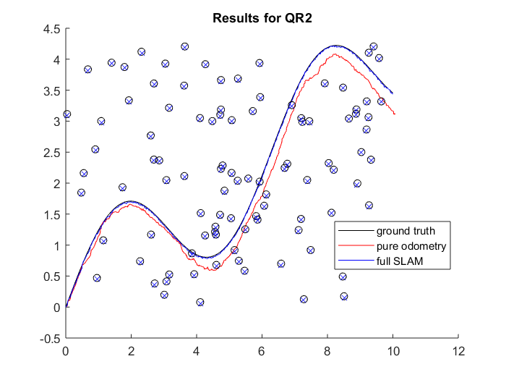

**Figure 1: Map Result for Linear 2D SLAM**

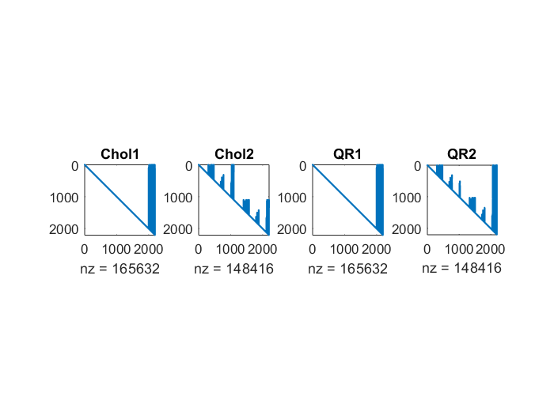

**Figure 2: Matrix Results for Linear 2D SLAM**

|  |  |
| --- | --- |
| **Timings for Linear 2D SLAM** | |
| **QR2** | 1.319814e-01 sec |
| **Chol2** | 1.390131e-01 sec |
| **QR2** | 2.416307e-01 sec |
| **Chol1** | 2.482342e-01 sec |
| **Pinv** | 2.224639e+00 sec |

Both versions of QR and Cholesky operate in with the complexity of O(mn2) which is why QR1 is comparable to Chol1 and QR2 is comparable to Chol2. The 2nd version of each is faster than the original version because the reduced fill-in techniques used increase the sparsity of the respective matrixes allowing for higher efficiency in factorization.

ii.)

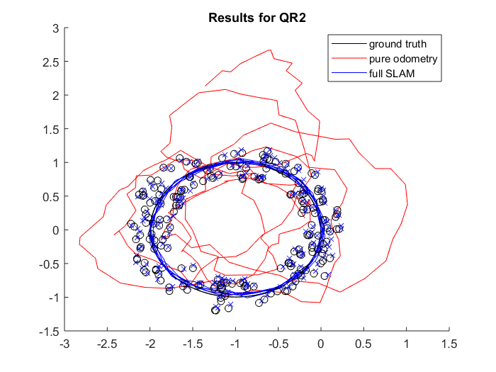

**Figure 3: Map Result for Linear 2D SLAM with Loop**

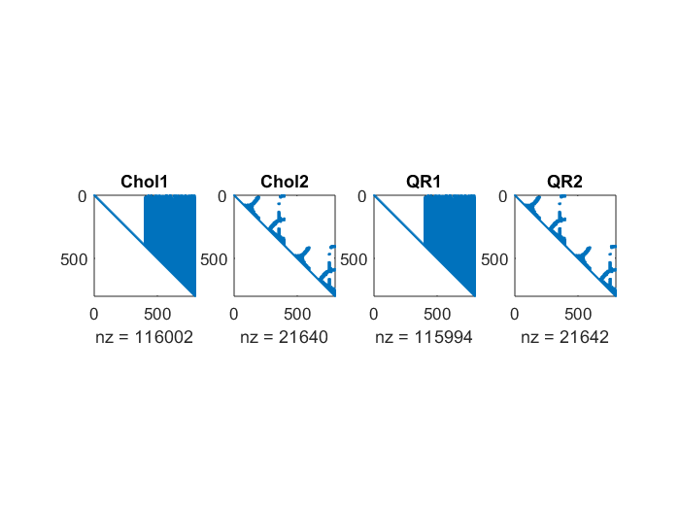

**Figure 4: Matrix Results for Linear 2D SLAM with Loop**

|  |  |
| --- | --- |
| **Timing Results** | |
| **QR2** | 7.566219e-03 sec |
| **Chol2** | 2.228305e-02 sec |
| **Pinv** | 8.502041e-02 sec |
| **Chol1** | 1.113201e-01 sec |
| **QR1** | 1.398858e-01 sec |

It is not in the same order.

**2D Nonlinear SLAM**

1. To get the Jacobian for the nonlinear measurement function we perform the same operations as in part 1:

$$H_{m}=\left[\begin{matrix}\frac{{δh}_{mx}}{r_{x}} & \frac{δh_{mx}}{r_{y}} & \frac{δh_{mx}}{l_{x}} & \frac{δh_{mx}}{l_{y}} \\ \frac{δh_{my}}{r_{x}} & \frac{δh_{my}}{r_{y}} & \frac{δh_{my}}{l_{x}} & \frac{δh_{my}}{l_{y}}\end{matrix}\right] \\ =\left[\begin{matrix}\frac{l_{y}-r_{y}}{d} & -\frac{l_{x}-r_{x}}{d} & -\frac{l_{y}-r_{y}}{d} & \frac{l_{x}-r_{x}}{d} \\ -\frac{l_{x}-r_{x}}{\sqrt{d}} & -\frac{l_{y}-r_{y}}{\sqrt{d}} & \frac{l_{x}-r_{x}}{\sqrt{d}} & \frac{\left(l_{y}-r_{y}\right)}{\sqrt{d}}\end{matrix}\right] \\ d={\left(l_{x}-r_{x}\right)}^{2}+{\left(l_{y}-r_{y}\right)}^{2}$$

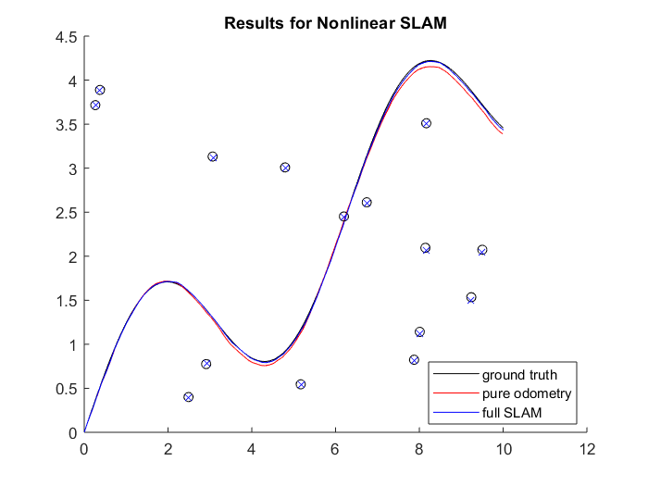

**Figure 5: Map Result for Nonlinear 2D SLAM**

|  |  |
| --- | --- |
| **Error Values** | |
| **RMSE Odom** | 0.0579 |
| **RMSE SLAM** | 0.0144 |