**Introduction**

**ICP**

1. **[talk about energy here]**
2. To derive equation 20 from the paper we must perform the following steps:

$${\tilde{R}}^{z}{\tilde{V}}_{k}^{g}\left(u\right)+{\tilde{t}}^{z}=G\left(u\right)x+ {\tilde{V}}_{k}^{g}\left(u\right)$$

From the paper we are given that:

$${\tilde{R}}^{z}=\left[\begin{matrix}1 & α & -γ \\ -α & 1 & β \\ γ & -β & 1\end{matrix}\right], {\tilde{t}}^{z}=\left[\begin{matrix}t_{x} \\ t_{y} \\ t_{z}\end{matrix}\right]$$

And we know that ${\tilde{V}}_{k}^{g}\left(u\right)$ is a vector of points which we can represent as such:

$${\tilde{V}}_{k}^{g}\left(u\right)=\left[\begin{matrix}{\tilde{V}}_{k,x}^{g} \\ {\tilde{V}}_{k,y}^{g} \\ {\tilde{V}}_{k,z}^{g}\end{matrix}\right]$$

Multiplying through we get:

$$\left[\begin{matrix}{\tilde{V}}_{k,x}^{g}+α{\tilde{V}}_{k,y}^{g}-γ{\tilde{V}}_{k,z}^{g}+t_{x} \\ -α{\tilde{V}}_{k,x}^{g}+{\tilde{V}}_{k,y}^{g}+β{\tilde{V}}_{k,z}^{g}+t_{y} \\ γ{\tilde{V}}_{k,x}^{g}-β{\tilde{V}}_{k,y}^{g}+{\tilde{V}}_{k,z}^{g}+t_{z}\end{matrix}\right] \\ =\left[\begin{matrix}α{\tilde{V}}_{k,y}^{g}-γ{\tilde{V}}_{k,z}^{g}+t_{x} \\ -α{\tilde{V}}_{k,x}^{g}+β{\tilde{V}}_{k,z}^{g}+t_{y} \\ γ{\tilde{V}}_{k,x}^{g}-β{\tilde{V}}_{k,y}^{g}+t_{z}\end{matrix}\right]+\left[\begin{matrix}{\tilde{V}}_{k,x}^{g} \\ {\tilde{V}}_{k,y}^{g} \\ {\tilde{V}}_{k,z}^{g}\end{matrix}\right]$$ Again, from the paper we are given that:

$$G\left(u\right)=\left[{\left[{\tilde{V}}_{k}^{g}\left(u\right)\right]}_{×}| I_{3x3}\right] \\ =\left[\begin{matrix}0 & -{\tilde{V}}_{k,z}^{g} & {\tilde{V}}_{k,y}^{g} & 1 & 0 & 0 \\ {\tilde{V}}_{k,z}^{g} & 0 & -{\tilde{V}}_{k,x}^{g} & 0 & 1 & 0 \\ -{\tilde{V}}_{k,y}^{g} & {\tilde{V}}_{k,x}^{g} & 0 & 0 & 0 & 1\end{matrix}\right] \\ x=\left[\begin{matrix}β \\ γ \\ α \\ t_{x} \\ t_{y} \\ t_{z}\end{matrix}\right]$$

And multiplying these through and adding the points we get:

$$\left[\begin{matrix}α{\tilde{V}}_{k,y}^{g}-γ{\tilde{V}}_{k,z}^{g}+t_{x} \\ -α{\tilde{V}}_{k,x}^{g}+β{\tilde{V}}_{k,z}^{g}+t_{y} \\ γ{\tilde{V}}_{k,x}^{g}-β{\tilde{V}}_{k,y}^{g}+t_{z}\end{matrix}\right]+\left[\begin{matrix}{\tilde{V}}_{k,x}^{g} \\ {\tilde{V}}_{k,y}^{g} \\ {\tilde{V}}_{k,z}^{g}\end{matrix}\right]$$

Which is of the same form as the equation above.

1. 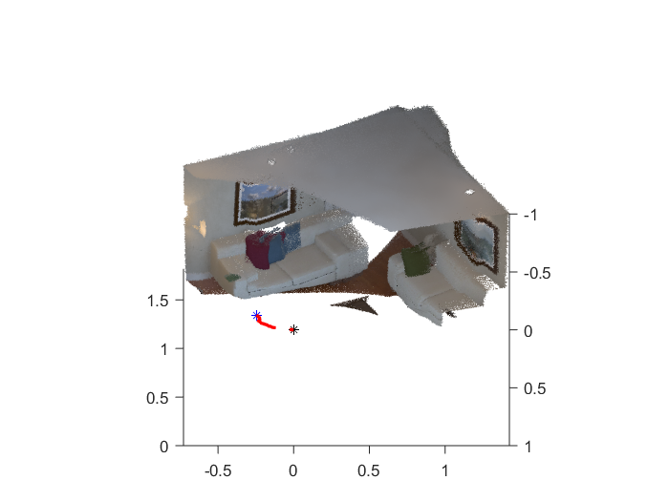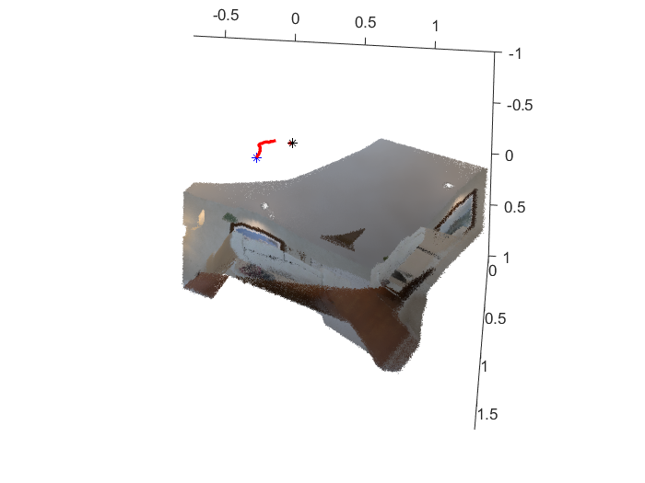
2. **B.**

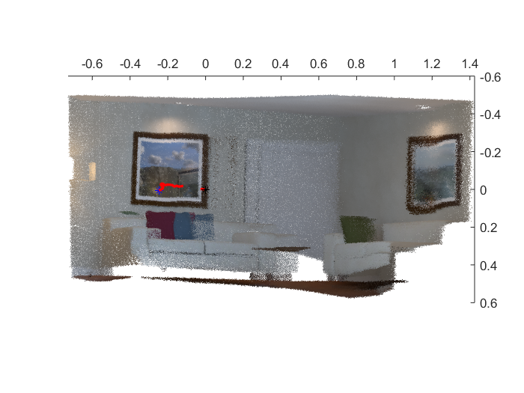

**C.**

**Figure 1 A-C: Results of the ICP algorithm without fusion**

In Figure 1 above we can see the reconstruction of a small room using the Iterative Closest Point algorithm. The red line represents the estimated camera trajectory, with the black asterisk representing the starting position and the blue the final position. A discontinuity in the camera trajectory can be noticed. Within the reconstruction there are some inaccuracies present, the blue pillow on the couch was not fully reconstructed and looks like a second version of it was partially built. The paintings on the wall are also wavy instead of straight. The reconstruction is also grainy in some areas.

**Point-based Fusion**

1. [**Talk about benefits here]**