Jonathan Roland

Assignment 1.5

Milestone 1: Personal Portfolio

Web 330

Instructor: Prof. Krasso

Market Research

Robby Leonardi

<http://www.rleonardi.com/interactive-resume/>

This developer’s portfolio is a technical standout that flexes his animation strength to great effect. While the technical capability on display here is far more ambitious than my site plans, I do want to take some inspiration from his core ideas.

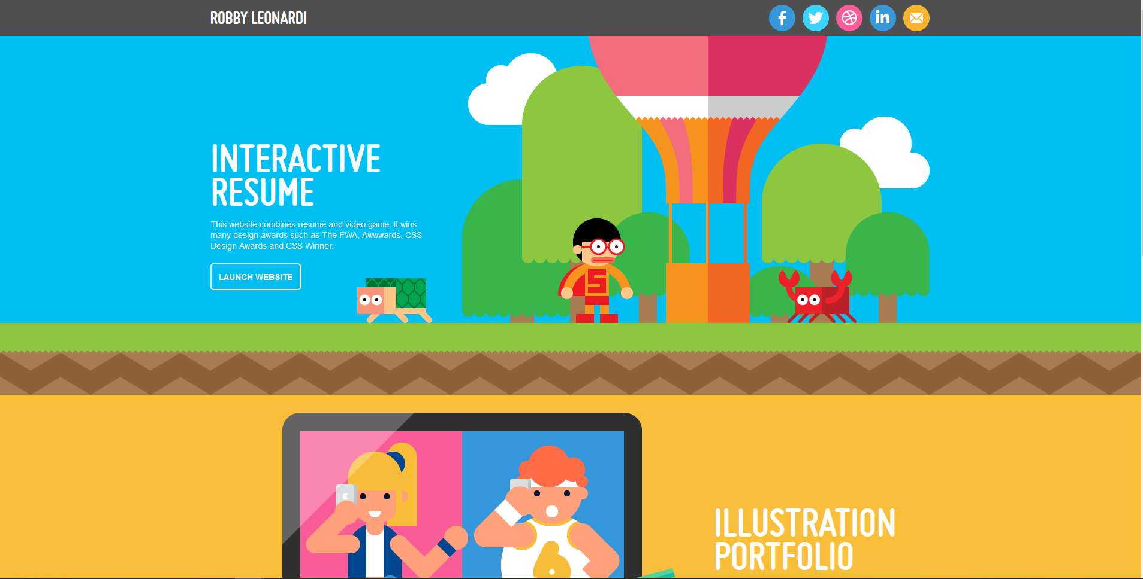

First, I love this site’s scrolling interaction. The developer went all in to simulate the feeling of a classic side scrolling video game (chiefly Mario). It immediately and simultaneously calls attention to his technical prowess and personality.



The second thing I love here is the presentation of graphs. I like how he brings the user’s to fun and stylized graphs that into his skill set. He also presents himself humbly with the areas he’s less versed in. This is a good social move to show that he may be skilled but isn’t arrogant.

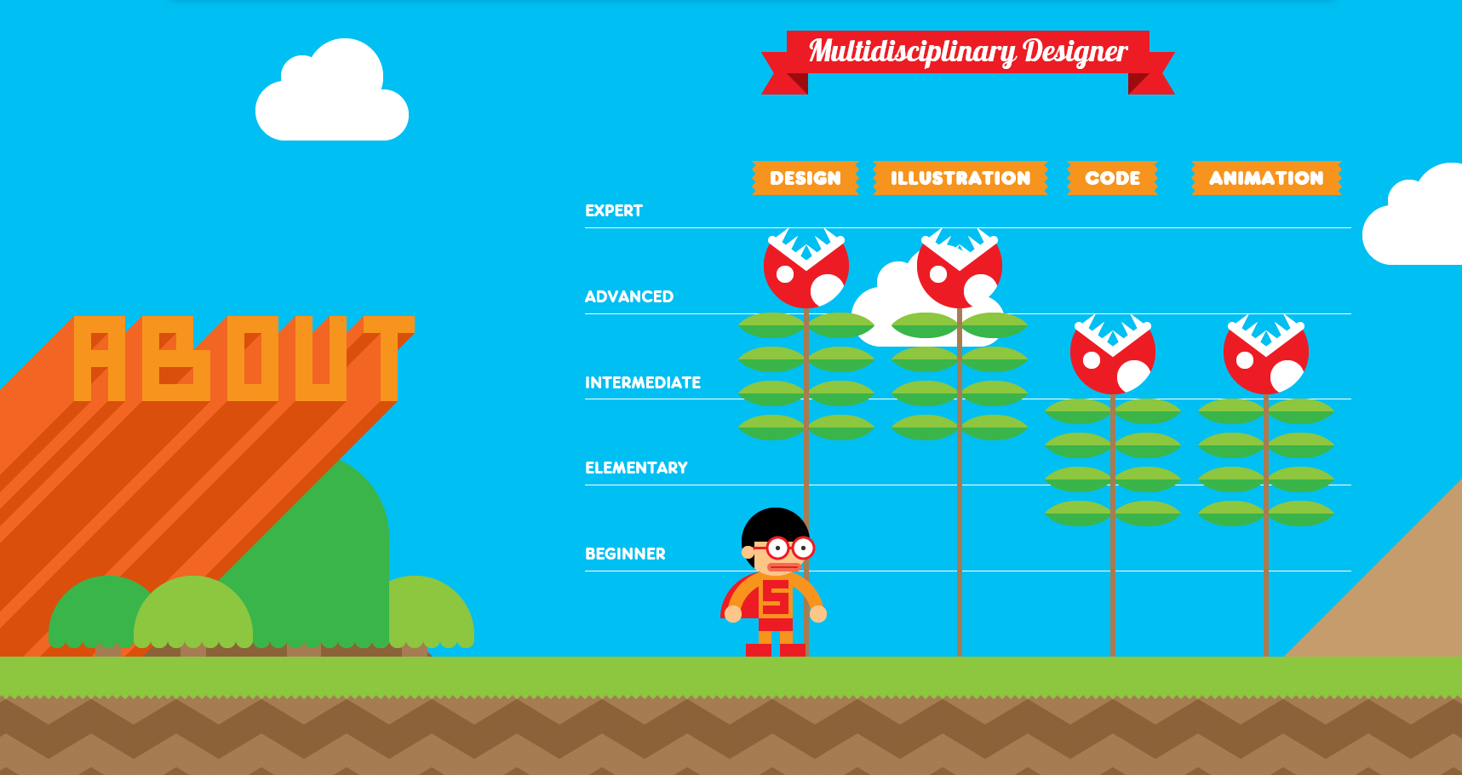

The disadvantage to this layout (aside from very bright coloration) is that it is a little hard to commit the listed skills to memory because the main feature is so exciting. I think it works for this developer since animation is the main draw, but others may not want their animation to be a dominating feature if it’s important to communicate more hard data.

My takeaway from this site is that I would like to incorporate a similar scrolling interaction that displays my personality while presenting my professional skills. I love playing guitar so I may do something that involves a quality photo of one of my guitars with a nice background, zoomed into the fretboard, and do a slow scroll down the frets as I present information.

STRV

<https://www.strv.com/>

This site utilizes minimalism, sparse but powerful color and heroically scaled text to grab attention.

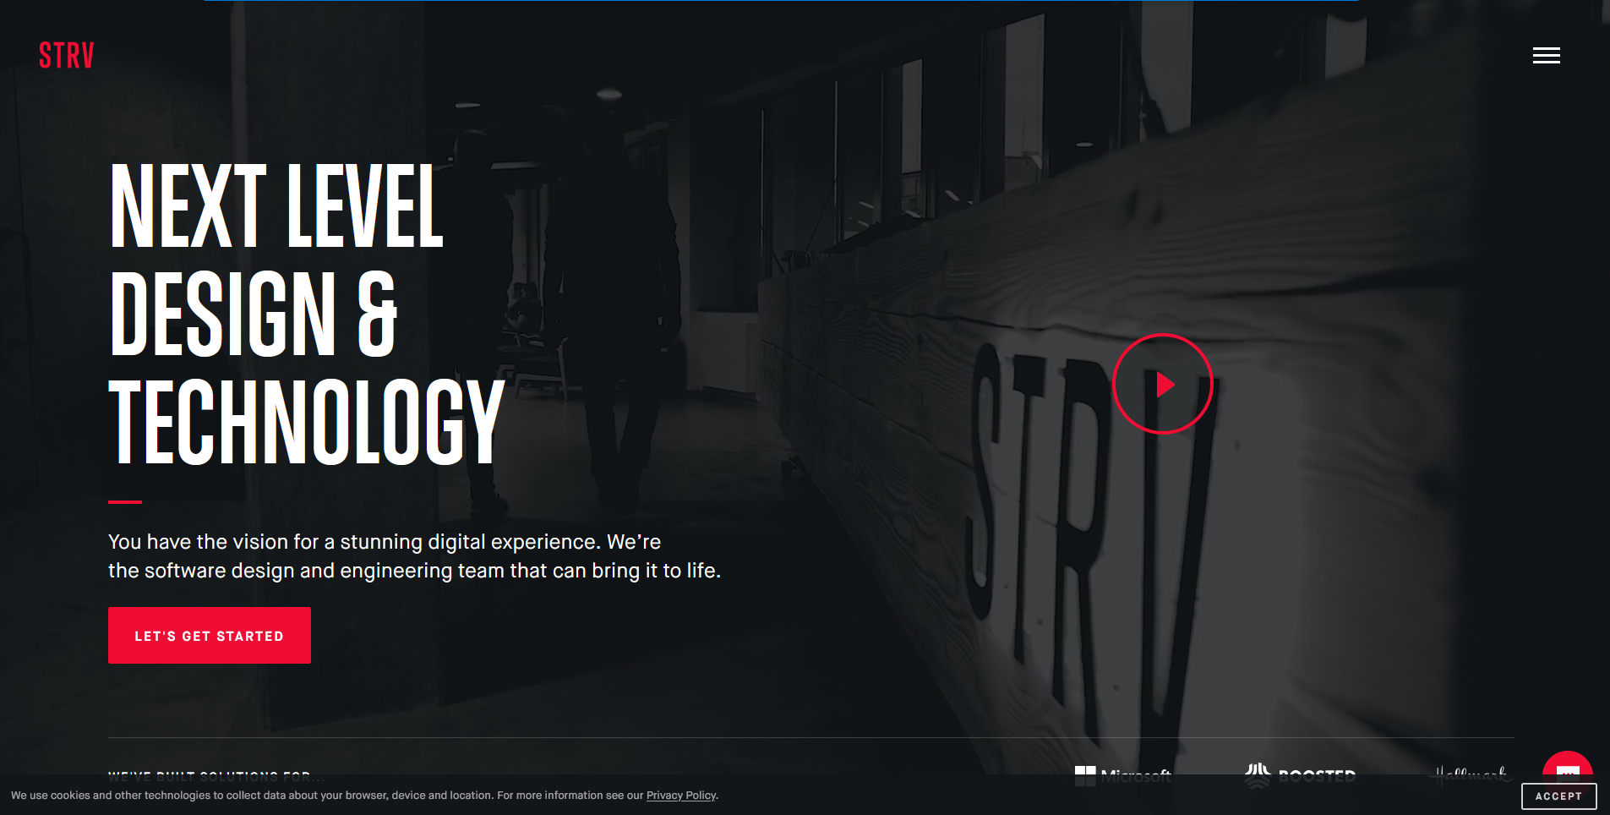

The opaque background gives way to video to breathe life into the site and humanize the team without overtaking the focus. The obvious red button takes the site visitor on a soft exploration tour. Each frame retains the minimalist style and consistency.

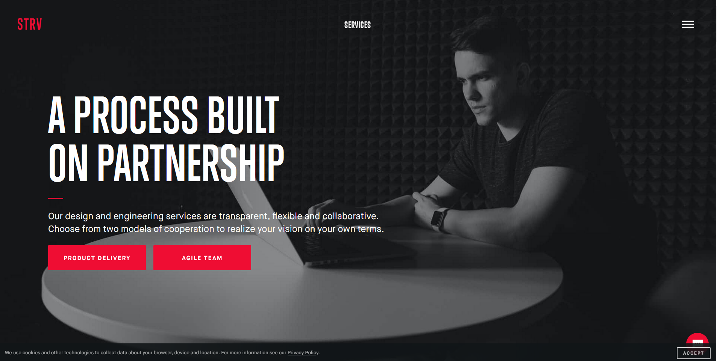

The universal menu bars in the upper right allow a visitor that resists a guided narrative to see a site content listing a jump directly to points of interest.

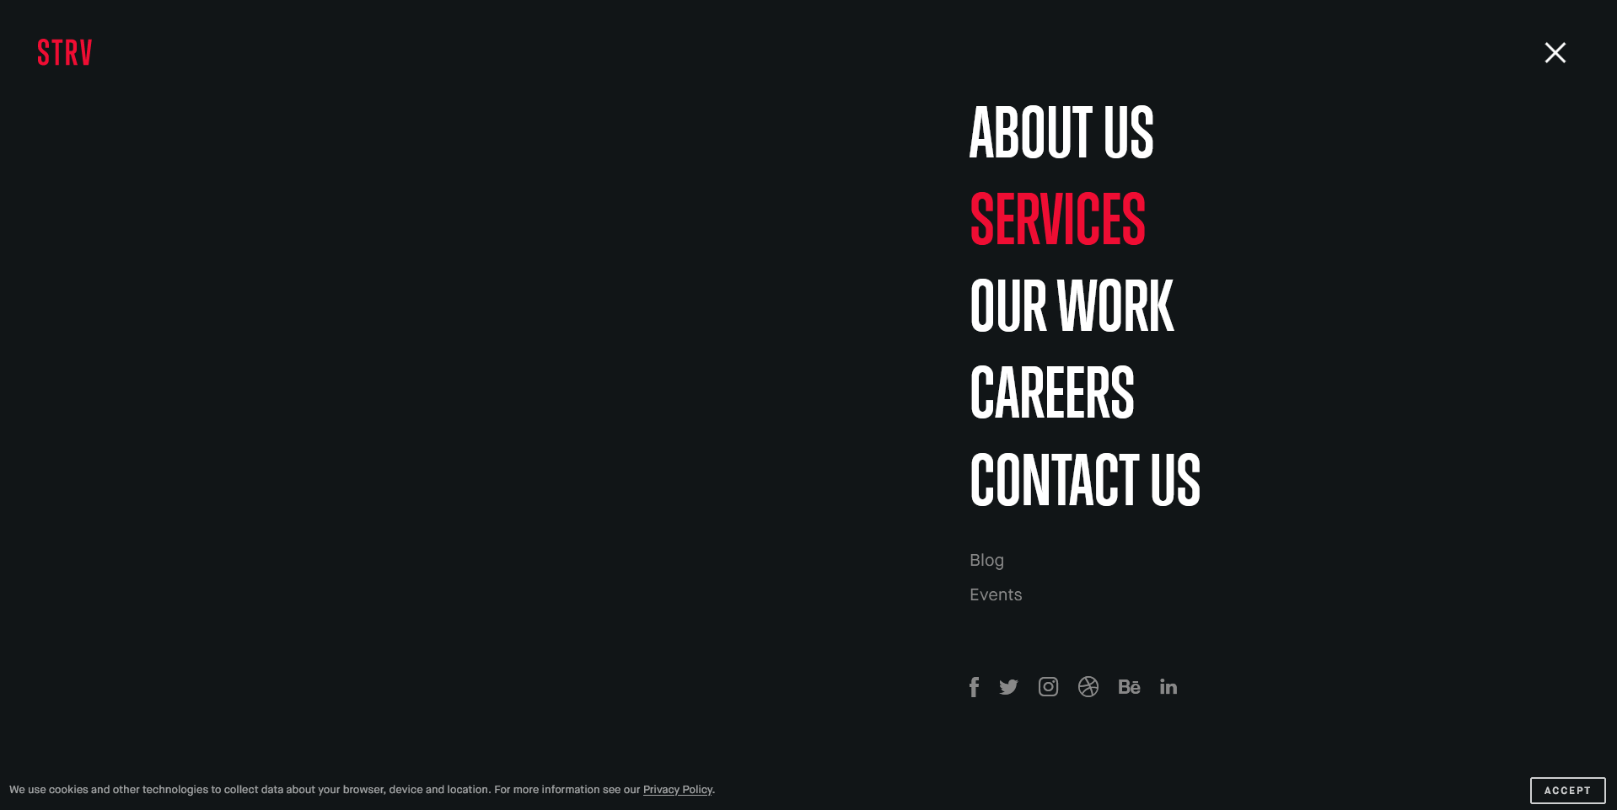

The disadvantage to this site is that is relies on a lot of high production expense media (looping video clips in the background and high-quality photography) to fill in the potential void of a layout that uses a lot of empty space to emphasize focus elements. These are not easily accessible options for a student developer or even a more established solo developer.

My biggest takeaways from this site are to consider minimal color scheme and big heroic text, as well as reserving site navigation from immediate view to give a guided narrative a chance to engage visitors.

Matt Farley

<https://mattfarley.ca/>

This site relies less on animation and content technical prowess, and instead focuses on natural scrolling and very thoughtful layout order to step through the developer’s portfolio. The sense of storytelling really sells this site.

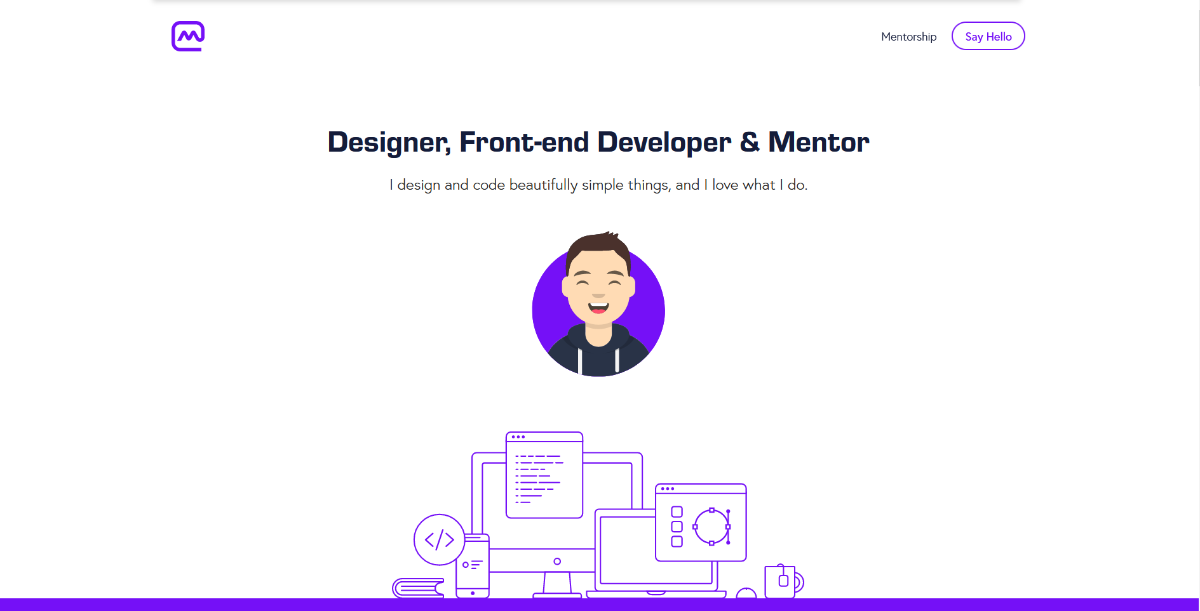

Matt chose to start at a friendly, personable introduction then build out into an explanation of technical capabilities, work history, personal projects, testimonials, and end on presenting a contact form.

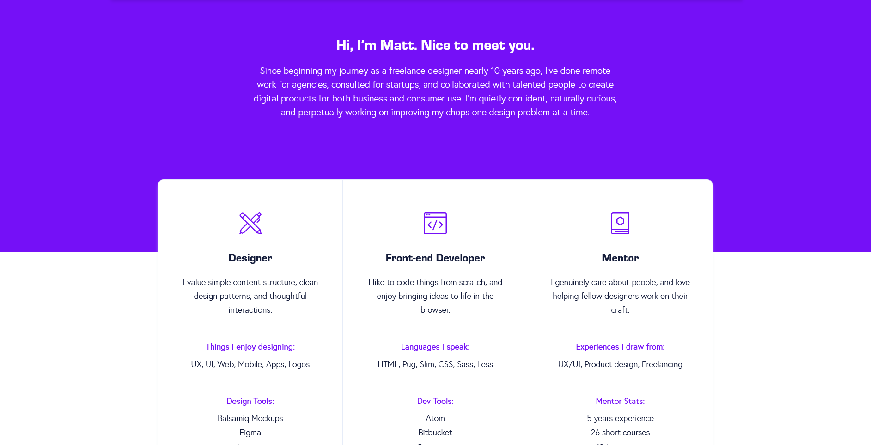

This site is deceptively simple. A lot of thought went into this layout with iconography, element positioning, background and text color, and mouseover events.

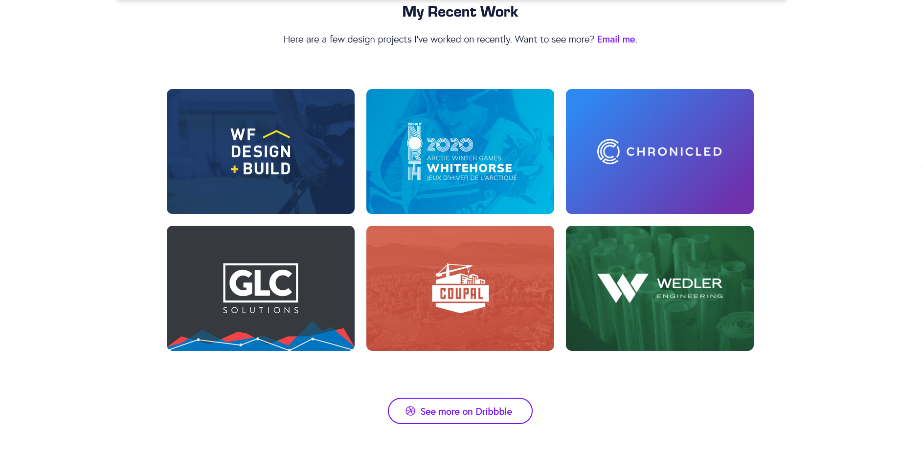

The disadvantage of this site is not having a readily apparent navigation menu to jump to specific content areas at the start of the page. Navigation is entirely dependent on scrolling.

My big takeaway from this site is to carefully consider structure and narrative, as well as opportunities for small pleasing things like icons, mouseover events, and narrative branching points (external links for example). This site is a study of brilliance in the basics.