Jonathan Roland

WEB 335 Introduction to NoSQL

Instructor: Prof. Krasso

11/16/2020

Assignment 5.2

Select one document, filtered by employee_id with the following fields:

* last_name
* email
* date_created

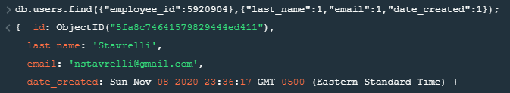

Select a second document, filtered by last_name with the following fields:

* first_name
* last_name
* email

