Jonathan Roland

WEB 335 Introduction to NoSQL

Instructor: Prof. Krasso

11/16/2020

Assignment 5.3

Find one user:

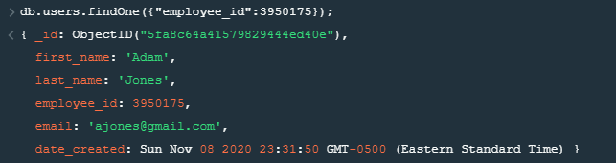

Update user email:

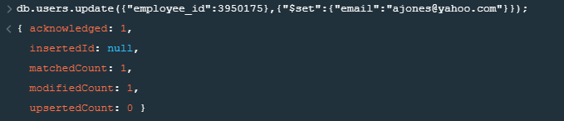

Confirm same user was updated:

