Jonathan Roland

WEB 335 Introduction to NoSQL

Instructor: Prof. Krasso

11/16/2020

Assignment 5.4

Remove one filtered user by email:

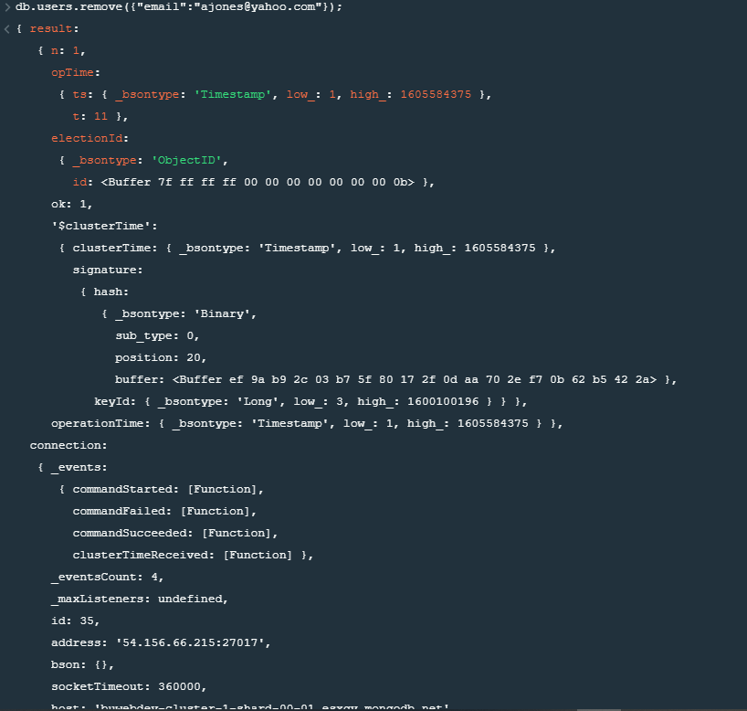

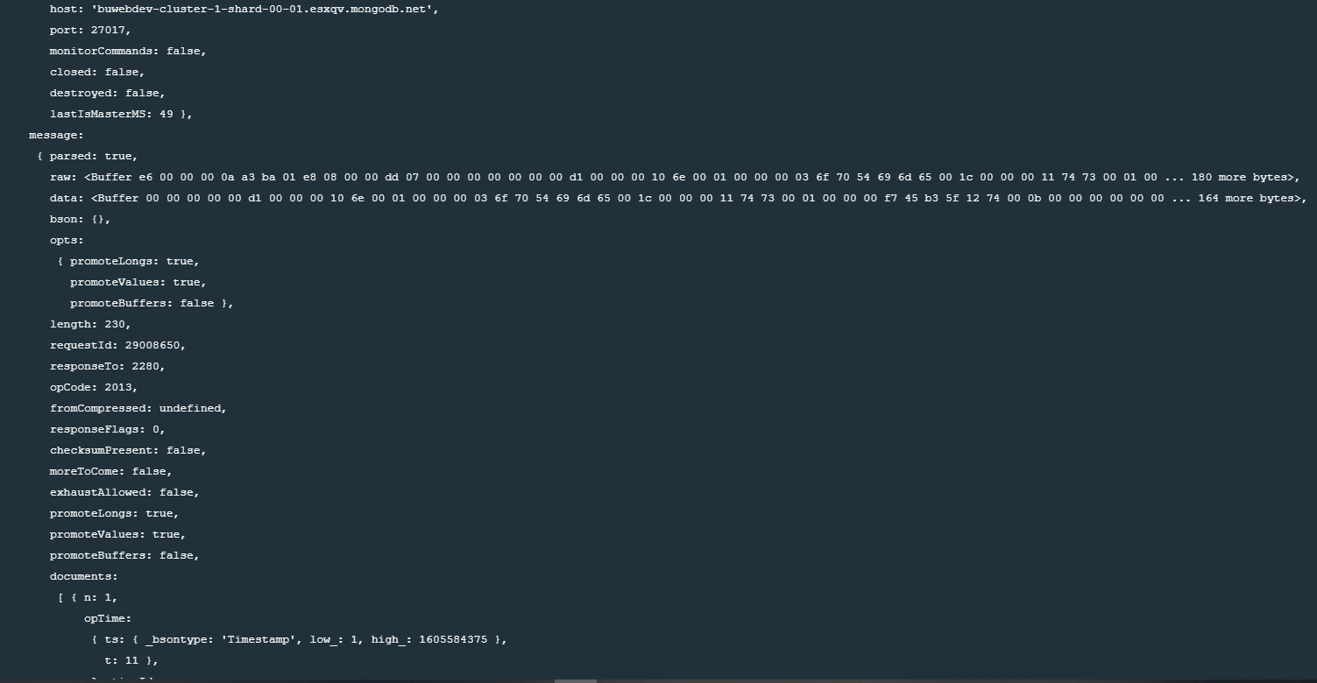

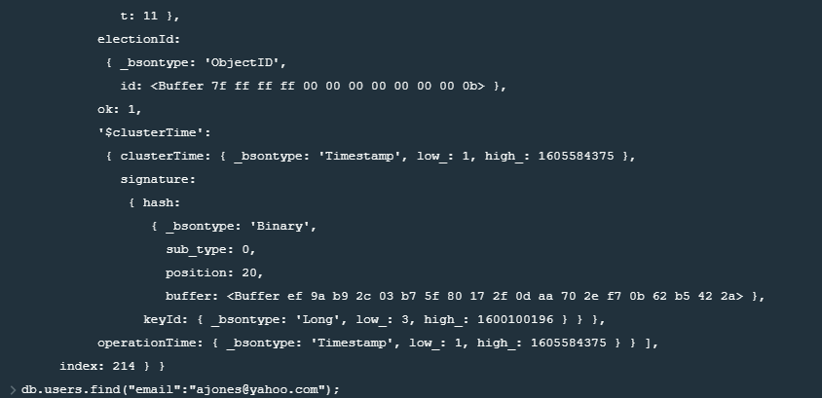

Execute a find() operation to confirm the user was removed:

