Jonathan Roland

WEB 335 RESTful APIs

Instructor: Prof. Krasso

12/05/2020

Assignment 8.2

Anaconda Navigator:

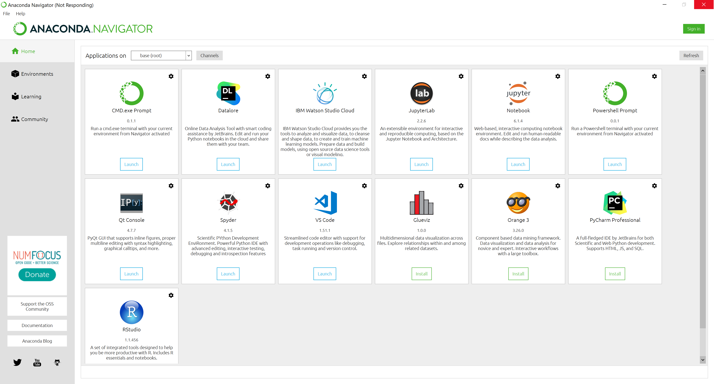

Hello World:

