Jonathan Roland

WEB 420 RESTful APIs

Instructor: Prof. Krasso

11/15/2020

Assignment 5.3

Request:

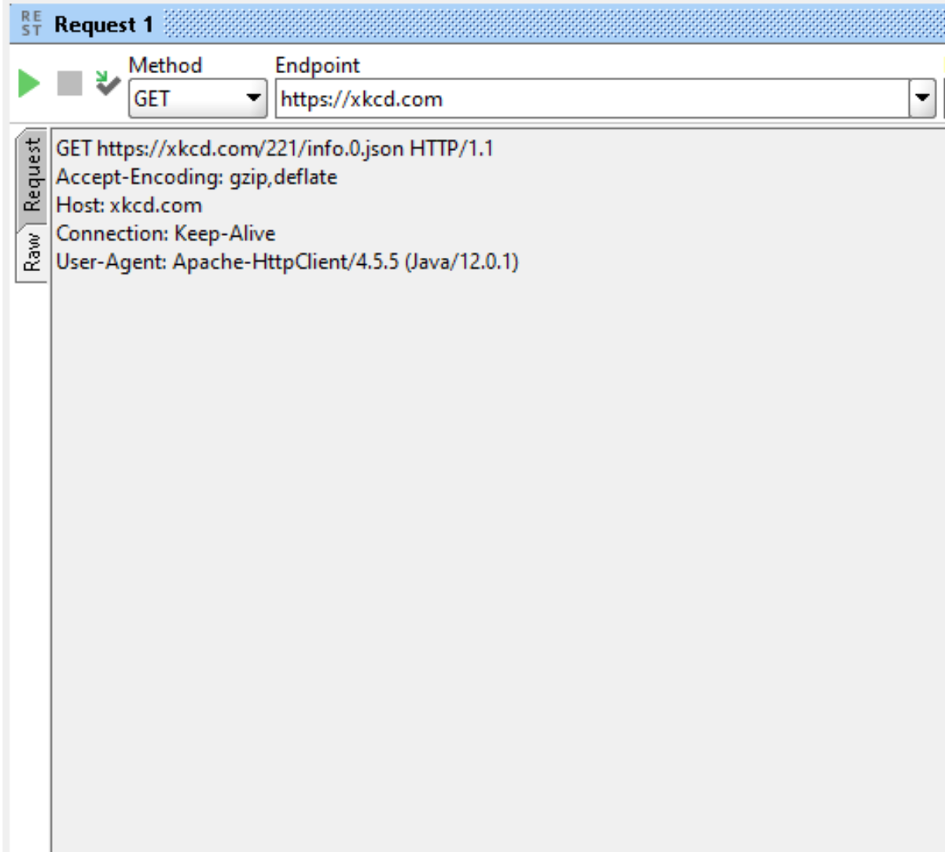

Response:

