Jonathan Roland

WEB 420 RESTful APIs

Instructor: Prof. Krasso

11/16/2020

Assignment 5.4

CLI window:

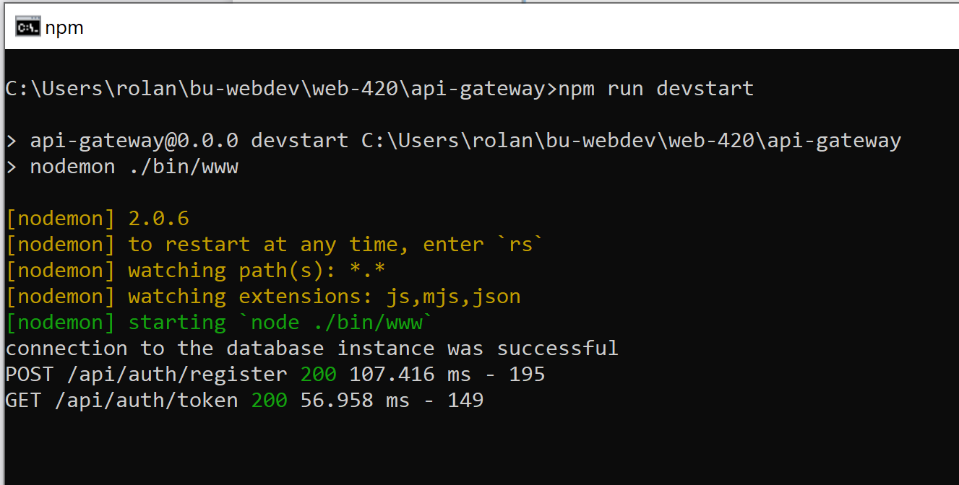

Response:

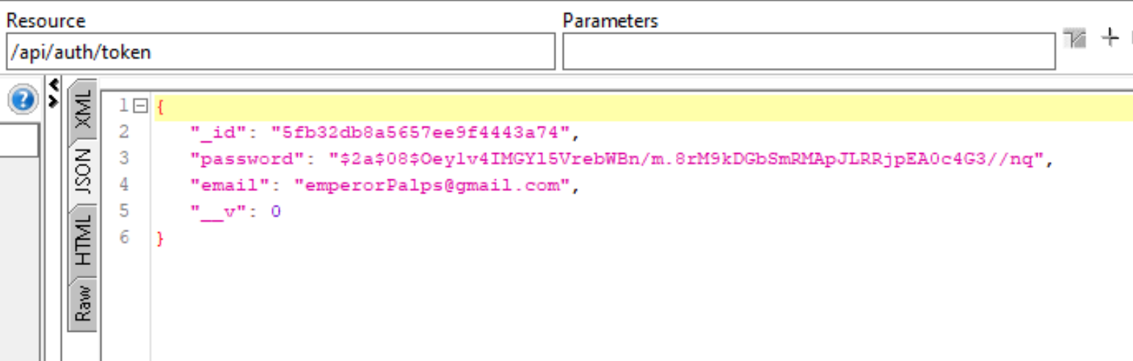

Original document:

