Jonathan Roland

WEB 420 RESTful APIs

Instructor: Prof. Krasso

11/23/2020

Assignment 6.3

Login request:

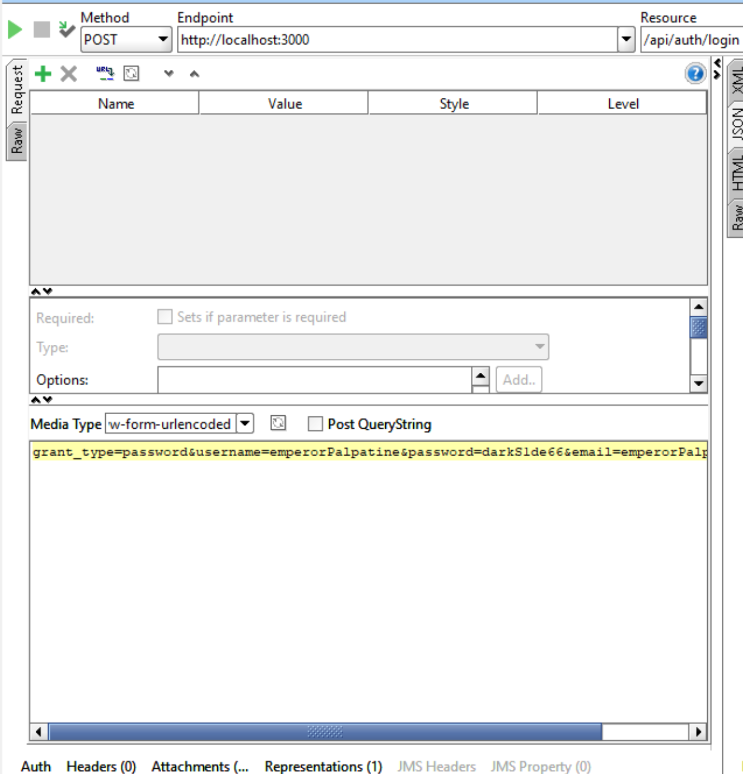

Login response:

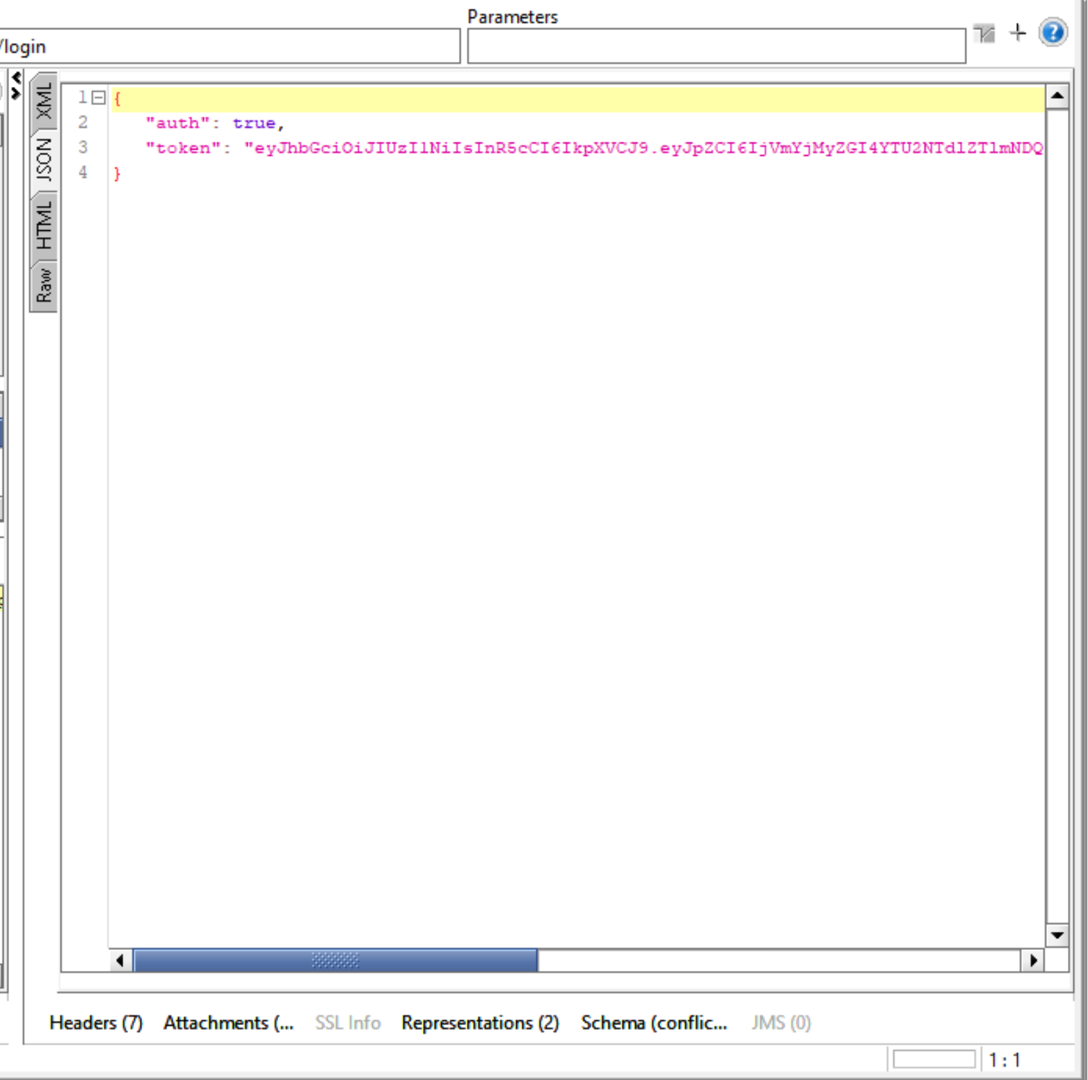

Logout request:

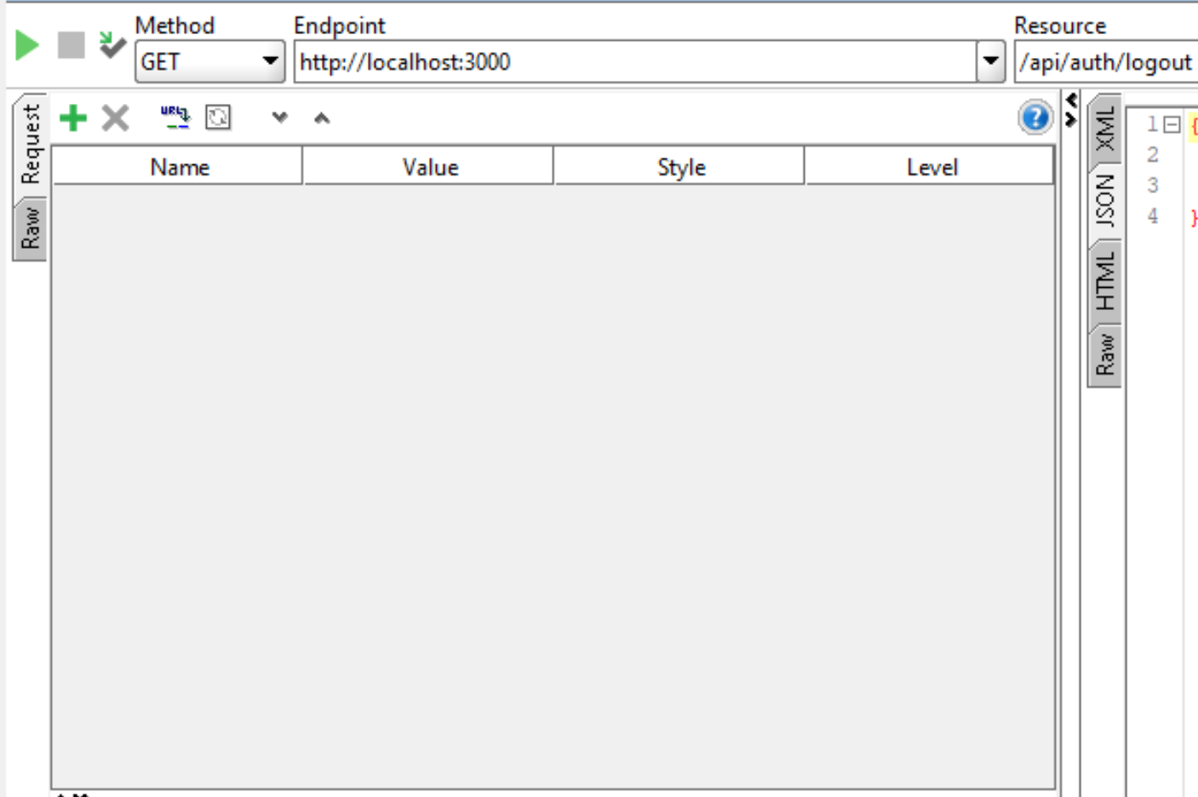

Logout response:

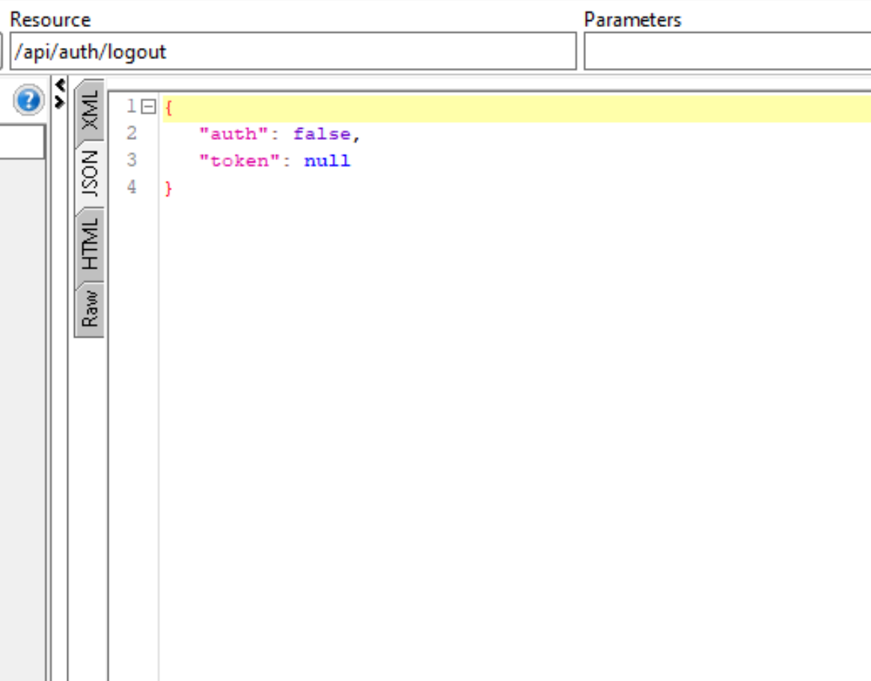

Solution directory:

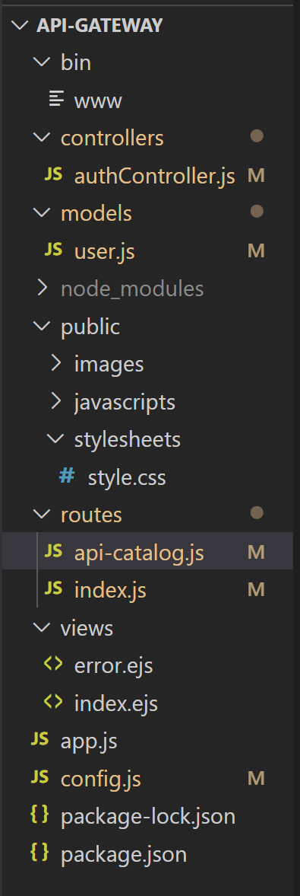

Solution running in browser:

