Jonathan Roland

WEB 420 RESTful APIs

Instructor: Prof. Krasso

11/27/2020

Discussion 7.1

* Select two domain-specific formats and explain their purpose, protocol semantics, application semantics, medium, and where they are defined.
* Create two original diagrams showing the work-flow of the selected formats.

VoiceXML

**Purpose:**

Provides vocal navigation of branching options and forms. It utilizes W3C’s Speech Recognition Grammar Specification (SRGS) to format an XML form representing navigation choices. SRGS translates speech into key-value pairs for POST operations.

**Protocol Semantics:**

GET navigation, arbitrary state transitions through forms, GET for safe transitions, POST for unsafe transitions.

**Application Semantics:**

Spoken conversation.

**Medium:**

XML

**Defined at:**

[W3C open standard, with extensions](https://www.w3.org/TR/voicexml20/)

**State Diagram:**

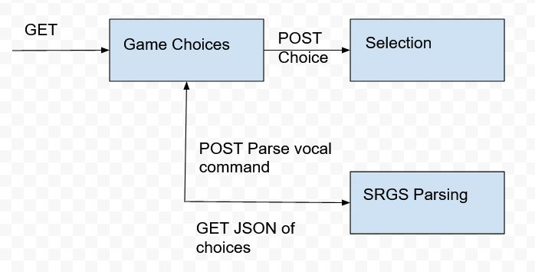

Problem Detail Documents

**Purpose:**

Provides human-readable error details for HTTP status codes in a JSON document. Seeks to offer a more common format instead of a novel solution for returning customized, detailed error descriptions.

The returned JSON document follows a standard format, as shown below:

{

“describedBy”:” http://example.com/no-content”,

“supportId”:” http://example.com/support/error/123456”,

“httpStatus”:204,

“title”:”No Content”,

“detail”:”Your request was successful, but there is no additional content to serve.”

}

The describedBy link provides a link to a human readable format describing the error. The supportId link is an optional URL for support ticket tracking regarding this particular instance of the error. The httpStatus is simply the standard status code, and the title is the standard title of that status code. The detail is the custom message area that can be implemented by the server owner.

**Protocol Semantics:**

Navigation with GET.

**Application Semantics:**

Error reporting.

**Medium:**

JSON, includes rules for automatically converting to XML.

**Defined at:**

<https://tools.ietf.org/html/rfc7807>

**State Diagram:**

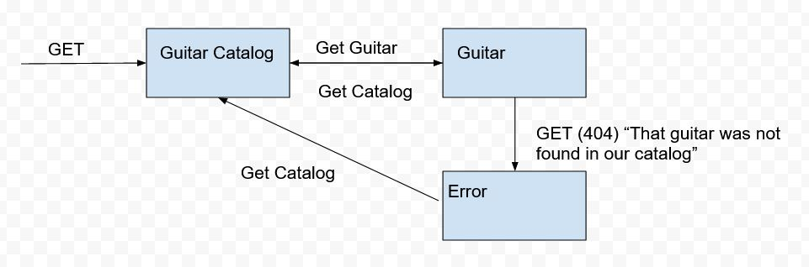

Reference:

Richardson, L., Amundsen, M., & Ruby, S. (2013). *RESTful Web APIs: Services for a Changing World* (1st ed.). O’Reilly Media.