Jonathan Roland

WEB 420 RESTful APIs

Instructor: Prof. Krasso

12/14/2020

Assignment 9.3 – API Gateway Part VI (Heroku Deployment)

Register request:

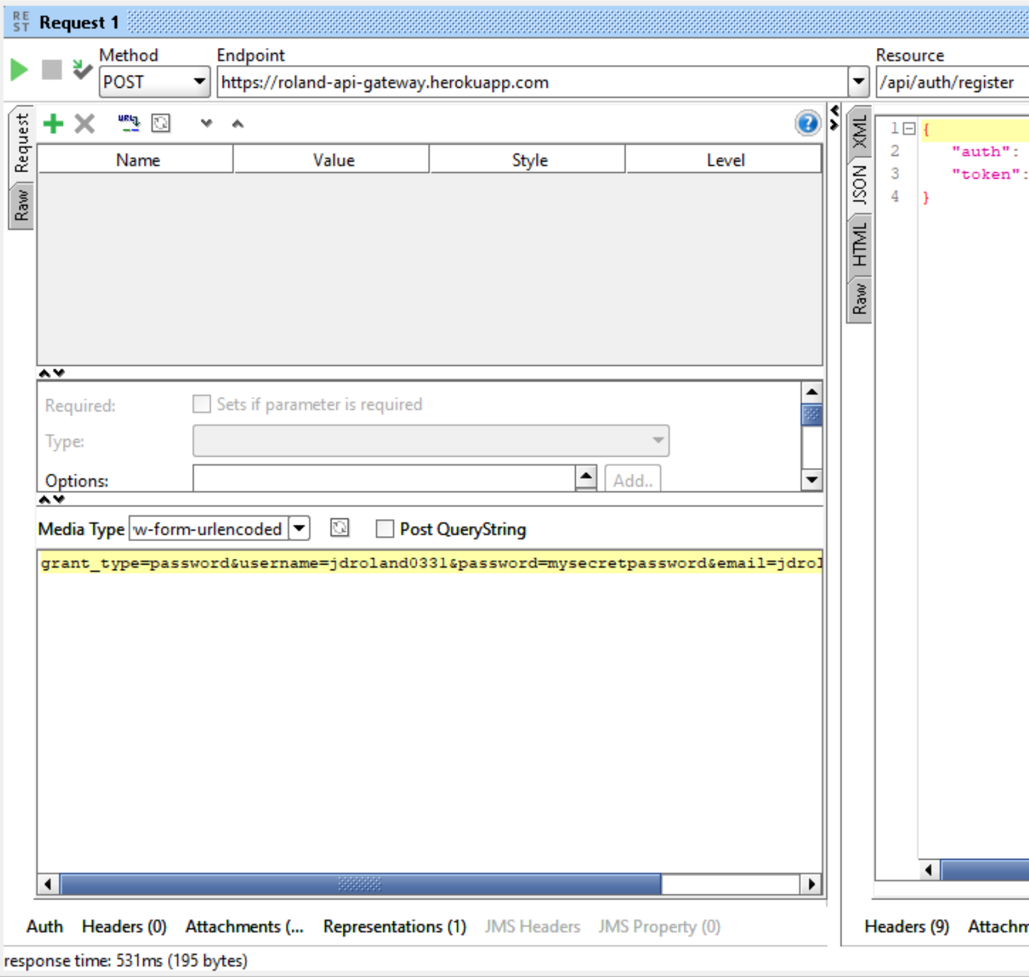

Register response:

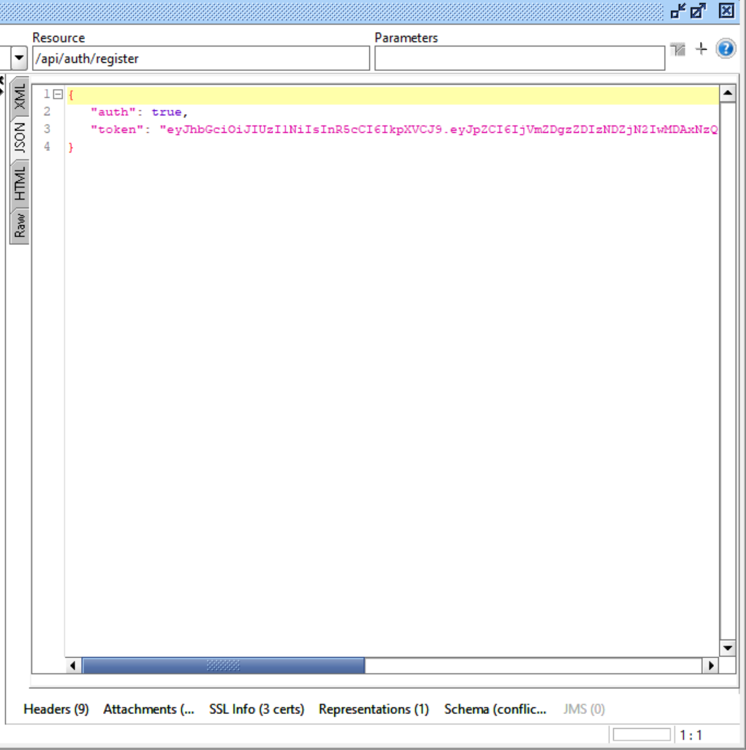

Token request:

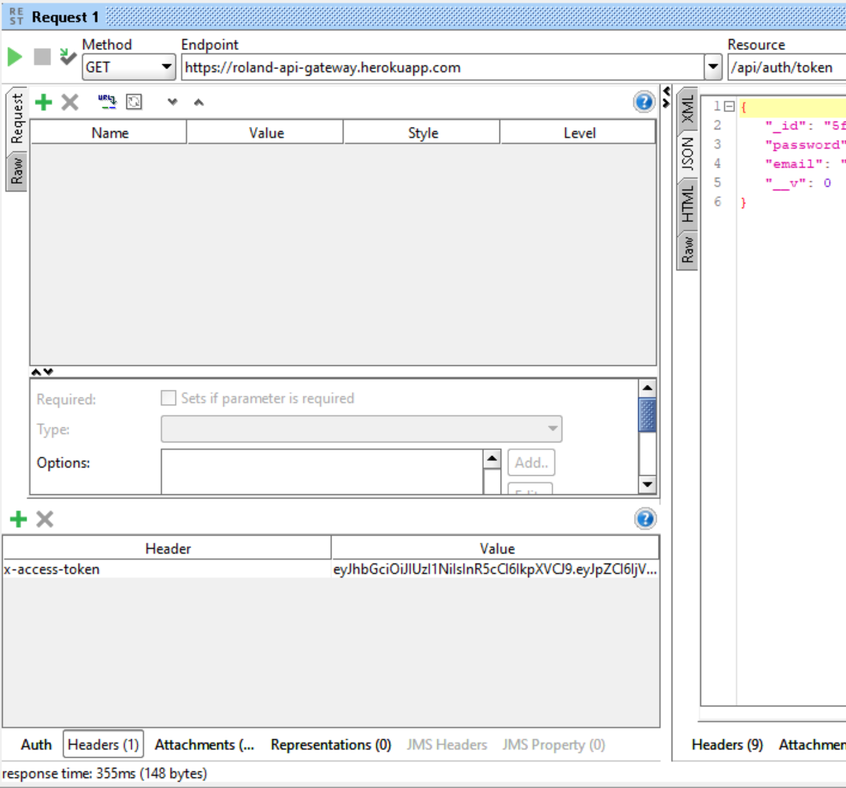

Token response:

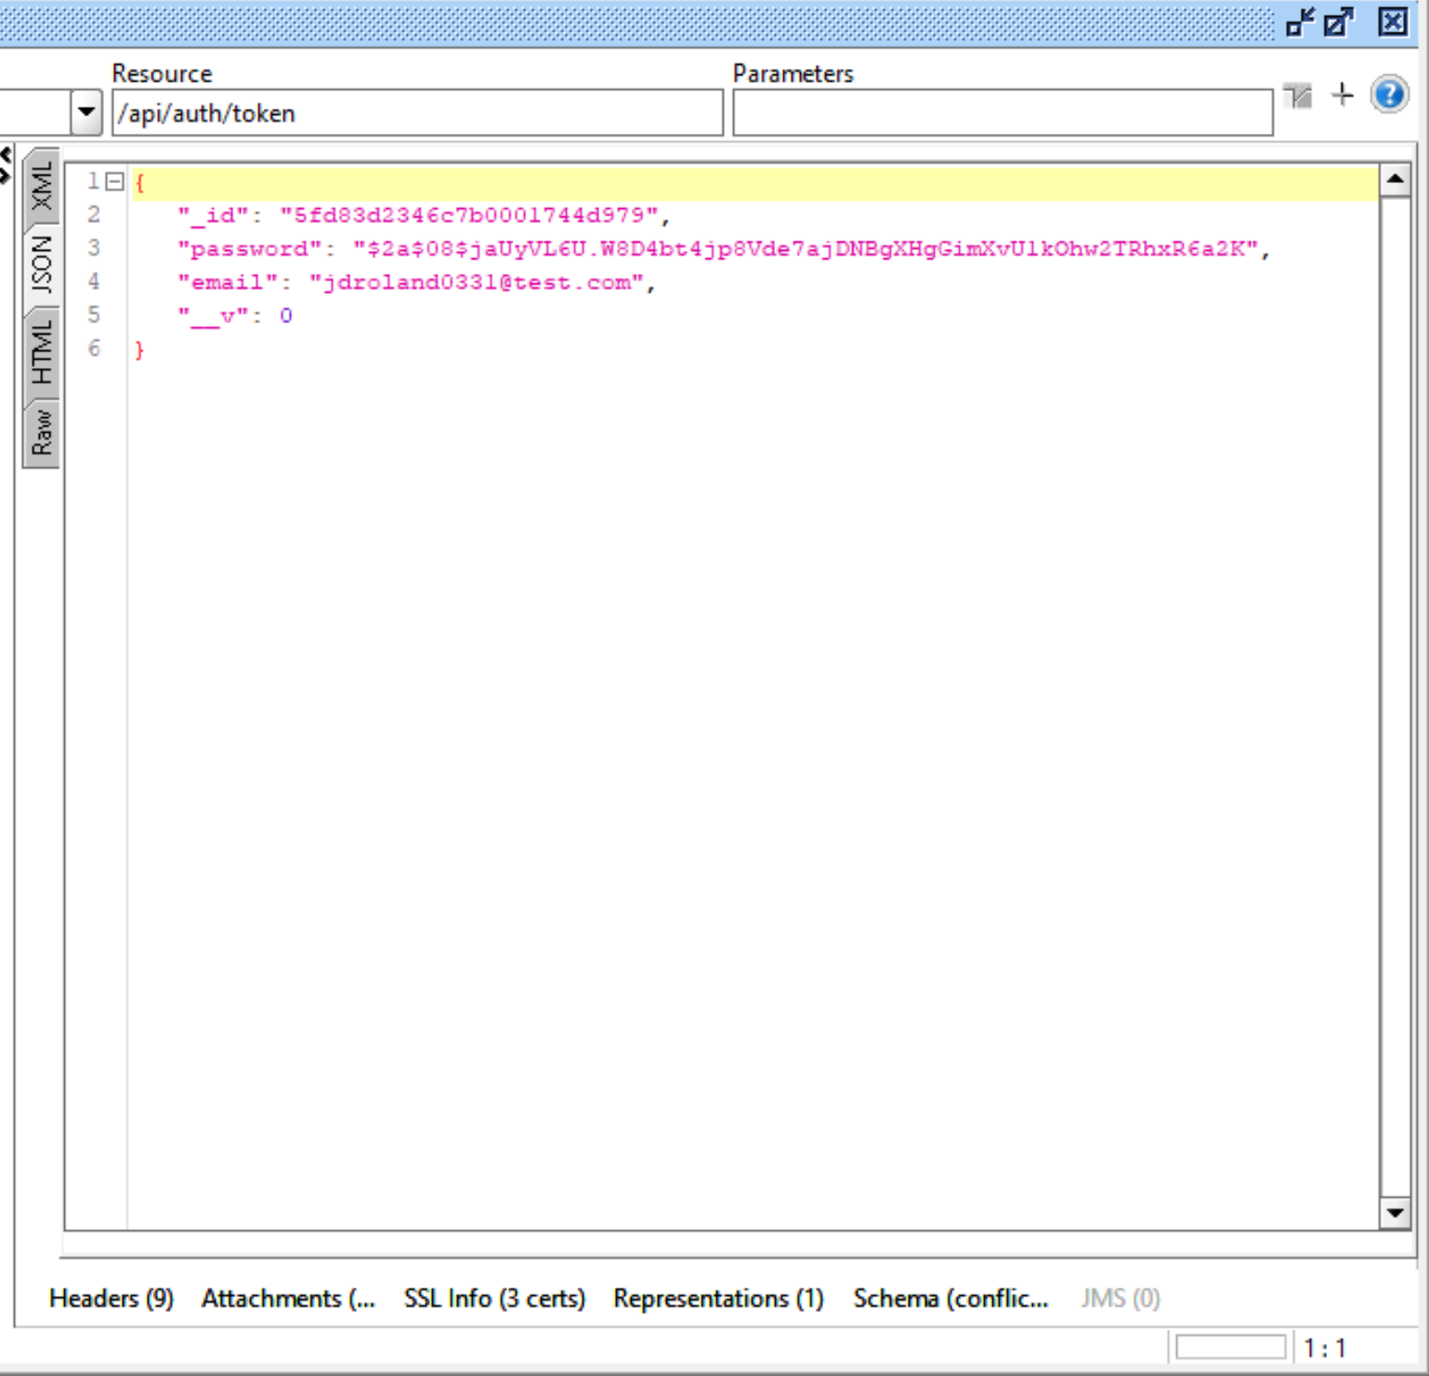

Login Request (I’m unsure why this failed with exactly the same credentials?):

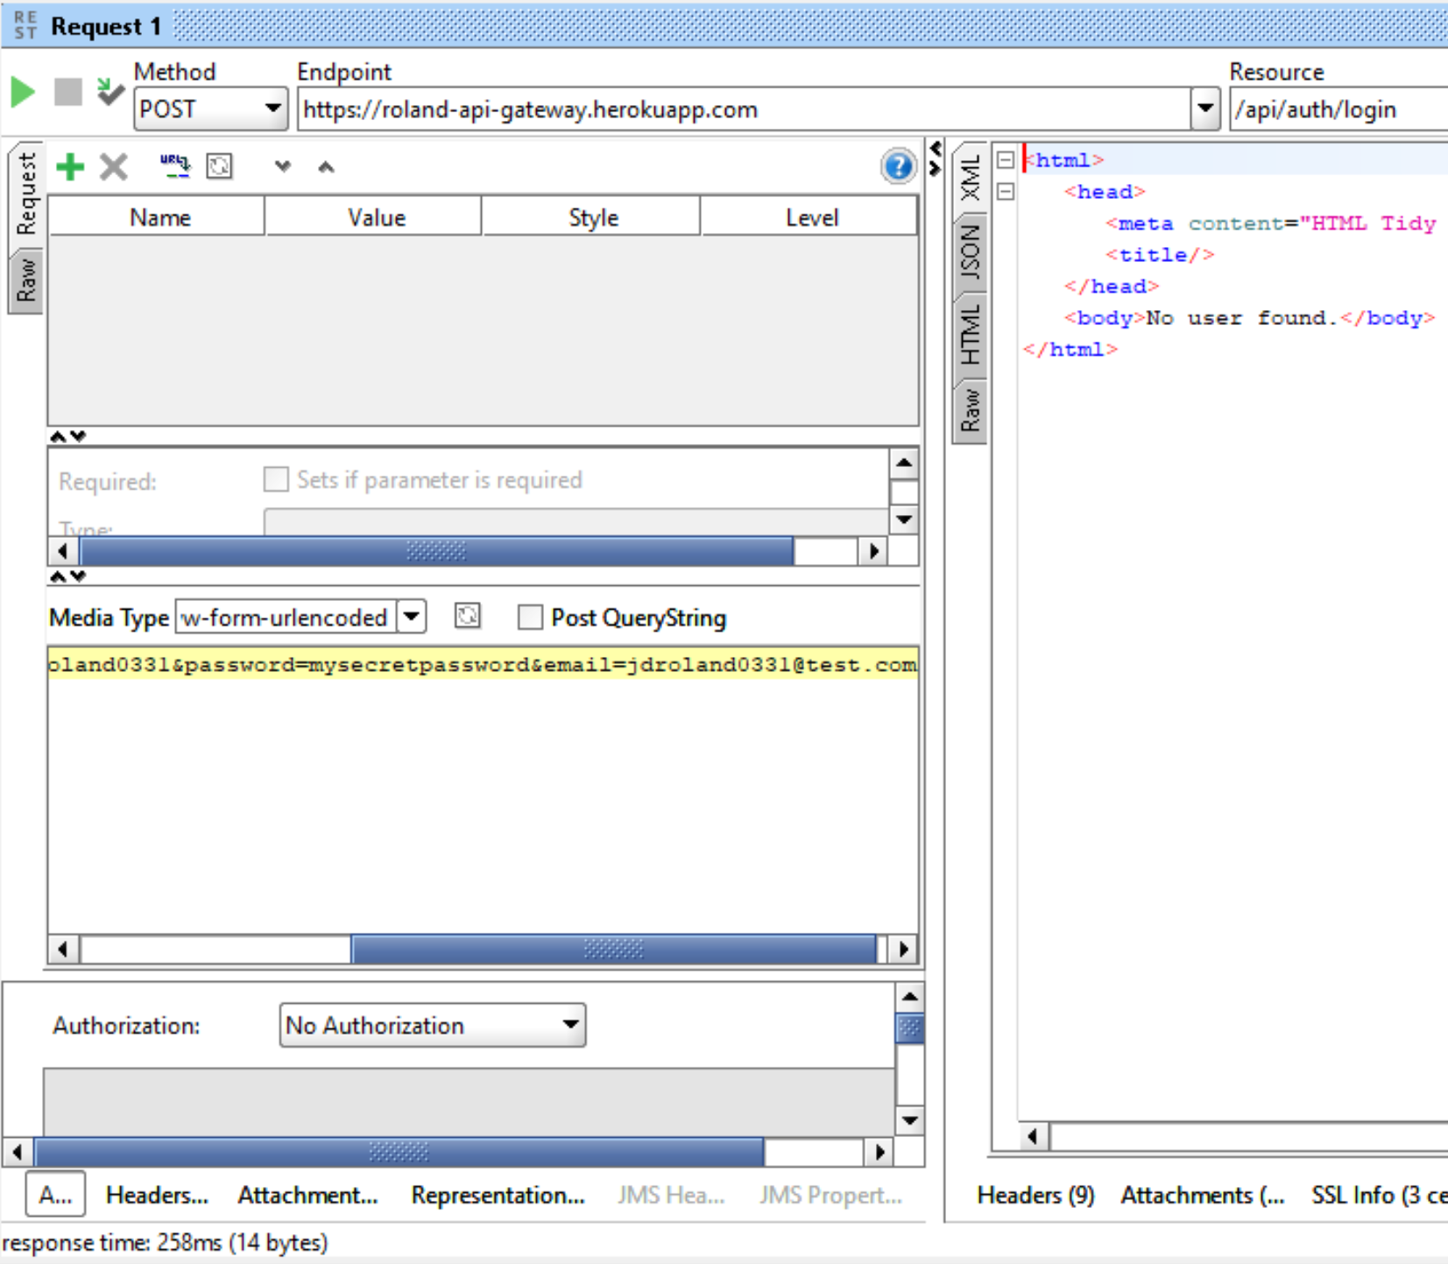

Login Response:

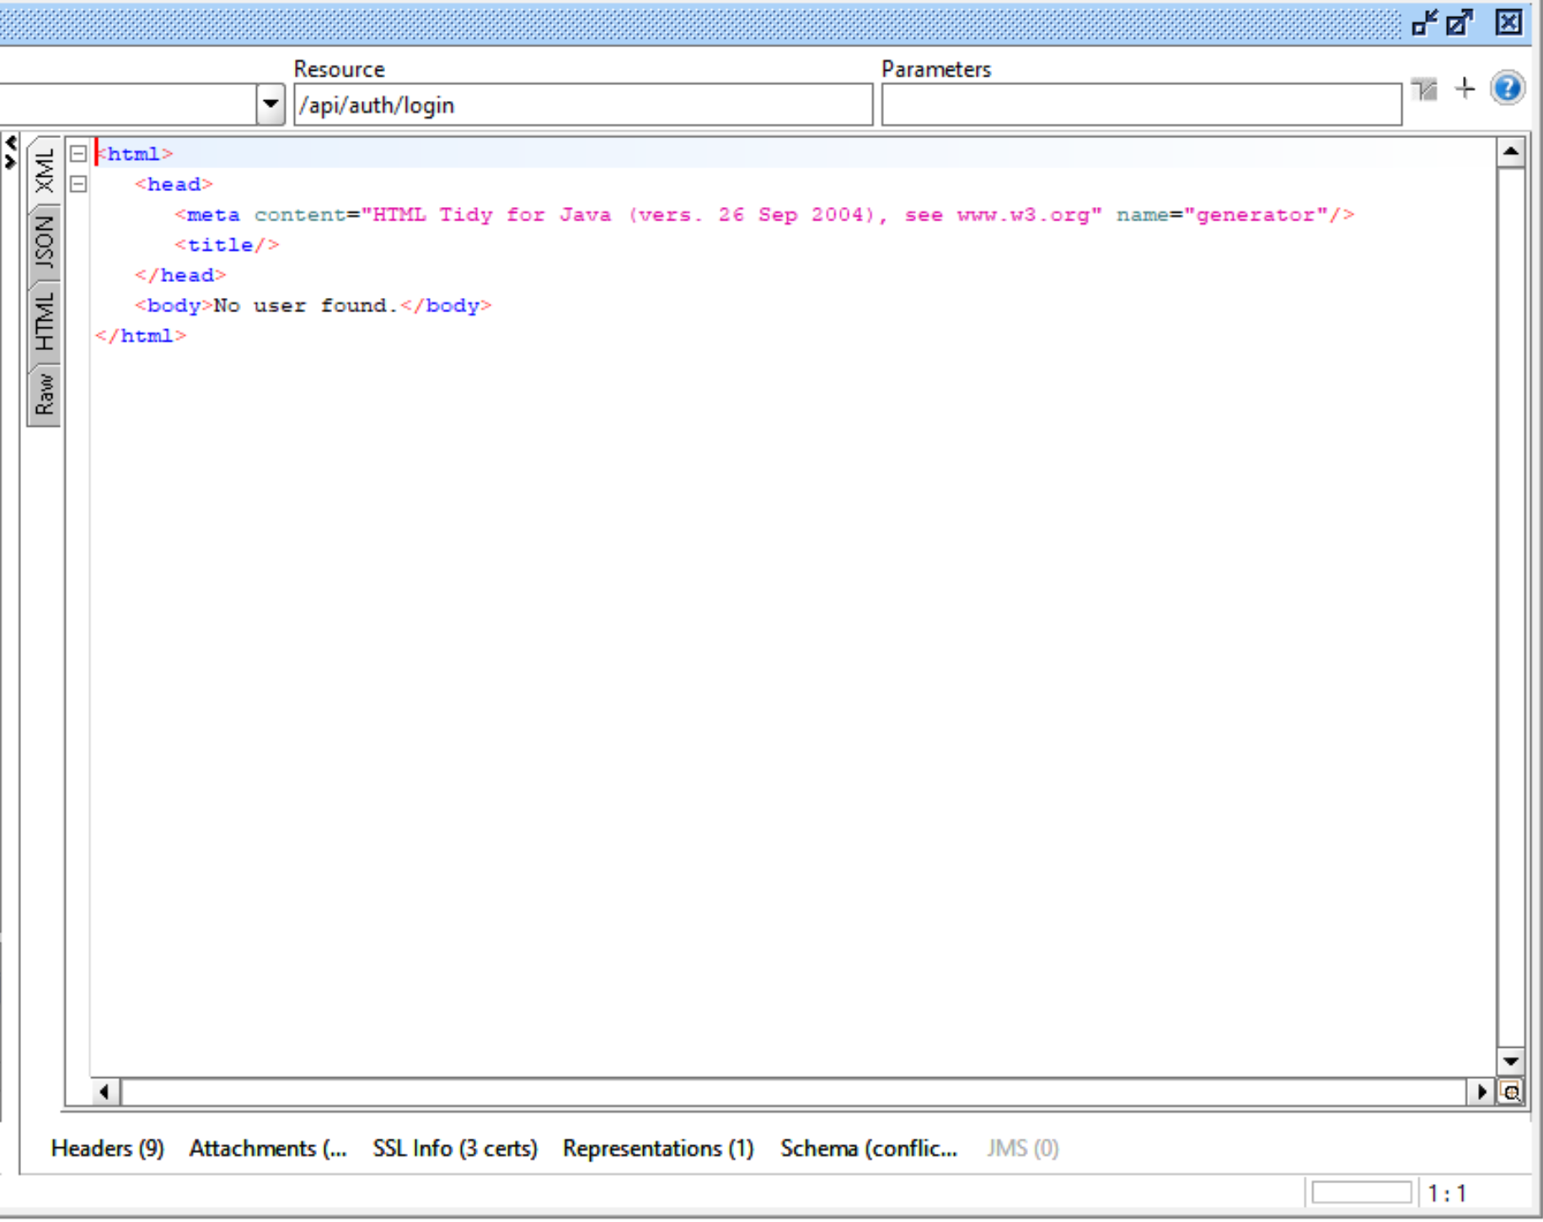

Logout Request:

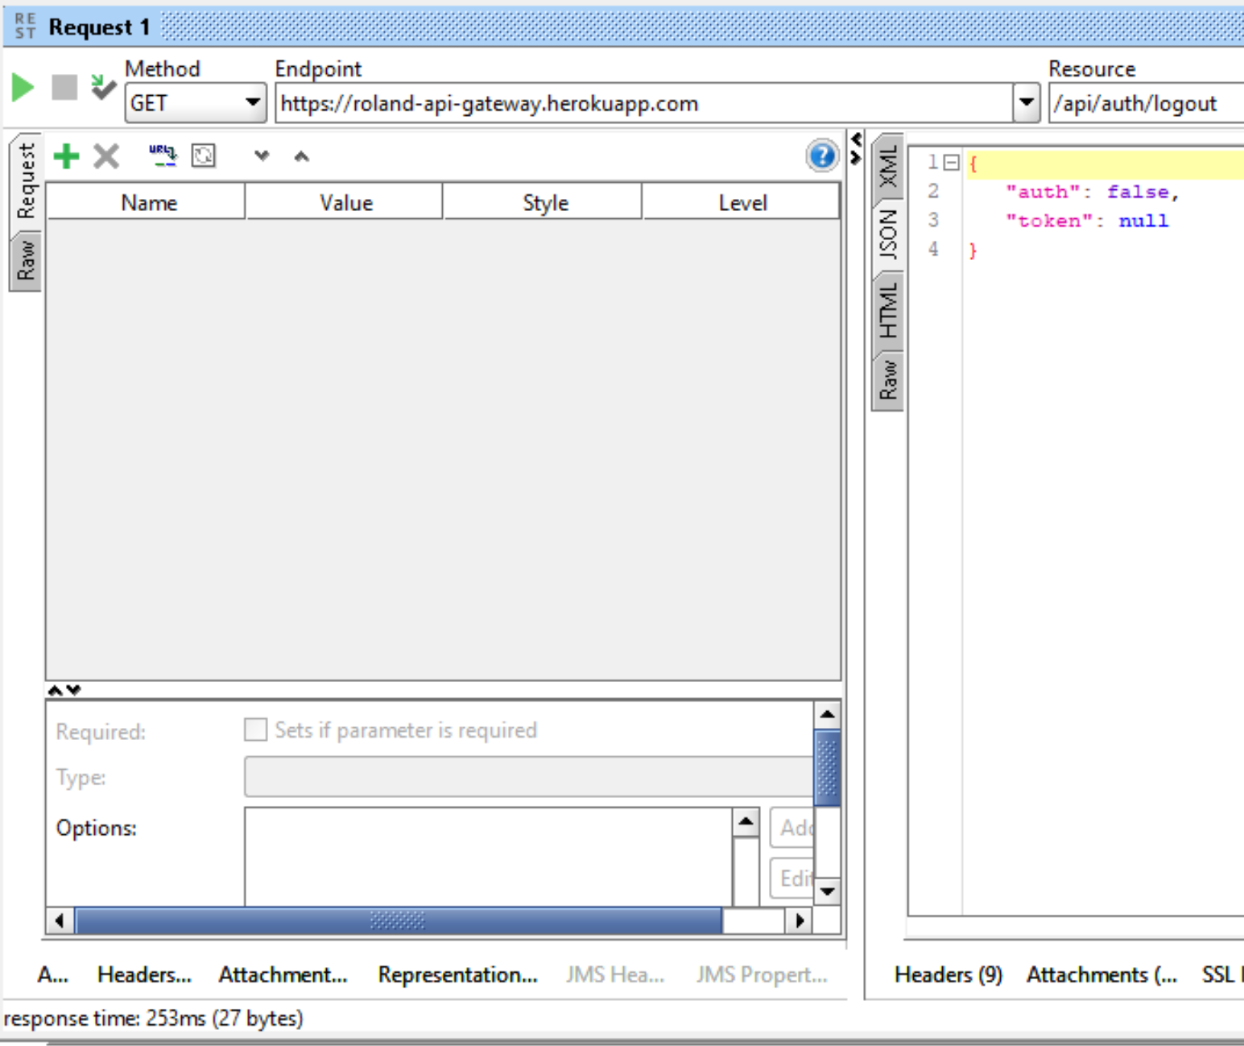

Logout Response:

