Sam Piazza, Jakob Russell, Sasha Fenton

Mr. Hayes

APCS

May 5, 2017

Connect Four (Camelids)

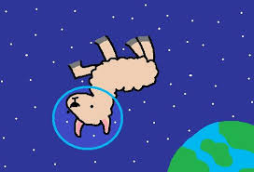

**Classes:**

* Plan on using Graphics 2D to create the image of the game with animations. Subclasses include the use of making different shaped objects, such as a line class to create a grid, or a circle class to make the pieces. The methods of these include setting the color (for player) and changing location (for animation). Most of the interaction with the Graphics 2D is used as a parent class of the objects that will be created for the game.
* A mouselistener class to be able to click on an area to place the piece. Research is needed.

**Graphical Output:**

* A menu page: graphic camelids (llamas and alpacas) floating around in space with space helmets, asteroids, play button, exit button, menu space music
* The game page: A header, a talking camelid for each player, the game board, background images, game music, quit option
  + Game will have multiple “levels” with various asteroid (blockade) patterns
  + Each piece will have a color and either a llama or alpaca on it (the two players)

**Interaction:**

* User interaction is going to require some research with using a mouse listener, however, will be accomplished by allowing the player to click on a specified area to drop their piece.

**Responsibilities:**

* Sam - Logistics behind the game such as how the game works (taking turns between players) and determining when four are in a row.
* Jake -Design and planning along with input methods, animation
* Sasha - Graphic design, background images and characters, dialogue, animation