*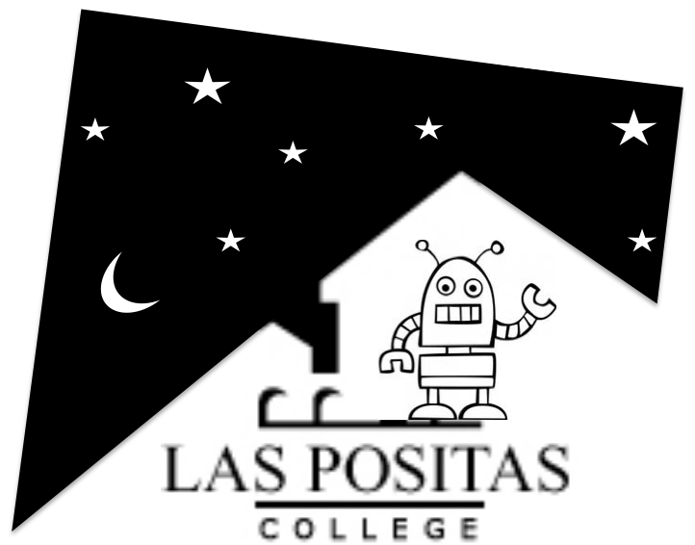***Making Makers**

**At the Boundary of Physics and Electronics**

*Makers aren’t born, they’re made.*

Spring 2016

Bldg 1850, Room 1822

Six Tuesday evenings: 6:00 to 7:30 pm

Dates: 2/23, 3/1*, 3/8, 3/15, 3/22, 4/12

*2nd meeting at Robot Garden, 2324 Second St, Livermore, CA 94550

Instructors: Jay Salmonson,

[jsalmonson@laspositascollege.edu](mailto:jsalmonson@laspositascollege.edu) (925) 422-9730 (week-days)

Andrew Lozano,

[alozano@laspositascollege.edu](mailto:alozano@laspositascollege.edu) (925) 424-1339 (week-days)

Office Hours: by appointment

**I. About this class:**

This course is meant to be an introduction to the maker movement from the bottom up. There are many books, kits, courses, and websites available that provide excellent introductions to electronics, particularly using the popular Arduino micro-controller that we will use. However, this course will explore the physics of actuators and sensors that can be controlled and interfaced with an Arduino. By exploring the physical principles and designing and building examples, we will obtain a deeper picture of how things work and why. By interfacing with the Robot Garden hacker-space, the student will be introduced to a network and support group that will enable and enhance his future maker endeavors. Several guest maker show-and-tells will be scheduled throughout the course.

**Prerequisites:** A desire to learn about some physics and electronics and how they can come together to enable your creativity.

**Recommended:** Laptops with the latest Arduino IDE software will be provided, however, you might prefer to bring your own computer (Linux, Mac, Windows) with said software installed. It can be downloaded for free by clicking “Download” at www.arduino.cc.

**Provided:** With your $100 materials fee (payable at the beginning of the first class) you will receive an Arduino UNO electronics kit as well as several additional electronic components provided throughout the course. You will also receive a student membership to the Robot Garden hacker-space in downtown Livermore (note that the 2nd class will be held there). In the classroom, laptops, bench power supplies, soldering irons and basic tools will be available.

**Catalog Description:** In this course we will build a robot from the bottom up. We will investigate the physics of sensors and actuators; how to build them and how they work, from solenoids, galvenometers and motors to piezoelectric transducers to shape memory alloys. We will then learn how to control said actuators by programming an Arduino microcontroller. We will then assemble these pieces into our own robot.

There will be a fee to cover parts necessary for completion of the project.

In addition, each student will get a student membership to the Robot Garden hackerspace in downtown Livermore over the duration of the course. We will learn to use those facilities to laser-cut, 3D print and CNC route our robot parts. No experience with electronics or programming is required.

**Course Outline:**

Class 1, 2/23: Introduction to principles of Electronics and Electromagnetism. Introduction to programming the Arduino.

Class 2, 3/1: Held at Robot Garden. Introduction to Robot Garden and its facilities. How to use the laser cutter and 3D printer.

Class 3, 3/8: Electromagnetism. Actuators: solenoids and electric motors.

Class 4, 3/15: More solenoids and electric motors. Shape Memory Alloy.

Class 5, 3/22: Sensors: piezoelectric, capacitive.

-- Two Week Spring Break –

Class 6, 4/12: More Sensors. Wrap-up. Student show-and-tell.

**Accommodations for students with disabilities**

Please let me know if you have any special needs (learning disabilities, physical or mental disabilities, health, vision, hearing problems). If you need course accommodations because of a disability (such as note takers, readers, or extended time on exams and assignments) please let me know and contact the campus Disability Resource Center located in building 1600 (room 1615, phone 925.424.1510).