USE CASE DIAGRAM

Diagram-1: Use Case Diagram for ATM Machine

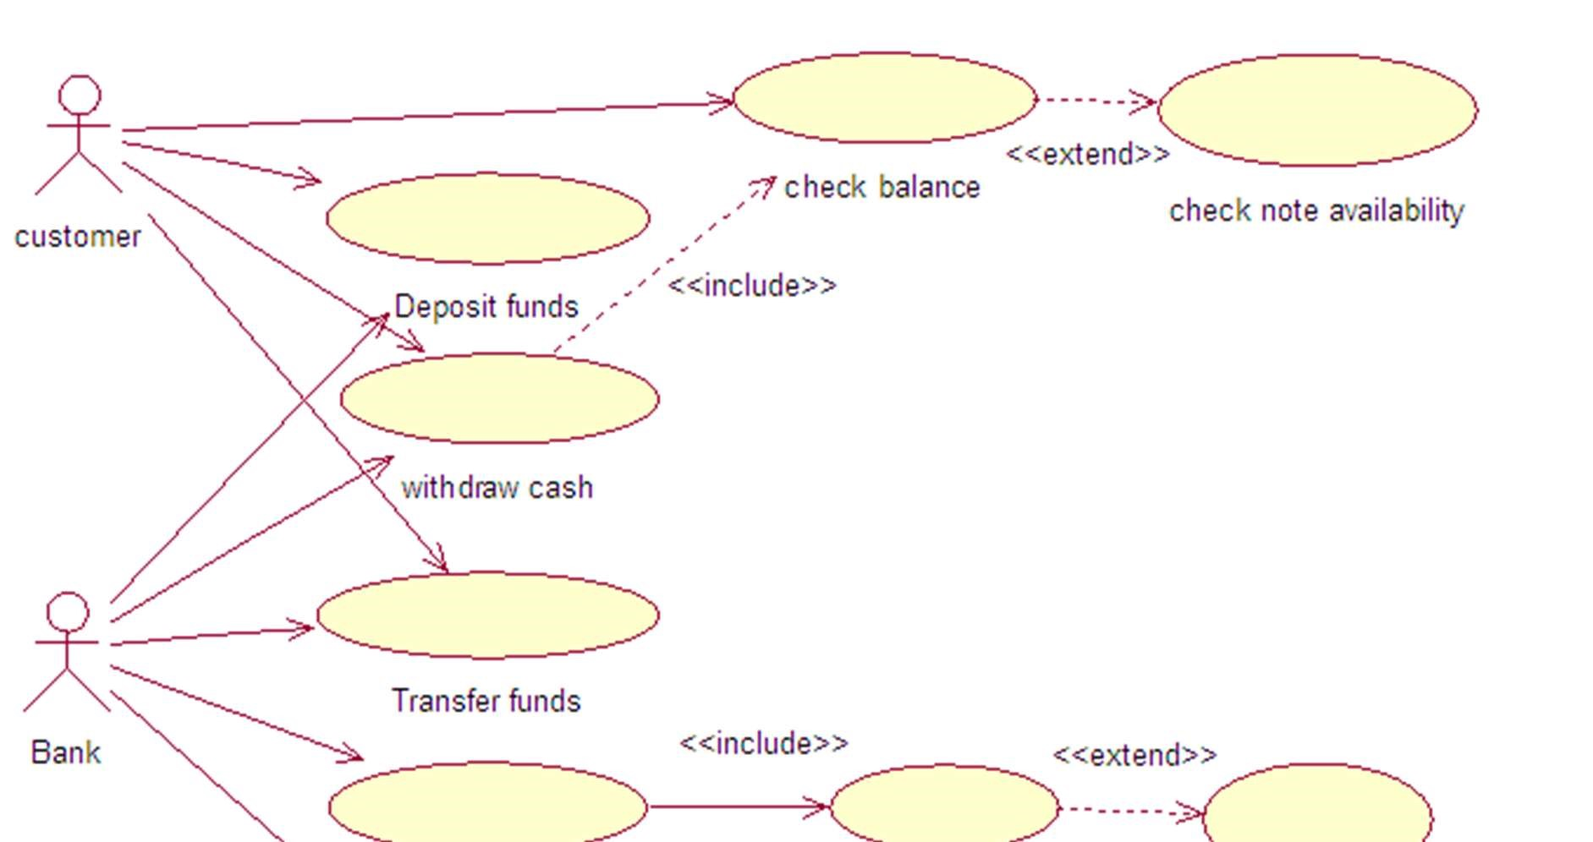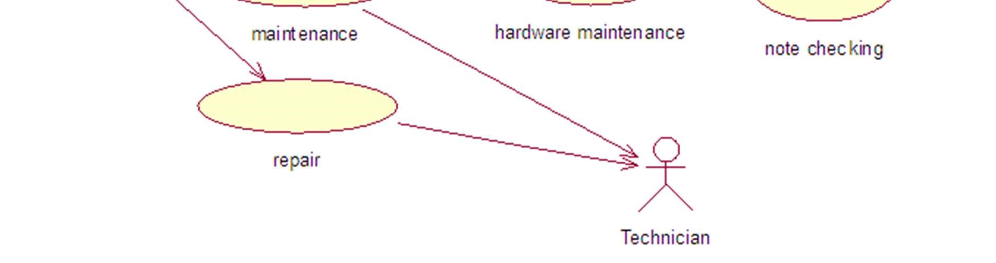

Diagram-2: Use Case Diagram for Online Book Store

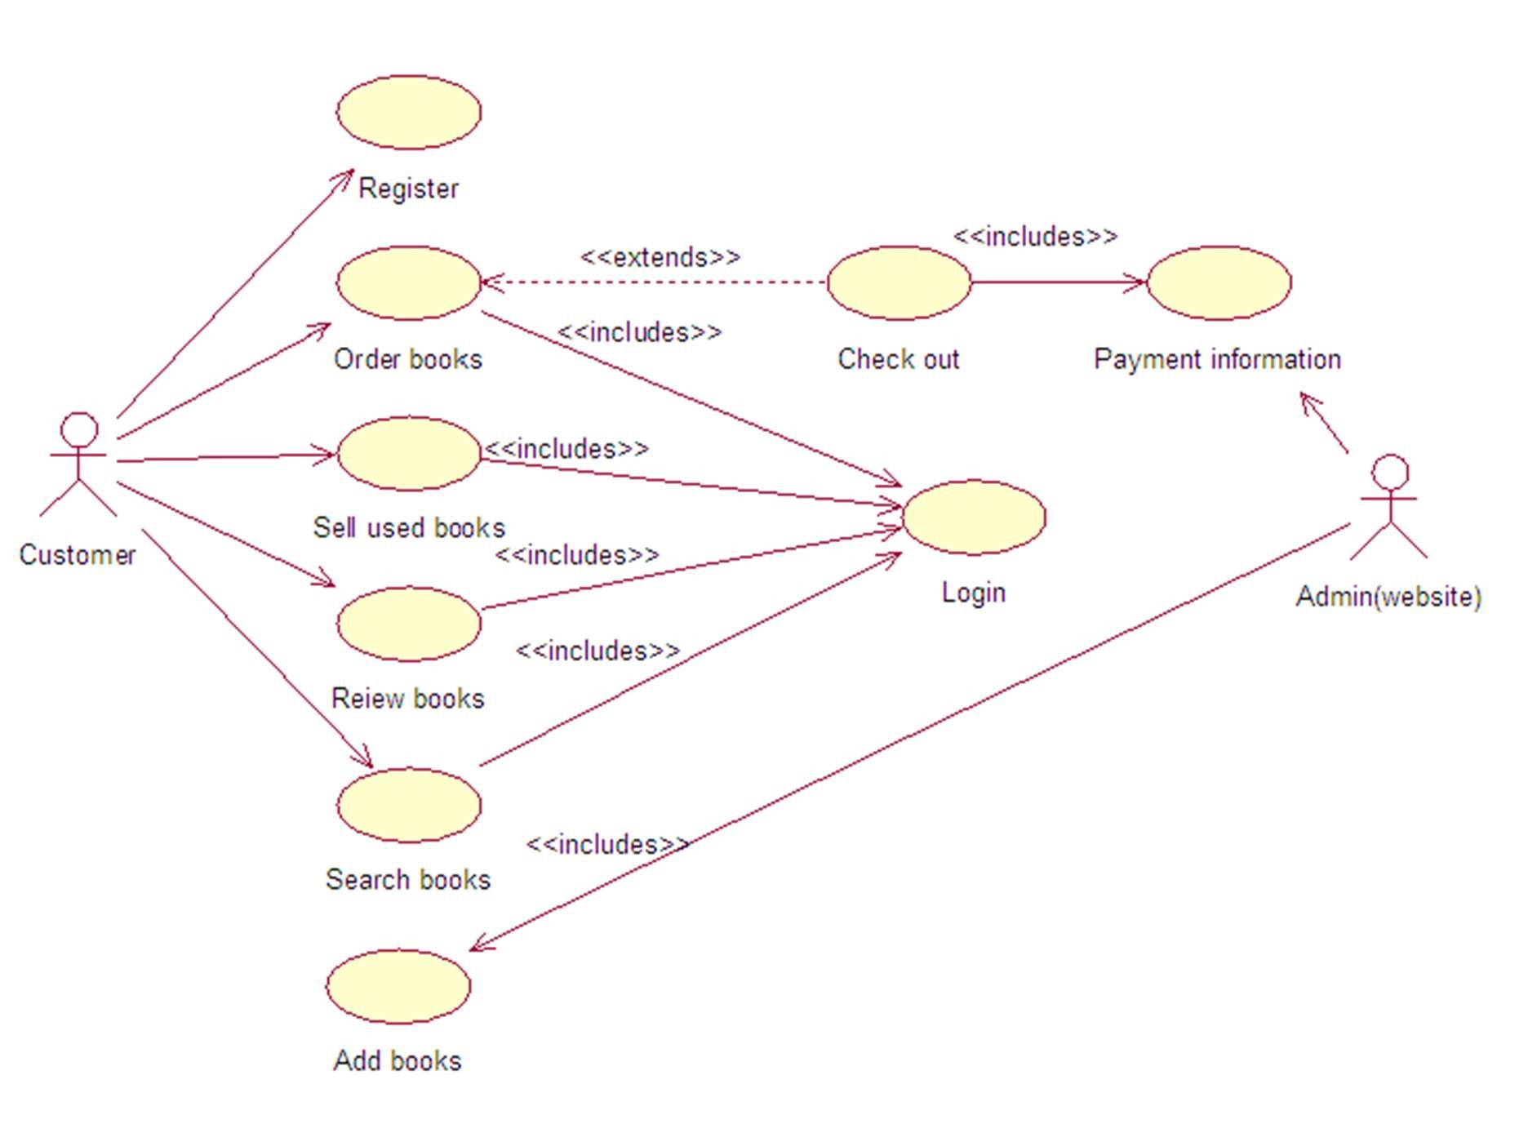

Diagram-3: Use Case Diagram for Cellular Calling System

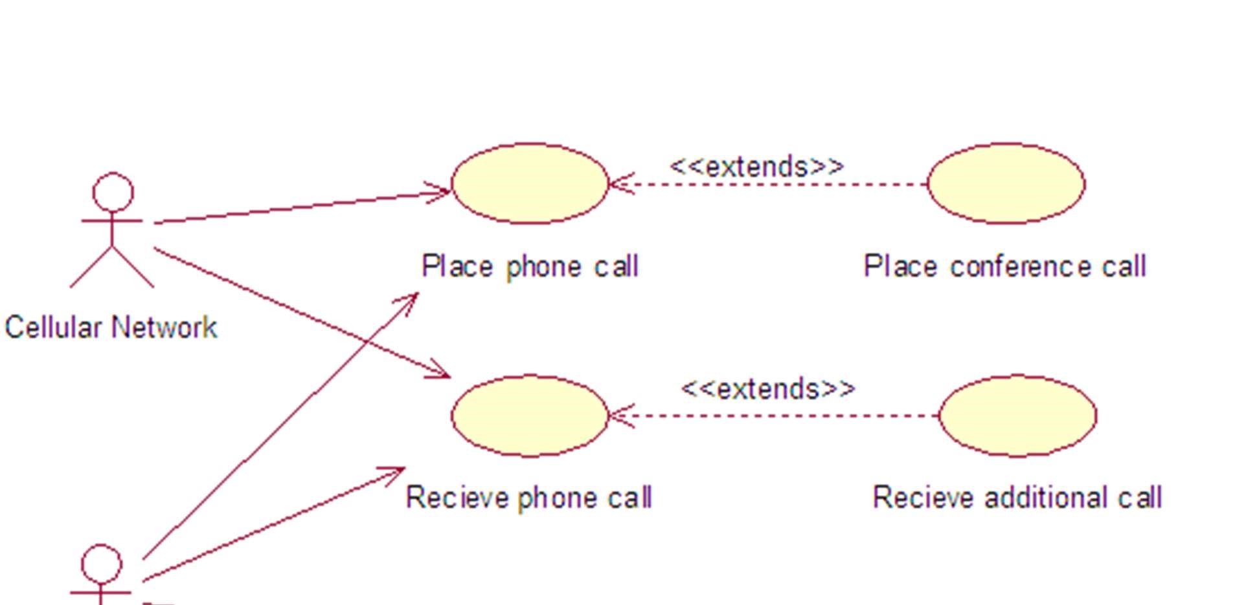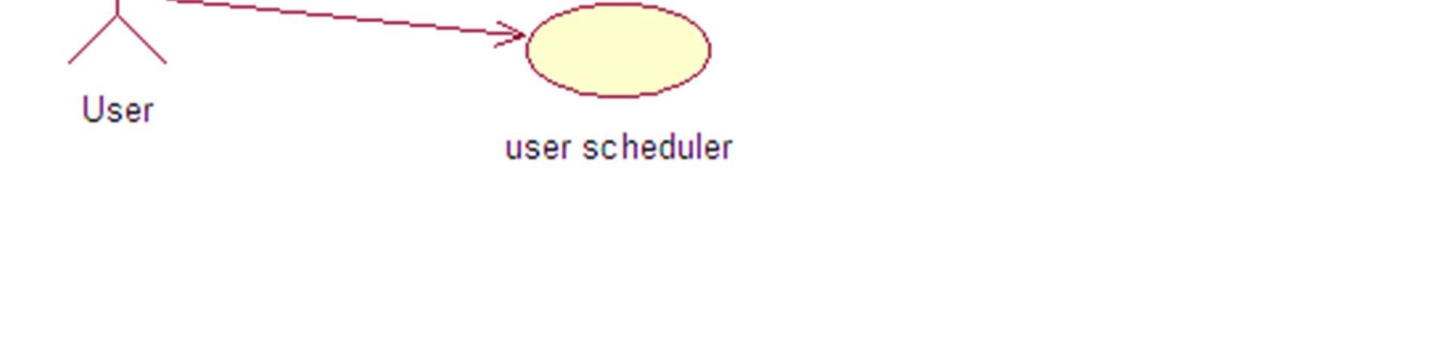

Diagram-4: Use Case Diagram for Flight Management System

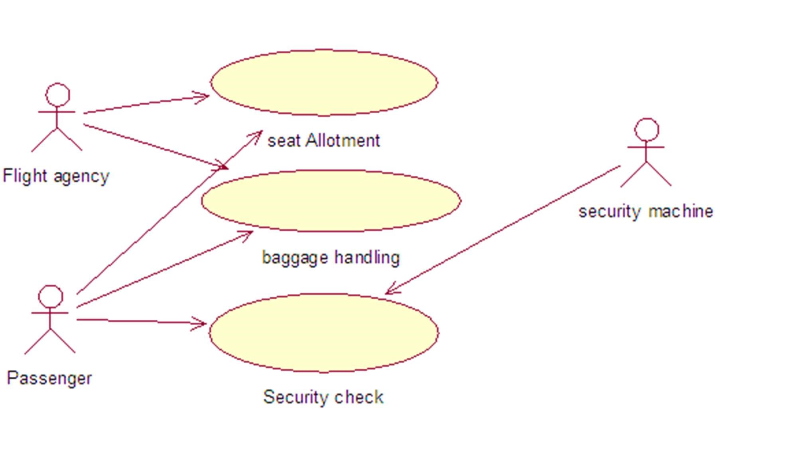

Diagram-5: Use Case Diagram for Payroll System

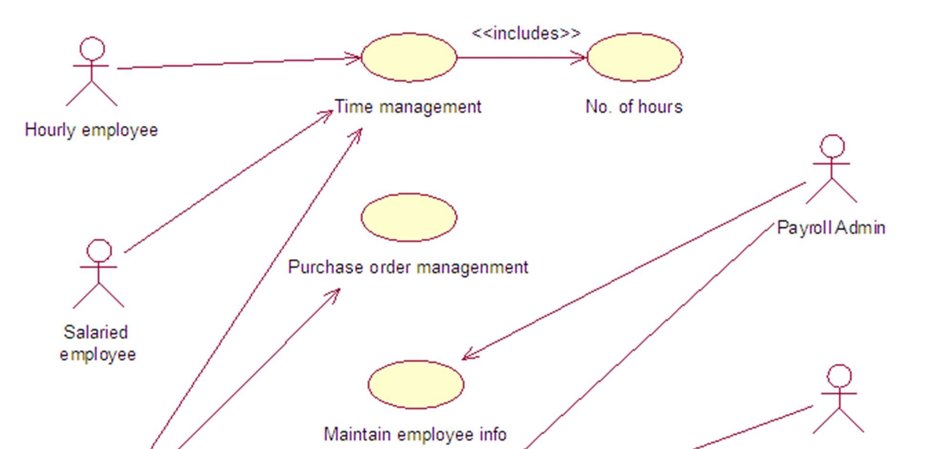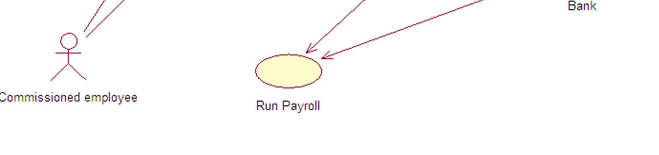

Diagram-6: Use Case Diagram for Shopping Cart.

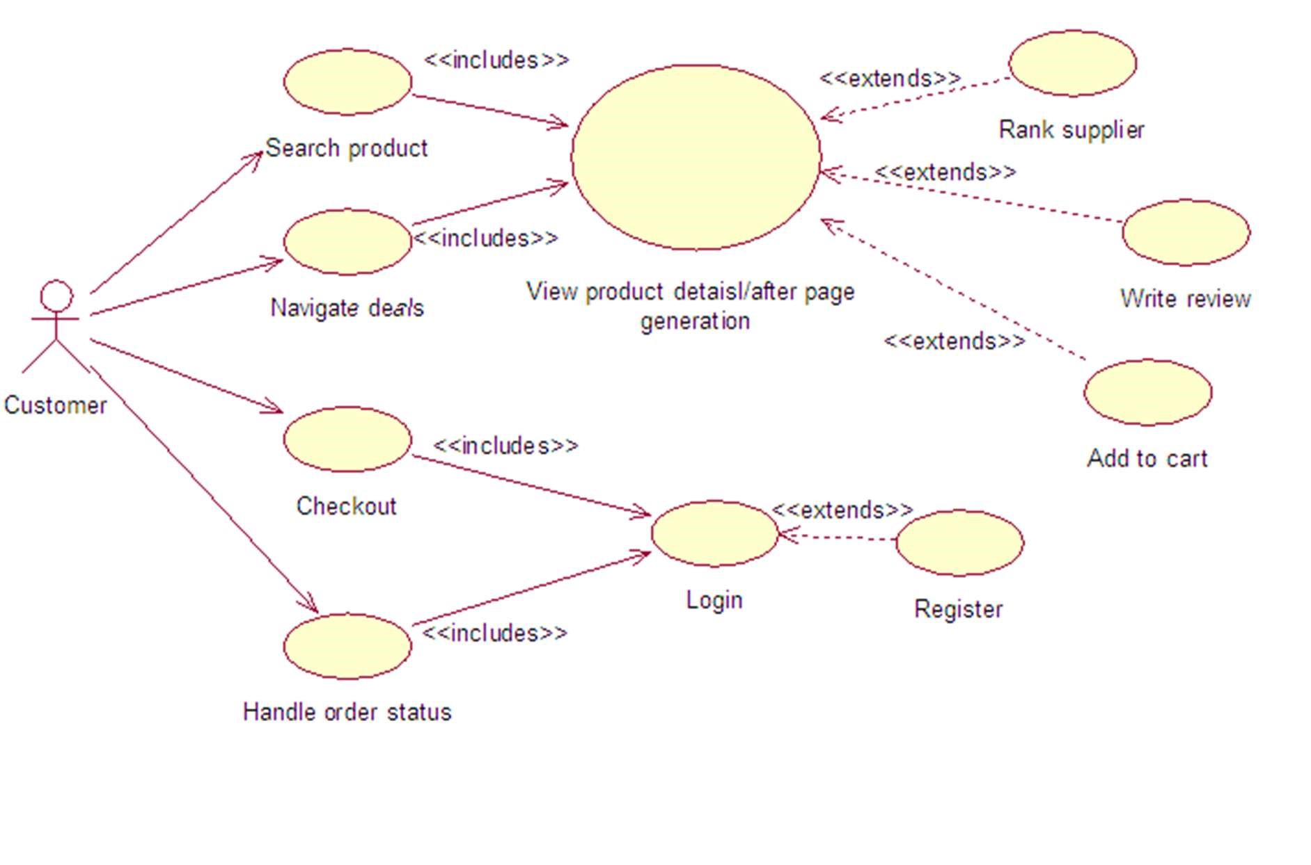

Diagram-7: Use Case Diagram for Super Market.

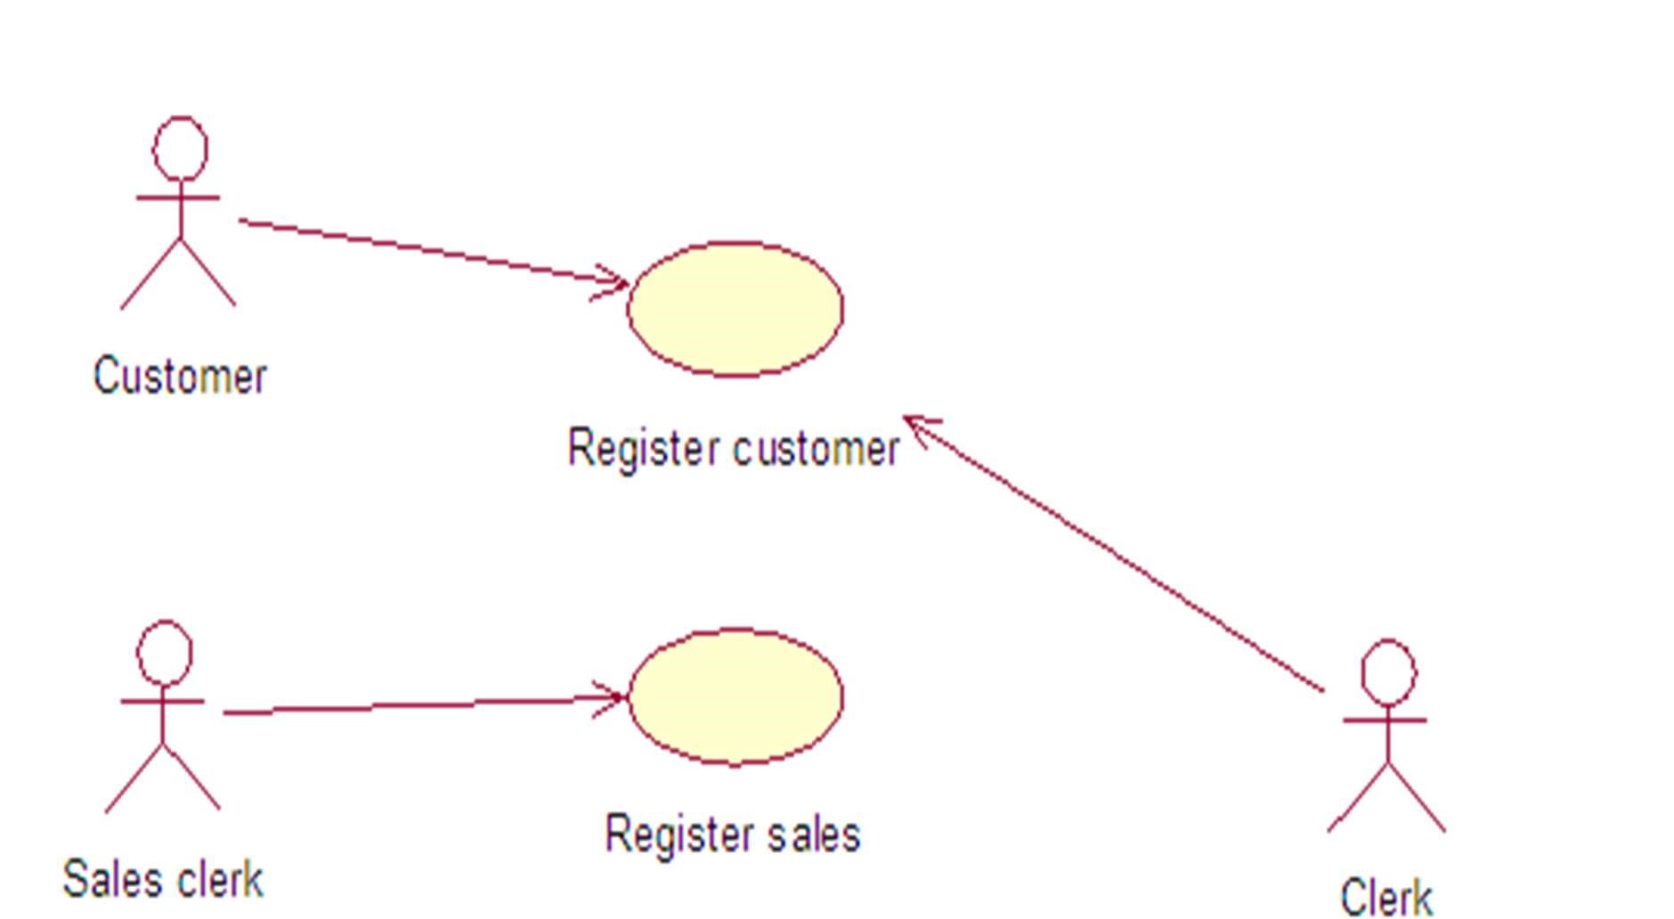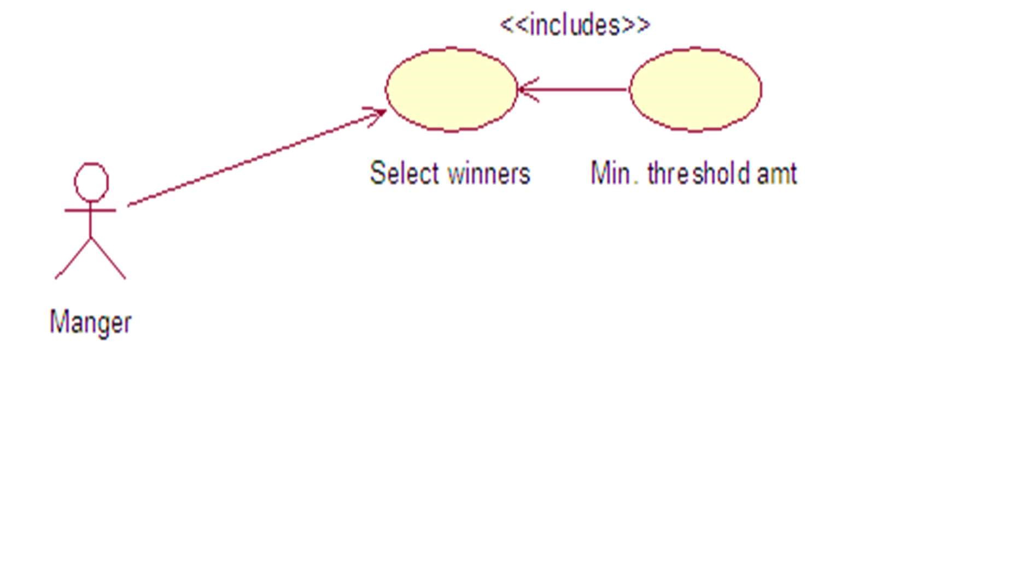

CLASS DIAGRAM

Diagram-1: Class Diagram for Air Transportation

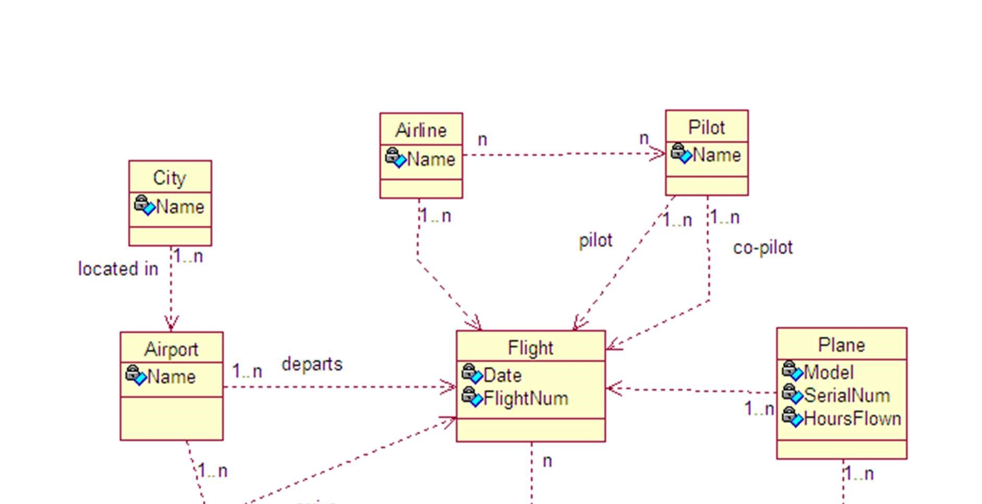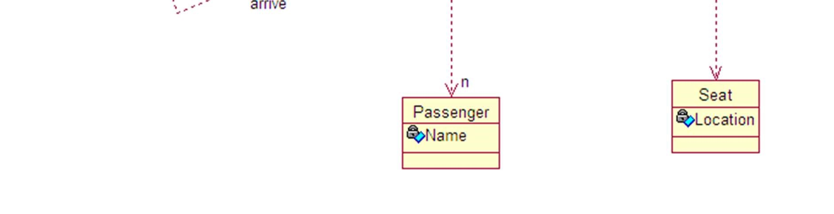

Diagram-2: Class Diagram for Geo-metrical Shape

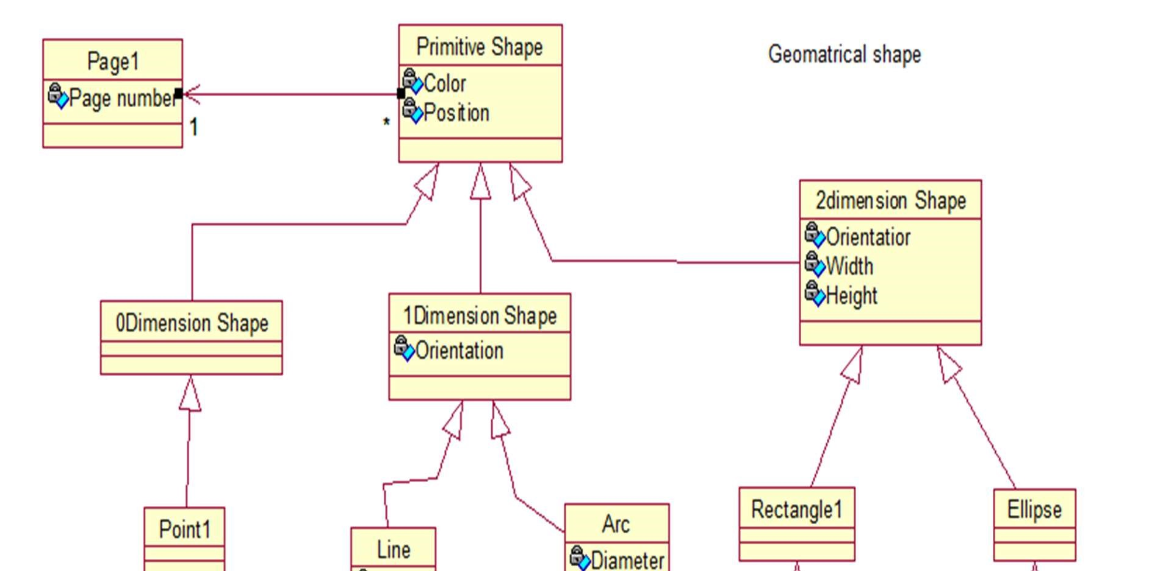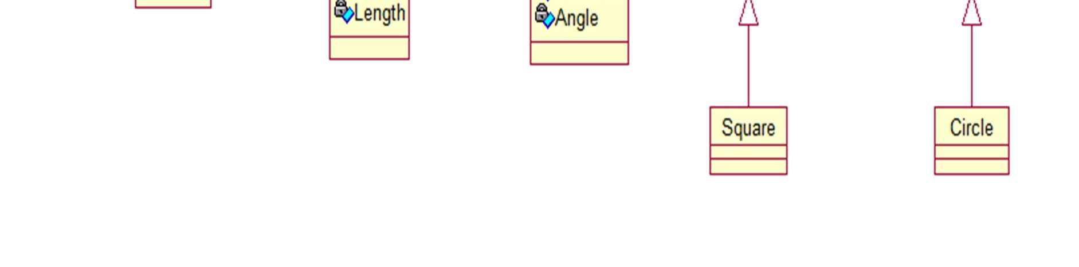

Diagram-3: Class Diagram for Online Exam

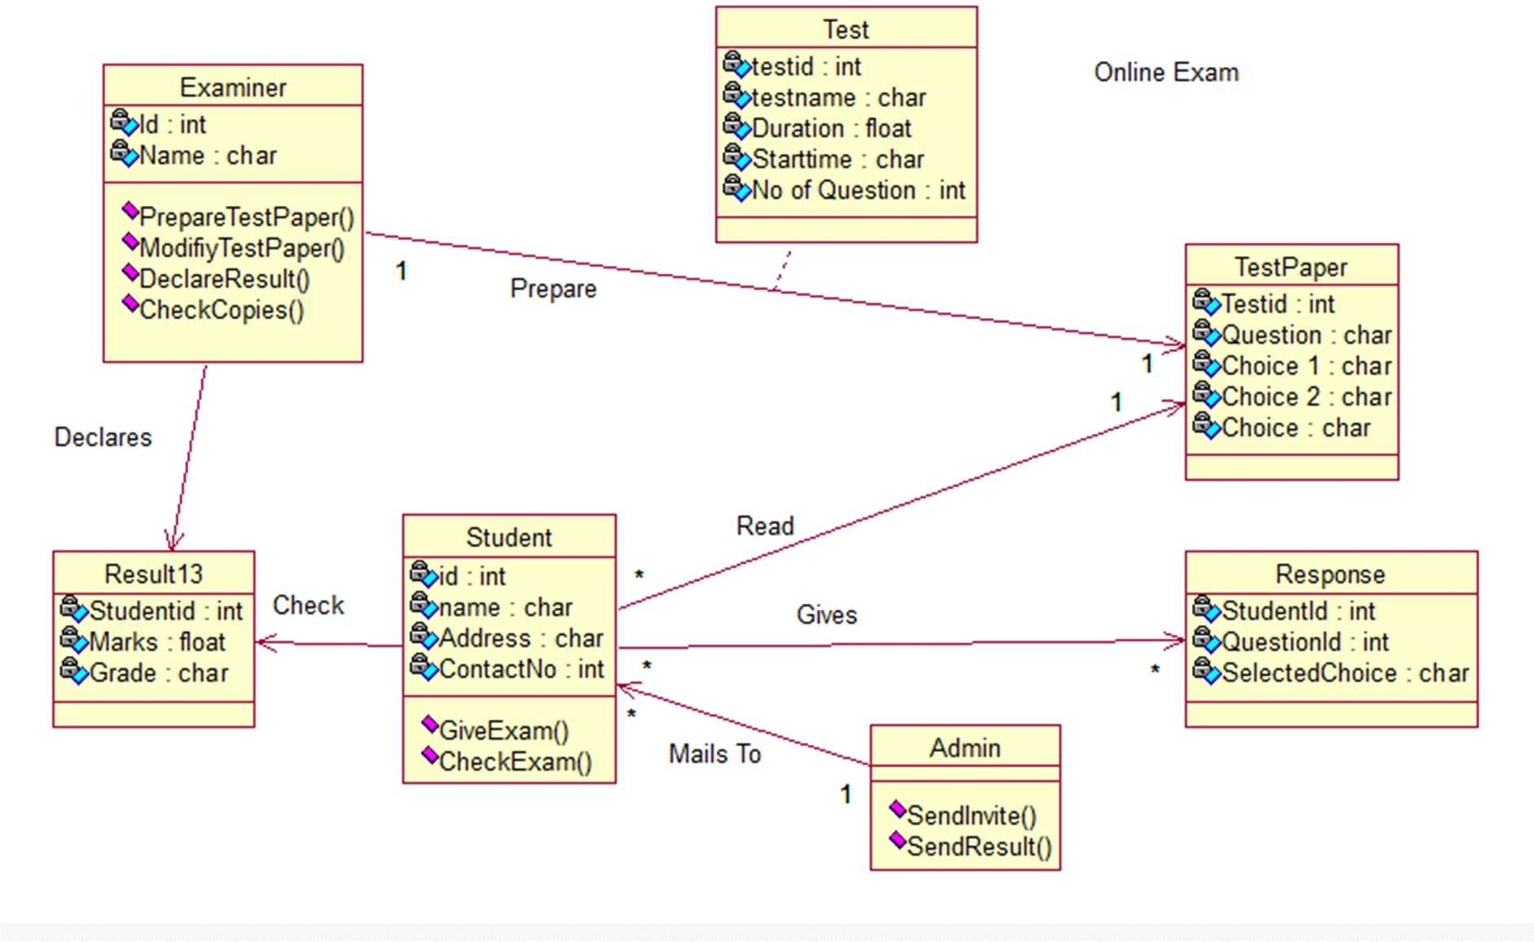

Diagram-4: Class Diagram for Online Order System

