**Name :- Dusara Jahanvi**

**Div :- A**

**Roll no :- 09**

**Subject :- Advanced Java**

**Day-1**

**1. How to create tables in Mysql. Create table employee. And understanding of software requirements and setting paths.**

CREATE TABLE employee

(

employee_id INT AUTO_INCREMENT PRIMARY KEY,

first_name VARCHAR(50) NOT NULL,

last_name VARCHAR(50) NOT NULL,

email VARCHAR(100) NOT NULL UNIQUE,

hire_date DATE,

salary DECIMAL(10, 2)

);

**Day-2**

**2. Create a java Application that connect java with mysql and display the data from employee table on command prompt.**

package employeedisplay;

import java.sql.Statement;

import java.sql.Connection;

import java.sql.DriverManager;

import java.sql.Connection;

import java.sql.DriverManager;

import java.sql.*;

import java.util.*;

public class EmployeeDisplay {

public static void main(String[] args) {

String url = "jdbc:mysql://localhost:3308/demo";

String user = "root";

String password = "";

String query = "SELECT * FROM students";

try {

Class.forName("com.mysql.cj.jdbc.Driver");

Connection con = DriverManager.getConnection("jdbc:mysql://localhost:3308/demo","root","");

Statement stmt = con.createStatement();

ResultSet rs = stmt.executeQuery(query);

while (rs.next()) {

int id = rs.getInt("student_id");

String studentName = rs.getString("student_name");

int enrollment_no = rs.getInt("enrollment_no");

int semester = rs.getInt("semester");

System.out.printf("ID: %d, Name: %s , EnrollmentNo: %d, Semester: %d",

id, studentName,enrollment_no,semester);

}

} catch (Exception e) {

e.printStackTrace();

}

}

}

**Output :-**

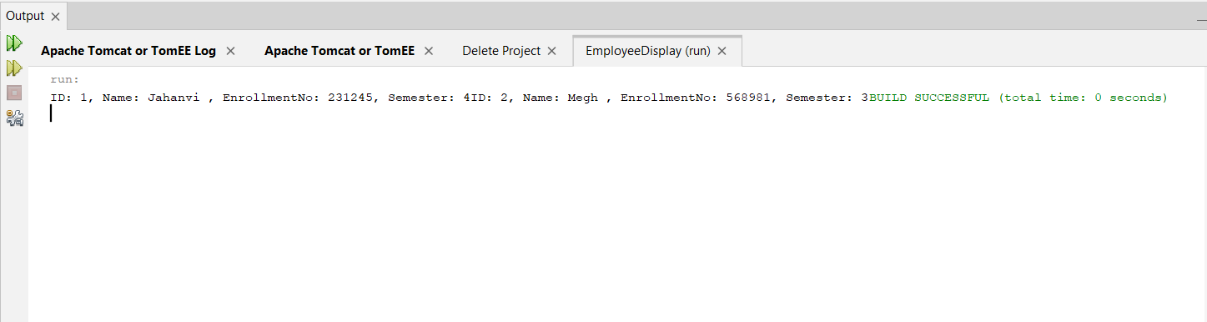

**Day-3**

**3. Create Java Application that Insert data in employee table.**

**4. Create Java Application that update data in employee table.**

**5. Create Java Application that delete data from employee table.**

/*

* Click nbfs://nbhost/SystemFileSystem/Templates/Licenses/license-default.txt to change this license

* Click nbfs://nbhost/SystemFileSystem/Templates/Classes/Main.java to edit this template

*/

package crudapplication;

import java.sql.Connection;

import java.sql.DriverManager;

import java.sql.*;

import java.util.*;

public class CrudApplication {

public static void main(String[] args) {

try{

Class.forName("com.mysql.cj.jdbc.Driver");

Connection con = DriverManager.getConnection("jdbc:mysql://localhost:3306/student","root","");

int op;

do{

System.out.println("1.Insert");

System.out.println("2.Update");

System.out.println("3.Delete");

System.out.println("4.Select");

System.out.println("0.Exit");

System.out.println("Enter your choice operation: ");

Scanner sc = new Scanner(System.in);

op = sc.nextInt();

switch(op)

{

case 1:

insertRecord(con);

break;

case 2:

updateRecord(con);

break;

case 3:

deleteRecord(con);

break;

case 4:

selectRecord(con);

break;

case 0:

break;

}

}while(op!=0);

}

catch(SQLException e)

{

e.printStackTrace();

}

catch(Exception e)

{

System.out.println(e);

}

}

private static void insertRecord(Connection con) throws SQLException

{

try{

PreparedStatement ps = con.prepareStatement("insert into stud(id,name,password,email) values(?,?,?,?)");

ps.setInt(1, 3);

ps.setString(2,"Megh");

ps.setString(3,"megh123");

ps.setString(4,"megh02@gmail.com");

int insert = ps.executeUpdate();

System.out.println("Inserted "+insert+"row");

}

catch(Exception e){

e.printStackTrace();

}

}

private static void updateRecord(Connection con) throws SQLException

{

try{

PreparedStatement ps = con.prepareStatement("update stud set name=? where id =?");

ps.setString(1, "Krisha");

ps.setInt(2,1);

int update = ps.executeUpdate();

System.out.println("Updated "+update+"row");

}

catch(Exception e){

e.printStackTrace();

}

}

private static void deleteRecord(Connection con) throws SQLException

{

try{

PreparedStatement ps = con.prepareStatement("delete from stud where email=?");

ps.setString(1,"megh02@gmail.com");

int delete = ps.executeUpdate();

System.out.println("Deleted "+delete+"row");

}

catch(Exception e){

e.printStackTrace()

}

private static void selectRecord(Connection con) throws SQLException

{

try{

PreparedStatement ps = con.prepareStatement("select * from stud where id=?");

ps.setInt(1, 2);

ResultSet rs = ps.executeQuery("select *from stud");

while(rs.next())

{

System.out.println("Id: "+rs.getInt("id"));

System.out.println("Name: "+rs.getString("name"));

System.out.println("Password: "+rs.getString("password"));

System.out.println("Email: "+rs.getString("email"));

}

}

catch(Exception e){

e.printStackTrace();

}

}

}

**Output :-**

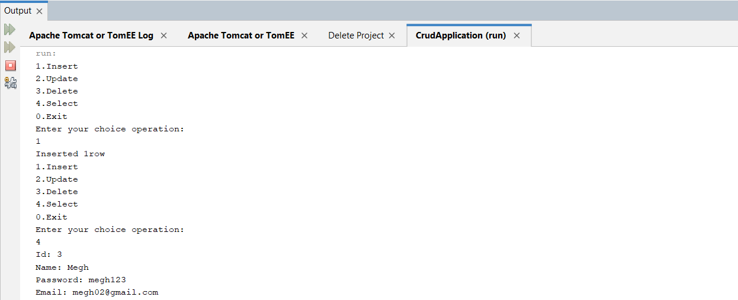

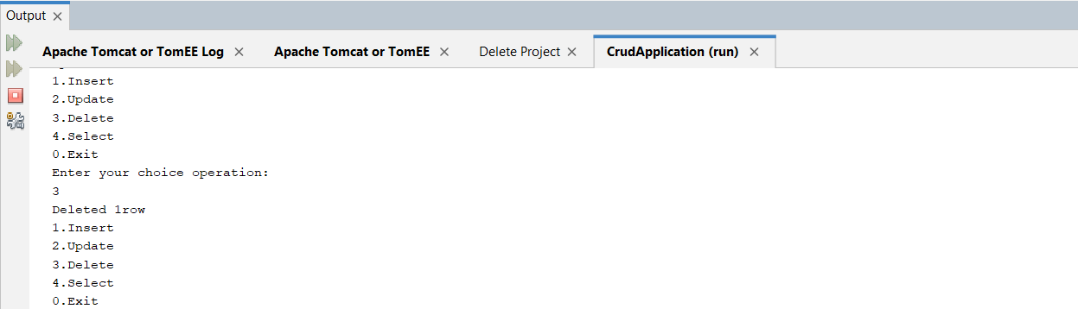

**Day-4**

**6. Create Java Application that demonstrate the use of InetAdrress class.**

package inetdemo;

import java.net.*;

public class Inetdemo {

public static void main(String[] args) {

try{

InetAddress ip = InetAddress.getByName("www.yahoo.com");

System.out.println("Host Name: "+ip.getHostName());

System.out.println("Host Address: "+ip.getHostAddress());

}

catch(Exception e)

{

System.out.println(e);

}

}

}

**Output :-**

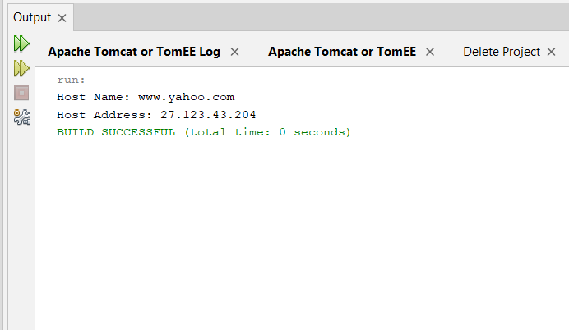

**7. Implement client server chat Application using socket programming.**

**ClientChat.java**

package clientchat;

import java.io.IOException;

import java.net.UnknownHostException;

import java.net.*;

import java.io.DataOutputStream;

import java.io.DataInputStream;

public class ClientChat {

public static void main(String[] args) {

try{

InetAddress ip = InetAddress.getLocalHost();

Socket sc = new Socket(ip.getHostName(),5600);

DataOutputStream dos = new DataOutputStream(sc.getOutputStream());

DataInputStream dis = new DataInputStream(System.in);

String line = "";

while(!line.equals("bye"))

{

try{

line = dis.readLine();

dos.writeUTF(line);

dos.flush();

}

catch(IOException ioe)

{

System.out.println("Sending error: "+ioe.getMessage());

}

}

dos.close();

dis.close();

}

catch(UnknownHostException e)

{

e.printStackTrace();

}

catch(IOException e)

{

e.printStackTrace();

}

}

}

**ServerChat.java**

package serverchat;

import java.io.*;

import java.net.*;

public class ServerChat {

private ServerSocket server;

private int port = 5600;

public ServerChat()

{

try

{

server = new ServerSocket(port);

}

catch(IOException e)

{

e.printStackTrace();

}

}

public static void main(String[] args) {

ServerChat server = new ServerChat();

server.connection();

}

public void connection()

{

System.out.println("Waitting for client..");

try{

Socket soc = server.accept();

System.out.println("Client accepted: "+soc);

DataInputStream dis = new DataInputStream(new BufferedInputStream(soc.getInputStream()));

boolean done = false;

while(!done)

{

try{

String line = dis.readUTF();

System.out.println(line);

done = line.equals("bye");

}

catch(IOException e)

{

done = true;

}

}

dis.close();

soc.close();

}

catch(IOException ioe)

{

System.out.println(ioe);

}

}

}

**Output :-**

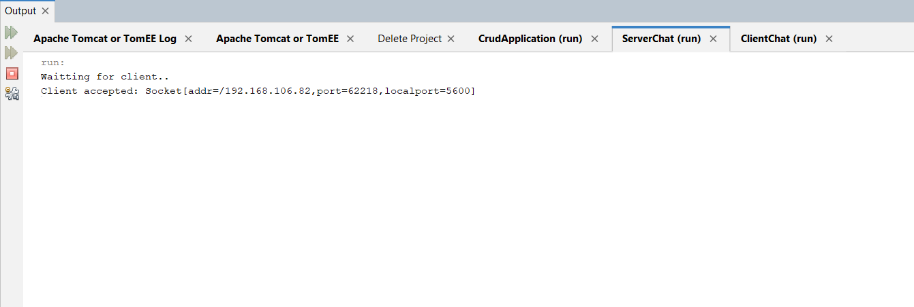

**Day-5**

**8. Implement client server chat application using datagram.**

**DReceiver.java**

package dreciever;

import java.net.*;

public class DReciever {

public static void main(String[] args) throws Exception {

DatagramSocket ds = new DatagramSocket(3000);

byte[] buf = new byte[1024];

DatagramPacket dp = new DatagramPacket(buf,1024);

ds.receive(dp);

String str = new String(dp.getData(),0,dp.getLength());

System.out.println(str);

ds.close();

}

}

**DSender.java**

package dsender;

import java.net.*;

public class DSender {

public static void main(String[] args) throws Exception{

DatagramSocket ds = new DatagramSocket();

String str = "Welcome java";

InetAddress ip = InetAddress.getByName("127.0.0.1");

DatagramPacket dp = new DatagramPacket(str.getBytes(),str.length(),ip,3000);

ds.send(dp);

ds.close();

}

}

**Output :-**

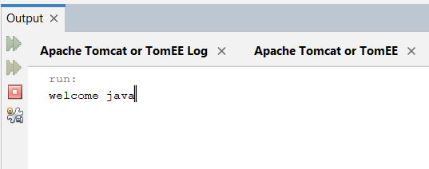

**9. Write an application that shows URL class demo.**

package urldemo;

import java.net.*;

public class URLDemo {

public static void main(String[] args) {

try{

URL url = new URL("http://www.javatpoint.com/java-tutorial");

System.out.println("Protocol: "+url.getProtocol());

System.out.println("Host Name: "+url.getHost());

System.out.println("Port Number: "+url.getPort());

System.out.println("File Name: "+url.getFile());

}

catch(Exception e)

{

System.out.println(e);

}

}

}

**Output :-**

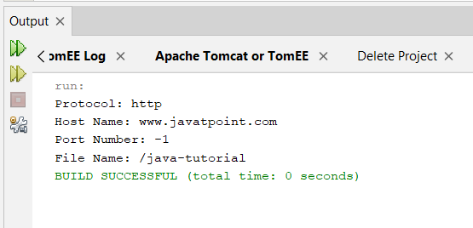

**Day-6**

**10. Basic Servlet Programming use of servlet and directory structure understanding html and xml.**

**MyServlet.java**

/*

* Click nbfs://nbhost/SystemFileSystem/Templates/Licenses/license-default.txt to change this license

* Click nbfs://nbhost/SystemFileSystem/Templates/JSP_Servlet/Servlet.java to edit this template

*/

import java.io.IOException;

import java.io.PrintWriter;

import jakarta.servlet.ServletException;

import jakarta.servlet.http.HttpServlet;

import jakarta.servlet.http.HttpServletRequest;

import jakarta.servlet.http.HttpServletResponse;

/**

*

* @author YASH

*/

public class MyServlet extends HttpServlet {

/**

* Processes requests for both HTTP <code>GET</code> and <code>POST</code>

* methods.

*

* @param request servlet request

* @param response servlet response

* @throws ServletException if a servlet-specific error occurs

* @throws IOException if an I/O error occurs

*/

protected void processRequest(HttpServletRequest request, HttpServletResponse response)

throws ServletException, IOException {

response.setContentType("text/html;charset=UTF-8");

try (PrintWriter out = response.getWriter()) {

/* TODO output your page here. You may use following sample code. */

out.println("<!DOCTYPE html>");

out.println("<html>");

out.println("<head>");

out.println("<title>Servlet MyServlet</title>");

out.println("</head>");

out.println("<body>");

out.println("<h1>Servlet MyServlet at " + request.getContextPath() + "</h1>");

out.println("</body>");

out.println("</html>");

}

}

// <editor-fold defaultstate="collapsed" desc="HttpServlet methods. Click on the + sign on the left to edit the code.">

/**

* Handles the HTTP <code>GET</code> method.

*

* @param request servlet request

* @param response servlet response

* @throws ServletException if a servlet-specific error occurs

* @throws IOException if an I/O error occurs

*/

@Override

protected void doGet(HttpServletRequest request, HttpServletResponse response)

throws ServletException, IOException {

response.setContentType("text/html");

PrintWriter out = response.getWriter();

out.println("<html><body>");

out.println("<h1>Hello, World!</h1>");

out.println("</body></html>");

}

/**

* Handles the HTTP <code>POST</code> method.

*

* @param request servlet request

* @param response servlet response

* @throws ServletException if a servlet-specific error occurs

* @throws IOException if an I/O error occurs

*/

@Override

protected void doPost(HttpServletRequest request, HttpServletResponse response)

throws ServletException, IOException {

processRequest(request, response);

}

/**

* Returns a short description of the servlet.

*

* @return a String containing servlet description

*/

@Override

public String getServletInfo() {

return "Short description";

}// </editor-fold>

}

**Web.XML**

<?xml version="1.0" encoding="UTF-8"?>

<web-app version="6.0" xmlns="https://jakarta.ee/xml/ns/jakartaee" xmlns:xsi="http://www.w3.org/2001/XMLSchema-instance" xsi:schemaLocation="https://jakarta.ee/xml/ns/jakartaee https://jakarta.ee/xml/ns/jakartaee/web-app_6_0.xsd">

<servlet>

<servlet-name>MyServlet</servlet-name>

<servlet-class>MyServlet</servlet-class>

</servlet>

<servlet-mapping>

<servlet-name>MyServlet</servlet-name>

<url-pattern>/hello</url-pattern>

</servlet-mapping>

</web-app>

**Index.html**

**Welcome to My Servlet Application**

Go to Hello Servlet

**Output :-**

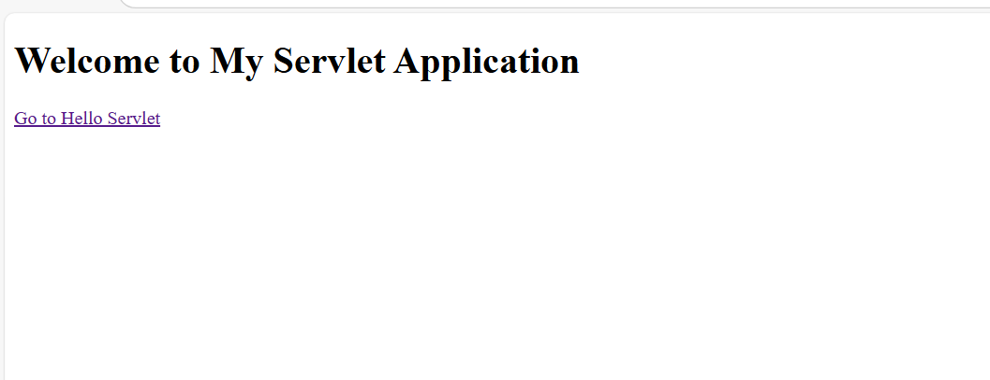

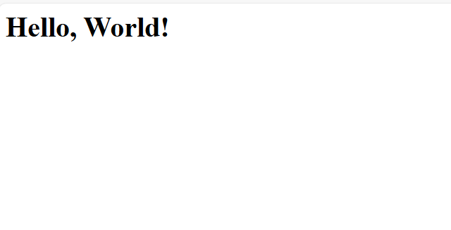

**11. Write a Servlet program to print system date and time.**

**DateTimeServlet.java**

/*

* Click nbfs://nbhost/SystemFileSystem/Templates/Licenses/license-default.txt to change this license

* Click nbfs://nbhost/SystemFileSystem/Templates/JSP_Servlet/Servlet.java to edit this template

*/

import java.io.IOException;

import java.io.PrintWriter;

import jakarta.servlet.ServletException;

import jakarta.servlet.http.HttpServlet;

import jakarta.servlet.http.HttpServletRequest;

import jakarta.servlet.http.HttpServletResponse;

import java.util.Date;

/**

*

* @author YASH

*/

public class DateTimeServlet extends HttpServlet {

/**

* Processes requests for both HTTP <code>GET</code> and <code>POST</code>

* methods.

*

* @param request servlet request

* @param response servlet response

* @throws ServletException if a servlet-specific error occurs

* @throws IOException if an I/O error occurs

*/

protected void processRequest(HttpServletRequest request, HttpServletResponse response)

throws ServletException, IOException {

response.setContentType("text/html;charset=UTF-8");

try (PrintWriter out = response.getWriter()) {

/* TODO output your page here. You may use following sample code. */

out.println("<!DOCTYPE html>");

out.println("<html>");

out.println("<head>");

out.println("<title>Servlet DateTimeServlet</title>");

out.println("</head>");

out.println("<body>");

out.println("<h1>Servlet DateTimeServlet at " + request.getContextPath() + "</h1>");

out.println("</body>");

out.println("</html>");

}

}

// <editor-fold defaultstate="collapsed" desc="HttpServlet methods. Click on the + sign on the left to edit the code.">

/**

* Handles the HTTP <code>GET</code> method.

*

* @param request servlet request

* @param response servlet response

* @throws ServletException if a servlet-specific error occurs

* @throws IOException if an I/O error occurs

*/

@Override

protected void doGet(HttpServletRequest request, HttpServletResponse response)

throws ServletException, IOException {

response.setContentType("text/html");

Date currentDate = new Date();

PrintWriter out = response.getWriter();

out.println("<html><body>");

out.println("<h1>System Date and Time</h1>");

out.println("<p>The current date and time is: " + currentDate.toString() + "</p>");

out.println("</body></html>");

out.close();

}

/**

* Handles the HTTP <code>POST</code> method.

*

* @param request servlet request

* @param response servlet response

* @throws ServletException if a servlet-specific error occurs

* @throws IOException if an I/O error occurs

*/

@Override

protected void doPost(HttpServletRequest request, HttpServletResponse response)

throws ServletException, IOException {

processRequest(request, response);

}

/**

* Returns a short description of the servlet.

*

* @return a String containing servlet description

*/

@Override

public String getServletInfo() {

return "Short description";

}// </editor-fold>

}

**Web.XML**

<?xml version="1.0" encoding="UTF-8"?>

<web-app version="6.0" xmlns="https://jakarta.ee/xml/ns/jakartaee" xmlns:xsi="http://www.w3.org/2001/XMLSchema-instance" xsi:schemaLocation="https://jakarta.ee/xml/ns/jakartaee https://jakarta.ee/xml/ns/jakartaee/web-app_6_0.xsd">

<servlet>

<servlet-name>DateTimeServlet</servlet-name>

<servlet-class>DateTimeServlet</servlet-class>

</servlet>

<servlet-mapping>

<servlet-name>DateTimeServlet</servlet-name>

<url-pattern>/datetime</url-pattern>

</servlet-mapping>

</web-app>

**Index.html**

**Welcome to the Date and Time Servlet Application**

Click the link below to get the current system date and time:

Get System Date and Time

**Output :-**

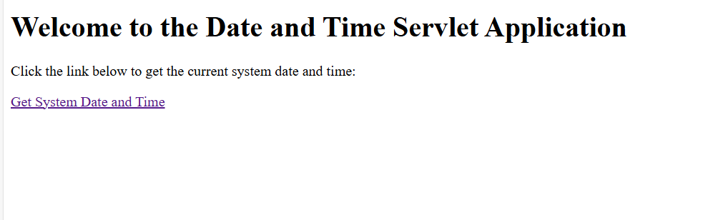

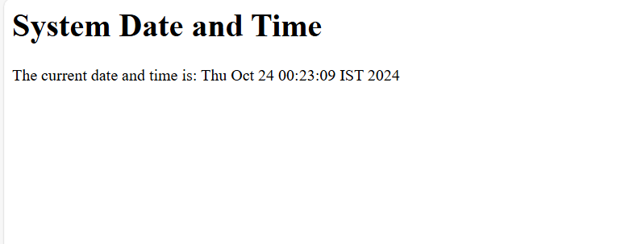

**Day-7**

**12. Create a Servlet that connect with database and retrieve data from database.**

**UserServlet.java**

/*

* Click nbfs://nbhost/SystemFileSystem/Templates/Licenses/license-default.txt to change this license

* Click nbfs://nbhost/SystemFileSystem/Templates/JSP_Servlet/Servlet.java to edit this template

*/

import java.io.IOException;

import java.io.PrintWriter;

import java.sql.*;

import java.sql.PreparedStatement;

import jakarta.servlet.ServletException;

import jakarta.servlet.http.HttpServlet;

import jakarta.servlet.http.HttpServletRequest;

import jakarta.servlet.http.HttpServletResponse;

/**

*

* @author YASH

*/

public class UserServlet extends HttpServlet {

private final String jdbcURL = "jdbc:mysql://localhost:3308/exampleDB";

private final String jdbcUsername = "root";

private final String jdbcPassword = "";

/**

* Processes requests for both HTTP <code>GET</code> and <code>POST</code>

* methods.

*

* @param request servlet request

* @param response servlet response

* @throws ServletException if a servlet-specific error occurs

* @throws IOException if an I/O error occurs

*/

protected void processRequest(HttpServletRequest request, HttpServletResponse response)

throws ServletException, IOException {

response.setContentType("text/html;charset=UTF-8");

try (PrintWriter out = response.getWriter()) {

/* TODO output your page here. You may use following sample code. */

out.println("<!DOCTYPE html>");

out.println("<html>");

out.println("<head>");

out.println("<title>Servlet UserServlet</title>");

out.println("</head>");

out.println("<body>");

out.println("<h1>Servlet UserServlet at " + request.getContextPath() + "</h1>");

out.println("</body>");

out.println("</html>");

}

}

// <editor-fold defaultstate="collapsed" desc="HttpServlet methods. Click on the + sign on the left to edit the code.">

/**

* Handles the HTTP <code>GET</code> method.

*

* @param request servlet request

* @param response servlet response

* @throws ServletException if a servlet-specific error occurs

* @throws IOException if an I/O error occurs

*/

@Override

protected void doGet(HttpServletRequest request, HttpServletResponse response)

throws ServletException, IOException {

response.setContentType("text/html");

PrintWriter out = response.getWriter();

// Connect to database and retrieve data

try {

// Load MySQL JDBC Driver

Class.forName("com.mysql.cj.jdbc.Driver");

// Establish connection

Connection conn = DriverManager.getConnection(jdbcURL, jdbcUsername, jdbcPassword);

System.out.println("Connection Successful!");

// Execute SQL query

Statement stmt = conn.createStatement();

String sql = "SELECT id, name, email FROM emp";

ResultSet rs = stmt.executeQuery(sql);

// Process the result set and display data

out.println("<html><body>");

out.println("<h1>List of Users</h1>");

out.println("<table border='1'>");

out.println("<tr><th>ID</th><th>Name</th><th>Email</th></tr>");

while (rs.next()) {

int id = rs.getInt("id");

String name = rs.getString("name");

String email = rs.getString("email");

out.println("<tr><td>" + id + "</td><td>" + name + "</td><td>" + email + "</td></tr>");

}

out.println("</table>");

out.println("</body></html>");

// Close resources

rs.close();

stmt.close();

conn.close();

} catch (Exception e) {

e.printStackTrace();

out.println("<p>Error: " + e.getMessage() + "</p>");

} finally {

out.close();

}

}

/**

* Handles the HTTP <code>POST</code> method.

*

* @param request servlet request

* @param response servlet response

* @throws ServletException if a servlet-specific error occurs

* @throws IOException if an I/O error occurs

*/

@Override

protected void doPost(HttpServletRequest request, HttpServletResponse response)

throws ServletException, IOException {

processRequest(request, response);

}

/**

* Returns a short description of the servlet.

*

* @return a String containing servlet description

*/

@Override

public String getServletInfo() {

return "Short description";

}// </editor-fold>

}

**Web.XML**

<?xml version="1.0" encoding="UTF-8"?>

<web-app version="6.0" xmlns="https://jakarta.ee/xml/ns/jakartaee" xmlns:xsi="http://www.w3.org/2001/XMLSchema-instance" xsi:schemaLocation="https://jakarta.ee/xml/ns/jakartaee https://jakarta.ee/xml/ns/jakartaee/web-app_6_0.xsd">

<servlet>

<servlet-name>UserServlet</servlet-name>

<servlet-class>UserServlet</servlet-class>

</servlet>

<servlet-mapping>

<servlet-name>UserServlet</servlet-name>

<url-pattern>/users</url-pattern>

</servlet-mapping>

</web-app>

**Index.html**

**Welcome to the User Data Application**

Click the link below to view the list of users stored in the database:

View Users

**Output :-**

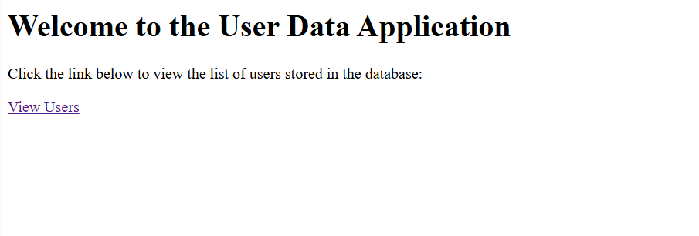

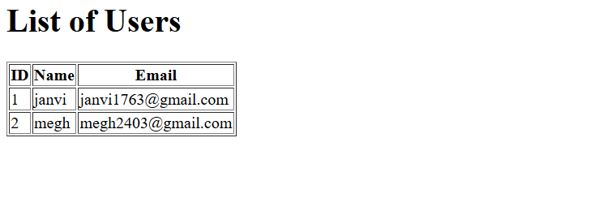

**13. Design a web page that takes the Username from user and if it is a valid username prints “Welcome Username”.**

**UserServlet.java**

/*

* Click nbfs://nbhost/SystemFileSystem/Templates/Licenses/license-default.txt to change this license

* Click nbfs://nbhost/SystemFileSystem/Templates/JSP_Servlet/Servlet.java to edit this template

*/

import java.io.IOException;

import java.io.PrintWriter;

import java.sql.*;

import java.sql.PreparedStatement;

import jakarta.servlet.ServletException;

import jakarta.servlet.http.HttpServlet;

import jakarta.servlet.http.HttpServletRequest;

import jakarta.servlet.http.HttpServletResponse;

import java.sql.Connection;

import java.sql.DriverManager;

import java.sql.Statement;

/**

*

* @author YASH

*/

public class UserServlet extends HttpServlet {

private final String jdbcURL = "jdbc:mysql://localhost:3308/exampleDB";

private final String jdbcUsername = "root";

private final String jdbcPassword = "";

/**

* Processes requests for both HTTP <code>GET</code> and <code>POST</code>

* methods.

*

* @param request servlet request

* @param response servlet response

* @throws ServletException if a servlet-specific error occurs

* @throws IOException if an I/O error occurs

*/

protected void processRequest(HttpServletRequest request, HttpServletResponse response)

throws ServletException, IOException {

response.setContentType("text/html;charset=UTF-8");

try (PrintWriter out = response.getWriter()) {

/* TODO output your page here. You may use following sample code. */

out.println("<!DOCTYPE html>");

out.println("<html>");

out.println("<head>");

out.println("<title>Servlet UserServlet</title>");

out.println("</head>");

out.println("<body>");

out.println("<h1>Servlet UserServlet at " + request.getContextPath() + "</h1>");

out.println("</body>");

out.println("</html>");

}

}

// <editor-fold defaultstate="collapsed" desc="HttpServlet methods. Click on the + sign on the left to edit the code.">

/**

* Handles the HTTP <code>GET</code> method.

*

* @param request servlet request

* @param response servlet response

* @throws ServletException if a servlet-specific error occurs

* @throws IOException if an I/O error occurs

*/

@Override

protected void doGet(HttpServletRequest request, HttpServletResponse response)

throws ServletException, IOException {

processRequest(request, response);

}

/**

* Handles the HTTP <code>POST</code> method.

*

* @param request servlet request

* @param response servlet response

* @throws ServletException if a servlet-specific error occurs

* @throws IOException if an I/O error occurs

*/

@Override

protected void doPost(HttpServletRequest request, HttpServletResponse response)

throws ServletException, IOException {

response.setContentType("text/html");

PrintWriter out = response.getWriter();

String username = request.getParameter("username");

try {

Class.forName("com.mysql.cj.jdbc.Driver");

Connection conn = DriverManager.getConnection(jdbcURL, jdbcUsername, jdbcPassword);

System.out.println("Connection Successful!");

Statement stmt = conn.createStatement();

String sql = "SELECT name FROM emp where name=?";

PreparedStatement ps = conn.prepareStatement(sql);

ps.setString(1, username);

ResultSet rs = ps.executeQuery();

if (rs.next()) {

out.println("<html>");

out.println("<head>");

out.println("<title>Welcome</title>");

out.println("</head>");

out.println("<body>");

out.println("<h1>Welcome " + username + "!</h1>");

out.println("</body>");

out.println("</html>");

} else {

out.println("<html>");

out.println("<head>");

out.println("<title>Error</title>");

out.println("</head>");

out.println("<body>");

out.println("<h1>Username not found. Please try again.</h1>");

out.println("</body>");

out.println("</html>");

}

rs.close();

ps.close();

conn.close();

}

catch(Exception e)

{

e.printStackTrace();

}

}

/**

* Returns a short description of the servlet.

*

* @return a String containing servlet description

*/

@Override

public String getServletInfo() {

return "Short description";

}// </editor-fold>

}

**Web.xml**

<?xml version="1.0" encoding="UTF-8"?>

<web-app version="6.0" xmlns="https://jakarta.ee/xml/ns/jakartaee" xmlns:xsi="http://www.w3.org/2001/XMLSchema-instance" xsi:schemaLocation="https://jakarta.ee/xml/ns/jakartaee https://jakarta.ee/xml/ns/jakartaee/web-app_6_0.xsd">

<servlet>

<servlet-name>UserServlet</servlet-name>

<servlet-class>UserServlet</servlet-class>

</servlet>

<servlet-mapping>

<servlet-name>UserServlet</servlet-name>

<url-pattern>/UserServlet</url-pattern>

</servlet-mapping>

</web-app>

Bottom of Form

**Output :-**

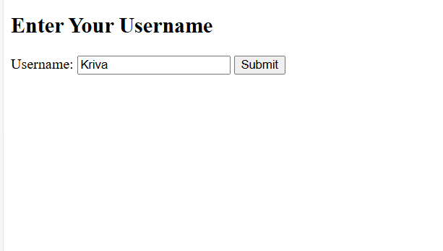

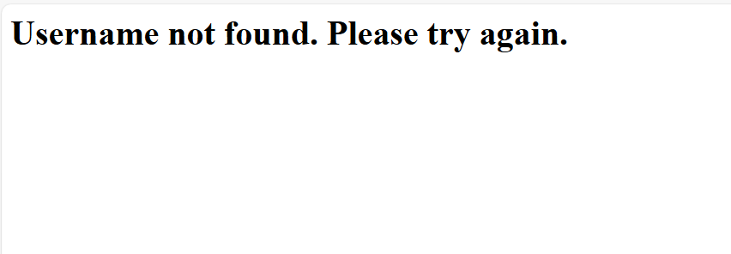

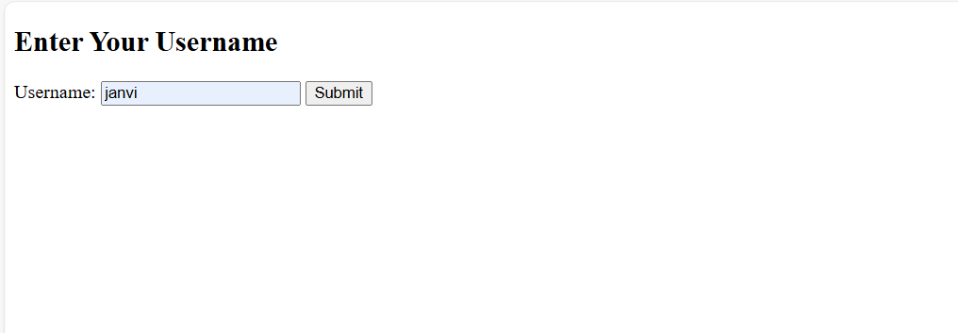

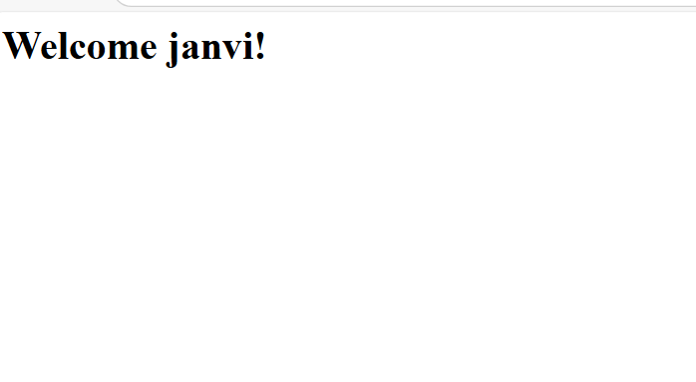



**Day-8**

**14. Write a java web application that connect with database and implement all crud operations using servlet.(create table customer(cust_id,name,address,phoneno))**

**CustomerServlet.java**

/*

* Click nbfs://nbhost/SystemFileSystem/Templates/Licenses/license-default.txt to change this license

* Click nbfs://nbhost/SystemFileSystem/Templates/JSP_Servlet/Servlet.java to edit this template

*/

import java.io.IOException;

import java.io.PrintWriter;

import java.sql.*;

import java.sql.PreparedStatement;

import jakarta.servlet.ServletException;

import jakarta.servlet.http.HttpServlet;

import jakarta.servlet.http.HttpServletRequest;

import jakarta.servlet.http.HttpServletResponse;

import java.sql.Connection;

import java.sql.DriverManager;

/**

*

* @author YASH

*/

public class CustomerServlet extends HttpServlet {

private final String jdbcURL = "jdbc:mysql://localhost:3308/exampleDB";

private final String jdbcUsername = "root";

private final String jdbcPassword = "";

/**

* Processes requests for both HTTP <code>GET</code> and <code>POST</code>

* methods.

*

* @param request servlet request

* @param response servlet response

* @throws ServletException if a servlet-specific error occurs

* @throws IOException if an I/O error occurs

*/

protected void processRequest(HttpServletRequest request, HttpServletResponse response)

throws ServletException, IOException {

response.setContentType("text/html;charset=UTF-8");

try (PrintWriter out = response.getWriter()) {

/* TODO output your page here. You may use following sample code. */

out.println("<!DOCTYPE html>");

out.println("<html>");

out.println("<head>");

out.println("<title>Servlet CustomerServlet</title>");

out.println("</head>");

out.println("<body>");

out.println("<h1>Servlet CustomerServlet at " + request.getContextPath() + "</h1>");

out.println("</body>");

out.println("</html>");

}

}

// <editor-fold defaultstate="collapsed" desc="HttpServlet methods. Click on the + sign on the left to edit the code.">

/**

* Handles the HTTP <code>GET</code> method.

*

* @param request servlet request

* @param response servlet response

* @throws ServletException if a servlet-specific error occurs

* @throws IOException if an I/O error occurs

*/

@Override

protected void doGet(HttpServletRequest request, HttpServletResponse response)

throws ServletException, IOException {

processRequest(request, response);

}

/**

* Handles the HTTP <code>POST</code> method.

*

* @param request servlet request

* @param response servlet response

* @throws ServletException if a servlet-specific error occurs

* @throws IOException if an I/O error occurs

*/

@Override

protected void doPost(HttpServletRequest request, HttpServletResponse response)

throws ServletException, IOException {

String action = request.getParameter("action");

switch (action) {

case "create":

createCustomer(request, response);

break;

case "read":

readCustomer(request, response);

break;

case "update":

updateCustomer(request, response);

break;

case "delete":

deleteCustomer(request, response);

break;

default:

response.sendError(HttpServletResponse.SC_BAD_REQUEST, "Invalid action");

}

}

private void createCustomer(HttpServletRequest request, HttpServletResponse response) throws IOException {

response.setContentType("text/html");

PrintWriter out = response.getWriter();

String name = request.getParameter("name");

String address = request.getParameter("address");

String phoneno = request.getParameter("phoneno");

try{

Class.forName("com.mysql.cj.jdbc.Driver");

Connection conn = DriverManager.getConnection(jdbcURL, jdbcUsername, jdbcPassword);

System.out.println("Connection Successful!");

String sql = "INSERT INTO customer (name, address, phoneno) VALUES (?, ?, ?)";

PreparedStatement ps = conn.prepareStatement(sql);

ps.setString(1, name);

ps.setString(2, address);

ps.setString(3, phoneno);

ps.executeUpdate();

int rowsAffected = ps.executeUpdate();

if (rowsAffected > 0) {

out.println("<h1>Customer created successfully.</h1>");

} else {

out.println("<h1>Failed to create customer.</h1>");

}

} catch (Exception e) {

e.printStackTrace();

System.out.println("Error creating customer: " + e.getMessage());

}

}

private void readCustomer(HttpServletRequest request, HttpServletResponse response) throws IOException {

response.setContentType("text/html");

PrintWriter out = response.getWriter();

try {

Class.forName("com.mysql.cj.jdbc.Driver");

Connection conn = DriverManager.getConnection(jdbcURL, jdbcUsername, jdbcPassword);

System.out.println("Connection Successful!");

String sql = "SELECT * FROM customer";

PreparedStatement ps = conn.prepareStatement(sql);

ResultSet rs = ps.executeQuery();

out.println("<html><body>");

out.println("<h2>Customer List:</h2>");

out.println("<table border='1'><tr><th>ID</th><th>Name</th><th>Address</th><th>Phone No</th></tr>");

while (rs.next()) {

out.println("<tr>");

out.println("<td>" + rs.getInt("cust_id") + "</td>");

out.println("<td>" + rs.getString("name") + "</td>");

out.println("<td>" + rs.getString("address") + "</td>");

out.println("<td>" + rs.getString("phoneno") + "</td>");

out.println("</tr>");

}

out.println("</table>");

out.println("</body></html>");

rs.close();

ps.close();

conn.close();

} catch (Exception e) {

e.printStackTrace();

out.println("Error reading customers: " + e.getMessage());

}

}

private void updateCustomer(HttpServletRequest request, HttpServletResponse response) throws IOException {

response.setContentType("text/html");

PrintWriter out = response.getWriter();

int id = Integer.parseInt(request.getParameter("cust_id"));

String name = request.getParameter("name");

String address = request.getParameter("address");

String phoneno = request.getParameter("phoneno");

try {

Class.forName("com.mysql.cj.jdbc.Driver");

Connection conn = DriverManager.getConnection(jdbcURL, jdbcUsername, jdbcPassword);

System.out.println("Connection Successful!");

String sql = "UPDATE customer SET name=?, address=?, phoneno=? WHERE cust_id=?";

PreparedStatement ps = conn.prepareStatement(sql);

ps.setString(1, name);

ps.setString(2, address);

ps.setString(3, phoneno);

ps.setInt(4, id);

ps.executeUpdate();

int rowsAffected = ps.executeUpdate();

if (rowsAffected > 0) {

out.println("<h1>Customer updated successfully.</h1>");

} else {

out.println("<h1>Failed to update customer.</h1>");

}

} catch (Exception e) {

e.printStackTrace();

System.out.println("Error updating customer: " + e.getMessage());

}

}

private void deleteCustomer(HttpServletRequest request, HttpServletResponse response) throws IOException {

response.setContentType("text/html");

PrintWriter out = response.getWriter();

int id = Integer.parseInt(request.getParameter("cust_id"));

try{

Class.forName("com.mysql.cj.jdbc.Driver");

Connection conn = DriverManager.getConnection(jdbcURL, jdbcUsername, jdbcPassword);

System.out.println("Connection Successful!");

String sql = "DELETE FROM customer WHERE cust_id=?";

PreparedStatement ps = conn.prepareStatement(sql);

ps.setInt(1, id);

ps.executeUpdate();

response.getWriter().println("Customer deleted successfully.");

} catch (Exception e) {

e.printStackTrace();

response.getWriter().println("Error deleting customer: " + e.getMessage());

}

}

/**

* Returns a short description of the servlet.

*

* @return a String containing servlet description

*/

@Override

public String getServletInfo() {

return "Short description";

}// </editor-fold>

}

**Web.xml**

<?xml version="1.0" encoding="UTF-8"?>

<web-app version="6.0" xmlns="https://jakarta.ee/xml/ns/jakartaee" xmlns:xsi="http://www.w3.org/2001/XMLSchema-instance" xsi:schemaLocation="https://jakarta.ee/xml/ns/jakartaee https://jakarta.ee/xml/ns/jakartaee/web-app_6_0.xsd">

<servlet>

<servlet-name>CustomerServlet</servlet-name>

<servlet-class>CustomerServlet</servlet-class>

</servlet>

<servlet-mapping>

<servlet-name>CustomerServlet</servlet-name>

<url-pattern>/CustomerServlet</url-pattern>

</servlet-mapping>

</web-app>

**Output :-**

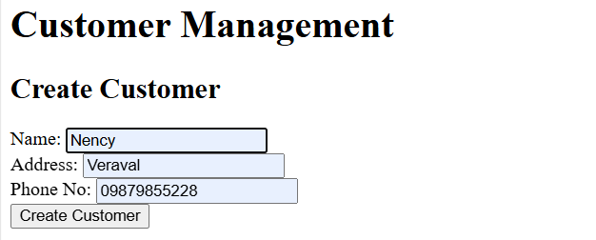

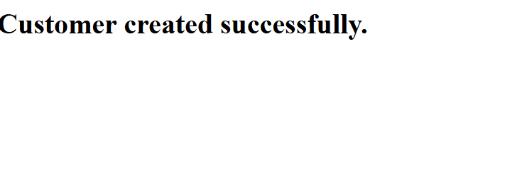

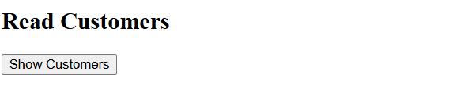

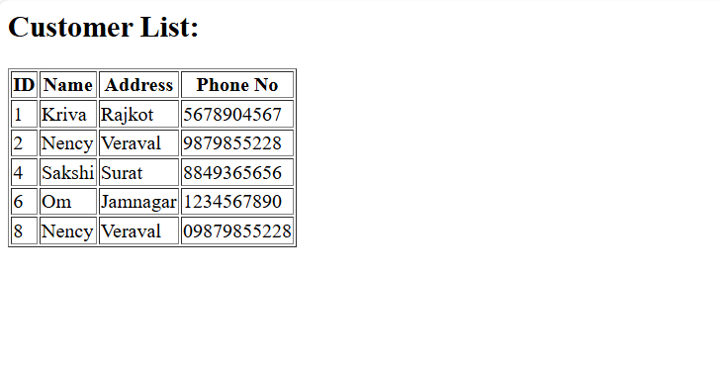

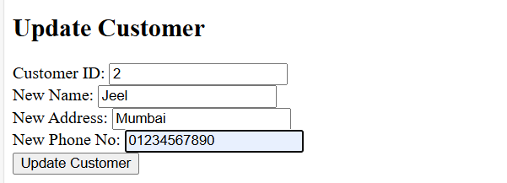

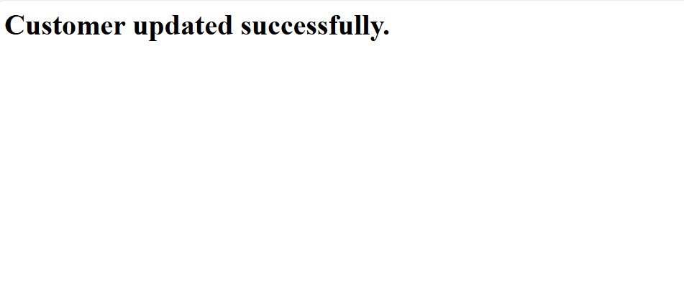

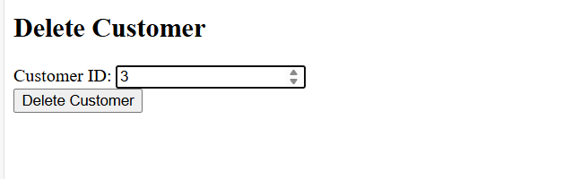

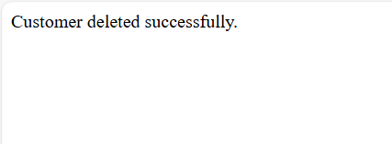

**Day-9**

**15. Implement cookies to store firstname and lastname using Java server pages.**

**Index.jsp**

<%--

Document : index

Created on : 22-Oct-2024, 1:34:00 pm

Author : YASH

--%>

<%@page contentType="text/html" pageEncoding="UTF-8"%>

<!DOCTYPE html>

<html>

<head>

<meta http-equiv="Content-Type" content="text/html; charset=UTF-8">

<title>Set Cookies Example</title>

</head>

<body>

<h2>Enter Your Name</h2>

<form action="setCookies.jsp" method="post">

First Name: <input type="text" name="firstName" required><br><br>

Last Name: <input type="text" name="lastName" required><br><br>

<input type="submit" value="Submit">

</form>

</body>

</html>

**setCookies.jsp**

<%--

Document : setCookies

Created on : 22-Oct-2024, 1:35:10 pm

Author : YASH

--%>

<%@page contentType="text/html" pageEncoding="UTF-8"%>

<!DOCTYPE html>

<html>

<head>

<meta http-equiv="Content-Type" content="text/html; charset=UTF-8">

<title>Set Cookies</title>

</head>

<body>

<%

// Get the parameters from the form

String firstName = request.getParameter("firstName");

String lastName = request.getParameter("lastName");

// Create cookies for first name and last name

Cookie firstNameCookie = new Cookie("firstName", firstName);

Cookie lastNameCookie = new Cookie("lastName", lastName);

// Set the maximum age of the cookies (optional - here it's 1 day)

firstNameCookie.setMaxAge(24 * 60 * 60); // 1 day

lastNameCookie.setMaxAge(24 * 60 * 60); // 1 day

// Add cookies to the response

response.addCookie(firstNameCookie);

response.addCookie(lastNameCookie);

// Redirect to another page to display the cookies

response.sendRedirect("showCookies.jsp");

%>

</body>

</html>

**showCookies.jsp**

<%--

Document : showCookies

Created on : 22-Oct-2024, 1:36:07 pm

Author : YASH

--%>

<%@ page import="jakarta.servlet.http.Cookie" %>

<%@ page import="java.io.*" %>

<%@page contentType="text/html" pageEncoding="UTF-8"%>

<!DOCTYPE html>

<html>

<head>

<meta http-equiv="Content-Type" content="text/html; charset=UTF-8">

<title>Show Cookies</title>

</head>

<body>

<h2>Stored Name from Cookies</h2>

<%

// Get all cookies from the request

Cookie[] cookies = request.getCookies();

String firstName = "";

String lastName = "";

if (cookies != null) {

for (Cookie cookie : cookies) {

if (cookie.getName().equals("firstName")) {

firstName = cookie.getValue();

}

if (cookie.getName().equals("lastName")) {

lastName = cookie.getValue();

}

}

}

if (!firstName.isEmpty() && !lastName.isEmpty()) {

out.println("<p>First Name: " + firstName + "</p>");

out.println("<p>Last Name: " + lastName + "</p>");

} else {

out.println("<p>No cookies found for first name and last name.</p>");

}

%>

</body>

</html>

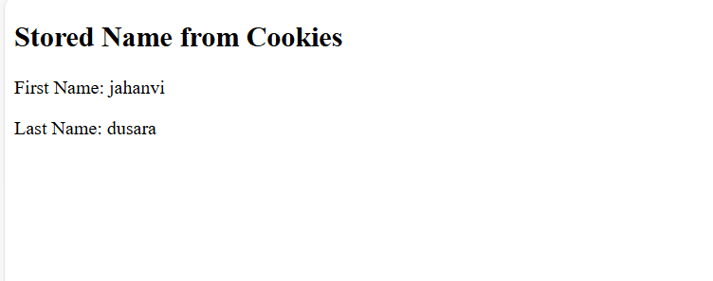

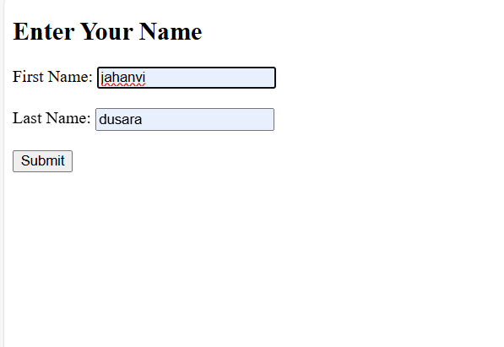

**Day-10**

**16. Implement the shopping cart for users for the online shopping. Apply the concept of session.**

**CartItem.java**

/*

* Click nbfs://nbhost/SystemFileSystem/Templates/Licenses/license-default.txt to change this license

* Click nbfs://nbhost/SystemFileSystem/Templates/Classes/Class.java to edit this template

*/

/**

*

* @author YASH

*/

package Shopping;

public class CartItem {

private Product product;

private int quantity;

public CartItem(Product product, int quantity) {

this.product = product;

this.quantity = quantity;

}

public Product getProduct() {

return product;

}

public void setProduct(Product product) {

this.product = product;

}

public int getQuantity() {

return quantity;

}

public void setQuantity(int quantity) {

this.quantity = quantity;

}

public double getTotalPrice() {

return this.product.getPrice() * this.quantity;

}

}

**CartServlet.java**

/*

* Click nbfs://nbhost/SystemFileSystem/Templates/Licenses/license-default.txt to change this license

* Click nbfs://nbhost/SystemFileSystem/Templates/JSP_Servlet/Servlet.java to edit this template

*/

package Shopping;

import java.io.IOException;

import java.io.PrintWriter;

import jakarta.servlet.ServletException;

import jakarta.servlet.http.HttpServlet;

import jakarta.servlet.http.HttpServletRequest;

import jakarta.servlet.http.HttpServletResponse;

import jakarta.servlet.http.HttpSession;

import java.util.ArrayList;

import java.util.List;

/**

*

* @author YASH

*/

public class CartServlet extends HttpServlet {

/**

* Processes requests for both HTTP <code>GET</code> and <code>POST</code>

* methods.

*

* @param request servlet request

* @param response servlet response

* @throws ServletException if a servlet-specific error occurs

* @throws IOException if an I/O error occurs

*/

protected void processRequest(HttpServletRequest request, HttpServletResponse response)

throws ServletException, IOException {

response.setContentType("text/html;charset=UTF-8");

try (PrintWriter out = response.getWriter()) {

/* TODO output your page here. You may use following sample code. */

out.println("<!DOCTYPE html>");

out.println("<html>");

out.println("<head>");

out.println("<title>Servlet CartServlet</title>");

out.println("</head>");

out.println("<body>");

out.println("<h1>Servlet CartServlet at " + request.getContextPath() + "</h1>");

out.println("</body>");

out.println("</html>");

}

}

// <editor-fold defaultstate="collapsed" desc="HttpServlet methods. Click on the + sign on the left to edit the code.">

/**

* Handles the HTTP <code>GET</code> method.

*

* @param request servlet request

* @param response servlet response

* @throws ServletException if a servlet-specific error occurs

* @throws IOException if an I/O error occurs

*/

@Override

protected void doGet(HttpServletRequest request, HttpServletResponse response)

throws ServletException, IOException {

request.getRequestDispatcher("viewCart.jsp").forward(request, response);

}

/**

* Handles the HTTP <code>POST</code> method.

*

* @param request servlet request

* @param response servlet response

* @throws ServletException if a servlet-specific error occurs

* @throws IOException if an I/O error occurs

*/

@Override

protected void doPost(HttpServletRequest request, HttpServletResponse response)

throws ServletException, IOException {

HttpSession session = request.getSession();

// Retrieve cart from session or create a new one if it doesn't exist

List<CartItem> cart = (List<CartItem>) session.getAttribute("cart");

if (cart == null) {

cart = new ArrayList<>();

}

// Retrieve product details from the form

int productId = Integer.parseInt(request.getParameter("productId"));

String productName = request.getParameter("productName");

double productPrice = Double.parseDouble(request.getParameter("productPrice"));

int quantity = Integer.parseInt(request.getParameter("quantity"));

// Create the product and cart item

Product product = new Product(productId, productName, productPrice);

CartItem cartItem = new CartItem(product, quantity);

// Add the item to the cart

cart.add(cartItem);

// Set the cart in the session

session.setAttribute("cart", cart);

// Redirect to view the cart

response.sendRedirect("viewCart.jsp");

}

/**

* Returns a short description of the servlet.

*

* @return a String containing servlet description

*/

@Override

public String getServletInfo() {

return "Short description";

}// </editor-fold>

}

**Product.java**

/*

* Click nbfs://nbhost/SystemFileSystem/Templates/Licenses/license-default.txt to change this license

* Click nbfs://nbhost/SystemFileSystem/Templates/Classes/Class.java to edit this template

*/

/**

*

* @author YASH

*/

package Shopping;

public class Product {

private int id;

private String name;

private double price;

public Product(int id, String name, double price) {

this.id = id;

this.name = name;

this.price = price;

}

// Getters and Setters

public int getId() {

return id;

}

public void setId(int id) {

this.id = id;

}

public String getName() {

return name;

}

public void setName(String name) {

this.name = name;

}

public double getPrice() {

return price;

}

public void setPrice(double price) {

this.price = price;

}

}

**addProduct.jsp**

<%--

Document : addProduct

Created on : 23-Oct-2024, 7:44:12 pm

Author : YASH

--%>

<%@page contentType="text/html" pageEncoding="UTF-8"%>

<!DOCTYPE html>

<html>

<head>

<meta http-equiv="Content-Type" content="text/html; charset=UTF-8">

<title>Add Product</title>

</head>

<body>

<h2>Add Product to Cart</h2>

<form action="CartServlet" method="post">

Product ID: <input type="text" name="productId" required><br>

Product Name: <input type="text" name="productName" required><br>

Product Price: <input type="text" name="productPrice" required><br>

Quantity: <input type="text" name="quantity" required><br>

<input type="submit" value="Add to Cart">

</form>

</body>

</html>

**ViewCart.jsp**

<%--

Document : viewCart

Created on : 23-Oct-2024, 7:44:59 pm

Author : YASH

--%>

<%@page import="java.util.List"%>

<%@ page import="Shopping.CartItem,Shopping.Product" %>

<%@page contentType="text/html" pageEncoding="UTF-8"%>

<!DOCTYPE html>

<html>

<head>

<meta http-equiv="Content-Type" content="text/html; charset=UTF-8">

<title>View Cart</title>

</head>

<body>

<h2>Your Shopping Cart</h2>

<table border="1">

<tr>

<th>Product ID</th>

<th>Product Name</th>

<th>Quantity</th>

<th>Price</th>

<th>Total Price</th>

</tr>

<%

List<CartItem> cart = (List<CartItem>) session.getAttribute("cart");

if (cart != null && !cart.isEmpty()) {

for (CartItem item : cart) {

Product product = item.getProduct();

%>

<tr>

<td><%= product.getId() %></td>

<td><%= product.getName() %></td>

<td><%= item.getQuantity() %></td>

<td><%= product.getPrice() %></td>

<td><%= item.getTotalPrice() %></td>

</tr>

<%

}

} else {

%>

<tr>

<td colspan="5">Your cart is empty.</td>

</tr>

<%

}

%>

</table>

<a href="addProduct.jsp">Add More Products</a>

</body>

</html>

**Web.xml**

<?xml version="1.0" encoding="UTF-8"?>

<web-app version="6.0" xmlns="https://jakarta.ee/xml/ns/jakartaee" xmlns:xsi="http://www.w3.org/2001/XMLSchema-instance" xsi:schemaLocation="https://jakarta.ee/xml/ns/jakartaee https://jakarta.ee/xml/ns/jakartaee/web-app_6_0.xsd">

<servlet>

<servlet-name>CartServlet</servlet-name>

<servlet-class>Shopping.CartServlet</servlet-class>

</servlet>

<servlet-mapping>

<servlet-name>CartServlet</servlet-name>

<url-pattern>/CartServlet</url-pattern>

</servlet-mapping>

</web-app>

**Output :-**

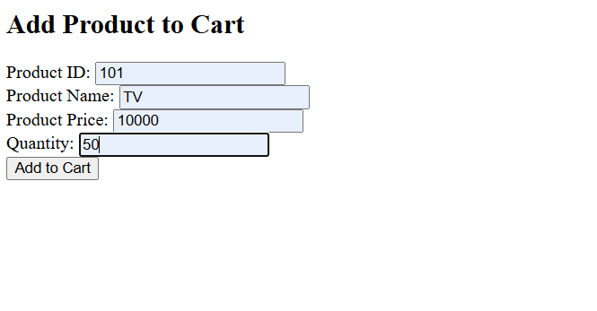

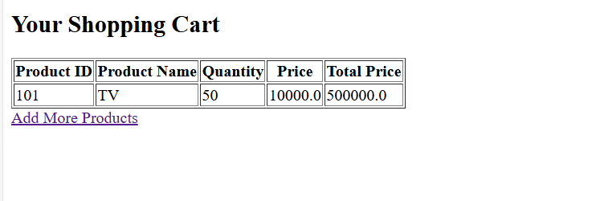

**Day-11**

**17. Create JSP that adds and subtract two numbers.**

**Calculator.jsp**

<%--

Document : Calculator

Created on : 23-Oct-2024, 8:10:40 pm

Author : YASH

--%>

<%@page contentType="text/html" pageEncoding="UTF-8"%>

<!DOCTYPE html>

<html>

<head>

<meta http-equiv="Content-Type" content="text/html; charset=UTF-8">

<title>Simple Calculator</title>

</head>

<body>

<h2>Simple Calculator</h2>

<form method="post" action="Calculator.jsp">

<label for="num1">Number 1:</label>

<input type="number" name="num1" id="num1" required>

<br><br>

<label for="num2">Number 2:</label>

<input type="number" name="num2" id="num2" required>

<br><br>

<input type="submit" value="Add">

<input type="submit" name="subtract" value="Subtract">

</form>

<%

// Retrieve the numbers from the form

String num1Str = request.getParameter("num1");

String num2Str = request.getParameter("num2");

if (num1Str != null && num2Str != null) {

// Parse the numbers

double num1 = Double.parseDouble(num1Str);

double num2 = Double.parseDouble(num2Str);

// Check which button was pressed

if (request.getParameter("subtract") != null) {

double result = num1 - num2;

out.println("<h3>Result: " + num1 + " - " + num2 + " = " + result + "</h3>");

} else {

double result = num1 + num2;

out.println("<h3>Result: " + num1 + " + " + num2 + " = " + result + "</h3>");}

}

%>

</body>

</html>

**Output :-**

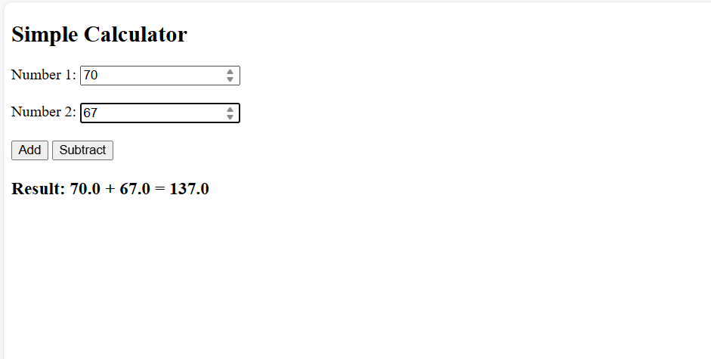

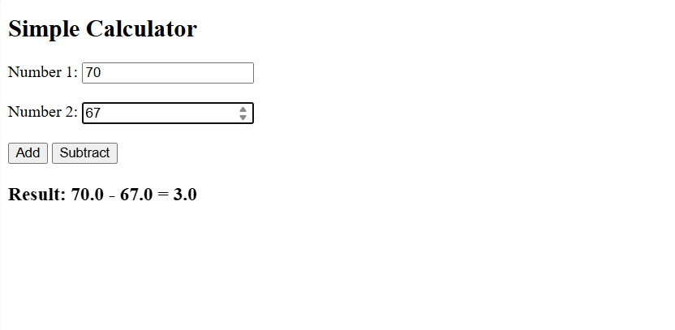

**18. Create JSP that display HelloWorld.**

**Helloworld.jsp**

<%--

Document : helloworld

Created on : 23-Oct-2024, 8:15:35 pm

Author : YASH

--%>

<%@page contentType="text/html" pageEncoding="UTF-8"%>

<!DOCTYPE html>

<html>

<head>

<meta http-equiv="Content-Type" content="text/html; charset=UTF-8">

<title>Hello World JSP</title>

</head>

<body>

<h1>Hello World!</h1>

</body>

</html>

**19. Create JSP that displays user details on other page.**

**UserDetails.jsp**

<%--

Document : userDetails

Created on : 23-Oct-2024, 8:18:40 pm

Author : YASH

--%>

<%@page contentType="text/html" pageEncoding="UTF-8"%>

<!DOCTYPE html>

<html>

<head>

<meta http-equiv="Content-Type" content="text/html; charset=UTF-8">

<title>User Details</title>

</head>

<body>

<h2>User Details</h2>

<%

// Retrieve user details from the request

String name = request.getParameter("name");

String email = request.getParameter("email");

String ageStr = request.getParameter("age");

int age = Integer.parseInt(ageStr); // Convert age to integer

// Display user details

%>

<p><strong>Name:</strong> <%= name %></p>

<p><strong>Email:</strong> <%= email %></p>

<p><strong>Age:</strong> <%= age %></p>

<br>

<a href="userInput.jsp">Go Back</a>

</body>

</html>

**UserInput.jsp**

<%--

Document : userInput

Created on : 23-Oct-2024, 8:18:01 pm

Author : YASH

--%>

<%@page contentType="text/html" pageEncoding="UTF-8"%>

<!DOCTYPE html>

<html>

<head>

<meta http-equiv="Content-Type" content="text/html; charset=UTF-8">

<title>User Input</title>

</head>

<body>

<h2>User Details Form</h2>

<form method="post" action="userDetails.jsp">

<label for="name">Name:</label>

<input type="text" name="name" id="name" required>

<br><br>

<label for="email">Email:</label>

<input type="email" name="email" id="email" required>

<br><br>

<label for="age">Age:</label>

<input type="number" name="age" id="age" required>

<br><br>

<input type="submit" value="Submit">

</form>

</body>

</html>

**Output :-**

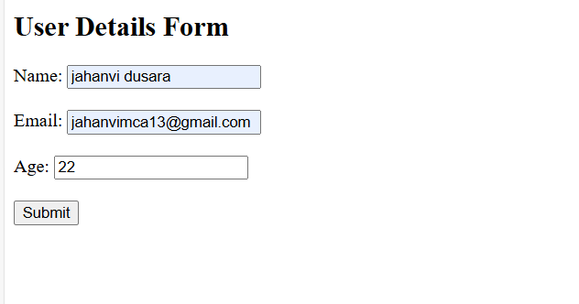

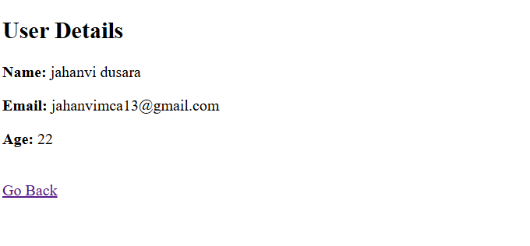

**Day-12**

**20. Write a demo program for explaining JSP tags and directives.**

**User.java**

/*

* Click nbfs://nbhost/SystemFileSystem/Templates/Licenses/license-default.txt to change this license

* Click nbfs://nbhost/SystemFileSystem/Templates/Classes/Class.java to edit this template

*/

package com.example;

/**

*

* @author YASH

*/

public class User {

private String name;

private String email;

public String getName() {

return name;

}

public void setName(String name) {

this.name = name;

}

public String getEmail() {

return email;

}

public void setEmail(String email) {

this.email = email;

}

}

**JspDemo.jsp**

<%--

Document : jspDemo

Created on : 23-Oct-2024, 8:24:13 pm

Author : YASH

--%>

<%@page contentType="text/html" pageEncoding="UTF-8"%>

<%@ page import="java.util.*" %>

<!DOCTYPE html>

<html>

<head>

<meta http-equiv="Content-Type" content="text/html; charset=UTF-8">

<title>JSP Tags and Directives Demo</title>

</head>

<body>

<h1>JSP Tags and Directives Demo</h1>

<h2>1. JSP Directives</h2>

<p>The following code snippet shows how to use directives:</p>

<pre>

</pre>

<h2>2. JSP Scriptlets</h2>

<p>JSP scriptlets allow you to embed Java code in your HTML. Below is an example:</p>

<%

// Java code within a scriptlet

String message = "Hello, this is a scriptlet!";

out.println(message);

%>

<h2>3. JSP Expressions</h2>

<p>JSP expressions are used to output data to the client. Here is an example:</p>

<%

int number = 42;

%>

<p>The answer to life, the universe, and everything is: <%= number %></p>

<h2>4. JSP Action Tags</h2>

<p>JSP action tags can be used to invoke JavaBeans or custom actions. Here’s an example:</p>

<jsp:useBean id="user" class="com.example.User" scope="session" />

<%

// Setting properties of the user bean

user.setName("John Doe");

user.setEmail("john.doe@example.com");

%>

<p>User Name: <jsp:getProperty name="user" property="name" /></p>

<p>User Email: <jsp:getProperty name="user" property="email" /></p>

<h2>5. JSP Comments</h2>

<p>Comments in JSP can be written like this:</p>

<pre>

<%-- This is a JSP comment and will not be included in the HTML output --%>

</pre>

</pre>

<li><strong>Scriptlets:</strong> Embedding Java code.</li>

<li><strong>Expressions:</strong> Outputting values directly.</li>

</ul>

<h2>7. JSP Standard Tag Library (JSTL)</h2>

<p>JSTL tags provide a powerful way to work with collections, conditionals, and internationalization.</p>

<%

// Create a list of items

List<String> items = Arrays.asList("Item 1", "Item 2", "Item 3");

request.setAttribute("items", items);

%>

<h3>Items List:</h3>

<ul>

<c:forEach var="item" items="${items}">

<li>${item}</li>

</c:forEach>

</ul>

</body>

</html>

**Output :-**

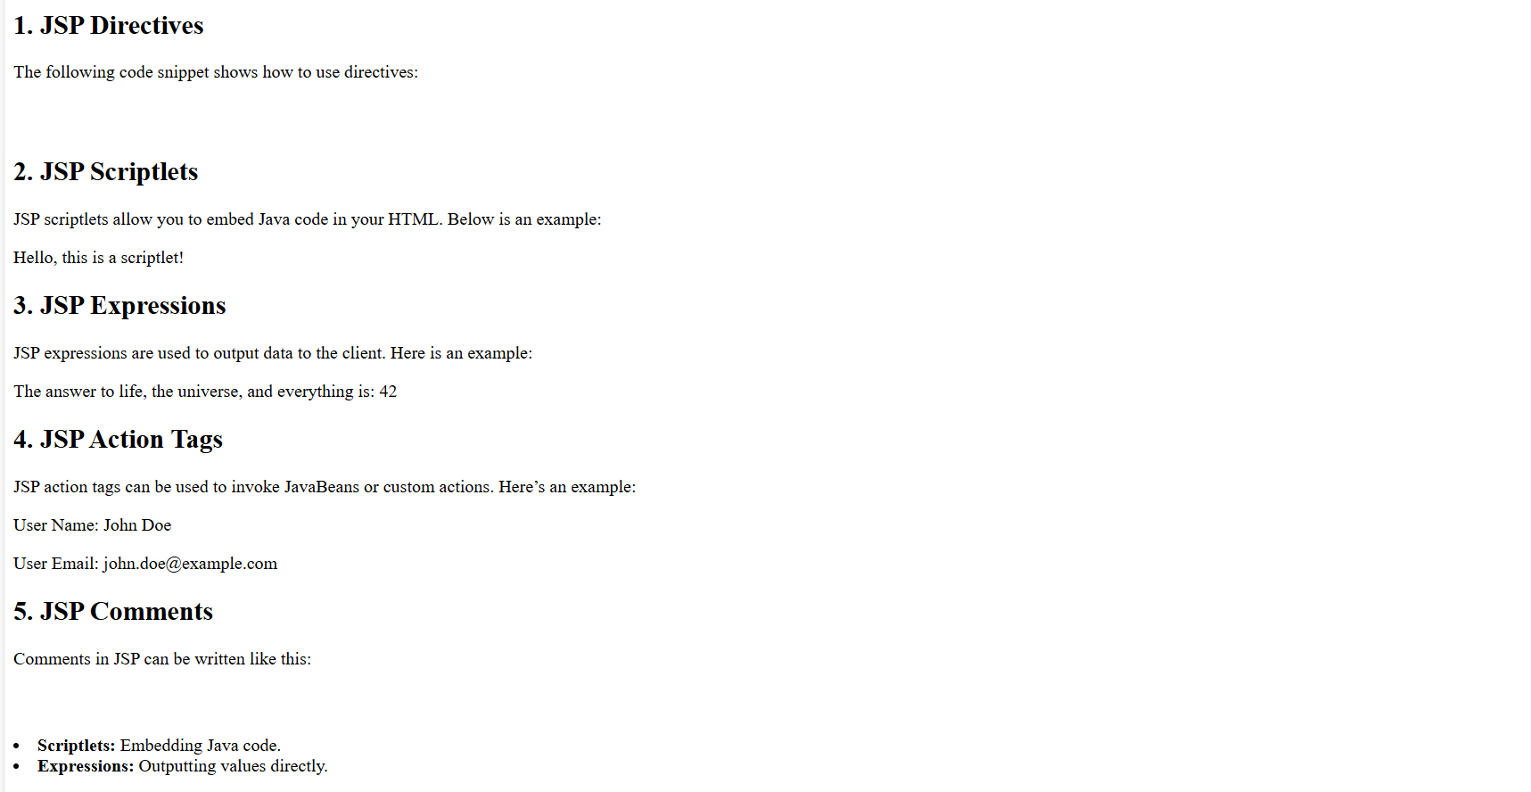

**21. Write a student bean class with property student_name, enrollment_no, address and cpi. Write jsp page to set and display all property.**

**StudentForm.jsp**

<%--

Document : studentForm

Created on : 23-Oct-2024, 8:35:15 pm

Author : YASH

--%>

<%@page import="beans.Student"%>

<%@page contentType="text/html" pageEncoding="UTF-8"%>

<!DOCTYPE html>

<html>

<head>

<meta http-equiv="Content-Type" content="text/html; charset=UTF-8">

<title>Student Details</title>

</head>

<body>

<h2>Student Registration Form</h2>

<form method="post" action="studentForm.jsp">

<label for="studentName">Student Name:</label>

<input type="text" name="studentName" id="studentName" required>

<br><br>

<label for="enrollmentNo">Enrollment No:</label>

<input type="text" name="enrollmentNo" id="enrollmentNo" required>

<br><br>

<label for="address">Address:</label>

<input type="text" name="address" id="address" required>

<br><br>

<label for="cpi">CPI:</label>

<input type="number" step="0.01" name="cpi" id="cpi" required>

<br><br>

<input type="submit" value="Submit">

</form>

<%

// Create a Student object and set its properties if form is submitted

String studentName = request.getParameter("studentName");

String enrollmentNo = request.getParameter("enrollmentNo");

String address = request.getParameter("address");

String cpiStr = request.getParameter("cpi");

if (studentName != null && enrollmentNo != null && address != null && cpiStr != null) {

Student student = new Student();

student.setStudentName(studentName);

student.setEnrollmentNo(enrollmentNo);

student.setAddress(address);

student.setCpi(Double.parseDouble(cpiStr));

%>

<h3>Student Details:</h3>

<p><strong>Name:</strong> <%= student.getStudentName() %></p>

<p><strong>Enrollment No:</strong> <%= student.getEnrollmentNo() %></p>

<p><strong>Address:</strong> <%= student.getAddress() %></p>

<p><strong>CPI:</strong> <%= student.getCpi() %></p>

<%

}

%>

</body></html>

**Output :-**

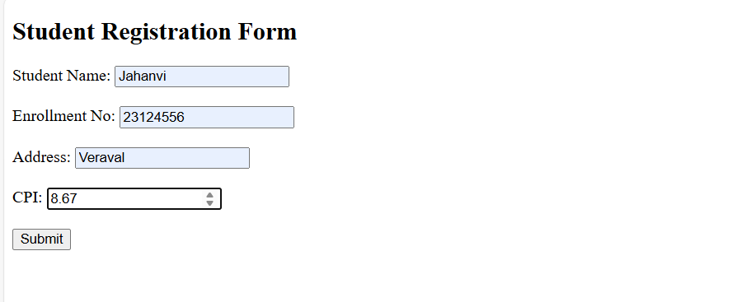

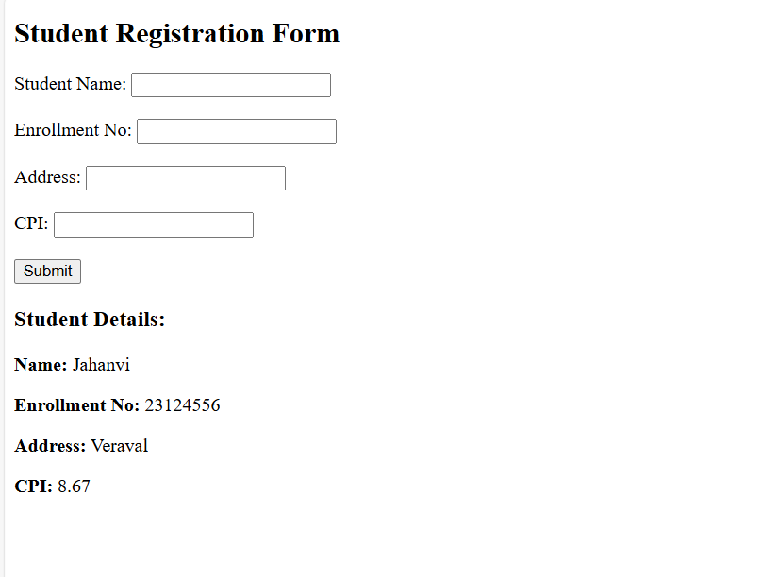

**Day-13**

**22.** **Develop JSP page to display student information with subjects for particular semester from database.**

**Student.jsp**

<%--

Document : student

Created on : 23-Oct-2024, 9:02:26 pm

Author : YASH

--%>

<%@ page import="java.sql.*" %>

<%@ page import="java.util.ArrayList" %>

<%@ page import="java.util.List" %>

<%@page contentType="text/html" pageEncoding="UTF-8"%>

<!DOCTYPE html>

<html>

<head>

<meta http-equiv="Content-Type" content="text/html; charset=UTF-8">

<title>Student and Subjects Information</title>

</head>

<body>

<h2>Student and Subjects Information for Semester 4</h2>

<%

// Database connection details

String dbURL = "jdbc:mysql://localhost:3308/demo";

String username = "root";

String password = "";

Connection conn = null;

PreparedStatement ps = null;

ResultSet rs = null;

try {

// Load the MySQL JDBC driver

Class.forName("com.mysql.cj.jdbc.Driver");

// Establish the connection

conn = DriverManager.getConnection(dbURL, username, password);

// Query to get student information and subjects for a particular semester

String sql = "SELECT students.student_name, students.enrollment_no, subjects.subject_name " +

"FROM students " +

"JOIN subjects ON students.student_id = subjects.student_id " +

"WHERE students.semester = ?";

ps = conn.prepareStatement(sql);

ps.setInt(1, 3); // Example: Get details for semester 4

rs = ps.executeQuery();

// Display the result in an HTML table

if (rs.isBeforeFirst()) { // Check if any results were returned

%>

<table border="1">

<thead>

<tr>

<th>Student Name</th>

<th>Enrollment No</th>

<th>Subject</th>

</tr>

</thead>

<tbody>

<%

while (rs.next()) {

String studentName = rs.getString("student_name");

String enrollmentNo = rs.getString("enrollment_no");

String subjectName = rs.getString("subject_name");

%>

<tr>

<td><%= studentName %></td>

<td><%= enrollmentNo %></td>

<td><%= subjectName %></td>

</tr>

<%

}

%>

</tbody>

</table>

<%

} else {

out.println("<p>No data found for this semester.</p>");

}

} catch (Exception e) {

e.printStackTrace();

} finally {

if (rs != null) try { rs.close(); } catch (SQLException ignore) {}

if (ps != null) try { ps.close(); } catch (SQLException ignore) {}

if (conn != null) try { conn.close(); } catch (SQLException ignore) {}

}

%>

</body>

</html>

**Output :-**

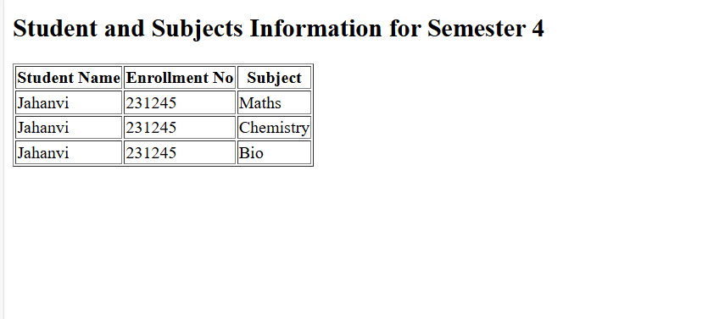

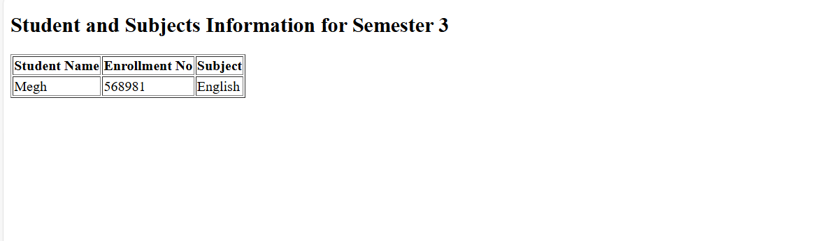

**23. Using JSP MVC implement student registration form with enrollment number, first name, last name, semester, contact number. Store the details in database. Also implement search, delete and modify facility for student records.**

**Register.jsp**

<%@ page language="java" contentType="text/html; charset=UTF-8" pageEncoding="UTF-8"%>

<%@ page session="false" %>

<!DOCTYPE html>

<html>

<head>

<title>Student Registration</title>

</head>

<body>

<h2>Student Registration Form</h2>

<%

String successMessage = (String) request.getSession().getAttribute("successMessage");

String errorMessage = (String) request.getSession().getAttribute("errorMessage");

if (successMessage != null) {

%>

<p style="color:green;"><%= successMessage %></p>

<%

request.getSession().removeAttribute("successMessage");

}

if (errorMessage != null) {

%>

<p style="color:red;"><%= errorMessage %></p>

<%

request.getSession().removeAttribute("errorMessage");

}

%>

<form action="RegisterStudent" method="post">

Enrollment Number: <input type="text" name="enrollmentNo" required><br>

First Name: <input type="text" name="firstName" required><br>

Last Name: <input type="text" name="lastName" required><br>

Semester: <input type="number" name="semester" required><br>

Contact Number: <input type="text" name="contactNumber" required><br>

<input type="submit" value="Register">

</form>

<a href="search.jsp">Search Student</a>

</body>

</html>

**Search.jsp**

<%@ page language="java" contentType="text/html; charset=UTF-8" pageEncoding="UTF-8"%>

<%@ page import="java.util.List" %>

<%@ page import="model.Student" %>

<!DOCTYPE html>

<html>

<head>

<title>Search Student</title>

</head>

<body>

<h2>Search Student</h2>

<form action="SearchStudent" method="get">

Enrollment Number: <input type="text" name="enrollmentNo" required><br>

<input type="submit" value="Search">

</form>

<br>

<h2>Students List</h2>

<%

List<Student> students = (List<Student>) request.getAttribute("students");

String errorMessage = (String) request.getAttribute("errorMessage");

if (errorMessage != null) {

%>

<p style="color: red;"><%= errorMessage %></p>

<%

} else if (students != null && !students.isEmpty()) {

%>

<table border="1">

<tr>

<th>Enrollment Number</th>

<th>First Name</th>

<th>Last Name</th>

<th>Semester</th>

<th>Contact Number</th>

</tr>

<%

for (Student student : students) {

%>

<tr>

<td><%= student.getEnrollmentNumber() %></td>

<td><%= student.getFirstName() %></td>

<td><%= student.getLastName() %></td>

<td><%= student.getSemester() %></td>

<td><%= student.getContactNumber() %></td>

</tr>

<%

}

%>

</table>

<%

} else {

%>

<p>No student found with the provided enrollment number.</p>

<%

}

%>

<a href="register.jsp">Register Student</a>

</body>

</html>

**Modify.jsp**

<!DOCTYPE html>

<html>

<head>

<title>Modify Student</title>

</head>

<body>

<h2>Modify Student</h2>

<form action="UpdateStudent" method="post">

Enrollment Number: <input type="text" name="enrollment_number" value="${student.enrollment_number}" readonly><br>

First Name: <input type="text" name="first_name" value="${student.first_name}" required><br>

Last Name: <input type="text" name="last_name" value="${student.last_name}" required><br>

Semester: <input type="number" name="semester" value="${student.semester}" required><br>

Contact Number: <input type="text" name="contact_number" value="${student.contact_number}" required><br>

<input type="submit" value="Update">

</form>

</body>

</html>

**RegisterStudent.java**

import jakarta.servlet.ServletException;

import jakarta.servlet.annotation.WebServlet;

import jakarta.servlet.http.HttpServlet;

import jakarta.servlet.http.HttpServletRequest;

import jakarta.servlet.http.HttpServletResponse;

import java.io.IOException;

import java.sql.Connection;

import java.sql.DriverManager;

import java.sql.PreparedStatement;

@WebServlet("/RegisterStudent")

public class RegisterStudent extends HttpServlet {

protected void doPost(HttpServletRequest request, HttpServletResponse response) throws ServletException, IOException {

String enrollmentNo = request.getParameter("enrollmentNo");

String firstName = request.getParameter("firstName");

String lastName = request.getParameter("lastName");

String semester = request.getParameter("semester");

String contactNumber = request.getParameter("contactNumber");

try {

Class.forName("com.mysql.cj.jdbc.Driver");

Connection conn = DriverManager.getConnection("jdbc:mysql://localhost:3308/studentDB", "root", "");

String sql = "INSERT INTO student (enrollmentNo, firstName, lastName, semester, contactNumber) VALUES (?, ?, ?, ?, ?)";

PreparedStatement statement = conn.prepareStatement(sql);

statement.setInt(1, Integer.parseInt(enrollmentNo));

statement.setString(2, firstName);

statement.setString(3, lastName);

statement.setInt(4, Integer.parseInt(semester));

statement.setString(5, contactNumber);

statement.executeUpdate();

conn.close();

// Store success message in session

request.getSession().setAttribute("successMessage", "Student registered successfully!");

response.sendRedirect("register.jsp");

} catch (Exception e) {

e.printStackTrace();

request.getSession().setAttribute("errorMessage", "Error registering student: " + e.getMessage());

response.sendRedirect("register.jsp");

}

}

}

**SearchStudent.java**

import jakarta.servlet.ServletException;

import jakarta.servlet.annotation.WebServlet;

import jakarta.servlet.http.HttpServlet;

import jakarta.servlet.http.HttpServletRequest;

import jakarta.servlet.http.HttpServletResponse;

import jakarta.servlet.RequestDispatcher;

import java.io.IOException;

import java.sql.Connection;

import java.sql.DriverManager;

import java.sql.PreparedStatement;

import java.sql.ResultSet;

import java.util.ArrayList;

import java.util.List;

import model.Student;

@WebServlet("/SearchStudent")

public class SearchStudent extends HttpServlet {

protected void doGet(HttpServletRequest request, HttpServletResponse response) throws ServletException, IOException {

String enrollmentNumber = request.getParameter("enrollmentNo");

List<Student> students = new ArrayList<>();

try {

Class.forName("com.mysql.cj.jdbc.Driver");

Connection conn = DriverManager.getConnection("jdbc:mysql://localhost:3308/studentDB", "root", "");

String sql = "SELECT * FROM student WHERE enrollmentNo = ?";

PreparedStatement statement = conn.prepareStatement(sql);

statement.setInt(1, Integer.parseInt(enrollmentNumber));

ResultSet resultSet = statement.executeQuery();

while (resultSet.next()) {

Student student = new Student();

student.setEnrollmentNumber(resultSet.getInt("enrollmentNo"));

student.setFirstName(resultSet.getString("firstName"));

student.setLastName(resultSet.getString("lastName"));

student.setSemester(resultSet.getInt("semester"));

student.setContactNumber(resultSet.getString("contactNumber"));

students.add(student);

}

request.setAttribute("students", students);

RequestDispatcher dispatcher = request.getRequestDispatcher("search.jsp");

dispatcher.forward(request, response);

conn.close();

} catch (Exception e) {

e.printStackTrace();

request.setAttribute("errorMessage", "Error occurred while searching: " + e.getMessage());

RequestDispatcher dispatcher = request.getRequestDispatcher("search.jsp");

dispatcher.forward(request, response);

}

}

}

**modifyStudent.java**

import model.Student;

import jakarta.servlet.ServletException;

import jakarta.servlet.annotation.WebServlet;

import jakarta.servlet.http.HttpServlet;

import jakarta.servlet.http.HttpServletRequest;

import jakarta.servlet.http.HttpServletResponse;

import jakarta.servlet.RequestDispatcher;

import java.io.IOException;

import java.sql.Connection;

import java.sql.DriverManager;

import java.sql.PreparedStatement;

import java.sql.ResultSet;

@WebServlet("/ModifyStudent")

public class ModifyStudent extends HttpServlet {

protected void doGet(HttpServletRequest request, HttpServletResponse response) throws ServletException, IOException {

String enrollmentNumber = request.getParameter("enrollment_number");

Student student = new Student();

try {

Class.forName("com.mysql.cj.jdbc.Driver");

Connection conn = DriverManager.getConnection("jdbc:mysql://localhost:3308/studentDB", "root", "");

String sql = "SELECT * FROM student WHERE enrollmentNo=?";

PreparedStatement statement = conn.prepareStatement(sql);

statement.setInt(1, Integer.parseInt(enrollmentNumber));

ResultSet resultSet = statement.executeQuery();

if (resultSet.next()) {

student.setEnrollmentNumber(resultSet.getInt("enrollmentNo"));

student.setFirstName(resultSet.getString("firstName"));

student.setLastName(resultSet.getString("lastName"));

student.setSemester(resultSet.getInt("semester"));

student.setContactNumber(resultSet.getString("contactNumber"));

}

request.setAttribute("student", student);

RequestDispatcher dispatcher = request.getRequestDispatcher("modify.jsp");

dispatcher.forward(request, response);

conn.close();

} catch (Exception e) {

e.printStackTrace();

}

}

}

**UpdateStudent.java**

import jakarta.servlet.ServletException;

import jakarta.servlet.annotation.WebServlet;

import jakarta.servlet.http.HttpServlet;

import jakarta.servlet.http.HttpServletRequest;

import jakarta.servlet.http.HttpServletResponse;

import java.io.IOException;

import java.sql.Connection;

import java.sql.DriverManager;

import java.sql.PreparedStatement;

@WebServlet("/UpdateStudent")

public class UpdateStudent extends HttpServlet {

protected void doPost(HttpServletRequest request, HttpServletResponse response) throws ServletException, IOException {

String enrollmentNumber = request.getParameter("enrollmentNo");

String firstName = request.getParameter("firstName");

String lastName = request.getParameter("lastName");

String semester = request.getParameter("semester");

String contactNumber = request.getParameter("contactNumber");

try {

Class.forName("com.mysql.cj.jdbc.Driver");

Connection conn = DriverManager.getConnection("jdbc:mysql://localhost:3308/studentDB", "root", "");

String sql = "UPDATE student SET firstName=?, lastName=?, semester=?, contactNumber=? WHERE enrollmentNo=?";

PreparedStatement statement = conn.prepareStatement(sql);

statement.setString(1, firstName);

statement.setString(2, lastName);

statement.setInt(3, Integer.parseInt(semester));

statement.setString(4, contactNumber);

statement.setInt(5, Integer.parseInt(enrollmentNumber));

statement.executeUpdate();

conn.close();

response.sendRedirect("search.jsp");

} catch (Exception e) {

e.printStackTrace();

}

}

}

**DeleteStudent.java**

import jakarta.servlet.ServletException;

import jakarta.servlet.annotation.WebServlet;

import jakarta.servlet.http.HttpServlet;

import jakarta.servlet.http.HttpServletRequest;

import jakarta.servlet.http.HttpServletResponse;

import java.io.IOException;

import java.sql.Connection;

import java.sql.DriverManager;

import java.sql.PreparedStatement;

@WebServlet("/DeleteStudent")

public class DeleteStudent extends HttpServlet {

protected void doGet(HttpServletRequest request, HttpServletResponse response) throws ServletException, IOException {

String enrollmentNumber = request.getParameter("enrollmentNo");

try {

Class.forName("com.mysql.cj.jdbc.Driver");

Connection conn = DriverManager.getConnection("jdbc:mysql://localhost:3308/studentDB", "root", "");

String sql = "DELETE FROM student WHERE enrollmentNo=?";

PreparedStatement statement = conn.prepareStatement(sql);

statement.setInt(1, Integer.parseInt(enrollmentNumber));

statement.executeUpdate();

conn.close();

response.sendRedirect("search.jsp");

} catch (Exception e) {

e.printStackTrace();

}

}

}

**Student.java**

package model;

public class Student {

private int enrollmentNumber;

private String firstName;

private String lastName;

private int semester;

private String contactNumber;

// Getters and setters

public int getEnrollmentNumber() { return enrollmentNumber; }

public void setEnrollmentNumber(int enrollmentNumber) { this.enrollmentNumber = enrollmentNumber; }

public String getFirstName() { return firstName; }

public void setFirstName(String firstName) { this.firstName = firstName; }

public String getLastName() { return lastName; }

public void setLastName(String lastName) { this.lastName = lastName; }

public int getSemester() { return semester; }

public void setSemester(int semester) { this.semester = semester; }

public String getContactNumber() { return contactNumber; }

public void setContactNumber(String contactNumber) { this.contactNumber = contactNumber; }

}

**Output :-**

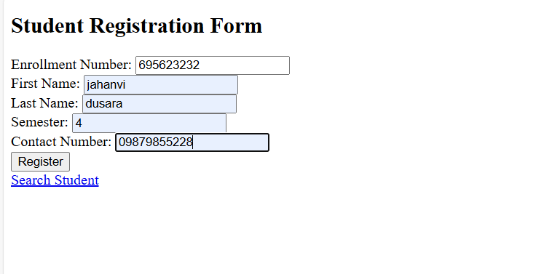



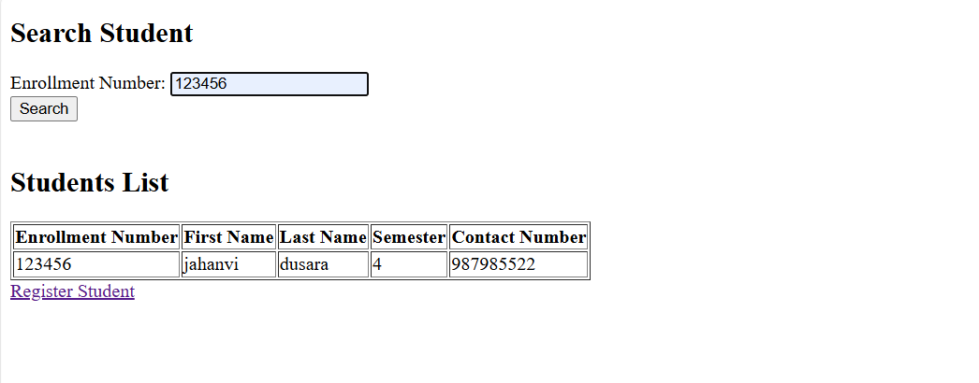

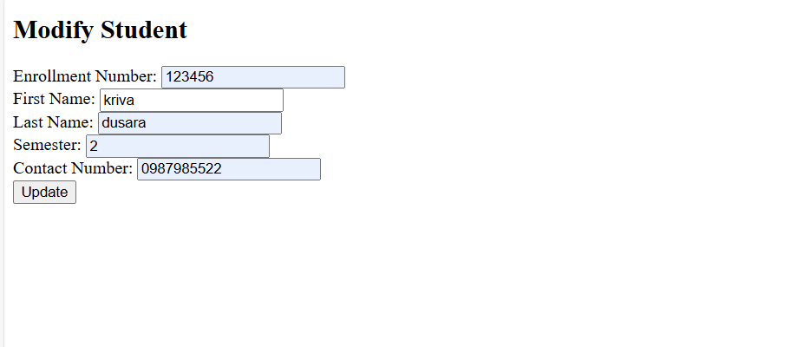

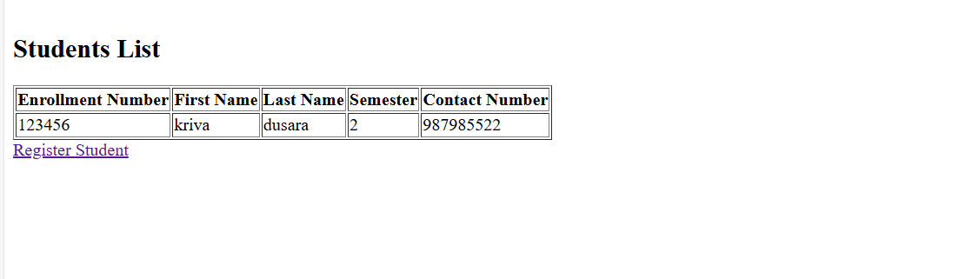

**Day-15**

**24. Write Hibernate application to store customer records and retrieve the customer record including name, contact number, address.**

**Customer.java**

/*

* Click nbfs://nbhost/SystemFileSystem/Templates/Licenses/license-default.txt to change this license

* Click nbfs://nbhost/SystemFileSystem/Templates/Classes/Class.java to edit this template

*/

package com.example.hibernate;

/**

*

* @author YASH

*/

public class Customer {

private int id;

private String name;

private String contactNumber;

private String address;

// Constructor

public Customer(int id, String name, String contactNumber, String address) {

this.id = id;

this.name = name;

this.contactNumber = contactNumber;

this.address = address;

}

// Getters and setters

public int getId() {

return id;

}

public void setId(int id) {

this.id = id;

}

public String getName() {

return name;

}

public void setName(String name) {

this.name = name;

}

public String getContactNumber() {

return contactNumber;

}

public void setContactNumber(String contactNumber) {

this.contactNumber = contactNumber;

}

public String getAddress() {

return address;

}

public void setAddress(String address) {

this.address = address;

}

@Override

public String toString() {

return "Customer [ID=" + id + ", Name=" + name + ", Contact Number=" + contactNumber + ", Address=" + address + "]";

}

}

**CustomerDao.java**

/*

* Click nbfs://nbhost/SystemFileSystem/Templates/Licenses/license-default.txt to change this license

* Click nbfs://nbhost/SystemFileSystem/Templates/Classes/Class.java to edit this template

*/

package com.example.hibernate;

import java.util.ArrayList;

import java.util.List;

/**

*

* @author YASH

*/

public class CustomerDao {

private List<Customer> customerList = new ArrayList<>();

// Method to add a customer

public void addCustomer(Customer customer) {

customerList.add(customer);

}

// Method to retrieve all customers

public List<Customer> getAllCustomers() {

return customerList;

}

// Method to retrieve a customer by ID

public Customer getCustomerById(int id) {

for (Customer customer : customerList) {

if (customer.getId() == id) {

return customer;

}

}

return null; // Return null if customer not found

}

}

**Main.java**

package com.example.hibernate;

import java.util.List;

public class Main {

public static void main(String[] args) {

// Create a new instance of CustomerDao

CustomerDao customerDao = new CustomerDao();

// Add a few customers

customerDao.addCustomer(new Customer(1, "John Doe", "1234567890", "123 Main St"));

customerDao.addCustomer(new Customer(2, "Jane Smith", "0987654321", "456 Elm St"));

customerDao.addCustomer(new Customer(3, "Alice Johnson", "1122334455", "789 Oak St"));

// Retrieve and display all customers

List<Customer> customers = customerDao.getAllCustomers();

System.out.println("All Customers:");

for (Customer customer : customers) {

System.out.println(customer);

}

// Retrieve a customer by ID

Customer customer = customerDao.getCustomerById(2);

System.out.println("\nCustomer with ID 2:");

System.out.println(customer != null ? customer : "Customer not found.");

}

}

**Day-16**

**25. Develop program to get Employee Id, name data from database using hibernate. Write necessary xml files.**

**Employee table**

CREATE TABLE Employee

(

id INT PRIMARY KEY AUTO_INCREMENT,

name VARCHAR(100) NOT NULL

);

**hibernate.cfg.xml**

<?xml version="1.0" encoding="utf-8"?>

<!DOCTYPE hibernate-configuration PUBLIC

"-//Hibernate/Hibernate Configuration DTD 3.0//EN"

"http://hibernate.sourceforge.net/hibernate-configuration-3.0.dtd">

<hibernate-configuration>

<session-factory>

<!-- Database connection settings -->

<property name="hibernate.connection.driver_class">com.mysql.cj.jdbc.Driver</property>

<property name="hibernate.connection.url">jdbc:mysql://localhost:3306/testdb</property>

<property name="hibernate.connection.username">your_username</property>

<property name="hibernate.connection.password">your_password</property>

<!-- JDBC connection pool settings -->

<property name="hibernate.c3p0.min_size">5</property>

<property name="hibernate.c3p0.max_size">20</property>

<!-- Specify dialect -->

<property name="hibernate.dialect">org.hibernate.dialect.MySQLDialect</property>

<!-- Echo all executed SQL to stdout -->

<property name="hibernate.show_sql">true</property>

<!-- Drop and re-create the database schema on startup -->

<property name="hibernate.hbm2ddl.auto">update</property>

<!-- Mapped classes -->

<mapping class="com.example.Employee"/>

</session-factory>

</hibernate-configuration>

**Employee Entity Class**

package com.example;

import javax.persistence.Entity;

import javax.persistence.GeneratedValue;

import javax.persistence.GenerationType;

import javax.persistence.Id;

@Entity

public class Employee {

@Id

@GeneratedValue(strategy = GenerationType.IDENTITY)

private int id;

private String name;

// Getters and Setters

public int getId() {

return id;

}

public void setId(int id) {

this.id = id;

}

public String getName() {

return name;

}

public void setName(String name) {

this.name = name;

}

}

**Main.java**

package com.example;

import org.hibernate.Session;

import org.hibernate.SessionFactory;

import org.hibernate.Transaction;

import org.hibernate.cfg.Configuration;

import java.util.List;

public class Main {

public static void main(String[] args) {

// Create session factory

SessionFactory sessionFactory = new Configuration().configure().buildSessionFactory();

Session session = sessionFactory.openSession();

Transaction transaction = null;

try {

transaction = session.beginTransaction();

// Query to get employees

List<Employee> employees = session.createQuery("FROM Employee", Employee.class).list();

for (Employee employee : employees) {

System.out.println("ID: " + employee.getId() + ", Name: " + employee.getName());

}

transaction.commit();

} catch (Exception e) {

if (transaction != null) transaction.rollback();

e.printStackTrace();

} finally {

session.close();

sessionFactory.close();

}

}

}

**Pom.xml**

<dependencies>

<dependency>

<groupId>org.hibernate</groupId>

<artifactId>hibernate-core</artifactId>

<version>5.4.32.Final</version>

</dependency>

<dependency>

<groupId>mysql</groupId>

<artifactId>mysql-connector-java</artifactId>

<version>8.0.25</version>

</dependency>

<dependency>

<groupId>org.slf4j</groupId>

<artifactId>slf4j-api</artifactId>

<version>1.7.30</version>

</dependency>

<dependency>

<groupId>com.mchange</groupId>

<artifactId>c3p0</artifactId>

<version>0.9.5.5</version>

</dependency>

</dependencies>

**Day-17**

**26. Develop small application using Spring MVC framework.**

**Pom.xml**

<dependencies>

<dependency>

<groupId>org.springframework</groupId>

<artifactId>spring-webmvc</artifactId>

<version>5.3.10</version>

</dependency>

<dependency>

<groupId>javax.servlet</groupId>

<artifactId>javax.servlet-api</artifactId>

<version>4.0.1</version>

<scope>provided</scope>

</dependency>

<dependency>

<groupId>org.springframework</groupId>

<artifactId>spring-context</artifactId>

<version>5.3.10</version>

</dependency>

<dependency>

<groupId>org.springframework</groupId>

<artifactId>spring-web</artifactId>

<version>5.3.10</version>

</dependency>

<dependency>

<groupId>org.thymeleaf</groupId>

<artifactId>thymeleaf-spring5</artifactId>

<version>3.0.12.RELEASE</version>

</dependency>

</dependencies>

**dispatcher-servlet.xml**

<?xml version="1.0" encoding="UTF-8"?>

<beans xmlns="http://www.springframework.org/schema/beans"

xmlns:xsi="http://www.w3.org/2001/XMLSchema-instance"

xmlns:context="http://www.springframework.org/schema/context"

xsi:schemaLocation="http://www.springframework.org/schema/beans

http://www.springframework.org/schema/beans/spring-beans.xsd

http://www.springframework.org/schema/context

http://www.springframework.org/schema/context/spring-context.xsd">

<context:component-scan base-package="com.example.controller" />

<bean class="org.springframework.web.servlet.view.InternalResourceViewResolver">

<property name="prefix" value="/WEB-INF/views/" />

<property name="suffix" value=".html" />

</bean>

</beans>

**EmployeeController.java**

package com.example.controller;

import org.springframework.stereotype.Controller;

import org.springframework.ui.Model;

import org.springframework.web.bind.annotation.GetMapping;

import org.springframework.web.bind.annotation.PostMapping;

import org.springframework.web.bind.annotation.RequestParam;

import java.util.ArrayList;

import java.util.List;

@Controller

public class EmployeeController {

private List<String> employees = new ArrayList<>();

@GetMapping("/")

public String index(Model model) {

model.addAttribute("employees", employees);

return "index";

}

@PostMapping("/add")

public String addEmployee(@RequestParam("name") String name) {

employees.add(name);

return "redirect:/";

}

}

**Index.html**

<!DOCTYPE html>

<html xmlns:th="http://www.thymeleaf.org">

<head>

<title>Employee Management</title>

</head>

<body>

<h1>Employee List</h1>

<form action="/add" method="post">

<input type="text" name="name" placeholder="Enter Employee Name" required/>

<button type="submit">Add Employee</button>

</form>

<h2>Employees:</h2>

<ul>

<li th:each="employee : ${employees}" th:text="${employee}"></li>

</ul>

</body>

</html>

**Web.xml**

<web-app xmlns="http://xmlns.jcp.org/xml/ns/javaee"

xmlns:xsi="http://www.w3.org/2001/XMLSchema-instance"

xsi:schemaLocation="http://xmlns.jcp.org/xml/ns/javaee

http://xmlns.jcp.org/xml/ns/javaee/web-app_3_1.xsd"

version="3.1">

<servlet>

<servlet-name>dispatcher</servlet-name>

<servlet-class>org.springframework.web.servlet.DispatcherServlet</servlet-class>

<load-on-startup>1</load-on-startup>

</servlet>

<servlet-mapping>

<servlet-name>dispatcher</servlet-name>

<url-pattern>/</url-pattern>

</servlet-mapping>

</web-app>