Compiled by
Amara Gitomer
Michael Binney
Kurtis McCammon
Christian Chinchilla

Bram’s Castle

Last updated: March 22, 2020

Overview - Executive summary

Elevator Pitch / High Concept
In Castle Bram, a child of Dark Souls and Metroid-Vanias, you take up a sword and shield to face the dark forces of the sinister vampire Bram.
Castle Bram is a 2D platformer with difficult boss fights, taking place in a castle filled with monsters. The player must climb the dark castle to slay the sinister vampire Bram. Take up your trusty Grapplehook and defeat the dark forces within.
William will rescue your sister from the Count’s mansion facing dangers that will end in victory or death.

Genre
Castle Bram is a 2D side scrolling dungeon crawler that is inspired by games like Dark souls and Metroid-Vania.

Key/Exotic Features
- Puzzling and challenging and levels
The core portion of the game will revolve around dealing with obstacles whether monsters or spikes and finding interesting ways of dealing with it.
- Simple to learn. Difficult to master.
The game will ramp up in difficulty rapidly with monsters dealing more and more damage per level. While you as a player will have to find hidden puzzles and secrets to increase your own power.

Target Audience
Primary:
Castle Bram’s primary audience is people who want a quick and lite version of Dark Souls with a linear layout and optional ways to make the game easier.
Secondary:
Castle Bram’s Secondary audience is people who play other Metroid-vanias and want something that may have a slower and more methodical approach to gameplay.

Play Action and Cadence
The experience we want our players to have is a fast-paced combat game that will use the players creative and strategic mind to get past obstacles. For the cadence we are expecting the players to take about 1-3 minutes with a total time between 15mins to 45 mins of game play including the cutscenes.

Win Condition / Player Goal
Defeating each floor’s boss as you climb the tower to save your sister who was taken by Bram. With a final battle between yourself and the evil vampire himself. Upon victory you and your sister flee the tower and return home.

Loss Condition / Continuation
<Loss condition> The player dies when their life is reduced to 0. Upon death the player is sent back to the beginning of the level. They are allowed to do this as many times as they like.

Comparable products

shovel knight
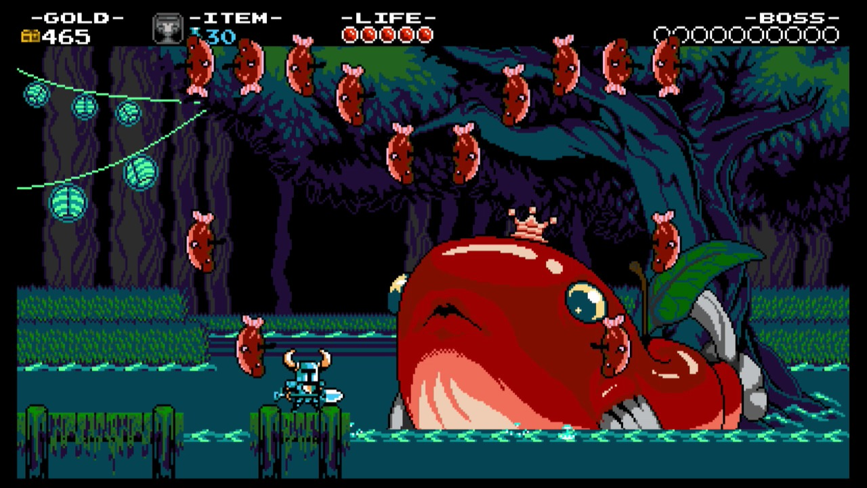
Shovel knight inspired the difficulty that we wish to set our game to. The strategy with the scale made Shovel Knight a widely successful game that we wish to replicate with the difficulty of the game. From this game we were inspired to not have a direct leveling system but have items instead that would give you better armor and health throughout the game if the player wished to find them.

megaman
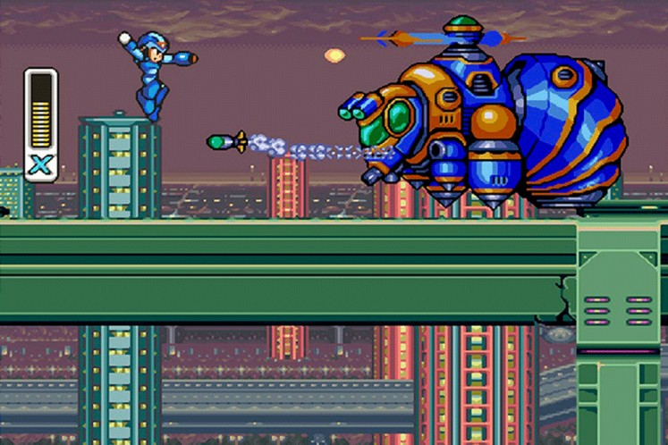
For our enemies AI system we took inspiration from Megaman as while the AI is simple many people through the years have enjoyed this pattern style AI as while being predictable does not mean it is easy to defeat. We will make our own AI in our game have a similar pattern based AI system that will allow movement and from the enemies and strategy from the player on how to encounter and possibly defeat the enemy whether it be a boss fight or a grunt fight.

castlevania
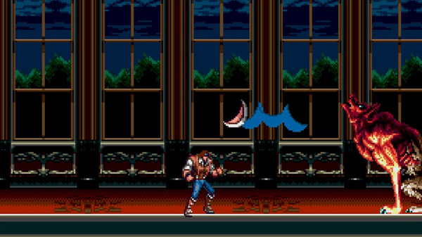
The art direction of our game was inspired by Castlevania with the Victorian athletics, deep rich coloring, and mansion background that many beloved. From this we took the inspiration and looked at it for the color choices we made in choosing darker tones that speak of an eerie setting but still rich in hue to present a grandness about the setting. We also looked to this aesthetic with the music choice as well as the dark tones helped guide us to darker, abstract music that would give anxiety to the user to create a contrast to the richness of the environment to fit the aesthetic of soft horror/thriller more.

The Ledgend of Zelda (series)
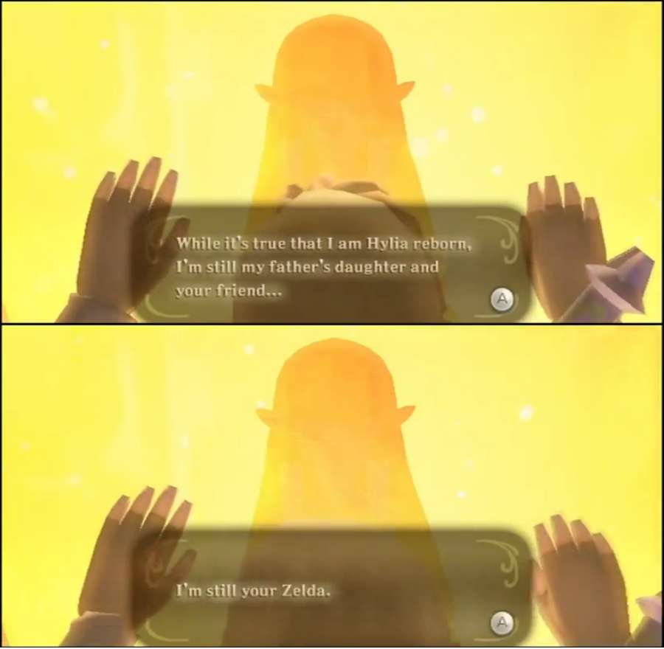
Zelda heavily inspired the story of our game in the aspect that we wanted something that people could easily connect to but was not needed to be in every part of the game. It was to make it so that the story moves along when the player moves it along by going through the levels and defeating mini-bosses and the final boss. Drawing inspiration from the tales of Zelda and Link we tried to emulate a story that people would care about and be naturally drawn to.

Super Smash Bros. Melee
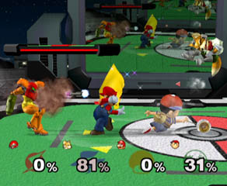
Super Smash Bros Melee we drew inspiration from the combat within the popular fighting game. From how the characters punch to ledge grabbing we wanted to implement the high intensity combat within our game to make it engaging and diverse. We also drew inspiration from the multiple characters that you can play in the game and hope for more advance features of our game to have it also have more than one playable character for players to choose from.

Hotel Transylvania
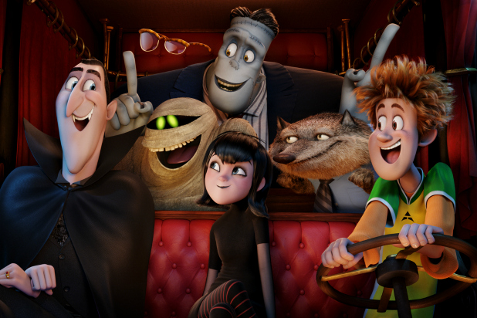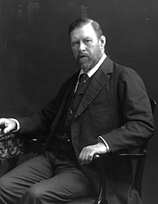
Boss inspirations
The inspiration of the bosses and mini bosses came from Hotel Transylvania and Bram Stoker. The main boss we were inspired by Bram Stokers work about the mysterious Count Dracula and how it was a great villain in his novel Dracula. Because of this large inspiration we have aptly coined our main boss with the title Count Bram in homage to Bram Stoker’s large influence. Hotel Transylvania also inspired us for our mini-bosses as it was a collaboration of different monster movies and novels and we wanted to do something similar with our game to have characters encounter different monsters throughout the film working in collaboration with each other to stop the player from advancing.

Art and Production Design

Colors
The theme of our game dark, rich colors that flow well with a fantasy vision of Victorian England




Art / visual Style
<Description of intended visuals>
The intended visual style of the game is an old castle style with easy to identify motifs of medieval and Victorian themes. We intend to do this with a night sky background, cartoonish 16-bit style characters and 2D models.
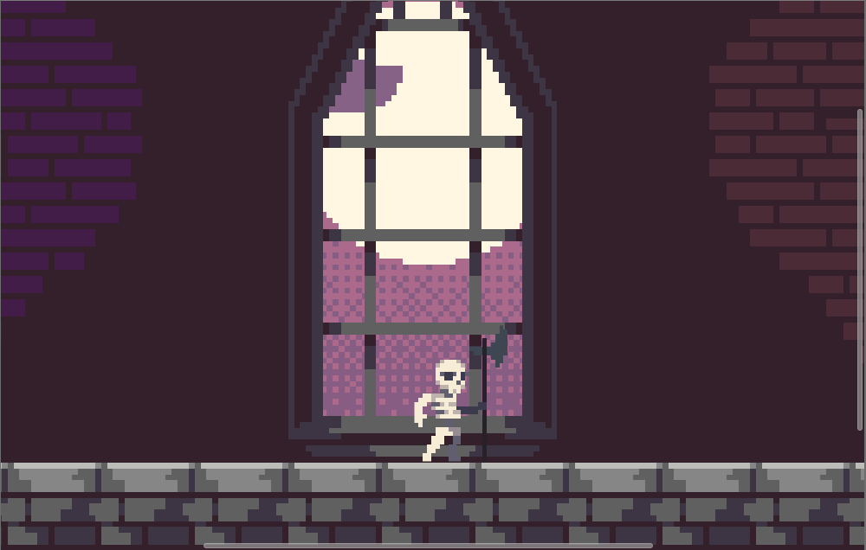

Music Style
Abstract, suspenseful, 8-bit, and dark sounds that makes the player hear sounds that instill an eeriness into the air as the play.
Examples of non-8-bit music style:
https://icons8.com/music/author/dmitriy-diomores

SFX Style
Sound effects will be very bitty and akin to sound effects found in games like Legend of Zelda: Link to the Past and Shovel Knight.
Example: (sadly it is really hard to find sound effects from both of those games.
https://gamebanana.com/sounds/34907

Interactivity

Camera Logic
Option 1:
A camera akin to Donkey Kong where the camera tightly follows the player’s x movement but has a bit of rubber banding for y
Option 2:
The camera rides along rails following the player’s x movement, but when they access a hidden or secret area the camera snaps to the new rail or to the player.
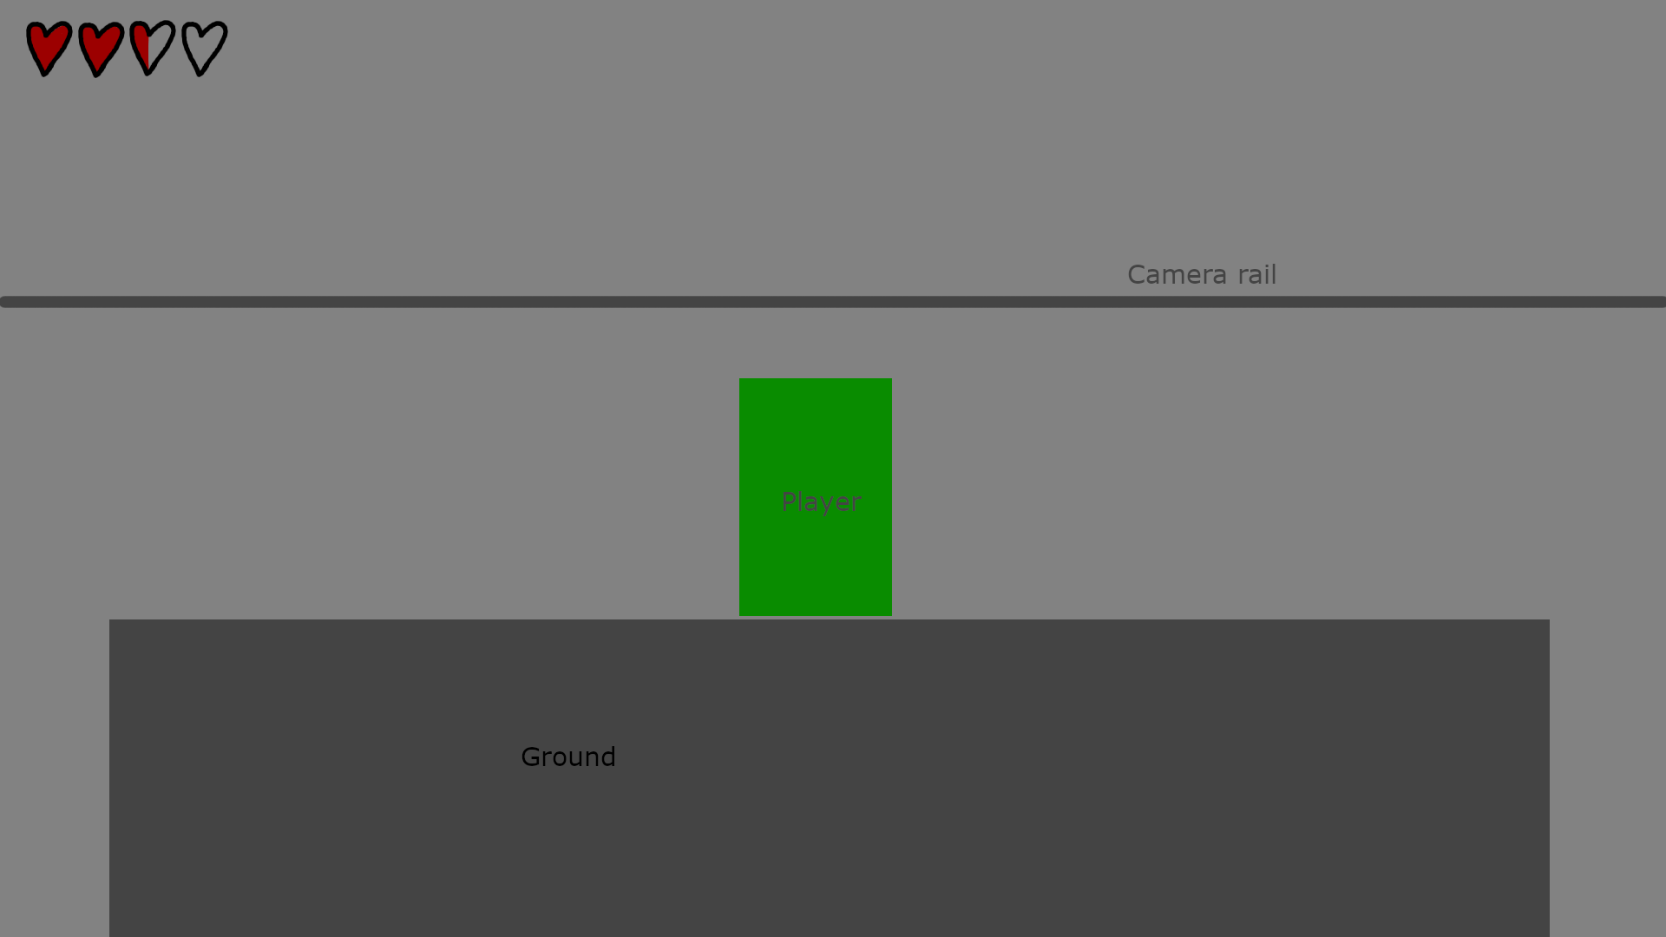
The player will be approx. 2 units high while the camera will be positioned to keep most the floor out of view that way the player doesn’t have to lose most of their screen to something static
A major consideration would be the rail system for the camera may break or create a lot of problems with vertical areas. We will have to either come up with a solution to this or fall back to option 1.

Controls

PC Controls

- Arrow keys – up arrow = movement
- Up arrow + C = shield up
- X = attack
- C = shield forward
- Z = hook
- Space for jump
- Up + Z = hook up

WebPlayer Controls
- Arrow keys – up arrow = movement
- Up arrow + C = shield up
- X = attack
- C = shield forward
- Z = hook
- Space for jump
- Up + Z = hook up

Tablet

- Directional pad for movement
- A Button for attack
- B Button for Jump
- X Button for block
- Y button for Hook
- Up + X Block up
- <Control>
- <Control>
- <Control>
- <Control>

Scope

Game Progress – Player Milestones
- Beat the Foyer(Tutorial)
  - 2 normal levels
  - 1 normal level with Frankenstein at the end
  - Defeat Frankenstein
- Beat the Library
  - 2 normal levels
  - 1 normal level with Mummy at the end
  - Defeat Mummy
- Beat the Dungeon
  - 2 normal levels
  - 1 normal level with Werewolf at the end
  - Defeat werewolf
- Defeat the final boss
  - One level against Bram
  - Win

Worlds/Levels
- 6 normal levels
  - 2 Foyer Levels
  - 2 Library Levels
  - 2 Dungeon Levels
- 3 Levels with boss rooms at the end
  - Each boss getting their own room that matches their levels theme
- 1 final boss fight against Bram
  - Top of a tower
Normal level 1-3 minutes
Mini boss level 2-5 minutes
Final boss 4-6 minutes
Total play time 16-39 minutes

Mechanics
<List out and describe in complete detail the game mechanics here>

Combat
Enemies have a simple ai but are in difficult locations
Players have a very limited pool of tools, but can use them in different ways.
Combat begins whenever the player wants to attack or engage an enemy. It ends when either the player or the enemy is dead.

Resources
There will be hidden sword and armor/shield upgrades hidden on the levels along with healing items.
The player needs to only walk over the item to pick it up.

Puzzles
Most of the puzzles will deal with enemies and traps placed in positions that make it difficult to access areas or require you to attack walls to reveal hidden paths.
An enemy is on the opposite side of a pit trap that the player can’t jump across. The player can hookshot the enemy after jumping as far as they can to pull themself the rest of the way, or they can look for the hidden room that will create a bridge over the pit. Though by building the bridge more enemies spawn to make it’s difficulty equal to that of the jump.

Player abilities
The player will have the ability to block and to hookshot.
The shield provides the player a way to block attacks and to avoid some obstacles.
The hookshot gives the player a new and interesting way to traverse the level.

Enemy types
There will be 2 types of enemies simple and complex:
- Simple:
A simple enemy follows a simple repeating movement pattern and does not react to the player.
  - Rats
  - Bats
  - Skeleton
- Complex:
A complex enemy will either have a more complex movement patter or will react to the player
  - Slimes
  - Wolves
  - Spider

Boss mechanics
- Frankenstein
  - Very simple with a lot of telegraphs for his attacks
  - Ground Smash
    - Hits the ground sending out shockwaves that will hurt and knock back the player
  - Thunder Clap
    - Claps his hands together sending out a shockwave in the air that will hurt and knock back the player
- Mummy
  - Has a more complex movement around the room and as the fight progresses his telegraphs become shorter
  - Scarab Swarm
    - Sends a swarm of scarabs to a position on the screen that will damage the player if the come in contact with it.
  - Mummy wrap
    - Sends out his wraping to cut off one of the layers of the screen. The player will take damage from coming into contact with them
- Werewolf
  - Is a much more difficult fight with little to no telegraph before his attack
  - Charge
    - The werewolf Charges across the screen. The player’s only way to dodge this is by using their hookshot to help them jump over him.
  - Claw Swipe(1,2,3)
    - The werewolf will swipe 1-3 times in a direction dealing more damage to the player then it would with it’s charge. This attack has a short telegraph before he swipes and moves.
- Bram(Vampire)

Cutscenes
- One at beginning for story setup
- One at end for closure

Dialog system
Not appplicable yet

Collectable items
- Sword upgrade
  - Increases the players damage and changes the visual appearance of the sword.
  - Each zone will have one of these hidden in it.
- Shield/armor upgrade
  - Decreases how much damage the player takes from attacks and changes the appearance of the player
  - Each zone will have one hidden in it.
- Health upgrade
  - Increases the overall health of the player
  - Each zone will have one hidden in it

