Potion of Healing - You regain hit points when you drink this potion. The potion’s red liquid glimmers when agitated.

Potion of Clairvoyance - When you drink this potion, you gain the effect of the [clairvoyance](https://www.dndbeyond.com/spells/clairvoyance) spell. An eyeball bobs in this yellowish liquid but vanishes when the potion is opened.

Potion of Invisibility - This potion's container looks empty but feels as though it holds liquid. When you drink it, you become [invisible](https://www.dndbeyond.com/compendium/rules/basic-rules/appendix-a-conditions#Invisible) for 1 hour. Anything you wear or carry is [invisible](https://www.dndbeyond.com/compendium/rules/basic-rules/appendix-a-conditions#Invisible) with you. The effect ends early if you attack or cast a spell.

Potion of Invulnerability - For 1 minute after you drink this potion, you have resistance to all damage. The potion's syrupy liquid looks like liquefied iron.

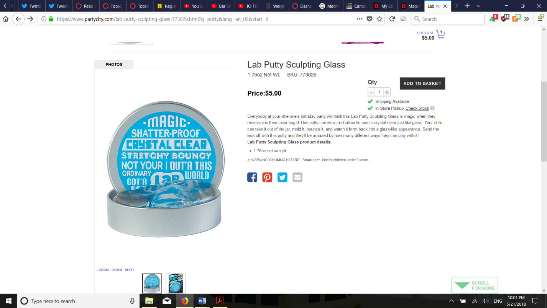

Healing

Healing

Clairvoyance

Clairvoyance

**Invisibility**

**Invisibility**

Invulnerability

Invulnerability