# Data base

1. Open Microsoft SQL Server Management Studio
2. Connect to server

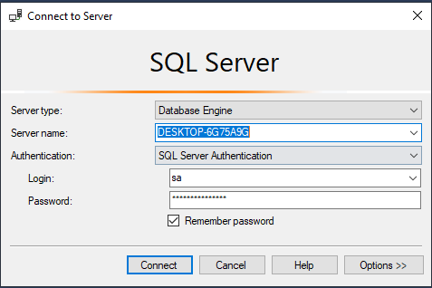

1. Open the file “roofstock_JoseDavidSolis.sql”

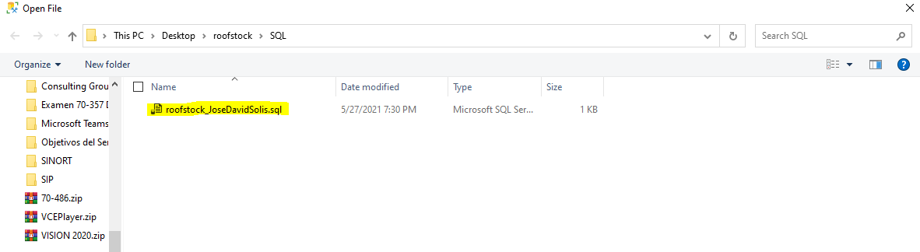

1. run the file

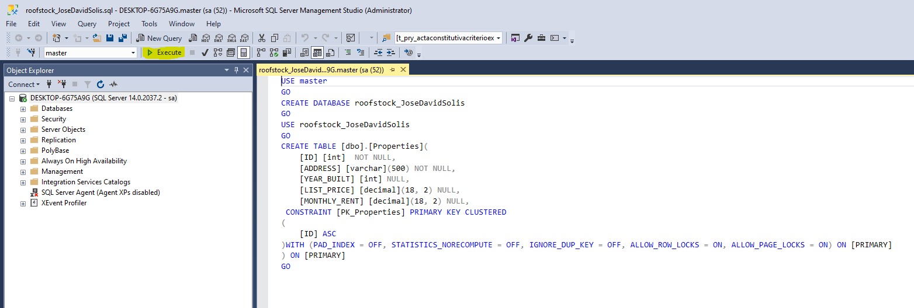

# Solution

1. Open Visual Studio
2. Open the solution “roofstock_JoseDavidSolis.sln”

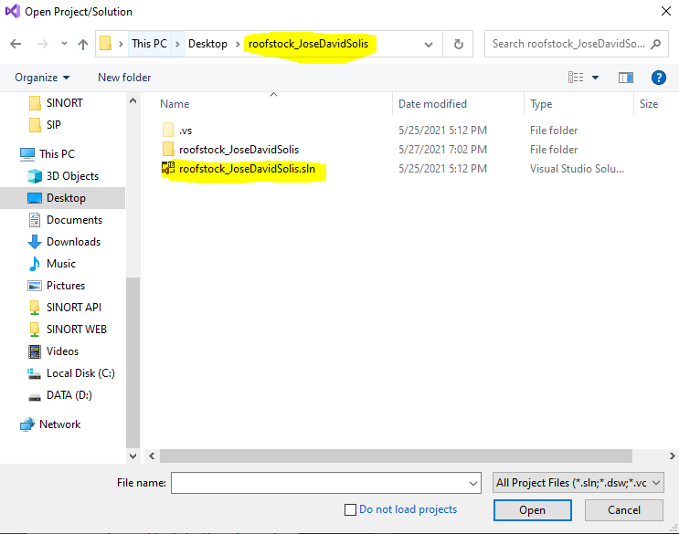

1. Open the file “appsettings.json”
2. Change key value “DefaultConnection”

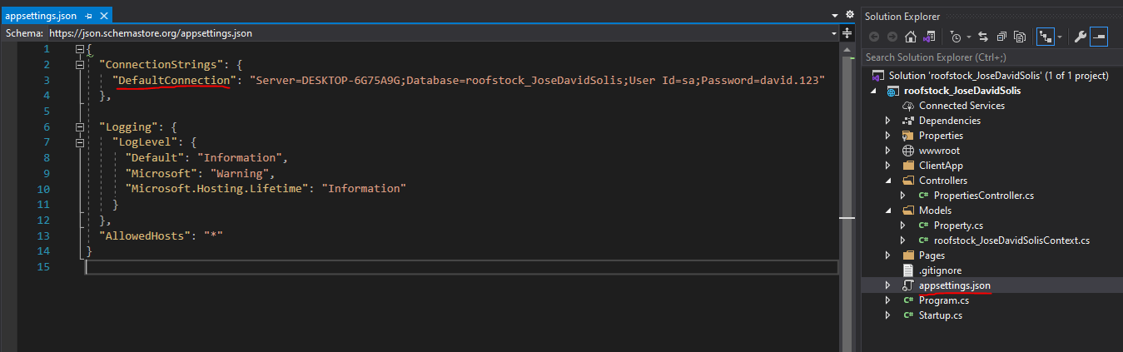

1. Run the solution

