James Donner
CPSC 5125
Rubik’s Cube

Almost everyone has owned or at least played with a Rubik’s cube at some point. So the game play should be familiar to most people.
The virtual cube is the standard 6 sided 3x3 cube. Each side of a solved cube has faces of the same color. The player is given a cube in the solved state which he/she then jumbles to begin. The object of the game is to return the cube to its original state.
The cube is displayed in four different viewports. The main view will be in the lower right viewport. It originally looks as follows:
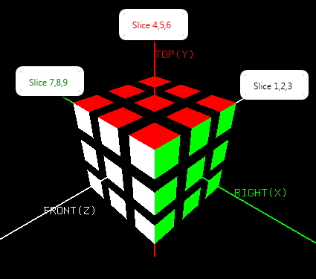

The cube will initially have the front face white, back face yellow, right side green, left side blue, top red, and bottom orange. These are the same colors as found on the standard cube. There are X, Y and Z axes upon which the cube is oriented as shown. Our initial view of the cube will be from over the cube between the front and right axes. Thus, this viewport will provide a view of three sides of the cube. These include the front, right and top views.
The default lower left viewport will look similar to the following:
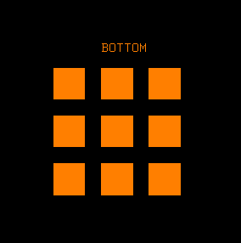
It simply shows the bottom view of the cube. The upper left viewport will show the left side of the cube. The upper right viewport will show the back of it. This way all six sides of the cube will be visible during game play. There is an option to toggle the viewports to display the top, right and front sides instead of just viewing these defaults.
One other change of view is allowed in the lower right viewport and it offers the exact opposite view of the cube. The view will be from underneath the cube between the back and left faces. It will display the back, left and bottom faces of the cube as shown below.
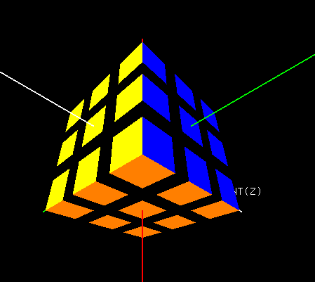
Upon toggling to this view of the cube the lower left viewport will also be automatically updated. The top or bottom cube face will be automatically redrawn to show the view from our new vantage point. And to assist in viewing the entire cube we can also rotate the whole cube around each axis. The view will reset itself to its previous orientation upon ending the rotation though.
To play the game we rotate one of 9 “slices” of the cube. Each of the slices will contain nine cubes. The first three slices are on the Z axis. Slice one being in the back, two in the middle and three in front. Toggling between counterclockwise and clockwise slice rotations is also allowed. Slices four, five and six are rotated around the Y axis. Four being the top slice (or stack if you prefer). Five being the middle and six the bottom. The X axis will center slices seven, eight, and nine. Slice seven contains the left face. We then have slice eight as the middle slice. Slice nine will be the right face. The user/player may also wish to remember that the cubes are broken down in this manner:
- 26 visible cubes
- 6 single faced cubes (center of each side)
- 8 three faced cubes (corners)
- 12 two faced cubes (edges that are not corners)
User input is via the keyboard. The keys necessary to play are as follows:
‘X’,’ x’ or ‘Y’, ’y’ or ‘Z’, ‘z’ Rotate the whole cube around the respective axis
‘1’, ‘2’, ‘3’ Rotate slice 1, 2 or 3 on the Z axis
‘4’, ‘5’, ‘6’ Rotate slice 4, 5 or 6 on the Y axis
‘7’, ‘8’, ‘9’ Rotate slice 7, 8, or 9 on the X axis
‘R’, ‘r’ Alternate slice rotation between counterclockwise and clockwise
‘<’, ‘,’ Alternate view (back, left, bottom) of cube in lower right viewport

‘>’, ‘.’ Original view (front, right, top) of cube in lower right viewport

‘V’, ‘v’ Alternate view in 3 other viewports from (front, right, top)
to (back, left, bottom )

‘+’, ’=’ Zoom in on cube in lower right viewport

‘-‘, ‘_’ Zoom out off cube in lower right viewport

‘F’, ‘f’ Toggle fullscreen

‘W’, ‘w’ Toggle between wireframe and solid

‘L’, ‘l’ Toggle lighting on/off

‘T’, ‘t’ Toggle texture mapping on/off

‘Q’, ‘q’ Quit
A click of the right mouse button offers the following menu options:
“Lens Angle” 15, 30, 45, 60, 75, 90, 120 for the lower right viewport
“Texture Image” Choose from a small selection of texture images
“Exit” …

