YEAR 1 · TERM 1 · MODULE 3 · WEEK 1
Database management systems
Study Guide · SE Study Lab
Organisations run on data. This week you see why scattered files failed, what a database and a DBMS are, who works with them, and how the relational model organises data in tables linked by keys. You will protect data with constraints and transactions, and write your first SQL queries in a real database inside your browser.
SE Study Lab · Study material

Learning objectives
- Explain the problems of file-based systems and how a DBMS solves them.
- Distinguish data, information, database, DBMS, and database system.
- Identify the roles that work with a database.
- Read and design tables with primary keys, foreign keys, and N:M junction tables.
- Explain integrity constraints, transactions, and the three-schema architecture.
- Write SELECT queries with WHERE, ORDER BY, and JOIN.

LESSON 1 · 20 min

From files to databases
Before databases, each program kept its data in its own simple files: one record after another, in a format only that program understood. A sales program had a customer file; the billing program had another customer file. Nothing was shared, so the same customer appeared in several places, and sometimes several times inside the same file.
As companies came to depend on their data, the problems became serious. Redundant copies drifted apart, so the same customer could have two different addresses. Sharing data between applications meant copying it. A damaged file often could not be rebuilt. Anyone who could open a file could read all of it. And because each program knew the exact layout of its files, any change in the layout forced programmers to rewrite code.
The answer was the database management system (DBMS): one piece of software that stores the data once, describes its structure, and lets many programs and people use it safely. In 1970, Edgar F. Codd proposed the relational model, which organises data in tables linked by keys. Over the following decade it went from a research idea to the foundation of most business systems.
Think of it like this
Picture every office in a company keeping its own paper address book. When a customer moves, someone has to update every book, and some will be missed. A database is one shared, well-organised address book that everyone consults.

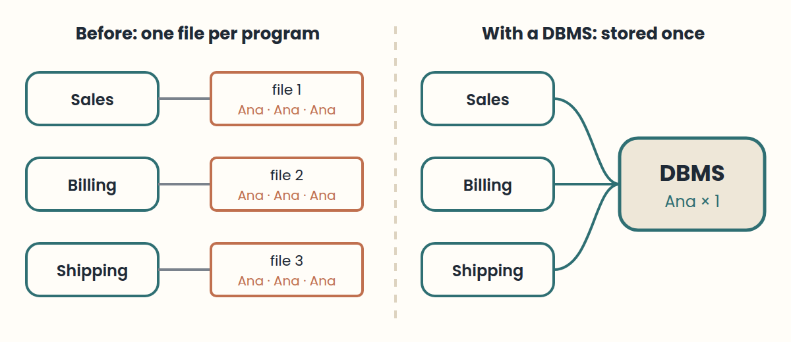

Key takeaways
- File-based systems duplicated data, so copies became inconsistent.
- Programs depended on file layouts: a layout change meant rewriting code.
- A DBMS stores data once, describes it, protects it, and shares it.

Common mistakes
- Thinking a spreadsheet shared by email is a database. → Fix: Ask: is there one copy, a described structure, and controlled access?

Exercises
1.1 Spot the redundancy Level 1
A flat file stores: order, customer name, customer phone, product. Ana ordered three times. Which values repeat, and what can go wrong?
Hint: Look at the columns that describe the customer, not the order.
1.2 Before and after Level 2
List three problems of file-based systems and the DBMS feature that solves each one.
Hint: Think of redundancy, recovery, and security.

LESSON 2 · 15 min

Data, information, and what a database is
Data are raw facts that can be recorded, such as "35000" or "F". On their own they are ambiguous: "F" could mean female in one context and false in another. Information is data given context and meaning: "the USB drive costs 35,000 pesos". Knowledge is the understanding people build on top of information, such as "the USB drive sells best at the start of term".
A database is an organised collection of related data with a purpose. It represents part of the real world, sometimes called the mini-world or universe of discourse, such as a campus store. Its data are logically coherent: random facts, even if true, are not a database. And it is designed, built, and filled for specific users and uses.
A database also describes itself. Besides the data, it stores a catalogue with the structure of every table, the type of every column, and the rules the data must follow. This data about data is called metadata. Programs, and the DBMS itself, read the catalogue to know how the data are organised.
Think of it like this
A single puzzle piece is data. Seeing that it is part of the sky is information. Knowing where to start the puzzle next time is knowledge. The box with the picture on the lid is the metadata.

Key takeaways
- Data + context = information; people turn information into knowledge.
- A database models a mini-world, is coherent, and has a purpose.
- The catalogue stores metadata: the structure and rules of the data.

Exercises
2.1 Name the mini-world Level 1
For a school library database, describe its mini-world in one sentence and name two kinds of facts it stores.
Hint: Who borrows what, and when?

LESSON 3 · 20 min

What a DBMS does
A database management system is general-purpose software for creating and maintaining databases. It does four jobs. It defines the database: tables, data types, and rules. It constructs it: stores the data on disk under its own control. It manipulates it: answers queries, inserts, updates, and reports. And it shares it: many users and programs work with the same data at the same time.
Well-known DBMSs include PostgreSQL, MySQL, SQL Server, Oracle Database, and SQLite for relational data, and MongoDB or Redis for other data models. The DBMS together with the data and the application programs that use it is called a database system.
Compared with files, a DBMS brings real advantages: it controls redundancy, enforces access rules, uses indexes and a query optimiser to answer quickly, backs up and recovers data after failures, represents complex relationships, and enforces integrity rules, also called business rules, such as "a price cannot be negative".
Think of it like this
A DBMS is like a librarian. You do not walk into the storage room yourself: you ask, and the librarian finds the book quickly, checks you may borrow it, records the loan, and makes sure two people do not take the last copy.

Key takeaways
- A DBMS defines, constructs, manipulates, and shares databases.
- Database system = DBMS + data + application programs.
- Key advantages: less redundancy, access control, fast queries, recovery, integrity.

Common mistakes
- Confusing the database (the data) with the DBMS (the software). → Fix: PostgreSQL is a DBMS; "the store database" is the data it manages.

LESSON 4 · 12 min

Who works with a database
Several roles share a database. The database administrator (DBA) authorises access, monitors performance and security, controls changes to the structure, and plans hardware and software. The database designer decides which data to store and how to structure it, talks with future users, defines integrity rules, and designs views for each group.
Systems analysts find out what end users need and specify the transactions that serve them. Application programmers turn those specifications into programs, then test, document, and maintain them.
End users are the reason the database exists. Casual users query it now and then, each time asking something different. Parametric users, such as a cashier, repeat the same standard operations all day. Sophisticated users, such as data analysts, write their own queries and tools. Stand-alone users keep a personal database for their own work.
Think of it like this
Think of a theatre: the designer draws the stage, the administrator runs the building and holds the keys, programmers build the props, and the audience, the end users, are why the show exists.

Key takeaways
- DBA: access, performance, security. Designer: structure, rules, views.
- Analysts specify; application programmers build and maintain.
- End users can be casual, parametric, sophisticated, or stand-alone.

LESSON 5 · 20 min

The relational model: tables, rows, and columns
In the relational model, data live in tables. Each table, formally a relation, represents one kind of thing, such as Product. Each column, or attribute, holds one property, such as price. Each row, also called a record or tuple, describes one specific thing: product 20, a USB drive that costs 35,000.
The schema is the structure: table names, columns, and their data types. The data, sometimes called the instance, is the content at a given moment. Adding a stock column changes the schema; changing a price changes only the data. Common data types are integers, decimals, text such as VARCHAR(60), booleans, dates, and timestamps.
The relational model is not the only one. Hierarchical databases organise records as trees, like an organisation chart. Network databases connect records with links. Object-oriented databases store objects with their methods. Many modern NoSQL systems use documents or key-value pairs. The relational model remains the starting point because tables and keys are simple and powerful.
Think of it like this
A table is like a well-designed form printed many times: the questions on the form are the columns (the schema), and each filled-in copy is a row (the data).

Key takeaways
- Relation = table, attribute = column, tuple = row.
- Schema = structure; data (instance) = content at a moment.
- Other models exist: hierarchical, network, object-oriented, NoSQL.

Common mistakes
- Storing several values in one cell, such as "red, blue, green". → Fix: One value per cell; use another table for lists.

LESSON 6 · 25 min

Keys and relationships
A primary key (PK) identifies each row of a table. It must be unique and never empty. In Customer, customer_id 1, 2, and 3 each appear once. Two customers with id 2 would break the key.
A foreign key (FK) is a column that stores the primary key of another table, creating a relationship. Order has a customer_id column pointing to Customer. One customer can place many orders, so this is a one-to-many (1:N) relationship. The DBMS can refuse an order for customer 99 if no such customer exists: that is referential integrity.
Some relationships are many-to-many (N:M): an order can include several products, and a product can appear in several orders. Relational databases model this with an intermediate table, often called a junction table, such as Order_Item with order_id, product_id, and quantity. Its primary key combines both foreign keys.
Think of it like this
A primary key is like a national ID number: one per person, never shared. A foreign key is that same number written on a form somewhere else, so you can always find the person it refers to.

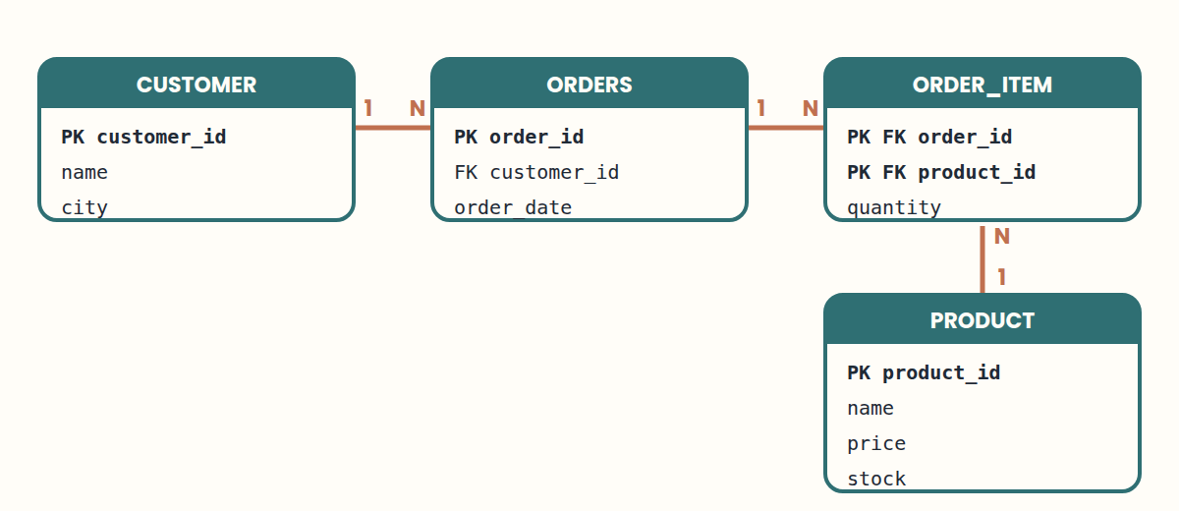

Key takeaways
- PK: unique and not null; it identifies each row.
- FK: stores another table's PK; it creates the relationship.
- N:M relationships need a junction table with two FKs.

Common mistakes
- Using a name as the primary key. → Fix: Names repeat and change. Use a stable identifier such as customer_id.

Exercises
6.1 Design a library Level 2
A library stores members (code, name), books (code, title), and loans (member, book, date). Propose the tables, their primary keys, and the foreign keys in Loan.
Hint: A member can have many loans; a book can be lent many times.
6.2 Find the hidden N:M Level 3
A music app stores playlists and songs. A song can be in many playlists, and a playlist has many songs, in a chosen order. Design the junction table.
Hint: Where does "position in the playlist" belong?

LESSON 7 · 25 min

Integrity, transactions, and safety
Integrity constraints are rules the DBMS enforces so invalid data never gets in. PRIMARY KEY forbids repeated identifiers. FOREIGN KEY keeps relationships valid. NOT NULL requires a value. CHECK tests a condition, such as price >= 0. Because the database enforces them, every application gets the same protection.
A transaction groups several operations into one unit: all or nothing. Selling a USB drive means creating the order, adding the item, and reducing stock. If every step succeeds, the transaction is committed (COMMIT). If any step fails, all changes are undone (ROLLBACK), so the database never stays half-updated.
The DBMS also coordinates concurrent users: if two cashiers try to sell the last USB drive at the same time, only one sale may succeed. It keeps a log of changes to recover after failures, supports regular backups and a recovery plan, and controls security with roles and permissions, following the principle of least privilege: each user gets only the access they need.
Think of it like this
A transaction is like a bank transfer: money leaves one account and arrives in the other, or nothing happens. You never want the money to leave and not arrive.

Key takeaways
- Constraints: PRIMARY KEY, FOREIGN KEY, NOT NULL, CHECK.
- Transaction = all or nothing: COMMIT or ROLLBACK.
- Concurrency control, logs, backups, and least privilege keep data safe.

Common mistakes
- Checking rules only in the app's screens. → Fix: Also declare them in the database, so every program must follow them.

LESSON 8 · 20 min

Three levels, views, and indexes
The three-schema architecture separates how data is seen, organised, and stored. The external level holds the views of each user group: a cashier sees orders and prices. The conceptual level describes the whole database logically: Customer, Order, Product, and their relationships. The internal level describes physical storage: files, pages, and indexes.
This separation gives data independence. Physical independence means the storage can change, for example by adding an index, without changing the applications. Logical independence means the conceptual schema can grow, for example with a new table, without breaking existing views. A view is a named query: CREATE VIEW expensive_products AS SELECT … lets users query a tailored subset as if it were a table, and can also hide sensitive columns.
Most databases follow a client-server architecture: the application, the client, sends SQL; the server, the DBMS, validates it, plans it, and runs it. An index works like the index of a book: it finds rows without reading the whole table. The query optimiser chooses an execution plan, for example whether to use an index. Indexes speed up reads but take space and must be updated on every change.
Think of it like this
A restaurant: diners see the menu (external), the chef works from recipes (conceptual), and the pantry is organised in shelves and fridges (internal). Reorganising the pantry should not change the menu.

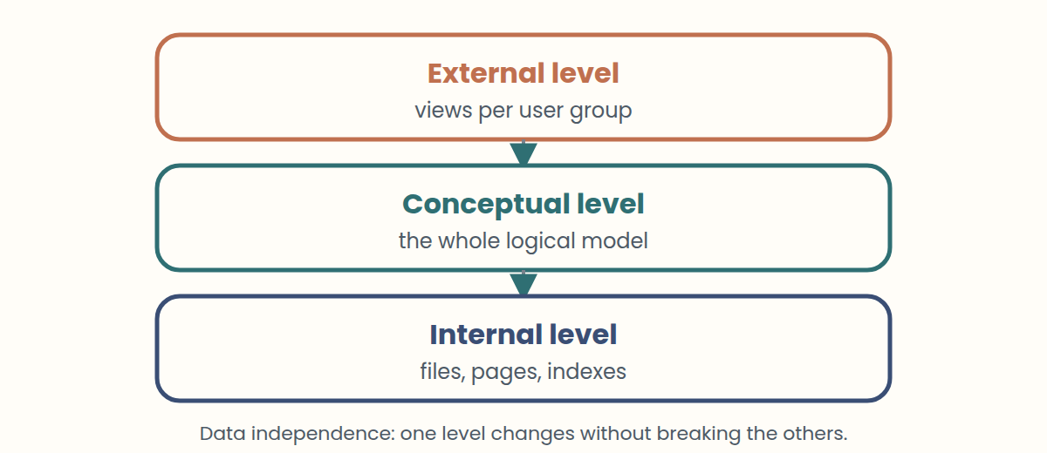

Key takeaways
- External = user views; conceptual = logical model; internal = physical storage.
- Data independence lets one level change without breaking the others.
- Indexes speed up searches but cost space and update time.

LESSON 9 · 30 min

First SQL queries
SQL is the language for working with relational data. A query starts with three words: SELECT says which columns to show, FROM says which table to read, and WHERE says which rows qualify. SELECT name, price FROM product WHERE price > 20000; returns only the products that cost more than 20,000.
AND combines conditions, and ORDER BY sorts the result: ORDER BY price DESC goes from highest to lowest. JOIN brings related tables together using their keys: joining Customer and Order on customer_id lists each customer with their orders, so a customer with two orders appears twice.
SQL also changes data. INSERT adds a row, UPDATE changes rows, and DELETE removes rows. Always write a WHERE clause on UPDATE and DELETE: without it, the change applies to every row in the table. Try every query in this week's SQL Lab, which runs a real database in your browser.
Think of it like this
SELECT is like asking a librarian: "show me the titles and authors (SELECT) from the history shelf (FROM) published after 2000 (WHERE)".

Key takeaways
- SELECT columns FROM table WHERE condition.
- ORDER BY sorts; JOIN … ON combines tables through keys.
- UPDATE and DELETE always need a WHERE clause.

Common mistakes
- Running UPDATE without WHERE. → Fix: Write the WHERE first, and test it with a SELECT using the same condition.

Exercises
9.1 Write the query Level 1
List the name and price of products that cost less than 10,000, cheapest first.
Hint: WHERE for the condition, ORDER BY … ASC for the order.
9.2 Who bought what? Level 2
Write a query that shows each customer's name next to the id of every order they placed.
Hint: Join customer and orders on customer_id.

Worked solutions
1.1 Spot the redundancy. Ana's name and phone repeat in all three rows. If her phone changes and only one row is updated, the file contradicts itself.
1.2 Before and after. Redundancy → data stored once and shared. Damaged files → backup and recovery with a change log. Anyone can read everything → access control per user and per table.
2.1 Name the mini-world. The mini-world is the library: its members, books, and loans. It stores facts such as "member 7 borrowed book 120 on 3 May" and "book 120 has 2 copies".
6.1 Design a library. Member(member_id PK, name), Book(book_id PK, title), Loan(loan_id PK, member_id FK → Member, book_id FK → Book, loan_date). Member 1:N Loan and Book 1:N Loan.
6.2 Find the hidden N:M. Playlist_Song(playlist_id FK, song_id FK, position) with primary key (playlist_id, song_id). Position belongs to the pair, not to the song or the playlist alone.
9.1 Write the query. SELECT name, price FROM product WHERE price < 10000 ORDER BY price ASC;
9.2 Who bought what?. SELECT c.name, o.order_id FROM customer AS c JOIN orders AS o ON c.customer_id = o.customer_id;

Glossary
Question | Answer
Name three problems of file-based systems. | Redundant and inconsistent data, no sharing between programs, weak recovery and security, programs tied to file layouts.
What did Edgar F. Codd propose in 1970? | The relational model: data organised in tables (relations) linked by keys.
Data vs information | Data are raw facts ("35000"). Information is data with context and meaning ("the USB drive costs 35,000").
Three properties of a database? | It represents a mini-world, its data are logically coherent, and it is built for a specific purpose and users.
What is metadata? | Data about data: the structure, types, and rules of the database, stored in its catalogue.
Four jobs of a DBMS? | Define, construct, manipulate, and share databases.
Database vs DBMS vs database system | Database = the data. DBMS = the software that manages it. Database system = DBMS + data + applications.
Name three relational DBMSs. | Any three of: PostgreSQL, MySQL, SQL Server, Oracle Database, SQLite.
What does a DBA do? | Authorises access, monitors performance and security, controls structural changes, and plans resources.
Database designer vs application programmer | The designer decides what data to store and how to structure it. The programmer builds the programs that use it.
Four kinds of end users? | Casual, parametric (naive), sophisticated, and stand-alone.
Relation, attribute, tuple? | Relation = table, attribute = column, tuple = row (record).
Schema vs data (instance) | The schema is the structure (tables, columns, types). The data are the content at a given moment.
Name three data models besides relational. | Hierarchical (trees), network (linked records), object-oriented; also document and key-value (NoSQL).
Two rules of a primary key? | Unique for every row, and never null.
What is a foreign key? | A column that stores another table's primary key, creating a relationship.
How do you model a many-to-many relationship? | With a junction table holding the two foreign keys, often as a combined primary key.
What is referential integrity? | Every foreign key value must match an existing primary key, so no order points to a missing customer.
Four common integrity constraints? | PRIMARY KEY, FOREIGN KEY, NOT NULL, CHECK.
What is a transaction? | A group of operations treated as one unit: all succeed (COMMIT) or all are undone (ROLLBACK).
Principle of least privilege? | Give each user only the permissions they need for their job.
The three levels of the three-schema architecture? | External (user views), conceptual (logical model), internal (physical storage).
Physical vs logical data independence | Physical: storage changes without affecting the logical schema or apps. Logical: the logical schema grows without breaking views.
Benefit and cost of an index? | Faster searches; it uses space and must be updated on every insert, update, or delete.
What do SELECT, FROM, and WHERE each do? | SELECT chooses columns, FROM chooses the table, WHERE filters rows.
What does JOIN … ON do? | Combines rows of two tables whose key columns match.
Why always use WHERE with UPDATE and DELETE? | Without it, the change applies to every row of the table.

Practice quiz
1. What is the main risk of storing the same customer in several files?
A. The copies become inconsistent
B. The files load faster
C. Programs need less code
2. True or false: in file-based systems, changing a file's layout usually forces changes in the programs that use it.
A. True
B. False
3. Which statement is information, not just data?
A. "Customer 2 lives in Lima"
B. "Lima"
C. "2"
4. Data about data, such as the structure and types of each table, is called ____.
Answer: ______________________
5. Match each DBMS job with an example.
1. Definition
2. Construction
3. Manipulation
4. Sharing
A. Two cashiers sell at the same time safely
B. Creating the Product table with its columns
C. Running a query for today's sales
D. Storing the rows on disk
6. True or false: PostgreSQL is a database.
A. True
B. False
7. A data analyst writes her own SQL queries and small tools to study sales. What kind of end user is she?
A. Sophisticated
B. Parametric
C. Casual
8. Who is responsible for granting access and monitoring performance?
A. The database administrator (DBA)
B. A casual end user
C. The application programmer
9. Match each formal term with its everyday name.
1. Relation
2. Attribute
3. Tuple
A. Column
B. Row
C. Table
10. Interpret the statement. What does it change?
ALTER TABLE product ADD COLUMN stock INTEGER;
A. The schema: Product gains a column
B. Only the data of one product
C. Nothing until COMMIT is typed twice
11. Orders contain many products, and products appear in many orders. What do you add?
A. A junction table with order_id and product_id
B. A product_id column in Orders
C. A list of product names in one cell
12. A column that uniquely identifies each row and cannot be null is the ____ key.
Answer: ______________________
13. An INSERT into Orders with customer_id = 99 fails with a foreign key error. Why?
A. No customer with id 99 exists
B. Order ids must be even
C. Foreign keys must be text
14. A sale creates an order, adds the item, and reduces stock. The power fails after step two. What should happen?
A. The DBMS undoes the partial sale using its log
B. The order stays without stock change
C. The whole table is deleted
15. Match each constraint with the error it prevents.
1. PRIMARY KEY
2. FOREIGN KEY
3. NOT NULL
4. CHECK (price >= 0)
A. A product without a name
B. A negative price
C. Two products with id 10
D. An order for a customer who does not exist
16. Two cashiers try to sell the last USB drive at the same time. In one or two sentences, what must the DBMS guarantee?
Answer: ______________________
17. Which level describes files, pages, and indexes?
A. Internal
B. Conceptual
C. External
18. True or false: adding indexes to every column always makes the database faster.
A. True
B. False
19. Products: Notebook 8000, USB drive 35000, Bottle 18000. What does this query return?
SELECT name FROM product · WHERE price > 10000 · ORDER BY price DESC;
A. USB drive, then Bottle
B. Bottle, then USB drive
C. Notebook only
20. After running UPDATE product SET price = 0; every product is free. What went wrong?
A. The WHERE clause was missing
B. SET only works with SELECT
C. Prices cannot be updated
21. To combine Customer and Orders rows whose customer_id match, you use JOIN … ____ c.customer_id = o.customer_id.
Answer: ______________________

Answer key
1. A — When one copy changes and the others do not, the data contradict each other.
2. A — True. Each program knew the exact layout, so data and programs were tightly coupled.
3. A — It places the values in context. Alone, "Lima" or "2" have no clear meaning.
4. The catalogue stores metadata, which the DBMS and programs read to understand the data.
5. 1→B, 2→D, 3→C, 4→A — Definition creates structure, construction stores data, manipulation queries and updates, sharing coordinates users.
6. B — False, strictly speaking: PostgreSQL is a DBMS, the software that manages databases.
7. A — Sophisticated users know the database well enough to build their own queries and tools.
8. A — Access, security, performance, and structural control belong to the DBA.
9. 1→C, 2→A, 3→B — Relation = table, attribute = column, tuple = row.
10. A — ALTER TABLE changes the structure. Changing a price with UPDATE would change only data.
11. A — Many-to-many needs a third table holding both foreign keys, plus details such as quantity.
12. That is the primary key. Foreign keys point to it from other tables.
13. A — Referential integrity: the foreign key must match an existing primary key. Create the customer first.
14. A — Transactions are all or nothing. Recovery uses the log to roll back incomplete work.
15. 1→C, 2→D, 3→A, 4→B — Each constraint blocks one kind of invalid data, for every program that uses the database.
16. Concurrency control lets only one sale succeed; the other sees that stock is zero.
17. A — The internal level is physical storage. Conceptual is the logical model; external are user views.
18. B — False. Indexes speed up reads but cost space and slow down inserts, updates, and deletes.
19. A — Two products cost more than 10,000; DESC sorts from highest to lowest price.
20. A — Without WHERE, UPDATE changes every row. Test the condition with SELECT first, and use a transaction.
21. ON gives the matching condition of the join.

