Effects of FDI on Inequality Code

2023-03-09

#Gini calculation from quintiles  
quintiles <- master[,11:15]  
  
for (i in 1:nrow(quintiles)){  
master$gini[i] <- gini.wtd(quintiles[i,])  
  
}

#Natural log-transforming skewed variables  
master$log_cap <- log(master$Total.registered.capital..Mill..USD.)  
master$log_pro <- log(master$Number.of.projects)  
master$log_income <- log(master$Income)  
master$log_ent <- log(master$Number.of.Enterprises)  
master$log_rur <- log(master$RuralPop)  
master$log_urb <- log(master$UrbanPop)

#Covariate pairwise correlations  
covariates <- master[,c("log_income","log_cap","UrbanPercent", "gini", "Ratio", "Trained.Labour.Rate", "Employment.Rate", "Governance.Score")]  
  
ggpairs(covariates)

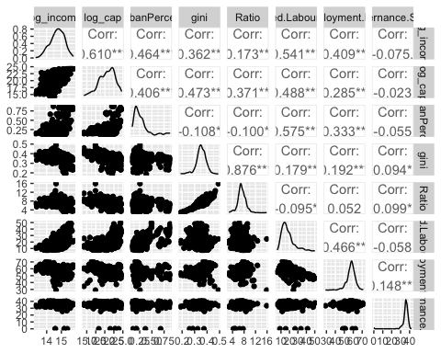

#Descriptive statistics  
  
 get_summary_stats(covariates, type = "common")

## # A tibble: 8 × 10  
## variable n min max median iqr mean sd se ci  
## <fct> <dbl> <dbl> <dbl> <dbl> <dbl> <dbl> <dbl> <dbl> <dbl>  
## 1 log_income 570 13.2 15.8 14.7 0.675 14.7 0.475 0.02 0.039  
## 2 log_cap 570 14.2 24.7 20.8 3.18 20.6 2.17 0.091 0.179  
## 3 UrbanPercent 570 0.097 0.874 0.23 0.152 0.279 0.171 0.007 0.014  
## 4 gini 570 0.188 0.491 0.354 0.045 0.353 0.039 0.002 0.003  
## 5 Ratio 570 2.72 15.9 7.10 1.47 7.21 1.38 0.058 0.114  
## 6 Trained.Labour.Rate 570 5.5 50.3 16.0 8.3 18.1 7.88 0.33 0.649  
## 7 Employment.Rate 570 29 71.3 57.8 5 57.4 4.86 0.204 0.4   
## 8 Governance.Score 570 0 42.3 36.0 2.50 35.5 4.00 0.168 0.329

# Capital inequality  
fe_cap_gini <- plm(gini ~ log_cap + log_income + Trained.Labour.Rate + Employment.Rate + Governance.Score + UrbanPercent, data = master, index = c("Province", "Year"), model = "within", effect = "twoways")  
  
fe_cap_ratio <- plm(Ratio ~ log_cap + log_income + Trained.Labour.Rate + Employment.Rate + Governance.Score + UrbanPercent, data = master, index = c("Province", "Year"), model = "within", effect = "twoways")  
  
# Cluster-robust standard errors  
se_gini1 <- coeftest(fe_cap_gini, vcov=vcovHC(fe_cap_gini, cluster = "group", type="HC1"))  
  
se_ratio2 <- (coeftest(fe_cap_ratio, vcov=vcovHC(fe_cap_ratio, cluster = "group", type="HC1")))  
  
stargazer(fe_cap_gini, fe_cap_ratio, type = "text", column.labels = c("Model 1", "Model 2"), title = "Accumulated FDI Capital and Inequality Measures", se = list(se_gini1[,2],se_ratio2[,2]))

##   
## Accumulated FDI Capital and Inequality Measures  
## ======================================================  
## Dependent variable:   
## ----------------------------  
## gini Ratio   
## Model 1 Model 2   
## (1) (2)   
## ------------------------------------------------------  
## log_cap -0.007*** -0.243***   
## (0.003) (0.092)   
##   
## log_income 0.018 0.806   
## (0.023) (0.727)   
##   
## Trained.Labour.Rate -0.001* -0.053**   
## (0.001) (0.026)   
##   
## Employment.Rate -0.002*** -0.120***   
## (0.001) (0.030)   
##   
## Governance.Score -0.0001 0.008   
## (0.0003) (0.010)   
##   
## UrbanPercent -0.005 1.360   
## (0.088) (2.891)   
##   
## ------------------------------------------------------  
## Observations 570 570   
## R2 0.101 0.190   
## Adjusted R2 -0.027 0.074   
## F Statistic (df = 6; 498) 9.307*** 19.413***   
## ======================================================  
## Note: *p<0.1; **p<0.05; ***p<0.01

# Graphs for Models 1 and 2  
  
ggplot(master, mapping = aes(log_cap, gini)) + geom_point() + geom_smooth(method = "lm")

## `geom_smooth()` using formula = 'y ~ x'

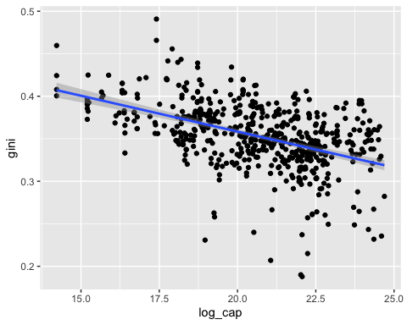

ggplot(master, mapping = aes(log_cap, Ratio)) + geom_point() + geom_smooth(method = "lm")

## `geom_smooth()` using formula = 'y ~ x'

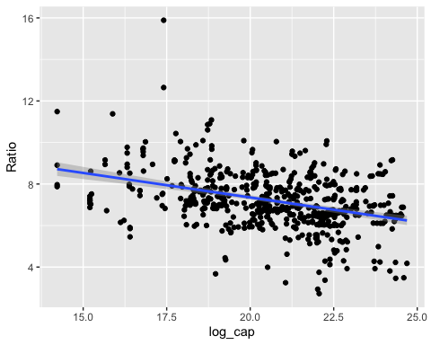

# Model for interaction between FDI and trained labour rates  
  
int_cap_gini <- plm(gini ~ log_cap + log_cap*Trained.Labour.Rate + Trained.Labour.Rate + UrbanPercent + log_income + Employment.Rate + Governance.Score, data = master,index = c("Province", "Year"), model = "within", effect = "twoways")  
  
int_cap_ratio <- plm(Ratio ~ log_cap + log_cap*Trained.Labour.Rate + Trained.Labour.Rate + log_income + UrbanPercent + Employment.Rate + Governance.Score, data = master, index = c("Province", "Year"), model = "within", effect = "twoways")  
  
# Cluster-robust standard errors  
se_gini3 <- coeftest(int_cap_gini, vcov=vcovHC(int_cap_gini, cluster = "group", type="HC1"))  
  
se_ratio4 <- coeftest(int_cap_ratio, vcov=vcovHC(int_cap_ratio, cluster = "group", type="HC1"))  
  
stargazer(int_cap_gini, int_cap_ratio, type = "text", column.labels = c("Model 3", "Model 4"), title = "Interaction of FDI and Trained Labour Rates and Inequality", se = list(se_gini3[,2], se_ratio4[,2]))

##   
## Interaction of FDI and Trained Labour Rates and Inequality  
## ========================================================  
## Dependent variable:   
## ----------------------------  
## gini Ratio   
## Model 3 Model 4   
## (1) (2)   
## --------------------------------------------------------  
## log_cap 0.004 0.195   
## (0.004) (0.120)   
##   
## Trained.Labour.Rate 0.015*** 0.597***   
## (0.003) (0.112)   
##   
## UrbanPercent 0.042 3.216   
## (0.079) (2.548)   
##   
## log_income 0.024 1.035   
## (0.022) (0.663)   
##   
## Employment.Rate -0.001** -0.088***   
## (0.001) (0.031)   
##   
## Governance.Score -0.0003 -0.004   
## (0.0003) (0.010)   
##   
## log_cap:Trained.Labour.Rate -0.001*** -0.029***   
## (0.0002) (0.005)   
##   
## --------------------------------------------------------  
## Observations 570 570   
## R2 0.178 0.275   
## Adjusted R2 0.059 0.170   
## F Statistic (df = 7; 497) 15.410*** 26.908***   
## ========================================================  
## Note: *p<0.1; **p<0.05; ***p<0.01

# Changes in slope with interaction terms  
  
plot_model(int_cap_ratio, type ="int", terms = c("log_cap", "Trained.Labour.Rate"))

## Warning in predict.plm(model, newdata = fitfram, type = pr.type, level = 0, :  
## Data supplied in argument 'newdata' is not a pdata.frame; weighted mean of  
## fixed effects as in original model used for prediction, see ?predict.plm.

## Could not compute variance-covariance matrix of predictions. No  
## confidence intervals are returned.

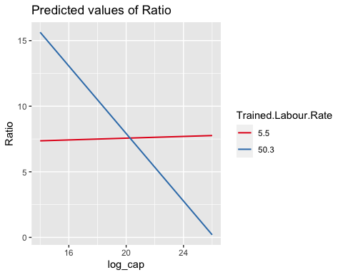

plot_model(int_cap_gini, type ="int", terms = c("log_cap", "Trained.Labour.Rate"))

## Warning in predict.plm(model, newdata = fitfram, type = pr.type, level = 0, :  
## Data supplied in argument 'newdata' is not a pdata.frame; weighted mean of  
## fixed effects as in original model used for prediction, see ?predict.plm.

## Could not compute variance-covariance matrix of predictions. No  
## confidence intervals are returned.

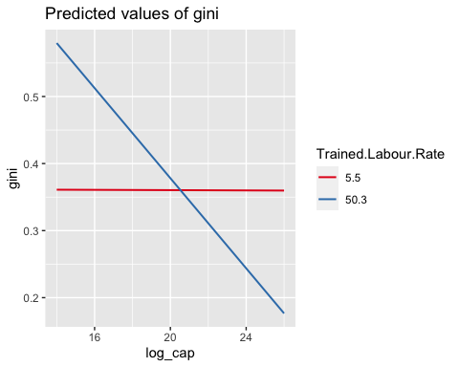

# Marginal effects plot from ratio interaction model with clustered standard errors  
marg_ef_ratio <- plot_slopes(int_cap_ratio, variables = "log_cap", condition = "Trained.Labour.Rate", vcov = vcovHC(int_cap_ratio, cluster = "group", type="HC1"), draw = TRUE)  
  
marg_ef_ratio +labs(y= "Marginal Effect of FDI on Ratio Measure of Inequality", x = "Trained Labour Rate")

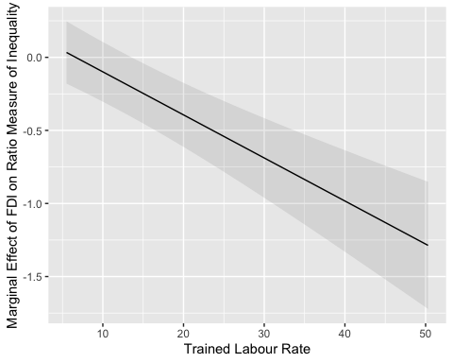

# Marginal effects plot from Gini interaction model with clustered standard errors  
marg_ef_gini <- plot_slopes(int_cap_gini, variables = "log_cap", condition = "Trained.Labour.Rate", vcov = vcovHC(int_cap_gini, cluster = "group", type="HC1"), draw = TRUE)  
  
marg_ef_gini +labs(y= "Marginal Effect of FDI on Gini Coefficient", x = "Trained Labour Rate")

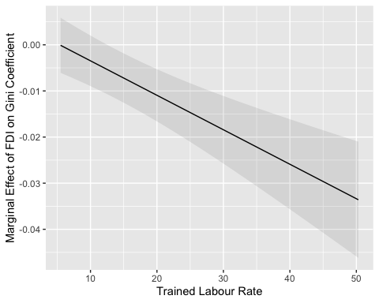

# Gini coefficient twoway random effects and pooled OLS  
re_cap_gini <- plm(gini ~ log_cap + log_income + Trained.Labour.Rate + Employment.Rate + Governance.Score + UrbanPercent, data = master, index = c("Province", "Year"), model = "random", effect = "twoways")  
  
  
pool_cap_gini <- plm(gini ~ log_cap + log_income + Trained.Labour.Rate + Employment.Rate + Governance.Score + UrbanPercent, data = master, model = "pooling")  
  
  
se_gini_re <- coeftest(re_cap_gini, vcov=vcovHC(re_cap_gini, cluster = "group", type="HC1"))  
  
  
stargazer(fe_cap_gini, re_cap_gini, pool_cap_gini, type = "text", title = "Accumulated FDI Capital and Provincial Gini", column.labels = c("Fixed effects", "Random effects", "Pooled-OLS"), se = list(se_gini1[,2],se_gini_re[,2]),align = TRUE)

##   
## Accumulated FDI Capital and Provincial Gini  
## =================================================================================  
## Dependent variable:   
## -------------------------------------------------------------  
## gini   
## Fixed effects Random effects Pooled-OLS   
## (1) (2) (3)   
## ---------------------------------------------------------------------------------  
## log_cap -0.007*** -0.008*** -0.008***   
## (0.003) (0.002) (0.001)   
##   
## log_income 0.018 0.003 -0.013***   
## (0.023) (0.004) (0.004)   
##   
## Trained.Labour.Rate -0.001* -0.001 0.0005*   
## (0.001) (0.0004) (0.0002)   
##   
## Employment.Rate -0.002*** 0.0004 0.001*   
## (0.001) (0.001) (0.0003)   
##   
## Governance.Score -0.0001 0.001** 0.001**   
## (0.0003) (0.0004) (0.0004)   
##   
## UrbanPercent -0.005 0.012 0.028***   
## (0.088) (0.023) (0.010)   
##   
## Constant 0.439*** 0.639***   
## (0.067) (0.062)   
##   
## ---------------------------------------------------------------------------------  
## Observations 570 570 570   
## R2 0.101 0.133 0.261   
## Adjusted R2 -0.027 0.123 0.253   
## F Statistic 9.307*** (df = 6; 498) 86.132*** 33.203*** (df = 6; 563)  
## =================================================================================  
## Note: *p<0.1; **p<0.05; ***p<0.01

# Ratio measure twoway random effects and pooled OLS  
  
re_cap_ratio <- plm(Ratio ~ log_cap + log_income + Trained.Labour.Rate + Employment.Rate + Governance.Score + UrbanPercent, data = master, index = c("Province", "Year"), model = "random", effect = "twoways")  
  
pool_cap_ratio <- plm(Ratio ~ log_cap + log_income + Trained.Labour.Rate + Employment.Rate + Governance.Score + UrbanPercent, data = master, model = "pooling")  
  
se_ratio_re <- coeftest(re_cap_gini, vcov=vcovHC(re_cap_gini, cluster = "group", type="HC1"))  
  
stargazer(fe_cap_ratio, re_cap_ratio, pool_cap_ratio, type = "text", title = "Accumulated FDI Capital and Provincial Ratio Measure", column.labels = c("Fixed effects", "Random effects", "Pooled-OLS"), se = list(se_ratio2[,2], se_ratio_re[,2]), align = TRUE)

##   
## Accumulated FDI Capital and Provincial Ratio Measure  
## ==================================================================================  
## Dependent variable:   
## --------------------------------------------------------------  
## Ratio   
## Fixed effects Random effects Pooled-OLS   
## (1) (2) (3)   
## ----------------------------------------------------------------------------------  
## log_cap -0.243*** -0.271*** -0.287***   
## (0.092) (0.002) (0.032)   
##   
## log_income 0.806 0.345*** 0.135   
## (0.727) (0.004) (0.157)   
##   
## Trained.Labour.Rate -0.053** -0.031*** 0.016   
## (0.026) (0.0004) (0.009)   
##   
## Employment.Rate -0.120*** -0.082*** -0.008   
## (0.030) (0.001) (0.013)   
##   
## Governance.Score 0.008 0.022*** 0.035***   
## (0.010) (0.0004) (0.014)   
##   
## UrbanPercent 1.360 0.213*** 0.053   
## (2.891) (0.023) (0.394)   
##   
## Constant 12.140*** 10.065***   
## (0.067) (2.360)   
##   
## ----------------------------------------------------------------------------------  
## Observations 570 570 570   
## R2 0.190 0.141 0.159   
## Adjusted R2 0.074 0.131 0.150   
## F Statistic 19.413*** (df = 6; 498) 92.040*** 17.700*** (df = 6; 563)  
## ==================================================================================  
## Note: *p<0.1; **p<0.05; ***p<0.01

# Interaction model two-way random effects and pooled OLS for Gini coefficient  
  
int_re_cap_gini <- plm(gini ~ log_cap + Trained.Labour.Rate*log_cap + Trained.Labour.Rate + UrbanPercent + log_income + Employment.Rate + Governance.Score, data = master,index = c("Province", "Year"), model = "random", effect = "twoways")  
  
  
int_pool_cap_gini <- plm(gini ~ log_cap + Trained.Labour.Rate*log_cap + Trained.Labour.Rate + UrbanPercent + log_income + Employment.Rate + Governance.Score, data = master, model = "pooling")  
  
se_int_gini_re <- coeftest(int_re_cap_gini, vcov=vcovHC(int_re_cap_gini, cluster = "group", type="HC1"))  
  
  
  
stargazer(int_cap_gini, int_re_cap_gini, int_pool_cap_gini, type = "text", title = "Interaction Models and Provincial Gini Measure", column.labels = c("Fixed effects", "Random effects", "Pooled-OLS"), se = list(se_gini3[,2], se_int_gini_re[,2]), align = TRUE)

##   
## Interaction Models and Provincial Gini Measure  
## ==========================================================================================  
## Dependent variable:   
## --------------------------------------------------------------  
## gini   
## Fixed effects Random effects Pooled-OLS   
## (1) (2) (3)   
## ------------------------------------------------------------------------------------------  
## log_cap 0.004 0.002 -0.006***   
## (0.004) (0.003) (0.002)   
##   
## Trained.Labour.Rate 0.015*** 0.013*** 0.003   
## (0.003) (0.003) (0.002)   
##   
## UrbanPercent 0.042 0.036 0.031***   
## (0.079) (0.028) (0.011)   
##   
## log_income 0.024 0.001 -0.013***   
## (0.022) (0.005) (0.004)   
##   
## Employment.Rate -0.001** 0.001* 0.001*   
## (0.001) (0.0005) (0.0003)   
##   
## Governance.Score -0.0003 0.001* 0.001*   
## (0.0003) (0.0003) (0.0004)   
##   
## log_cap:Trained.Labour.Rate -0.001*** -0.001*** -0.0001   
## (0.0002) (0.0002) (0.0001)   
##   
## Constant 0.230** 0.601***   
## (0.094) (0.069)   
##   
## ------------------------------------------------------------------------------------------  
## Observations 570 570 570   
## R2 0.178 0.177 0.263   
## Adjusted R2 0.059 0.167 0.254   
## F Statistic 15.410*** (df = 7; 497) 121.049*** 28.691*** (df = 7; 562)  
## ==========================================================================================  
## Note: *p<0.1; **p<0.05; ***p<0.01

# Interaction model two-way random effects and pooled OLS for ratio measure  
  
  
int_re_cap_ratio <- plm(Ratio ~ log_cap + Trained.Labour.Rate*log_cap + Trained.Labour.Rate + UrbanPercent + log_income + Employment.Rate + Governance.Score, data = master,index = c("Province", "Year"), model = "random", effect = "twoways")  
  
int_pool_cap_ratio <- plm(Ratio ~ log_cap + Trained.Labour.Rate*log_cap + Trained.Labour.Rate + UrbanPercent + log_income + Employment.Rate + Governance.Score, data = master, model = "pooling")  
  
se_int_ratio_re <- coeftest(int_re_cap_ratio, vcov=vcovHC(int_re_cap_ratio, cluster = "group", type="HC1"))  
  
  
  
stargazer(int_cap_ratio, int_re_cap_ratio, int_pool_cap_ratio, type = "text", title = "Accumulated FDI Capital and Provincial Ratio Measure", column.labels = c("Fixed effects", "Random effects", "Pooled-OLS"), se = list(se_ratio4[,2], se_int_ratio_re[,2]), align = TRUE)

##   
## Accumulated FDI Capital and Provincial Ratio Measure  
## ==========================================================================================  
## Dependent variable:   
## --------------------------------------------------------------  
## Ratio   
## Fixed effects Random effects Pooled-OLS   
## (1) (2) (3)   
## ------------------------------------------------------------------------------------------  
## log_cap 0.195 0.137 -0.156**   
## (0.120) (0.101) (0.067)   
##   
## Trained.Labour.Rate 0.597*** 0.546*** 0.193**   
## (0.112) (0.101) (0.081)   
##   
## log_income 1.035 0.325 0.123   
## (0.663) (0.297) (0.156)   
##   
## UrbanPercent 3.216 1.205 0.249   
## (2.548) (0.919) (0.403)   
##   
## Employment.Rate -0.088*** -0.065** -0.007   
## (0.031) (0.027) (0.013)   
##   
## Governance.Score -0.004 0.008 0.031**   
## (0.010) (0.012) (0.014)   
##   
## log_cap:Trained.Labour.Rate -0.029*** -0.026*** -0.008**   
## (0.005) (0.005) (0.004)   
##   
## Constant 2.836 7.420***   
## (5.444) (2.639)   
##   
## ------------------------------------------------------------------------------------------  
## Observations 570 570 570   
## R2 0.275 0.217 0.166   
## Adjusted R2 0.170 0.207 0.156   
## F Statistic 26.908*** (df = 7; 497) 155.742*** 15.972*** (df = 7; 562)  
## ==========================================================================================  
## Note: *p<0.1; **p<0.05; ***p<0.01

# F-test for gini fixed effects and pooled-OLS  
print(pFtest(fe_cap_gini,pool_cap_gini), digits = 3)

##   
## F test for twoways effects  
##   
## data: gini ~ log_cap + log_income + Trained.Labour.Rate + Employment.Rate + ...  
## F = 14, df1 = 65, df2 = 498, p-value <2e-16  
## alternative hypothesis: significant effects

# F-test for ratio fixed effects and pooled-OLS  
print(pFtest(fe_cap_ratio,pool_cap_ratio), digits = 3)

##   
## F test for twoways effects  
##   
## data: Ratio ~ log_cap + log_income + Trained.Labour.Rate + Employment.Rate + ...  
## F = 17, df1 = 65, df2 = 498, p-value <2e-16  
## alternative hypothesis: significant effects

# Hausman test for gini fixed and random effects  
print(phtest(fe_cap_gini,re_cap_gini), digits = 3)

##   
## Hausman Test  
##   
## data: gini ~ log_cap + log_income + Trained.Labour.Rate + Employment.Rate + ...  
## chisq = 118, df = 6, p-value <2e-16  
## alternative hypothesis: one model is inconsistent

# Hausman test for Ratio fixed and random effects  
print(phtest(fe_cap_ratio,re_cap_ratio), digits = 3)

##   
## Hausman Test  
##   
## data: Ratio ~ log_cap + log_income + Trained.Labour.Rate + Employment.Rate + ...  
## chisq = 61, df = 6, p-value = 3e-11  
## alternative hypothesis: one model is inconsistent