**MacDonald2007**

Minimal details, conference paper. Two types of tests, Taylor cylinder and manganin gauge flyers.

Millett 2008 uses pretty much the same data but also used rotated samples to investigate anisotropy.

Flyer plates

Flyer is 6mm thick matching anvil material (info from Millett2008)

8mm thick

Manganin gauge 4mm from front surface (reassembled with low-visc. Epoxy)

3mm driver (anvil) either Al 6082-T6 or copper (match flyer material)

** some experiments had another gauge sandwiched between driver and target to get particle velocities using impedance matching

Rosenberg et al. [8] for more manganin gauge details

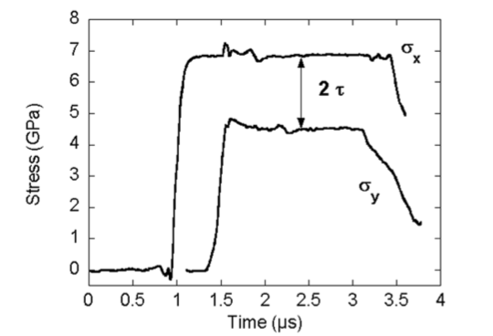454 m/s impact, 5mm copper flyer

Taylor cylinders

7.62 mm diameter, L/D ratio = 5, therefore 38.1 mm length

Rod on rod impact or into rigid anvil

Long axis of rod parallel to long axis of stock

More setup detail Maudlin et al. [9]

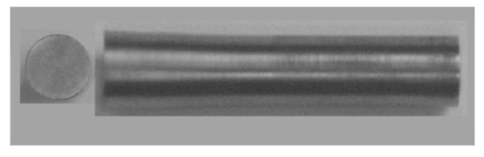Rod on rod impact, 353 m/s

Circular footprint, minimal anisotropy in radial plane

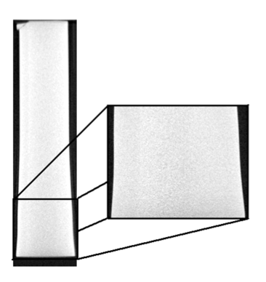rod on anvil, 238 m/s. No damage/spall observed

Material

Hot rolled, annealed bar stock 75mm. impact axis along long axis of bar

Longitudinal (CL) sound speed 6.11 mm/μs

Shear (cs) sound speed 3.13 mm/μs

Poisson's ratio (ν) 0.322.

The material was shown to possess a < 10 1(bar) 0 > rod axial fibre texture of moderate strength *{ca.* x 4). The microstructure consists of primary alpha particles in a transformed beta matrix.

Rosenberg et al. 1981

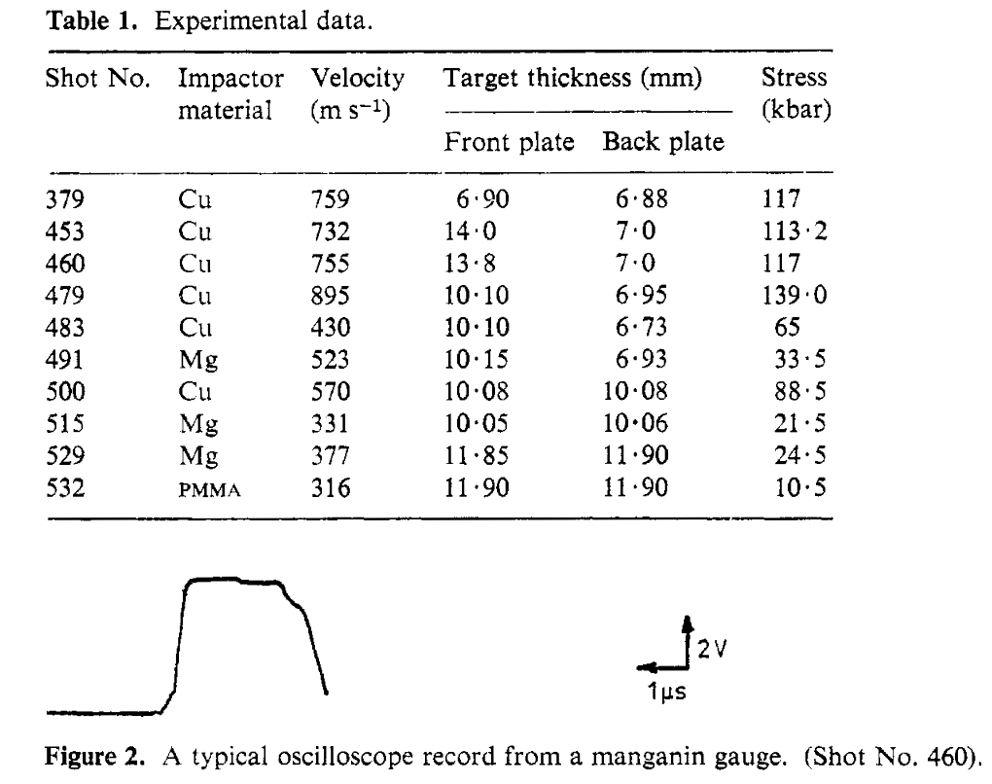15 mm flyers

Not much on material characterization

**Yu 2011 Taylor cylinders**

Chemical compositions exist for these

Basic grain composition information

7.8 mm diam, 25 mm length

Results given as undeformed length in table.

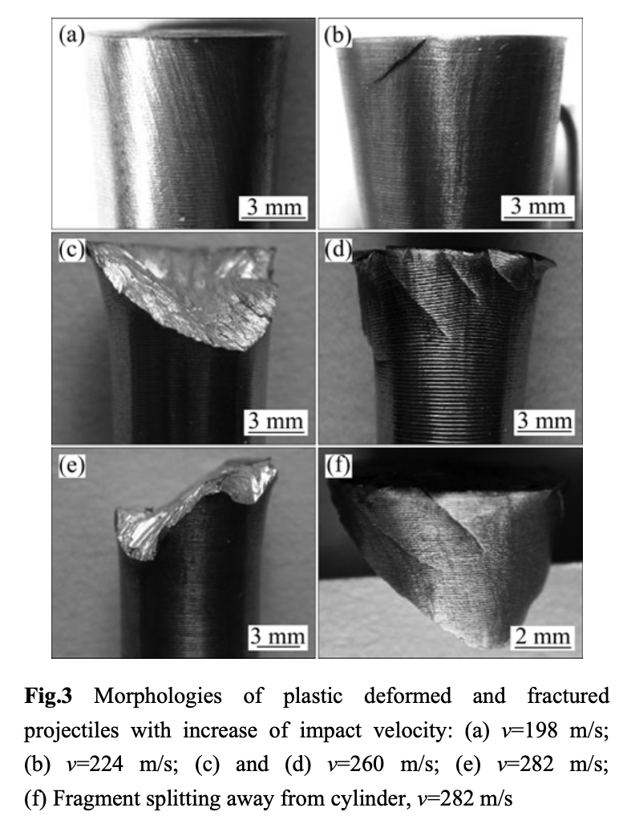

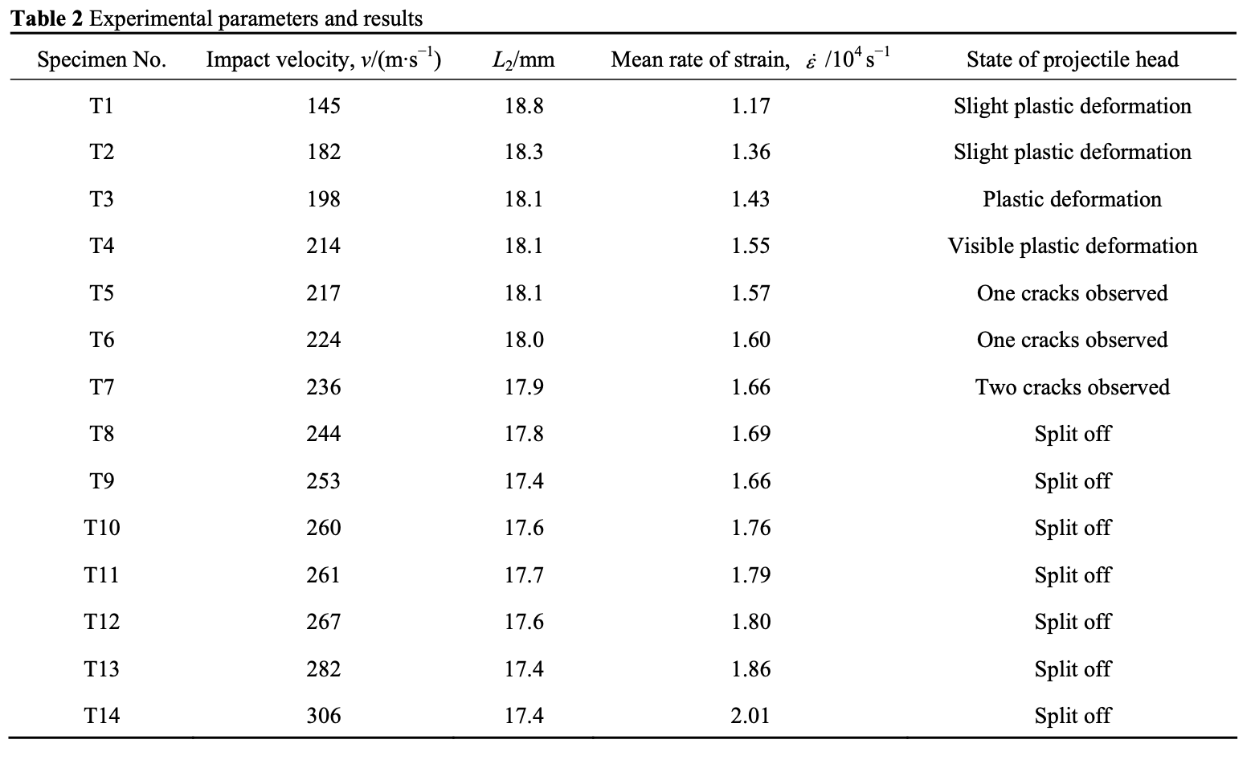

**Church 2002**

Investigate spall in Ti64 samples using flyers

Symmetric impact, 3mm flyer into 6mm target and 6mm flyer in 12mm target

Backed with PMMA with manganin gauge between target and PMMA backing

V=598 m/s and 591 m/s for thin and thick targets respectively.

V=765 m/s and 781 m/s

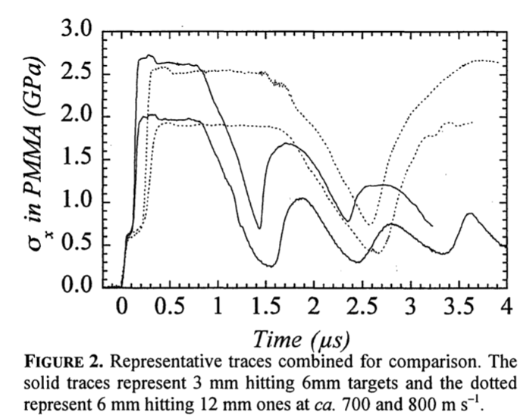

Also attempted hydrocode modeling.

**Dandekar2000 Plate impact Visar**

Plate impact with Visar data

Contains chemical composition

V=398-662 m/s

40mm diam 2-8mm thick

Ti64, sapphire and tungsten impactors

