**92.222.001 EXAM 2 Spring 2014 Name___ James Wood __________**

===========================================================================

**1)** Find *a*, *b*, and *c* so that following set of vectors is orthogonal: , , and . What has to be done to make the set orthonormal?

**2)** Is the following matrix orthogonal: ? Justify your answer.

**3)** What are the eigenvalues and associated eigenvectors of the matrix 

  is upper Triangular, so eigenvalues are on the diagonal.













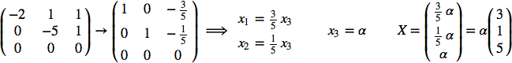**4)** What is the diagonalization of the matrix . Using *X* and *D* check that you get *A*.

**5)** Let  and 

a) Show  is an orthogonal set of vectors.

b) Using  form an orthonormal set of vectors .

c) Write the vector  as a linear combination of  and .

6) a) What are *a* andb so that the matrix *A* is Hermitian: 

b) Find an orthogonal or unitary diagonalizing matrix for .