**CHAPTER III**

**DESIGN AND METHODOLOGY**

This chapter presents the research design and methodology as well as the stages of software development of the proposed system.

**Software Development Life Cycle**

The Systems (Software) Development Life Cycle or SDLC is a process in which best describe the progress, continuing, changing or improving software. It is where ideas and strategies are being built in order to improve or to produce software that will provide or will surpass the expectancy of the user and will point the completion at exact time. SDLC also defines the duty that are being done in software development procedure step by step as well as maintaining the software.

**Agile SDLC Model**

Agile SDLC model is a combination of iterative and incremental process models with focus on process adaptability and customer satisfaction by rapid delivery of working software product. Agile Methods break the product into small incremental builds. These builds are provided in iterations. Each iteration typically lasts from about one to three weeks. Every iteration involves cross functional teams working simultaneously on various areas like - planning, requirement analysis, design, coding, unit testing and acceptance testing. At the end of the iteration, a working product is displayed to the customer and important stakeholders (Tutorial Point (India) Pvt. Ltd., 2013)**.**

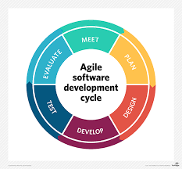

Figure 1: Agile Model

The Figure 1 Agile SDLC Modelshows the iterative and incremental software development cycle which from the beginning of the study until the end. This method of software development has manifesto principles which states Individual and interaction – it is important to consider the self-organization as well as the motivation. Working software, this the most important thing to be able to have a best interaction with the customer, by allowing them to test the software in many times until it reaches its satisfactory state. Customer collaboration, continuous interaction with the customer is very important for this will lead to proper identification of the systems’ requirement. And Responding to change, as the customer demands to have changes with the system, the software must have this attribute to be able to adopt to changes as well as in continuous development.

The proponents use this method of development because the concern of the iterative and incremental progress is to make the system proposed adoptable or versatile in changes due to the demand of the client. And by this method the proponents are able to perform the following:

**Planning Phase**

This phase of software development was a stimulus for the proponents to plan a software that will aid an organization or an office in document management, and the proponents were able to conduct an interview and observations to the institutions’ major offices that kept a large numbers of document such as Office of the Student Affairs, Office of Physical Plans, Development and Management (PPDM), Office of Research and Extensions, Office of the Supreme Student Government and Office of the Student Publication. Proponents asked for a processes that they’re doing when it comes to the documents and the proponents found out a problem in document handling and management.

**Designing Phase**

The proponents develop a design which is user-friendly and can obtained an ease access to the field requested by the user of the system. The proponents had first created a paper prototype of the design or a sketch of possible lay-out of the system. Thereafter, the proponents provide a sample lay-out which will be checked by the client for revision and furtherance to meet their satisfaction.

**Developing Phase**

In line of creating a design that best fit in the proposed system, the proponents has already created methods for the system’s process to work, however, the proponents has encountered some of the problem while developing the major processes of the system but thanks to the availability of the information on the Internet, these problem has been solved. And in agreement to this stage, the proponents has also seek some of the inputs that is vital to the system and formulate some further processes. Furthermore, knowledge in programming and logic is really needed in here in order to attain this stage.

**Testing Phase**

At this stage, proponent were able to test the proposed system, however, it’ll takes how many testing until it reaches its satisfactory level and appended to it is many thorough analysis and design was done also.

The first step that has been conducted by the proponents was to try upload a document and its information as input of the system. Then, the proponents try to search the document in many ways such as through of its document type, or in its name, document code and even on its date of when it was uploaded. Then the proponents added a borrower and try to send it a message for an alert of deadline.

**Evaluating Phase**

In this phase, the proponents will evaluate a system that

Meet

**Context Diagram**

The context diagram showcases the entities involved and its relationship as well as to established the context and boundaries of the proposed system.

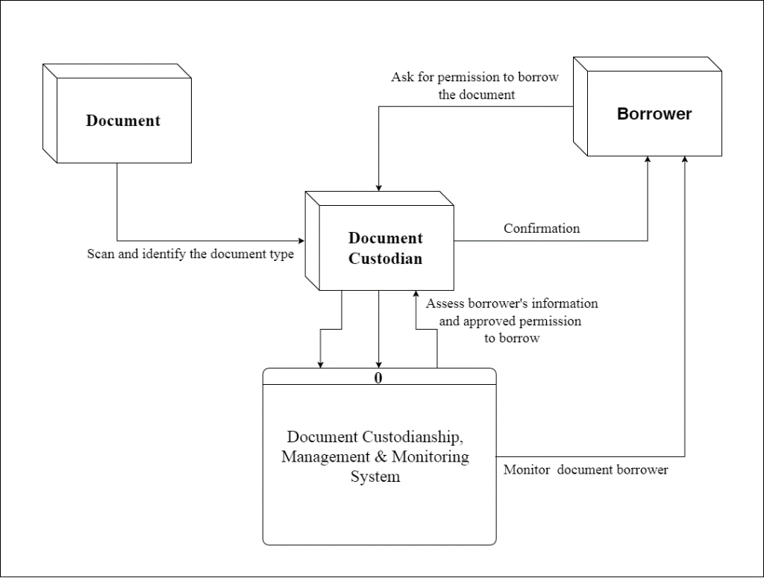

Figure 2: Context Diagram of CHMSC – Binalbagan Document Custodianship, Management and Monitoring System with SMS Notification

The Figure 2: Context Diagram of CHMSC – Binalbagan Document Custodianship, Management and Monitoring System with SMS Notification shows the context, boundaries and data flow of the proposed system. The whole process is centralized with the document custodian, this entity is the one who’ll use and act as administrator, when there is a document both out going and in-going, it has to be undergone provision of the document custodian for it will be classified in accordance with its type of document and if it is a controlled or uncontrolled document as well as to scan and stored it on the repository. Same with the borrowing transaction, it has to be evaluated by the custodian the transactor in order to have security and assurance that the document will be returned by the borrower so that monitoring will be meet.

**Data Flow Diagram**

The data flow diagram showcases the flow of the data in the proposed system of the proponents.

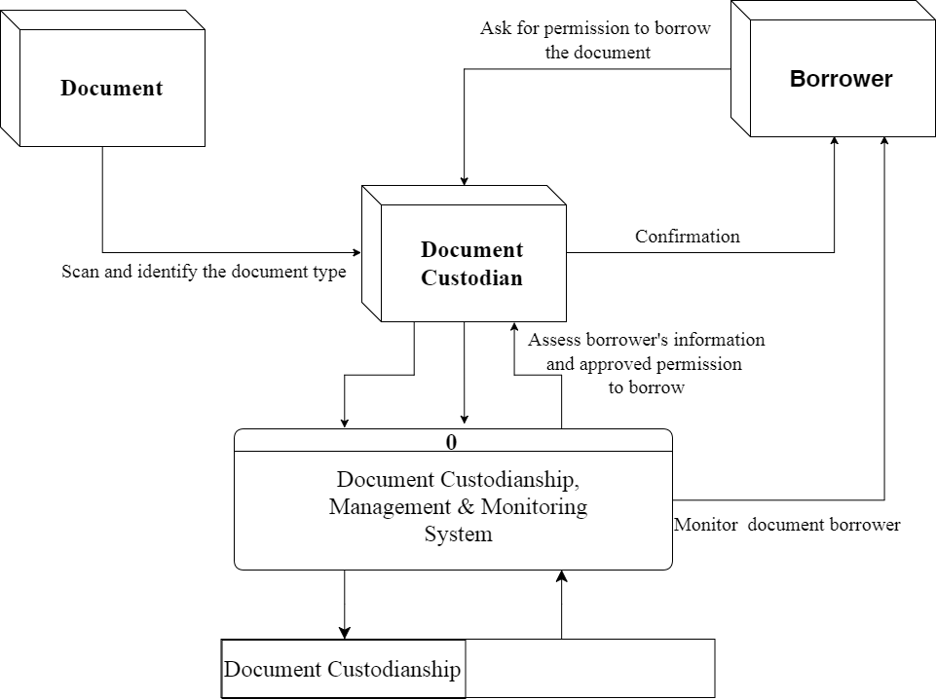

Figure 3: CHMSC- Binalbagan Document Custodianship, Management and Monitoring System with SMS Notification Data Flow Diagram

The Figure 3: CHMSC- Binalbagan Document Custodianship, Management and Monitoring System with SMS Notification Data Flow Diagram shows the data flow of the system proposed. Like the context diagram, the system is centralize in the document keeper or the custodian or simply the administrator where all of the input of document’s info, document control and management as well as monitoring of the borrowers are its major tasks; also the assessment on the document borrowers and approval of its request to borrow the document are his job.

**Use Case Diagram**

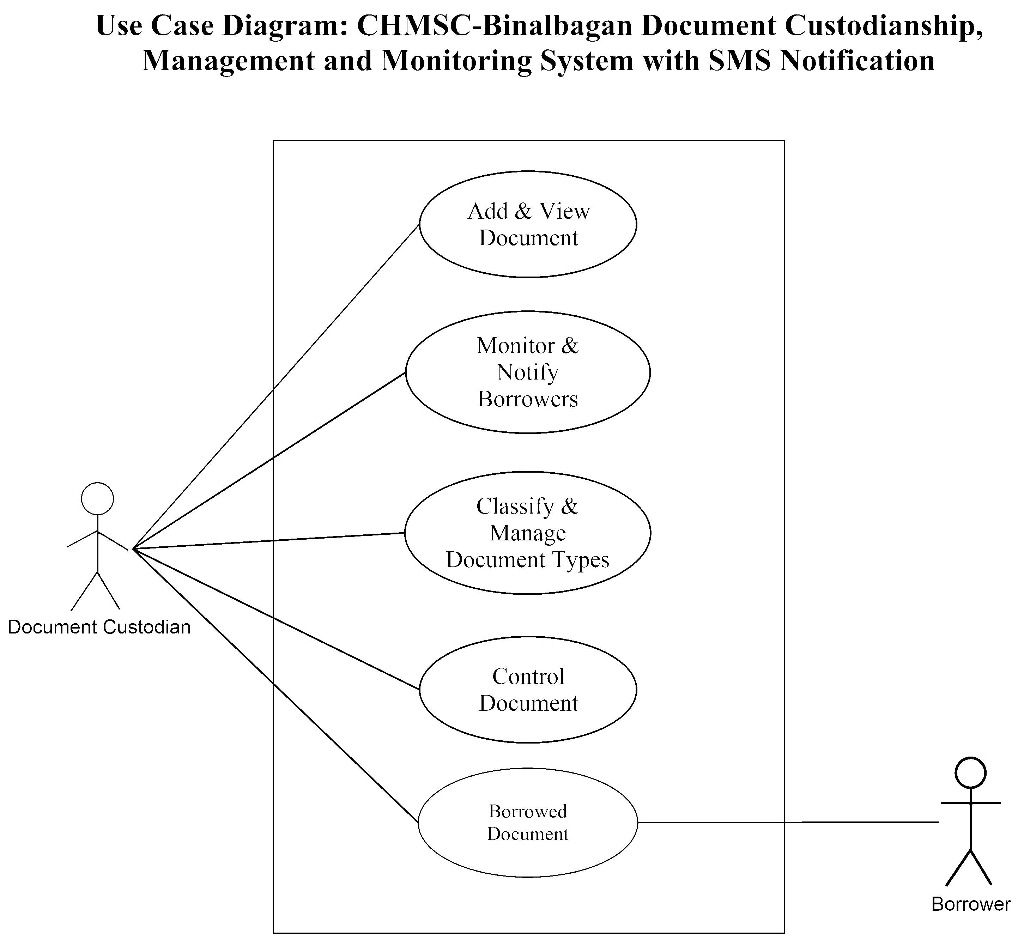

Figure 4: Use Case Diagram of CHMSC-Binalbagan Document Custodianship, Management and Monitoring System with SMS Notification

­­ The Figure 4: Use Case Diagram of CHMSC-Binalbagan Document Custodianship, Management and Monitoring System with SMS Notification showcases the concept of operation of the proposed system where the whole processes is only acted by the document custodian, the add and view of the document, monitor and notify the borrowers, classify and manage document type and control of the document.

**Actor:** Document Custodian – a person who’ll act as administrator who manages and control the document custodies that an organization or office have.

Barrower- a person who’s have the interest to the document that document custodian have, this person will be going to borrow the said custodies.

**Use Case Description**

The tables below describe the functions, conditions and alternative flows [if ever] to be met of the actor in every entities shows in use case diagram.

Table 1: Add and View Document

|  |  |
| --- | --- |
| Use Case Name | Add and View Document |
| Primary Actor: | Document Custodian |
| Description: | Add new document, view document and update document’s information |
| Pre-Condition: | Document Custodian- Evaluate the document’s information and confirm the document to be uploaded. |
| Main Success Scenario: | Document Custodian – process and input the document’s information and saved to document’s repository |

Table 2: Monitor and Notify Borrowers

|  |  |
| --- | --- |
| Use Case Name | Monitor and Notify Borrowers |
| Primary Actor: | Document Custodian, Borrowers |
| Description: | Monitoring of the document’s borrower and notify it for its deadline to be return the document. |
| Persons with Interest | Document Custodian – the primary actor that facilitates all of the document in an organization or an office  Borrower – a person who has the interest to borrow that an organization or office have. |
| Pre-Condition: | Document Custodian- Must confirm the request of the borrower and evaluate it and if it’s found out that the borrower has exceed to its deadline, then it is time for it to send an SMS for as notice to return the document that is been borrowed.  Borrower – Send request for the document to be borrowed. |
| Alternative Flow: | Document Custodian – decline request.   1. The borrowing request will be cancelled. 2. Borrower may fill-up another request form. |
| Main Success Scenario: | Document Custodian – process and input the borrower’s information and saved to document borrower’s repository  Borrower – Approved request and document that it’s been borrowed. |

Table 3: Classify and Manage Document Type

|  |  |
| --- | --- |
| Use Case Name | Classify and Manage Document Type |
| Primary Actor: | Document Custodian |
| Description: | Classification and management of the document |
| Pre-Condition: | Document Custodian – must classify the document in accordance with its identity; if it is a document, form or even record. |
| Main Success Scenario: | Document Custodian – classified and well manage document. |

Table 4: Control of Document

|  |  |
| --- | --- |
| Use Case Name | Control of Document |
| Primary Actor: | Document Custodian |
| Description: | Control document for dissemination purposes. |
| Pre-Condition: | Document Custodian – must identify if the document is control or uncontrolled and have prior approval for dissemination. |
| Main Success Scenario: | Document Custodian – disseminate yet identified it is a control or uncontrolled document. |

Table 5: Document

|  |  |
| --- | --- |
| Use Case Name | Borrowed Document |
| Primary Actor: | Document Custodian, Borrower |
| Description: | Borrowers interest to the document |
| Persons with Interest | Document Custodian – the primary actor that facilitates all of the document in an organization or an office  Borrower – a person who has the interest to borrow a document that an organization or office have as well as responsible of returning it. |
| Pre-Condition: | Document Custodian – must collect from the borrower its contact information and prior purpose to borrow the said document before approval.  Borrower – must seek information such as availability of the document and filled-up request form [if ever an office or organization have] for approval. |
| Alternative Flow | Document Custodian – decline request.   1. The borrowing request will be cancelled. 2. Borrower may fill-up another request form. |
| Main Success Scenario: | Document Custodian – process and input the borrower’s information and saved to document borrower’s repository and call for monitoring.  Borrower – Approved request and document that it’s been borrowed. |

**Activity Diagram**

The activity diagram showcases the activity flow that should be done by the actor involved in the proposed system

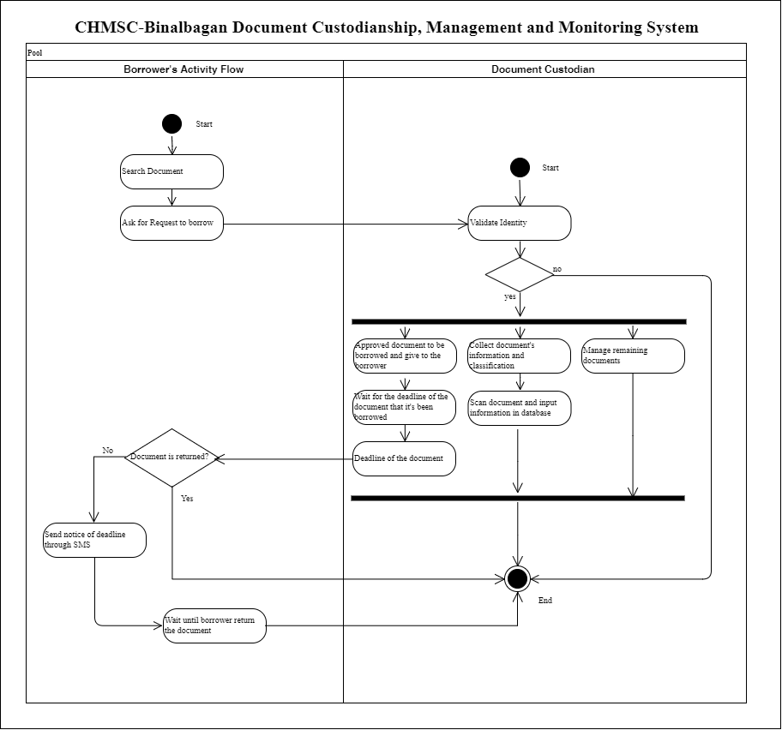

Figure 5: Activity Diagram of the Document Custodian

The Figure 5: Activity Diagram of the Document Custodian showcases the activity flow that document custodian should be done, the whole process starts with identity validation, if it is been identified identity, the major action should be done, such as: approved document to be borrowed, collect document’s information and classification as well as, scan the document and input document’s information in the database and manages remaining and borrowed documents.

**Decomposition Chart**

The decomposition chart is a tool used to show the decomposition of the system.

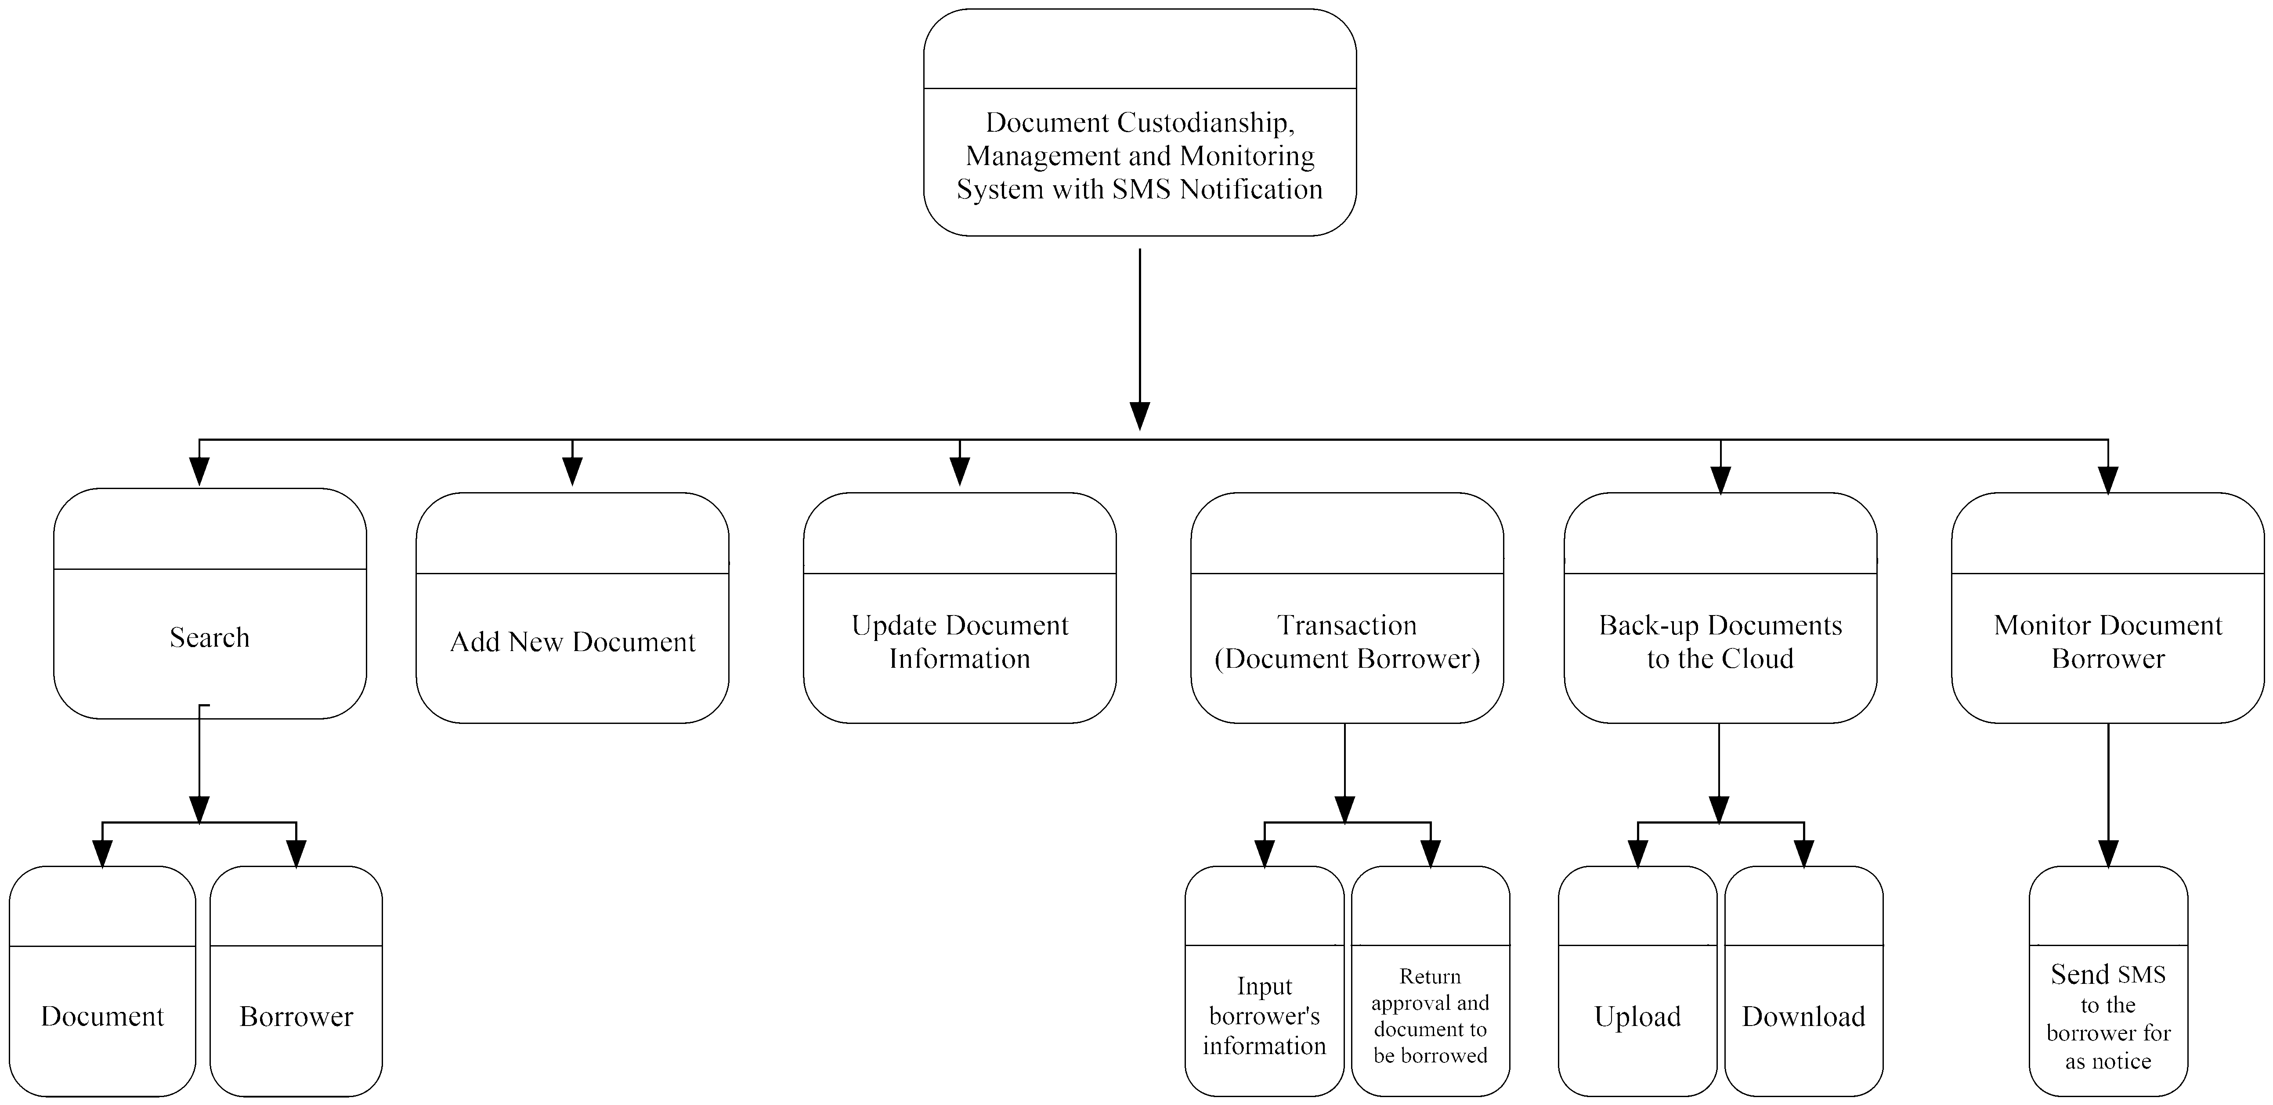

Figure 6: Decomposition Chart of CHMSC-Binalbagan Document Custodianship, Management and Monitoring System with SMS Notification

**­** The Figure 6: Decomposition Chart of CHMSC-Binalbagan Document Custodianship, Management and Monitoring System with SMS Notification shows the decomposition or hierarchy of processes that will be encountered in the proposed system. Where the system has six major classes namely search with sub classes for document and borrower, add new document, update document info, transaction for document borrowers with inputting of borrower’s information and return approval of request as well as the document to be borrowed, back-up document to the cloud with upload and download and monitor document borrower through sending SMS for as notification.

**Entity Relationship Diagram**

The Entity Relationship Diagram or ERD is representation of how the tables on the database are correlated with each other.

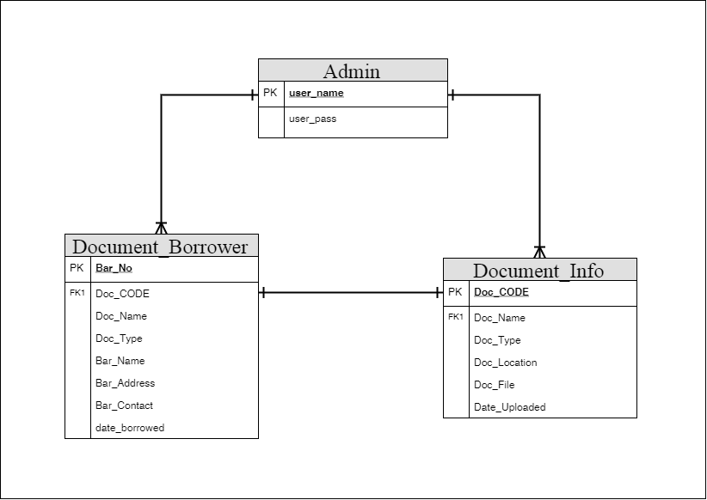

Figure 7: Entity Relationship Diagram of CHMSC-Binalbagan Document Custodianship, Management and Monitoring System with SMS Notification

The database of CHMSC-Binalbagan Document Custodianship, Management and Monitoring System is define and created using Structure Query Language or SQL were some of the tables of it are have relations to each other. The Figure 7: Entity Relationship Diagram of CHMSC-Binalbagan Document Custodianship, Management and Monitoring System with SMS Notification shows the relationship of the tables in the database which foresees one-to-one and one-to-many only.

**Operational Framework**

The operational framework is representation of concept of operation of the proposed system which is defining the process flow with the hardware interaction.

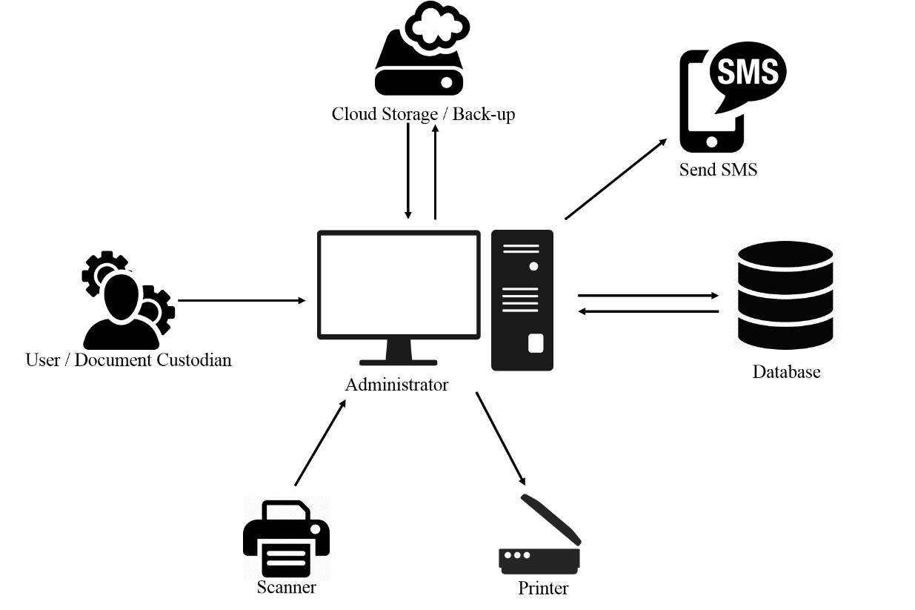

Figure 8: Operational Framework of CHMSC - Binalbagan Document Custodianship, Management and Monitoring System with SMS Notification

The Figure 8: Operational Framework of CHMSC - Binalbagan Document Custodianship, Management and Monitoring System with SMS Notification shows the concept of operation of the proposed system where it has to be the document custodian will be the stimulant in order to work the whole processes, the interactivity of the scanner is to scan the document and to be converted into pdf by the user’s computer so thus the data from the scanner will be an input to the system, the database for as storage of the inputted data, for back-upping purposes – the cloud storage; the printer for the output of the downloaded document and Send SMs for notice.

**Hardware and Software Requirement**

**Hardware Specification**

For the CHMSC-Binalbagan Document Custodianship, Management and Monitoring System with SMS Notification to run well the user must have:

* Intel Core i5 7500 Processor
* RAM (4 GB)
* 500 Gigabyte Hard Disk Drive
* 1024 x 768 resolution monitor
* Mouse and keyboard

**Recommended Network and Communication Devices**

* N300 Wireless ADSL2 + 4 Port Wi-Fi Router
* UTP Cat5e
* Internet Connection

**Recommended Software Specification (Server/Workstations)**

* PHP, MySQL, Apache
* A Backup Utility Software
* MySQL database MySQL Utilities
* Windows 7 and Higher Version

**Data Dictionary**

The table shows the list of conceptual database of CHMSC-Binalbagan Document Custodianship, Management and Monitoring System with SMS Notification. It showcases the table’s attribute, data types and description of every fieldname.

Table 6: Admin's Table

|  |  |  |  |
| --- | --- | --- | --- |
| Field Name | Description | Data Type | Length |
| user_name | Name of the user | VARCHAR | 50 |
| user_pass | User’s password | VARCHAR | 50 |

Table 7: Document Borrower

|  |  |  |  |
| --- | --- | --- | --- |
| Field Name | Description | Data Type | Length |
| Bar_No | Borrower Number | INT | 5 |
| Doc_CODE | Document Code | VARCHAR | 50 |
| Doc_Name | Document’s Name | VARCHAR | 50 |
| Doc_Type | Document Type | VARCHAR | 50 |
| Bar_Name | Borrower’s Name | VARCHAR | 50 |
| Bar_Address | Borrowers Address | VARCHAR | 50 |
| Bar_Contact | Borrower’s Contact | VARCHAR | 11 |
| date_borrowed | Date Borrowed | DATETIME | Null |

Table 8: Document Info

|  |  |  |  |
| --- | --- | --- | --- |
| Field Name | Description | Data Type | Length |
| Doc_CODE | Document’s Code | VARCHAR | 50 |
| Doc_Name | Document’s Name | VARCHAR | 50 |
| Doc_Type | Document Type | VARCHAR | 50 |
| Doc_Location | Document Location | VARCHAR | 50 |
| Doc_File | Document File | BLOB | Null |
| Date_Uploaded | Date Uploaded | DATETIME | Null |

**Gantt Chart**

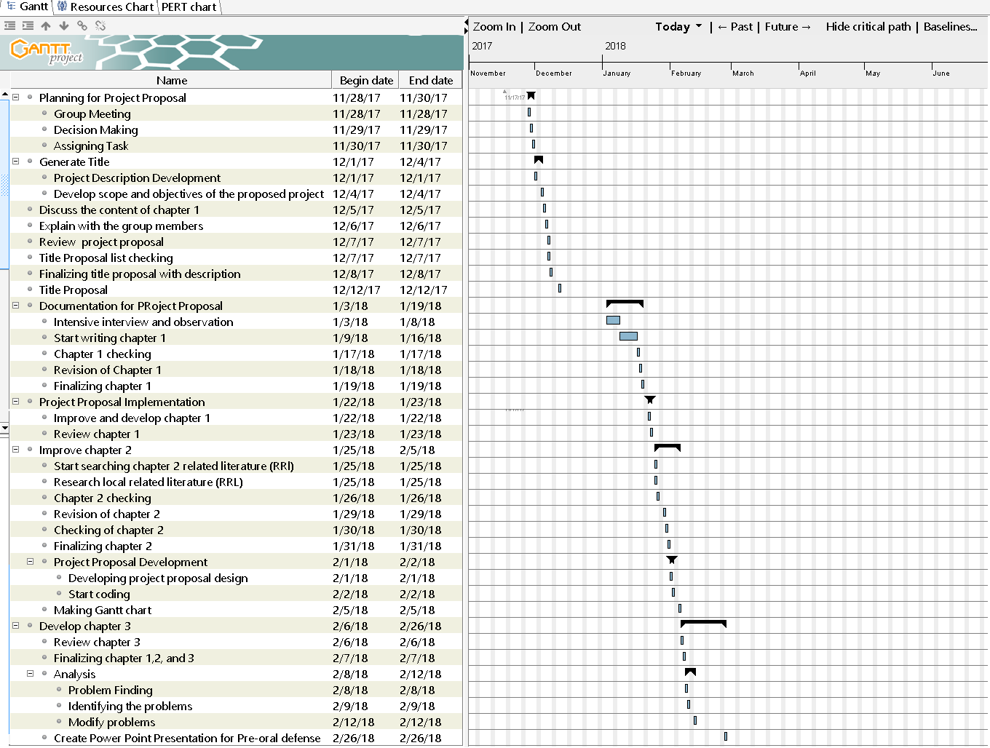

**Time Table**

|  |  |  |  |
| --- | --- | --- | --- |
| Task | Date Started | Date Finished | Assigned Members |
| Planning for Project Proposal | Nov. 28, 2017 | Nov. 30, 2017 | John Joseph G. Dubria, Kizzy G. Dela Cruz, Joelina V. Salopisa |
| Group Meeting | Nov. 28 | Nov. 28 | John Joseph G. Dubria, Kizzy G. Dela Cruz, Joelina V. Salopisa |
| Decision Making | Nov. 29 | Nov. 29 |  |
| Assigning Task | Nov. 30 | Nov. 30 |  |
| Generate Title | Dec. 1 | Dec. 2 | John Joseph G. Dubria, Kizzy G. Dela Cruz, Joelina V. Salopisa |
| Project Description Development | Dec. 2 | Dec. 3 | John Joseph G. Dubria, Kizzy G. Dela Cruz, Joelina V. Salopisa |
| Develop Scope and Objectives of the proposed project | Dec. 4 | Dec. 5 | John Joseph G. Dubria, Kizzy G. Dela Cruz, Joelina V. Salopisa |
| Discuss the content of chapter 1 |  |  |  |
| Explain with the group members | Dec. 6 | Dec. 6 | John Joseph G. Dubria, Kizzy G. Dela Cruz, Joelina V. Salopisa |
| Review project proposal | Dec. 12 | Dec. 12 | John Joseph G. Dubria, Kizzy G. Dela Cruz, Joelina V. Salopisa |
| Title proposal list checking | Dec. 15 | Dec. 15 | John Joseph G. Dubria, Kizzy G. Dela Cruz, Joelina V. Salopisa |
| Finalizing title proposal with description | Dec 19 | Dec. 22 | John Joseph G. Dubria, Kizzy G. Dela Cruz, Joelina V. Salopisa |
| Title proposal | Jan. 3 2018 | Jan. 3 2018 | John Joseph G. Dubria, Kizzy G. Dela Cruz, Joelina V. Salopisa |
| Document for project proposal | Jan. 4 | Jan. 5 | John Joseph G. Dubria, Kizzy G. Dela Cruz, Joelina V. Salopisa |
| Intensive interview and observation | Jan.18 | Jan. 18 | John Joseph G. Dubria, Kizzy G. Dela Cruz, Joelina V. Salopisa |
| Start writing chapter 1 | Jan. 19 | Jan. 19 | John Joseph G. Dubria, Kizzy G. Dela Cruz, Joelina V. Salopisa |
| Chapter 1 checking | Jan. 20 | Jan. 26 | John Joseph G. Dubria, Kizzy G. Dela Cruz, Joelina V. Salopisa |
| Revision of chapter 1 | Jan. 29 | Jan. 29 | John Joseph G. Dubria, Kizzy G. Dela Cruz, Joelina V. Salopisa |
| Finalizing chapter 1 | Jan. 30 | Jan. 30 | John Joseph G. Dubria, Kizzy G. Dela Cruz, Joelina V. Salopisa |
| Project proposed implementation | Jan. 31 | Jan. 31 | John Joseph G. Dubria, Kizzy G. Dela Cruz, Joelina V. Salopisa |
| Improve and develop chapter 1 | Feb. 1 | Feb. 1 | John Joseph G. Dubria, Kizzy G. Dela Cruz, Joelina V. Salopisa |
| Review chapter 1 | Feb. 2 | Feb. 9 | John Joseph G. Dubria, Kizzy G. Dela Cruz, Joelina V. Salopisa |
| Improve chapter 2 | Feb. 12 | Feb. 12 | John Joseph G. Dubria, Kizzy G. Dela Cruz, Joelina V. Salopisa |
| Start checking chapter2 related literature (RR) | Feb. 13 | Feb. 13 | John Joseph G. Dubria, Kizzy G. Dela Cruz, Joelina V. Salopisa |
| Research local related literature | Feb. 20 | Feb. 20 | John Joseph G. Dubria, Kizzy G. Dela Cruz, Joelina V. Salopisa |
| Chapter 2 chaecking | Feb. 22 | Feb. 23 | John Joseph G. Dubria, Kizzy G. Dela Cruz, Joelina V. Salopisa |
| Revision of chapter 2 |  |  |  |
| Checking of chapter 2 |  |  |  |
| Finalizing chapter 2 |  |  |  |
| Project proposal development |  |  |  |
| Developing project proposal design |  |  |  |
| Start coding |  |  |  |
| Making Gantt Chart |  |  |  |
| Develop chapter 3 |  |  |  |
| Review chapter 3 |  |  |  |
| Finalizing chapter 1,2 and 3 |  |  |  |
| Analysis |  |  |  |
| Problem finding |  |  |  |
| Identifying problems |  |  |  |
| Modify problems |  |  |  |
| Create power point presentation for pre-oral defense |  |  |  |