CHMSC-BINALBAGAN DOCUMENT CUSTODIANSHIP, MANAGEMENT AND MONITORING SYSTEM WITH SMS NOTIFICATION

Presented to

The Faculty of Information Technology

CARLOS HILADO MEMORIAL STATE COLLEGE

Barangay Enclaro, Binalbagan, Negros Occidental

In Partial Fulfillment

Of the Requirements of the

Bachelor of Science in Information Technology

By:

John Joseph G. Dubria

Kizzy G. De La Cruz

Joelina V. Salopisa

August 13, 2018

**ABSTRACT**

The proponents come up an idea and developed a system entitled “CHMSC –Binalbagan Document Custodianship, Management and Monitoring system with SMS Notification.” This system will help to minimize workloads of the document management officer/ staff as well to lessen and speed up the time they consume daily in document management. The proposed system requires the document custodians to upload the soft documents or files including the forms, records, etc., to system’s database so that document management will be done as well as the borrowing; this system can spread information to the borrowers that he/she will be reminded to the deadline of the document they’ve been borrowed through the use of SMS Notification.

*Keyword: CHMSC-Binalbagan Document Custodianship, Management and Monitoring System with SMS Notification*

**ACKNOWLEDGEMENT**

The development of this study is not possible without the help and support of the following persons:

First and foremost, we would like to give thanks to our almighty creator, Lord God, for giving us strength, wisdom and knowledge as well as for the continues blessing to surpass this study.

To our family who never get tired of supporting us to finish this study successfully and for motivating us that we can accomplish our task. We are thankful for giving us the illimitable inspiration and strength of mind, for understanding and patience to our hectic days and sleepless nights.

To Ms. Gaily Rey April M. Guzon our great research adviser, for her valuable provisions and wonderful advices to improve the system and our document as well. Her patience and motivation helped us to overcome the difficult situation and her guidance to lend a hand when we fall down and when our steps faltered.

To Mr. Joken E. Villanueva, MIT. who gave us resources, for sharing his experiences, advices and techniques to achieved this study.

To Engr. Dano for allowing us to conduct this study about their current system and for giving us all data and information that needed in our study.

To all faculty and staffs of Information Technology Department especially to Mr. Jose Armin G. Maningo. thank you for being there at all times that we need to ask recommendations and suggestions. Thank you for motivating us, for sharing your time and effort as well us for enlightening to do better on our project, to aim higher and for believing us that we can do it well.

Finally, this project would not be a successful one without the participation and collaboration of the team. This project will remain impossible and invisible without the help, hardships and sharing of ideas of the team members.

THANK YOU SO MUCH GOD SPEED!

**Kizzy G. De La Cruz**

**John Joseph G. Dubria**

**Joelina V. Salopisa**

**TABLE OF CONTENTS**

Title Page i

Approval Sheetii

Abstractiii

Acknowledgement**iv**

Table of Contentsv

List of Tables vi

List of Figures**vii**

**CHAPTER 1**

**I.INTRODUCTION**

Project Context 3

Purpose and Description**4**

General Objective5

Specific Objectives 6

Scope and Limitation **1**

Significance of the Study2

Definition of Terms 3

**II.BACKGROUND OF THE STUDY AND RELATED SYSTEM**

Background of the Study **4**

Related Literature 5

Prior Arts 6

**III. METHODOLOGY**

System Development Life Cycle ……………………….……………………………………………………………7

RAD (Rapid Application Development) Method …………………………………………………………….8

System Testing and Implementation …………………………………………………………………………….9

Context Diagram ………………………………………………………………………………………………………….10

Data Flow Diagram ……………………………………………………………………………………………………..11

Use Case Description …………………………………………………………………………………………………..13

Activity Diagram ………………………………………………………………………………………………………….14

Activity Diagram ………………………………………………………………………………………………………….14

Decomposition Chart …………………………………………………………………………………………………..15

Entity Relationship Diagram …………………………………………………………………………………………16

Operational Framework ………………………………………………………………………………………………17

System Testing and Implementation ……………………………………………………………………………18

CHMSC-BINALBAGAN Document Custodianship, Management and Monitoring System with SMS Notification …………………………………………………………………………………………………19

Recommended Hardware Specification for Development …………………………………………..20

Recommended Hardware Specification for Deployment ……………………………………………..21

Recommended Server Specification for Development …………………….…………………………..20

Recommended Server Specification for Deployment …………………………………………………..20

Recommended Software Specification for Development ……………………………………….…...20

Recommended Software Specification for Deployment ………………………………………….…..20

Data Dictionaries …………………………………………………………………………………………………………21

Time Table …………………………………………………………………………………………………………………..22

**LIST OF TABLES**

Features and Comparison of Foreign and Local system i

Manage Document ii

Monitor and Notify Borrowersiii

Classify and Manage Document Type**iv**

Control Documentv

Document vi

Admin’s Table**vii**

Document Borrower 3

Document Information**4**

Time Table5

Specific Objectives 6

Scope and Limitation **1**

Significance of the Study2

Definition of Terms 3

**II.BACKGROUND OF THE STUDY AND RELATED SYSTEM**

Background of the Study **4**

Related Literature 5

Prior Arts 6

**III. METHODOLOGY**

System Development Life Cycle ……………………….……………………………………………………………7

RAD (Rapid Application Development) Method …………………………………………………………….8

System Testing and Implementation …………………………………………………………………………….9

Context Diagram ………………………………………………………………………………………………………….10

Data Flow Diagram ……………………………………………………………………………………………………..11

Use Case Description …………………………………………………………………………………………………..13

Activity Diagram ………………………………………………………………………………………………………….14

Activity Diagram ………………………………………………………………………………………………………….14

Decomposition Chart …………………………………………………………………………………………………..15

Entity Relationship Diagram …………………………………………………………………………………………16

Operational Framework ………………………………………………………………………………………………17

System Testing and Implementation ……………………………………………………………………………18

CHMSC-BINALBAGAN Document Custodianship, Management and Monitoring System with SMS Notification …………………………………………………………………………………………………19

Recommended Hardware Specification for Development …………………………………………..20

Recommended Hardware Specification for Deployment ……………………………………………..21

Recommended Server Specification for Development …………………….…………………………..20

Recommended Server Specification for Deployment …………………………………………………..20

Recommended Software Specification for Development ……………………………………….…...20

Recommended Software Specification for Deployment ………………………………………….…..20

Data Dictionaries …………………………………………………………………………………………………………21

Time Table …………………………………………………………………………………………………………………..22

**LIST OF FIGURES**

Table 1: Agile Model**1**

Table 2: Context Diagram2

Table 3: Data Flow Diagram3

Table 4: Use Case Diagram**4**

Table 5: Activity Diagram5

Table 6: Decomposition Chart 6

Table7: Entity Relationship Diagram**1**

Table 8: Operational Framework2

Table 9: 3

Table 10: **4**

Table 11:5

Table 12: 6

Table 13: **1**

Table 14:2

Table 15: 3

Table 16: **4**

Table 17: 5

Table 18: 6

**CHAPTER I**

**INTRODUCTION**

In today’s modern age where people become technologically dependent, it is evident that many individuals have adopted new technology for an easier and efficient day-to-day living and works. Keeping and protecting valuable things or properties is a work done by custodians. One of its types is document custodianship where most of the organization, institution or even a company have this kind of work where it includes document handling, recording, keeping, controlling, managing and filling of documents, records, forms, mandatory procedures, etc. which uses manpower and technology. At some point, the secureness of protecting these papers when circumstances may occur will vanish this custody.

Document handling in every office is an exhausting job, and sometimes, appended to this job, it is inevitable that there are some individuals who’ll go to intervene the filed documents or to borrow a document. And for its retrieval, sometimes the custodian will have to get the entire filer box with bundled papers and manually search for a file or document, which is, this work is time costly and can cause inconvenience.

In a computer system, the back-up is what makes every information becomes secured because it can be retrieved, by copying all PC files and stored on the computer’s hard drive. This ability is what makes computer becomes reliable and efficient to its users since it can protect its custody against accidental computer data loss. In fact, one of the safest storage for back-up is cloud computing. A developer can make a system out of his observation of his environment or either out of his experiences. By these, he can create a concept of a system which can help to aid and eliminate the complexity of a work; and integration, on the other hand, is what most developers do by combining one process to another to build-up a system as a whole.

Consequently, the proponents of this study come-up with an idea of developing a digital document custodianship system with cloud storage, which has an electronic document management, and monitoring of document borrowers that includes SMS notification for the notice of the deadline of the return of the borrowed document. This proposed system is a mirror of the actual filling however in the digital world which has a database over the cloud. Thus, this proposed system will secure a no-document loss to the stakeholder.

**General Objective**

The study aims to develop a digital document management system for Carlos Hilado Memorial State College – Binalbagan Campus’ offices and organizations as well as the monitoring of document borrowers through SMS Notification.

**Specific Objectives:**

1. It aims to provide digital document custodianship, management and filing where:
   1. To ease the work of the office document custodian in document management.
   2. To secure that there will be a synchronization of actual document filed and in digital repository to avoid document loss.
2. To develop a system in terms of:
   1. Efficiency
   2. Functionality
   3. Portability
   4. Reliability
   5. Usability
3. To provide more efficient and reliable system to help Carlos Hilado Memorial State College faculty and staffs.

**Purpose and Description**

As Carlos Hilado Memorial State College – Binalbagan Campus engages into the accreditation of the International Organization for Standardization or ISO 9001:2015 certification, one of the requirements of the evaluation is how offices manage their document custody. The institution have prepared some measures to surpass the assessment in document management and accreditors have suggested that the institution must have an electronic document management system for managing electronic documents.

Thus, the Carlos Hilado Memorial State College Document Custodianship, Management and Monitoring System with SMS Notification will aid office document custodian in managing their electronic documents.

In managing electronic document, office document custodian must upload the file/s or document and input its information in to the system and it will be stored it into the database; and for the borrowers, custodian must input the contact and basic personal information of the borrowers so that reminding of the borrowers to return the borrowed document will be possible. The purpose of the proposed system is to aid document custodian in managing electronic documents and the document borrowers to be able to have monitoring and a secureness of document return. The system will provide the list of all files compiled in the cloud storage also, and the borrowers who borrowed document as well. Thus, via this system, the electronic documents are uploaded and the borrower will be reminded to return the document accurately in a lesser time.

The Carlos Hilado Memorial State College Document Custodianship, Management and Monitoring System with SMS Notification is a web-hosted application wherein the administrators both central and remote office, which are the document control managers of every office can upload, download, manage and monitor all documents that a certain office have. Borrowing of a document from an office is inevitable, therefore monitoring is necessary. In this proposed system, borrowers will be monitored and notified through SMS. Thus, this application will ensure offices of well-secured document storage and monitoring.

**Scope and Limitation**

The system proposed will only focus within the premise of Carlos Hilado Memorial State College – Binalbagan Campus especially in electronic document management and monitoring of document borrowers of every office and/or organization of CHMSC-Binalbagan. Other organizations or offices which are outside of CHMSC-Binalbagan premise is not covered of this system. Therefore, The Carlos Hilado Memorial State College – Binalbagan Document Custodianship, Management and Monitoring System with SMS Notification will only focus in the electronic document management and document borrower’s monitoring via SMS Notification and will be limited to Carlos Hilado Memorial State College- Binalbagan Campus.

**Significance of the Study**

TheCHMSC-Binalbagan Document Custodianship Management and Monitoring System with SMS Notification is intended for Carlos Hilado Memorial State College – Binalbagan offices and organizations and the study is essential and significant for the following:

* **Students and Student Organizations** - In order for them to have an electronic document management with borrower’s monitoring via SMS Notification for as reminder of the deadline of the document to be returned.
* **Faculty -** It will be easy for the faculty to find the document or files they needed in immediate time as well as the management of their electronic documents for future purposes.
* **Staff**  - In order for them to have an ease in terms of borrowing documents or files
* **Administrator** - It will be easy for them to manage the time they consumed in recording, filling, keeping and also for controlling of documents which is vital to the institution as well as in managing their electronic document.
* **Future researcher** - In order for them to make this study a source of knowledge as their study references.
* **Researcher** - In order for them to develop their skills and this study will add as their credential.

**Definition of terms**

**Borrower** - the one who has the interest to borrow something or anything under the possession of a person. In this study, a borrower is a person or entity that can take or obtain with the promise to return a file or documents.

**Cloud Storage** - model of data storage in which the digital data is stored in logical pools, the physical storage spans multiple servers, and the physical environment is typically owned and managed by a hosting company. In this study, cloud storage is a main storage of the system and the source where the system gathered data.

**Document controller - r**esponsible for controlling the numbering, filing, sorting, and retrieval of electronically stored or hard copy documentation produced by technical teams, projects, or departments in a timely, accurate and efficient manner. In this study, a document controller is a person who administer the entire document who come and go in an organization.

**Document handling** **-**  procedure for transporting and handling paper documents for data entry and scanning. In this study, document handling is an act of administering, filling, identifying the entire documents that an organization have.

**SMS (Short Message Service) Notification** - commonly referred to as text messaging, is a service for sending short messages of up to 160 characters to mobile devices, including cellular phones, smartphones and PDAs. In this study this refers to the medium used by the system to notify a borrower regarding the deadline of returning a borrowed document.

**CHAPTER II**

**REVIEW OF RELATED LITERATURE AND SYSTEMS**

This chapter presents a brief review of related literature and studies as well as interrelated system both local and foreign as proponents’ basis of making and developing the system for document custodianship.

**LOCAL RELATED LITERATURE**

**Librianship and Document Custodian**

In accordance to the Scope of the Practice of Librianship that the practice of librarianship shall constitute in holding out oneself as skilled in the knowledge, art and science of the organization, dissemination, preservation and conservation of recorded information (Philippine Librarianship Act, 1990). The nature of work of a librarian stated, is vital and needed for the user to know - in order to implement and practice well the proponents proposed system - because this is a digitize document librianship and management and it should be that the user has the capability and knowledge about document handling.

**Quality Management Manual of the National Housing Authority that Department**

While according to the page 3 section 5.2 of Quality Management Manual of the National Housing Authority that Department Document Custodian (DDC) is designated staff in the Group/Department to coordinate with document controllers; maintains controlled copies of documents and distribute to copy holders; responsible for the receipt and distribution of documents from external sources (National Housing Authority, 2015). In the proposed system of the proponents of this study, it is needed that there will be a one-person who new and be the authority to manage and control the entire document that an office or an organization have in order to implement proper the system proposed which is the document custodianship, management and monitoring. The need of this person is very vital to the proposed system because of its intensive and keen knowledge about document handling.

**Document Management**

The document management of Department of Tourism has involved many processes, a lot of transactions on a daily basis, where papers are generated and filed; and they are proposing a Document Management Project that will provide an efficient way of file storage retrieval and an organization with paperless environment to improve productivity and reduce cost by minimizing the time spent looking for documents or time spent recreating information (DEPARTMENT OF TOURISM, 2012). The stated requirements are the things that proponents aiming for the proposed system so that efficiency will be met.

**Monitoring**

Generally, to monitor or monitoring has something to do with observing and/or checking the development or quality or progress of something, and it is been stated in the background of Policies and Guidelines on the Planning and Implementation of DPWH River Dredging Projects by Administration (Singson, 2016), that “Monitoring is important to make sure that the equipment is properly maintained so as not to jeopardize or delay the operation.” And inevitably, that some of the borrowers may opted that it is okay on not to return back the document that it has been borrowed; what is dreadful to this is the damage to owner. So what should be the better thing to do? Proactive measures towards this circumstance may include monitoring and evaluation, as well as having relevant information about this individual so, in connection to the proponents proposed system, the monitoring should be necessary because vigilance is key prevent damages.

**SMS Notification**

In today’s time, many telecommunications have integrated into text messaging warning for potential danger coming for the people to be aware of. In a press release of Globe Telecom’s Senior Vice President for Corporate Communication Yolo Crisanto that Globe is privileged to be a conduit of useful information beneficial in ensuring the safety and security of people due to mandate by the law (Globe Telecom, 2015) and this only implies that awareness of something, it must be that an appropriate action must be done for security purposes. In this premise, the proponents of this study has this SMS notification on the proposed system for the borrowers, for informing them the dues of their borrowed document for as part of monitoring.

**FOREIGN RELATED LITERATURE**

**Property Custodian Job Responsibilities**

It is mention in the Property Custodian Job Responsibilities (Treadwell ) that property custodians are responsible for managing equipment, supplies, parts and even evidences in police investigations. They are found at colleges’, government agencies, warehouses, police evidence rooms and any other business or organization with inventory. To be a successful property custodian, you must have excellent organization and record keeping skills and possess a keen attention to detail. Knowledge of database and inventory software it also a necessity.

**Document Management**

According to the module of the document management in the study of Collaborate IT: A CCS IT Thesis Portal with Electronic Document Management System, that the document management is divided into three: storing, indexing and search and retrieval where the storing handles the storage of approved proposal document, thesis document, teaser videos, request forms and other document uploaded in the digital repository. The indexing handles the encoding of information about the document. It also includes tagging that would be used for easier searching. The search and retrieval module allows the users of the system to search for the thesis documents in the different ways and view it (del Rosario, del Rosario, Nieva, Tan, & Tangkeko , 2016). With due consideration to their project scope and limitation, their proposed system is something interrelated with the proponents’ proposed system on this study, the only thing, however that differs their system from the proponents proposed system on this study is the document control which supposedly used by only one person.

**Record Management**

In line with document management is record management. The Records Management is a term that covers an organization's management of all records (whatever their format) from their creation, through their maintenance (record keeping), to their disposition. Disposition includes archiving and destruction; and appended to it, there are some element of an Effective Record Management (Swift, 2017) which is vital to the proposed system, and these are Record Inventory and Classification, Retention Scheduling, **Records Storage & Conversion .**

**Auditing Documentation Control**

Document control is a process that need auditing from time to time to ensure compliance and control business risk. Auditing Document Control is probably not the most exciting audit to do, it is worth performing an audit across your business from time to time to assess how documenta**t**ion is controlled, (QCS International, 2010). The document control is vital to this proposed system because this is a practice towards quality management and it is being also needed because it has to be the custodian know to identify if the document is a controlled and / or uncontrolled for proper dissemination purposes.

**Research and Development**

In any line of professional work, documentation is important; however, it is even accurate when it comes to research and development. Disorganized and undocumented work can not only lead to lost progress and inaccurate results, but it can also lead to lost certifications and accreditations.(LogicalDOC, 2015) The document standardization and organization on them is considered to be very important because having this will improves their significance as organization, and also it will provide them a centralized access to information as well as allowing them to have an automatic data backup and in paperless and environmentally friendly. The proper classification and organization of information leads to improve the performance and collaboration as time and energy are not wasted trying to find information, this is the aim of the proponents as well of this study – to have a well-organized document organization which is easy and user friendly to ease the daily routine of the document custodian/manager.

**Local Related System**

**Choosing a Document Management System**

When choosing of Document Management System (Rivera, 2018) it must be considered the system’s functionality provision to the user which are Storing various document types, including word processing files, emails, PDFs and spreadsheets, Searching an entire library of files by individual keyword ,Document Monitoring Restricting access to certain documents, Monitoring who is viewing documents and when, Tracking edits to documents, Retrieving previous versions of edited documents, [Controlling and regulating when outdated documents can be deleted, Accessing, editing and sharing documents via mobile devices. These systems work in tandem with scanners, which change paper documents into digital versions. Through sophisticated search engines, document management systems allow quick access to any document or file. The functionalities stated are the things that the system proposed should be having in order employ the tittle of this study. The proponent has been identified this proponents must be work on this in order to meet these requirements. functionality during the proponent’s intensive analysis and therefore, abiding this functions; the

**Web-Based Document Management and Information Dissemination through Email and SMS Notification with Members Attendance Monitoring System**

On the other hand, in Web-Based Document Management and Information Dissemination through Email and SMS Notification with Members Attendance Monitoring System for LCFEA (Gonzales, Llanderal, Perez, & Marquez, 2016) their proposed system was accepted by their respondent in terms of usability, reliability, security and maintainability, which also aimed by the proponents of this study. Also, it’s been said that they are aiming to help their client in managing their documents, facilitating the information dissemination and in monitoring the attendance of their members and officers. Their proposed system is somehow related to the proponents proposed system however, it only differs in the SMS because in their study its purpose is for monitoring attendance while in this study, the notification is for monitoring the document borrower.

**Archive One Document Management System**

And, Archive-one a Document Management System [DMS] which is developed in the Philippines is designed to help document administrators, classify, store and search for and retrieve essential company record (Paperless Trail Inc., 2010). Their system is the same with the proponents proposed system especially on its feature of which searching for all document, weather old or new, fast and simple as long as the document is within or uploaded in the repository. However, their system has no monitoring through SMS of the document borrower and what makes the proponents proposed system differs from it. And a centralized document repository helps save time, reduce costs, improve operational efficiency and provide security for physical and electronic documents.

**Foreign Related System**

**Information Desk System**

In an electronic information desk system for information dissemination in educational institutions(INDIACom, 2015), they’ve proposed a system  that can be used to provide up-to-date information to students or employees of any institute using latest and most common technology via SMS. In this premise, it is being related to the proponents proposed system because of its capability to inform its benefactor through SMS which in the system proposed is for the notifying the borrower of its deadline.

**Document management system**

Meanwhile, the SeedDMS (Steinmann, 2013) is a document management system who is the same with the proponents proposed system especially in terms of how it’s been developed through PHP and MySQL. However, this DMS doesn’t support SMS notification for as notice to the document borrower. The feature of the system which searches a file in any ways such as through its name, document type, or through document file type is the same with the proponents proposed system.

**eRecording System**

The eRecording (PPDocs, Inc, 2013)is a system that allows user to upload document to the county clerk and get them recorded the same day in most cases. And therefore, their system is archival where users will upload their document to their repository and retrieved it for future purposes. Their system is being related to the proponents proposed system because of its ability to store and keeping of files until such time that user will need for it. Furthermore, this feature of the system is very needed in the system proposed.

Table 1: Features and Comparison of Foreign and Local system

|  |  |  |  |  |  |
| --- | --- | --- | --- | --- | --- |
| **RELATED PRIOR ARTS** | **FEATURES** | | | | |
| Automated System | Connectivity | Borrowing and Returning | SMS | Web-based |
| **Document Management System** | YES | YES | NO | NO | YES |
| **Web-Based Document Management and Information Dissemination through Email and SMS Notification with Members Attendance Monitoring System** | YES | YES | YES | YES | YES |
| **Document Management System [DMS]** | YES | YES | NO | NO | YES |
| **Information Desk System** | YES | YES | NO | NO | YES |
| **Document management System** | YES | YES | NO | NO | YES |
| **ERecording System** | YES | YES | NO | NO | YES |

*Table 1: Features and Comparison of Foreign and Local System*

**CHAPTER III**

**DESIGN AND METHODOLOGY**

This chapter presents the research design and methodology as well as the stages of software development of the proposed system.

**Software Development Life Cycle**

The Systems (Software) Development Life Cycle or SDLC is a process in which best describe the progress, continuing, changing or improving software. It is where ideas and strategies are being built in order to improve or to produce software that will provide or will surpass the expectancy of the user and will point the completion at exact time. SDLC also defines the duty that are being done in software development procedure step by step as well as maintaining the software.

**Agile SDLC Model**

Agile SDLC model is a combination of iterative and incremental process models with focus on process adaptability and customer satisfaction by rapid delivery of working software product. Agile Methods break the product into small incremental builds. These builds are provided in iterations. Each iteration typically lasts from about one to three weeks. Every iteration involves cross functional teams working simultaneously on various areas like - planning, requirement analysis, design, coding, unit testing and acceptance testing. At the end of the iteration, a working product is displayed to the customer and important stakeholders (Tutorial Point (India) Pvt. Ltd., 2013)**.**

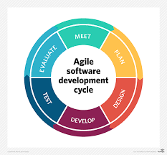

Figure 1: Agile Model

The Figure 1 Agile SDLC Modelshows the iterative and incremental software development cycle which is from the beginning of the study until the end. This method of software development has manifesto principles which states: individual and interaction – it is important to consider the self-organization as well as the motivation. Working software, this the most important thing to be able to have a best interaction with the customer, by allowing them to test the software in many times until it reaches its satisfactory state. Customer collaboration, continuous interaction with the customer is very important for this will lead to proper identification of the systems’ requirement. And responding to change, as the customer demands to have changes with the system, the software must have this attribute to be able to adopt to changes as well as in continuous development.

The proponents use this method of development because the concern of the iterative and incremental progress is to make the system proposed adoptable or versatile in changes due to the demand of the client. And by this method the proponents were able to perform the following:

**Planning Phase**

This phase of software development is the stimulant of the proponents to plan a software that will aid an organization or an office in document management and in document borrowing, the proponents conducted an interview and observations to the institutions’ major offices that kept a large amount of document such as Office of the Student Affairs, Office of Physical Plans, Development and Management (PPDM), Office of Research and Extensions and Office of the Supreme Student Government. Then, proponents asked for the processes they’re doing when it comes to document management and the proponents found out a problem that can be addressed by the proponent’s system proposed.

**Designing Phase**

The proponents develop a design which is user-friendly and can obtained an ease access to the field requested by the user of the system. The proponents had first created a paper prototype of the design or a sketch of possible lay-out of the system. Thereafter, the proponents provide a sample lay-out which was checked by the client for revision and furtherance to meet their satisfaction.

**Developing Phase**

In line of creating the design for the proposed system, the proponents has already created some methods for the system’s process to work, however, the proponents has encountered some of the problem while developing these processes, the availability of the information on the Internet, aided the proponents to solve the problems. And in agreement to this stage, the proponents has also seek some of the inputs that is vital to the system and formulate some further processes. Furthermore, knowledge in programming and logic is really needed in here in order to attain this stage.

**Testing Phase**

At this stage, the proponents conducted a series of testing of the proposed system, however, in every test done by the proponents, the user/s suggests further changes of the lay-out and the features that this system will be providing. The proponents took a lot of testing until user’s satisfaction met. Appended to the user/s request, the proponents done many thorough analysis and design as well.

The first step that has been conducted by the proponents was to try to upload an electronic document and its information as input of the system. Then, the proponents try to search the document in many ways such as through document type, document name, document code and even through the date of when it was uploaded. Then the proponents added a borrower and try to send it a message for an alert of deadline.

**Evaluating Phase**

In this phase, the proponents will evaluate the system carefully to make sure that the system will function well due to changes requested by the user. The proponents need to secure that the updates of the system will work efficiently, test and debug the system performance until the project is fully operated

**Meet**

At this phase, the proponents will deploy the system for testing so that the proponent will be able to identify if the user’s need reach. As this phase implemented by the proponents has always ended up for further changes as stated at testing phase. Thereafter, the proponents done furtherance for the system development so that user’s need will be meet.

**Context Diagram**

The context diagram is the representation of every entities involved and its relationship and interaction to the system proposed as well as to established the context and boundaries of the proposed system.

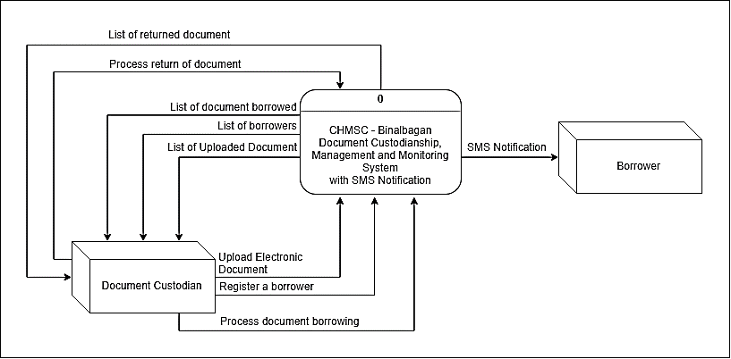

Figure 2: Context Diagram of CHMSC – Binalbagan Document Custodianship, Management and Monitoring System with SMS Notification

The Figure 2: Context Diagram of CHMSC – Binalbagan Document Custodianship, Management and Monitoring System with SMS Notification shows the contexts, boundaries and data flows of the proposed system. The whole process is centralized to the document custodian, this entity is the one who will use and act as administrator. When there is a document both out going or in-going, it has to be undergone administrator’s provision for he/she will classify the document according to document’s type, if it is a controlled or uncontrolled document and the filer where the actual file filed. Same with the borrowing transaction, it has to be evaluated by the custodian the transactor in order to have security and assurance that the document will be returned by the borrower so that monitoring will be meet.

**Data Flow Diagram**

The data flow diagram showcases the flow of the data in the proposed system of the proponents.

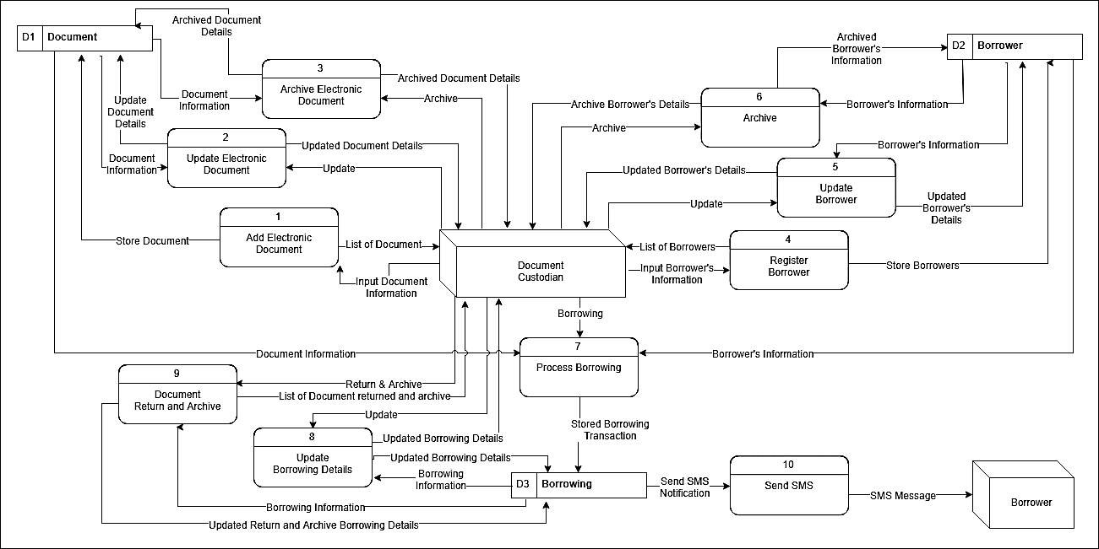

Figure 3: CHMSC- Binalbagan Document Custodianship, Management and Monitoring System with SMS Notification Data Flow Diagram

The Figure 3: CHMSC- Binalbagan Document Custodianship, Management and Monitoring System with SMS Notification Data Flow Diagram shows the data flow of the system proposed.

**Use Case Diagram**

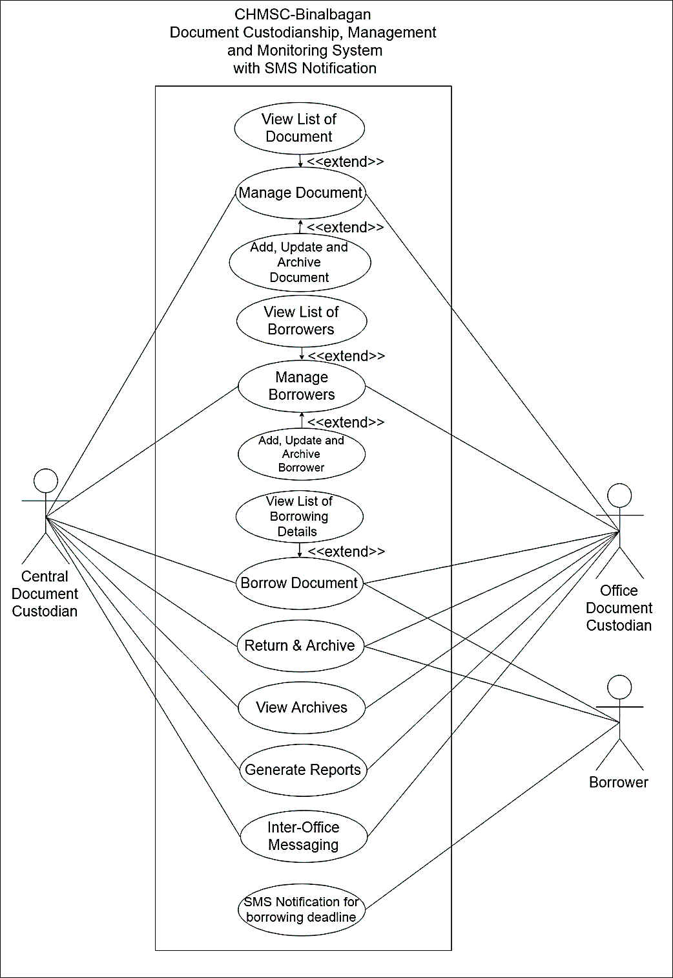

Figure 4: Use Case Diagram of CHMSC-Binalbagan Document Custodianship, Management and Monitoring System with SMS Notification

­­ The Figure 4: Use Case Diagram of CHMSC-Binalbagan Document Custodianship, Management and Monitoring System with SMS Notification showcases the concept of operation of the proposed system.

**Actor:** Central Document Custodian – The person who will act as a central administrator and will monitor the documents uploaded to the database by every organization and office and can manage the entire official documents.

Office Document Custodian- The person who will act as an administrator who manages and control the document that an organization or office have.

Borrower- a person who'd have the interest to borrow the document that document custodian have.

**Use Case Description**

The tables below describe the functions, conditions and alternative flows that have to be met by the actor/s of every use cases shows in the use case diagram.

Table 1: Manage Document

|  |  |
| --- | --- |
| Use Case Name | Manage Document |
| Primary Actors | Central Document Custodian, Office Document Custodian |
| Persons and Interests | Central Document Custodian – the person who will facilitate in managing and monitoring the entire documents uploaded to the database.  Office Document Custodian – the person who will facilitate in managing the documents that an office or organization have. |
| Pre-Condition | Office Document Custodian – have to evaluate the document identification and information and upload it to the system.  Central Document Custodian – have to evaluate the document identification and information and upload it to the system   * Have to be notified of document uploaded by the remote office in to the system and evaluate if there is an issue in the document. |
| Post-Condition | Record for electronic document has been added |
| Main Success Scenario | 1. Both office document custodian and central document custodian have to evaluate the electronic document identification and information before uploading in to the system. 2. Both office document custodian and central document custodian have to upload the file right after the document evaluation.   Central Document Custodian - will notified of the document uploaded in the database of an office.  Extensions   1. Both Central Document Custodian and Office Document Custodian may and can add, update, archive document 2. Both Central Document Custodian and Office Document can view list of document uploaded however, Office Document Custodian is limited on its office. |
| Alternative Flow | 1. If both Central Document Custodian and Office Document Custodian have identified the invalidity of the docume`nt. It couldn’t be uploaded. 2. If Central Document Custodian have monitored the error of the document uploaded of an office, the Central Document Custodian will have to send message to the office concern the error or an update must be done to correct the document information. |

Table 2: Monitor and Notify Borrowers

|  |  |
| --- | --- |
| Use Case Name | Manage Borrowers |
| Primary Actors | Central Document Custodian, Office Document Custodian |
| Persons and Interests | Central Document Custodian – the person who will facilitate in adding and managing the document borrower.  Office Document Custodian – the person who will facilitate in adding and managing the document borrower of an office or organization. |
| Pre-Condition | Both Central Document Custodian and Office Document Custodian will have to evaluate the borrower before entering its contact and basic information |
| Post-Condition | Record of document borrower has been added |
| Main Success Scenario | 1. Both Central Document and Office Document Custodian must have to evaluate the borrower before entering its information in to the database.   Extensions   1. Both Central Document Custodian and Office Document Custodian may and can add, update, archive borrower. 2. Both Central Document Custodian and Office Document Custodian can view list of borrower, yet Office Document Custodian is limited to its office. |
| Alternative Flow | 1. If both Central Document Custodian and Office Document Custodian finds the invalidity of the borrower. Borrower couldn’t be added. |

Table 3: Classify and Manage Document Type

|  |  |
| --- | --- |
| Use Case Name | Classify and Manage Document Type |
| Primary Actor: | Document Custodian |
| Description: | Classification and management of the document |
| Pre-Condition: | Document Custodian – must classify the document in accordance with its identity; if it is a document, form or even record. |
| Main Success Scenario: | Document Custodian – classified and well manage document. |

Table 4: Control of Document

|  |  |
| --- | --- |
| Use Case Name | Control of Document |
| Primary Actor: | Document Custodian |
| Description: | Control document for dissemination purposes. |
| Pre-Condition: | Document Custodian – must identify if the document is control or uncontrolled and have prior approval for dissemination. |
| Main Success Scenario: | Document Custodian – disseminate yet identified it is a control or uncontrolled document. |

Table 5: Document

|  |  |
| --- | --- |
| Use Case Name | Borrowed Document |
| Primary Actor: | Document Custodian, Borrower |
| Description: | Borrowers interest to the document |
| Persons with Interest | Document Custodian – the primary actor that facilitates all of the document in an organization or an office  Borrower – a person who has the interest to borrow a document that an organization or office have as well as responsible of returning it. |
| Pre-Condition: | Document Custodian – must collect from the borrower its contact information and prior purpose to borrow the said document before approval.  Borrower – must seek information such as availability of the document and filled-up request form [if ever an office or organization have] for approval. |
| Alternative Flow | Document Custodian – decline request.   1. The borrowing request will be cancelled. 2. Borrower may fill-up another request form. |
| Main Success Scenario: | Document Custodian – process and input the borrower’s information and saved to document borrower’s repository and call for monitoring.  Borrower – Approved request and document that it’s been borrowed. |

**Activity Diagram**

The activity diagram showcases the activity flow that should be done by the actor involved in the proposed system

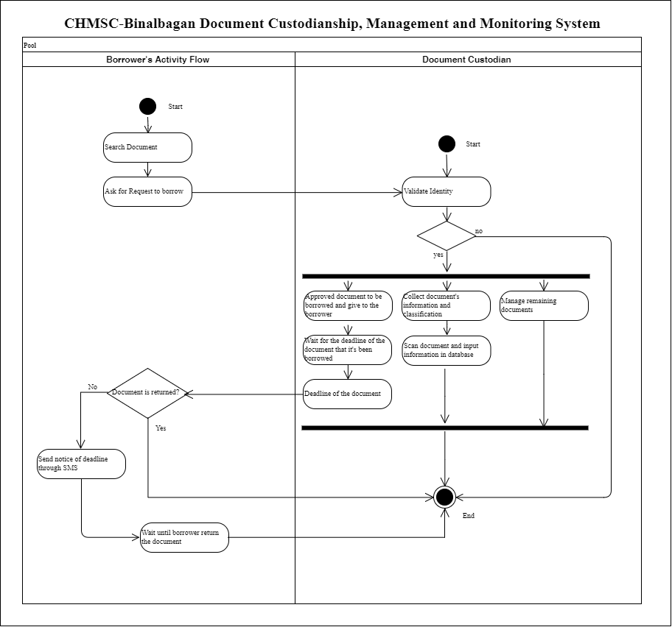

Figure 5: Activity Diagram of the Document Custodian

The Figure 5: Activity Diagram of the Document Custodian showcases the activity flow that document custodian should be done, the whole process starts with identity validation, if it is been identified identity, the major action should be done, such as: approved document to be borrowed, collect document’s information and classification as well as, scan the document and input document’s information in the database and manages remaining and borrowed documents.

**Decomposition Chart**

The decomposition chart is a tool used to show the decomposition of the system.

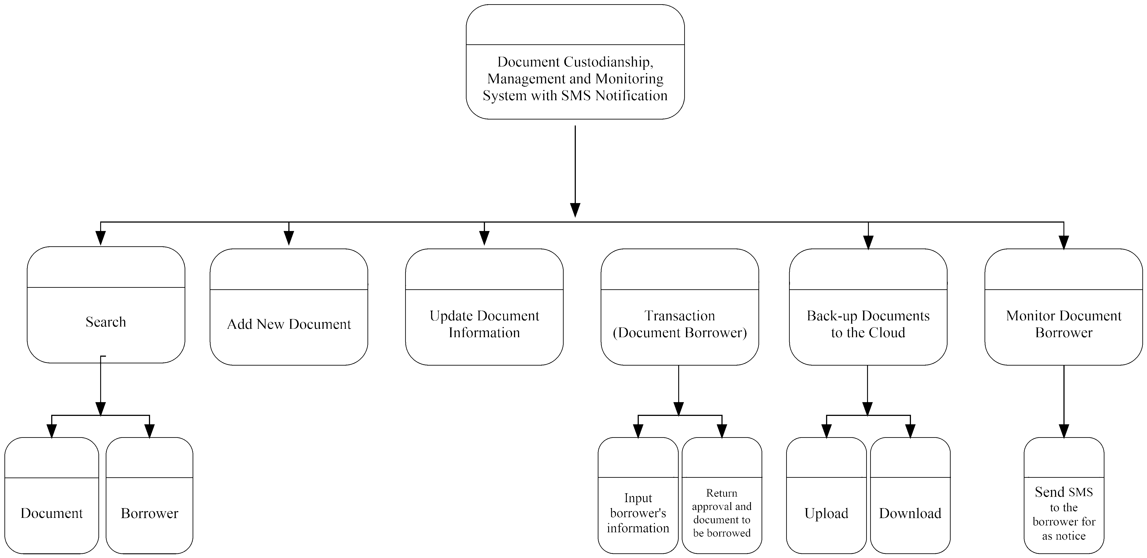

Figure 6: Decomposition Chart of CHMSC-Binalbagan Document Custodianship, Management and Monitoring System with SMS Notification

**­** The Figure 6: Decomposition Chart of CHMSC-Binalbagan Document Custodianship, Management and Monitoring System with SMS Notification shows the decomposition or hierarchy of processes that will be encountered in the proposed system. Where the system has six major classes namely search with sub classes for document and borrower, add new document, update document info, transaction for document borrowers with inputting of borrower’s information and return approval of request as well as the document to be borrowed, back-up document to the cloud with upload and download and monitor document borrower through sending SMS for as notification.

**Entity Relationship Diagram**

The Entity Relationship Diagram or ERD is representation of how the tables on the database are correlated with each other.

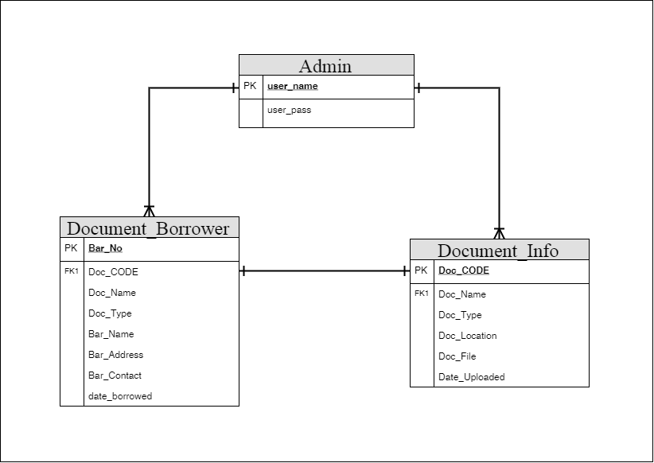

Figure 7: Entity Relationship Diagram of CHMSC-Binalbagan Document Custodianship, Management and Monitoring System with SMS Notification

The database of CHMSC-Binalbagan Document Custodianship, Management and Monitoring System is define and created using Structure Query Language or SQL were some of the tables of it are have relations to each other. The Figure 7: Entity Relationship Diagram of CHMSC-Binalbagan Document Custodianship, Management and Monitoring System with SMS Notification shows the relationship of the tables in the database which foresees one-to-one and one-to-many only.

**Operational Framework**

The operational framework is representation of concept of operation of the proposed system which is defining the process flow with the hardware interaction.

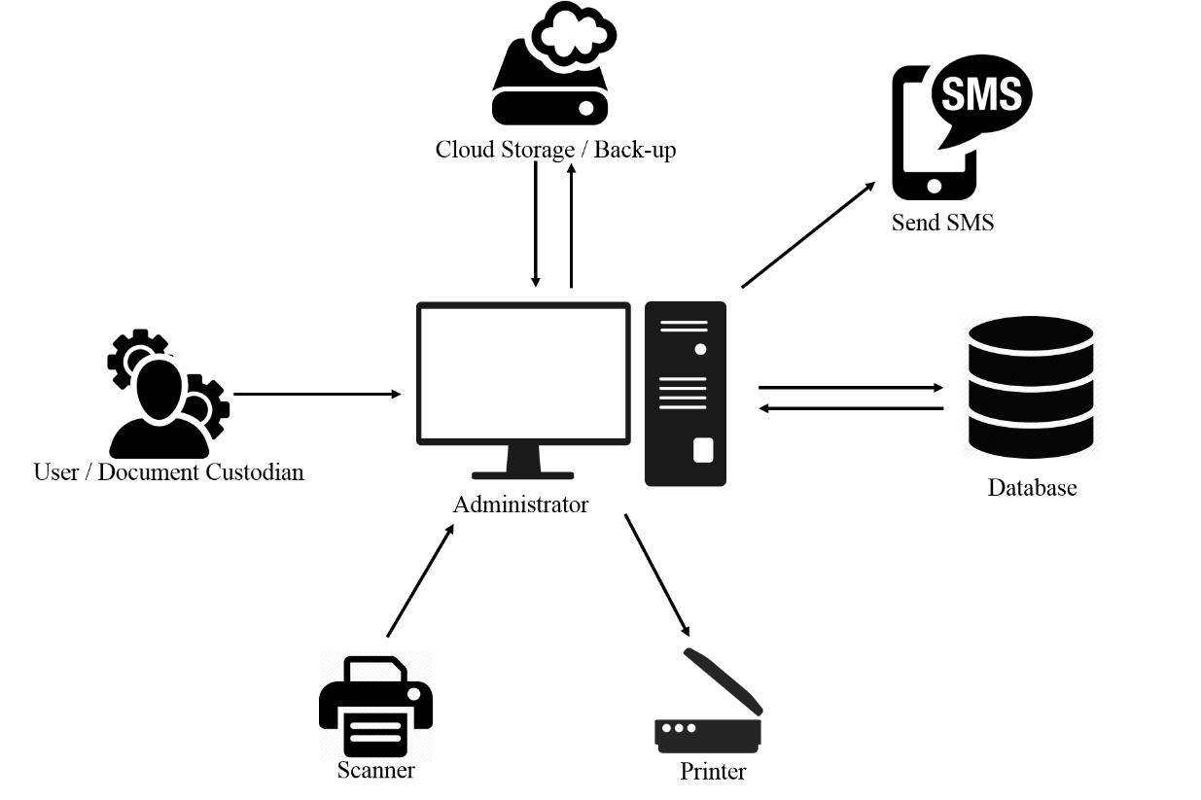

Figure 8: Operational Framework of CHMSC - Binalbagan Document Custodianship, Management and Monitoring System with SMS Notification

The Figure 8: Operational Framework of CHMSC - Binalbagan Document Custodianship, Management and Monitoring System with SMS Notification shows the concept of operation of the proposed system where it has to be the document custodian will be the stimulant in order to work the whole processes, the interactivity of the scanner is to scan the document and to be converted into pdf by the user’s computer so thus the data from the scanner will be an input to the system, the database for as storage of the inputted data, for back-upping purposes – the cloud storage; the printer for the output of the downloaded document and Send SMs for notice **Hardware and Software Requirement**

**Hardware Specification**

For the CHMSC-Binalbagan Document Custodianship, Management and Monitoring System with SMS Notification to run well the user must have:

* Intel® Core(TM) i3-55U CPU @ 2.00 GHz
* RAM (4 GB)
* 500 Gigabyte Hard Disk Drive
* 1024 x 768 resolution monitor
* Mouse and keyboard

**Recommended Network and Communication Devices**

* N300 Wireless ADSL2 + 4 Port Wi-Fi Router
* UTP Cat5e
* Internet Connection

**Recommended Software Specification (Server/Workstations)**

* PHP, MySQL, Apache
* A Backup Utility Software
* MySQL database MySQL Utilities
* Windows 7 and Higher Version

**Data Dictionary**

The table shows the list of conceptual database of CHMSC-Binalbagan Document Custodianship, Management and Monitoring System with SMS Notification. It showcases the table’s attribute, data types and description of every fieldname.

Table 6: Admin's Table

|  |  |  |  |
| --- | --- | --- | --- |
| Field Name | Description | Data Type | Length |
| user_name | Name of the user | VARCHAR | 50 |
| user_pass | User’s password | VARCHAR | 50 |

Table 7: Document Borrower

|  |  |  |  |
| --- | --- | --- | --- |
| Field Name | Description | Data Type | Length |
| Bar_No | Borrower Number | INT | 5 |
| Doc_CODE | Document Code | VARCHAR | 50 |
| Doc_Name | Document’s Name | VARCHAR | 50 |
| Doc_Type | Document Type | VARCHAR | 50 |
| Bar_Name | Borrower’s Name | VARCHAR | 50 |
| Bar_Address | Borrowers Address | VARCHAR | 50 |
| Bar_Contact | Borrower’s Contact | VARCHAR | 11 |
| date_borrowed | Date Borrowed | DATETIME | Null |

Table 8: Document Information

|  |  |  |  |
| --- | --- | --- | --- |
| Field Name | Description | Data Type | Length |
| Doc_CODE | Document’s Code | VARCHAR | 50 |
| Doc_Name | Document’s Name | VARCHAR | 50 |
| Doc_Type | Document Type | VARCHAR | 50 |
| Doc_Location | Document Location | VARCHAR | 50 |
| Doc_File | Document File | BLOB | Null |
| Date_Uploaded | Date Uploaded | DATETIME | Null |

**Gantt Chart**

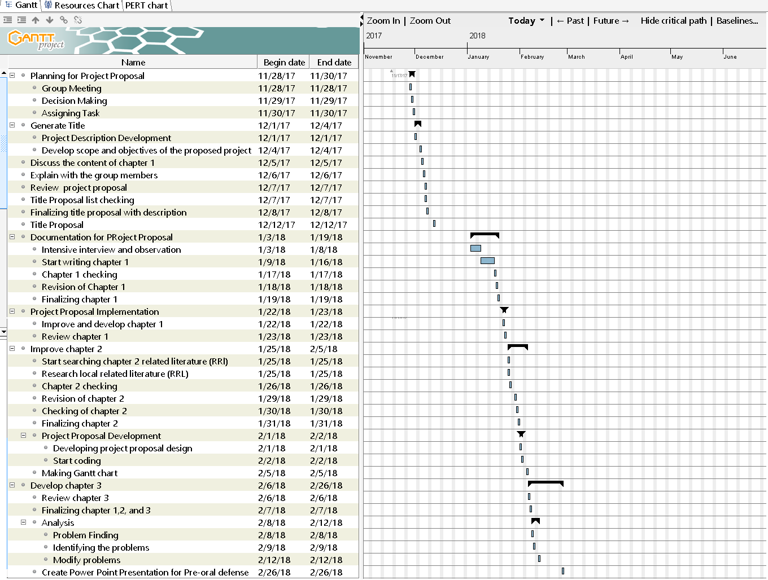

**Time Table**

|  |  |  |  |
| --- | --- | --- | --- |
| Task | Date Started | Date Finished | Assigned Members |
| Planning for Project Proposal | Nov. 28, 2017 | Nov. 30, 2017 | John Joseph G. Dubria, Kizzy G. De La Cruz, Joelina V. Salopisa |
| Group Meeting | Nov. 28 | Nov. 28 | John Joseph G. Dubria, Kizzy G. De La Cruz, Joelina V. Salopisa |
| Decision Making | Nov. 29 | Nov. 29 |  |
| Assigning Task | Nov. 30 | Nov. 30 |  |
| Generate Title | Dec. 1 | Dec. 2 | John Joseph G. Dubria, Kizzy G. Dela Cruz, Joelina V. Salopisa |
| Project Description Development | Dec. 2 | Dec. 3 | John Joseph G. Dubria, Kizzy G. Dela Cruz, Joelina V. Salopisa |
| Develop Scope and Objectives of the proposed project | Dec. 4 | Dec. 5 | John Joseph G. Dubria, Kizzy G. Dela Cruz, Joelina V. Salopisa |
| Discuss the content of chapter 1 |  |  | John Joseph G. Dubria, Kizzy G. De La Cruz, Joelina V. Salopisa |
| Explain with the group members | Dec. 6 | Dec. 6 | John Joseph G. Dubria, Kizzy G. De La Cruz, Joelina V. Salopisa |
| Review project proposal | Dec. 12 | Dec. 12 | John Joseph G. Dubria, Kizzy G. De La Cruz, Joelina V. Salopisa |
| Title proposal list checking | Dec. 15 | Dec. 15 | John Joseph G. Dubria, Kizzy G. De La Cruz, Joelina V. Salopisa |
| Finalizing title proposal with description | Dec 19 | Dec. 22 | John Joseph G. Dubria, Kizzy G. De La Cruz, Joelina V. Salopisa |
| Title proposal | Jan. 3 2018 | Jan. 3 2018 | John Joseph G. Dubria, Kizzy G. De La Cruz, Joelina V. Salopisa |
| Document for project proposal | Jan. 4 | Jan. 5 | John Joseph G. Dubria, Kizzy G. De La Cruz, Joelina V. Salopisa |
| Intensive interview and observation | Jan.18 | Jan. 18 | John Joseph G. Dubria, Kizzy G. De La Cruz, Joelina V. Salopisa |
| Start writing chapter 1 | Jan. 19 | Jan. 19 | John Joseph G. Dubria, Kizzy G. De La Cruz, Joelina V. Salopisa |
| Chapter 1 checking | Jan. 20 | Jan. 26 | John Joseph G. Dubria, Kizzy G. De La Cruz, Joelina V. Salopisa |
| Revision of chapter 1 | Jan. 29 | Jan. 29 | John Joseph G. Dubria, Kizzy G. De La Cruz, Joelina V. Salopisa |
| Finalizing chapter 1 | Jan. 30 | Jan. 30 | John Joseph G. Dubria, Kizzy G. De La Cruz, Joelina V. Salopisa |
| Project proposed implementation | Jan. 31 | Jan. 31 | John Joseph G. Dubria, Kizzy G. De La Cruz, Joelina V. Salopisa |
| Improve and develop chapter 1 | Feb. 1 | Feb. 1 | John Joseph G. Dubria, Kizzy G. De La Cruz, Joelina V. Salopisa |
| Review chapter 1 | Feb. 2 | Feb. 9 | John Joseph G. Dubria, Kizzy G. De La Cruz, Joelina V. Salopisa |
| Improve chapter 2 | Feb. 12 | Feb. 12 | John Joseph G. Dubria, Kizzy G. De La Cruz, Joelina V. Salopisa |
| Start checking chapter2 related literature (RR) | Feb. 13 | Feb. 13 | John Joseph G. Dubria, Kizzy G. De La Cruz, Joelina V. Salopisa |
| Research local related literature | Feb. 20 | Feb. 20 | John Joseph G. Dubria, Kizzy G. De La Cruz, Joelina V. Salopisa |
| Chapter 2 checking | Feb. 22 | Feb. 23 | John Joseph G. Dubria, Kizzy G. De La Cruz, Joelina V. Salopisa |
| Revision of chapter 2 |  |  | John Joseph G. Dubria, Kizzy G. De La Cruz, Joelina V. Salopisa |
| Checking of chapter 2 |  |  | John Joseph G. Dubria, Kizzy G. De La Cruz, Joelina V. Salopisa |
| Finalizing chapter 2 |  |  | John Joseph G. Dubria, Kizzy G. De La Cruz, Joelina V. Salopisa |
| Project proposal development |  |  | John Joseph G. Dubria, Kizzy G. De La Cruz, Joelina V. Salopisa |
| Developing project proposal design |  |  | John Joseph G. Dubria, Kizzy G. De La Cruz, Joelina V. Salopisa |
| Start coding |  |  | John Joseph G. Dubria, Kizzy G. De La Cruz, Joelina V. Salopisa |
| Making Gantt Chart |  |  | John Joseph G. Dubria, Kizzy G. De La Cruz, Joelina V. Salopisa |
| Develop chapter 3 |  |  | John Joseph G. Dubria, Kizzy G. De La Cruz, Joelina V. Salopisa |
| Review chapter 3 |  |  | John Joseph G. Dubria, Kizzy G. De La Cruz, Joelina V. Salopisa |
| Finalizing chapter 1,2 and 3 |  |  | John Joseph G. Dubria, Kizzy G. De La Cruz, Joelina V. Salopisa |
| Analysis |  |  | John Joseph G. Dubria, Kizzy G. De La Cruz, Joelina V. Salopisa |
| Problem finding |  |  | John Joseph G. Dubria, Kizzy G. De La Cruz, Joelina V. Salopisa |
| Identifying problems |  |  | John Joseph G. Dubria, Kizzy G. De La Cruz, Joelina V. Salopisa |
| Modify problems |  |  | John Joseph G. Dubria, Kizzy G. De La Cruz, Joelina V. Salopisa |
| Create power point presentation for pre-oral defense |  |  | John Joseph G. Dubria, Kizzy G. De La Cruz, Joelina V. Salopisa |

**CHAPTER IV**

**PRESENTATION AND DISCUSSION OF RESULTS**

This chapter shows the results of evaluation of the developed system conducted by the proponents.

SOFTWARE EVALUATION RESULTS

**Functionality Characteristics**

Table 9: Functionality Characteristics

|  |  |  |
| --- | --- | --- |
| **Criteria** | **Average** | **Verbal Interpretation** |
| Suitability |  |  |
| Accuracy |  |  |
| Interoperability |  |  |
| Security |  |  |
| Functionality Compliance |  |  |
| Sub Mean result | |  |

Table 9 displays the rating of functionality characteristics of the developed system. The suitability, accuracy, interoperability, security and functionality compliance were rated as good. The overall mean 4.3 is interpreted as good. This implied that the software has the capability to provide functions which meet stated and implied needs when it is used.

Functionality Characteristics shows the result of Functionality Characteristics rated

**Reliability Characteristics**

Table 10: Reliability Characteristics

|  |  |  |
| --- | --- | --- |
| **Criteria** | **Average** | **Verbal Interpretation** |
| Maturity |  |  |
| Fault Tolerance |  |  |
| Recoverability |  |  |
| Reliability |  |  |
| Sub Mean Result | |  |

Table 10: Reliability Characteristics display the rating of the functionally of the developed The Online Brokerage System. The sub-mean was --- interpret as a **Good.** The result implied that the Reliability characteristics satisfy the user.

**Usability Characteristics**

Table 15: Usability Characteristics

|  |  |  |
| --- | --- | --- |
| **Criteria** | **Average** | **Verbal Interpretation** |
| Understandability |  |  |
| Learnability |  |  |
| Operability |  |  |
| Attractiveness |  |  |
| Usability |  |  |
| Sub Mean Results | |  |

Table 17: Usability Characteristics display the rating of the functionally of the developed The Online Brokerage System. The sub-mean was --- interpret as a **Good.** The result implied that the Usability characteristics satisfy the user.

**Efficiency Characteristics**

Table 16: Efficiency Characteristics

|  |  |  |
| --- | --- | --- |
| **Criteria** | **Average** | **Verbal Interpretation** |
| Time Behavior |  |  |
| Resource Utilization |  |  |
| Efficiency |  |  |
| Sub Mean Result | |  |

Table 18: Efficiency Characteristics display the rating of the functionally of the developed The Online Brokerage System. The sub-mean was --- interpret as a **Very** **Good.** The result implied that the Efficiency characteristics satisfy the user.

**Portability Characteristics**

Table 17: Portability Characteristics

|  |  |  |
| --- | --- | --- |
| **Criteria** | **Average** | **Verbal Interpretation** |
| Adaptability |  |  |
| Instability |  |  |
| Co-existence |  |  |
| Replaceability |  |  |
| Portability |  |  |
| Sub Mean Results | |  |

Table 20: Portability Characteristics display the rating of the functionally of the developed The Online Brokerage System. The sub-mean was --- interpret as a **Good.** The result implied that the Portability characteristics satisfy the user.

Table 19: Expert Evaluation Results

|  |  |  |
| --- | --- | --- |
| **Criteria** | **Average** | **Verbal Interpretation** |
| Auditability |  |  |
| Accuracy |  |  |
| Completeness |  |  |
| Communication |  |  |
| Conciseness |  |  |
| Consistency |  |  |
| Observability |  |  |
| Security |  |  |
| Operability |  |  |
| Self-Documentation |  |  |
| Simplicity |  |  |
| Software System Independence |  |  |
| Traceability |  |  |
| Training |  |  |
| Controllability |  |  |
| Data Commonality |  |  |
| Decomposability |  |  |
| Error Tolerance |  |  |
| Execution Efficiency |  |  |
| Expandability |  |  |
| Generality |  |  |
| Hardware Independence |  |  |
| Instrumentation |  |  |
| Modularity |  |  |
| Sub Mean Result | |  |

The **overall mean** of the expert survey is --- which is interpreted as **Good,** specifies that the proponents developed the system according to the need and wants of the user which based on the comments and rating of the five (5) IT experts.

**CHAPTER V**

**SUMMARY, CONCLUSION AND RECOMMENDATIONS**

SUMMARY of FINDINGS

The researcher conducted an evaluation of the proposed system to determine the acceptability from the users. The following are the findings of the proposed system evaluation.

1. Several user the over-all mean of the Chmsc- Binalbagan Document Custodianship, Management and Monitoring System with SMS Notification based on the specified criteria is interpreted as “Good”.
2. The results of the evaluation of the experts showed that the brokerage system was good and conformed to the criteria for the quality software product.

CONCLUSIONS

Based on the result of evaluation that was discussed in this chapter, the following conclusions were derived.

1. The developed The CHMSC-BINALBAGAN Document Custodianship, Management and Monitoring System with SMS Notification as per evaluated by the user revealed that all the software characteristics conformed to the software quality standard. Based on the evaluation ISO questionnaire, all characteristics had been rated by the users as a very good. The proponents conclude that the users expectation was successfully fulfilled by the proponents and by the user, it mean that is ready to deploy.

RECOMMENDATION

1. The developer may be modified by the other developers for further improvement. Future researcher can also modify the features and contents of the application as long related to the previous one.