Höhlenverein Blaubeuren e.V.
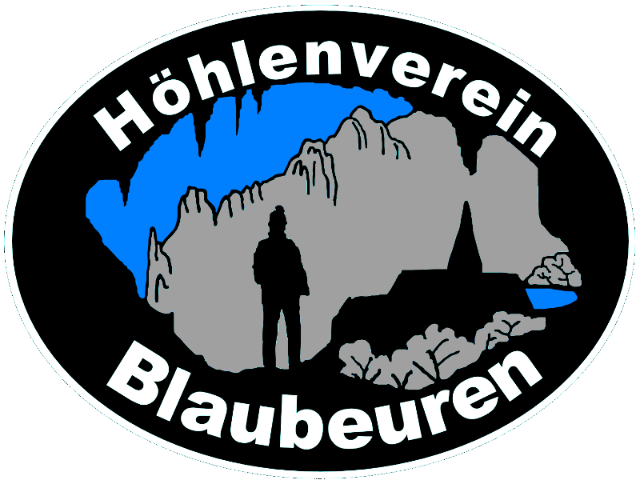
Petra Boldt
Hauptstr.4

D - 89601 Schelklingen - Schmiechen

Registration for the International Training Camp for Young Speleologists on the Schwabian Alb from July 30th – August 14th, 2010

Name:________________________ First name:________________ Date of birth:__________ (d.m.y)
Address:___________________________________________________________________________
Phone:_______________________ e-mail:________________________________________________
Nationality:_________________________ Profession:______________________________________

Courses you want to attend:

[ ] Techniques for Cave Exploration [ ] Electronics in Cave Research
[ ] Cave Survey [ ] Acquisition of Climate Data in Caves
[ ] Biology, Fauna and Eco-Systems in Caves [ ] Cave Climate
[ ] Geology [ ] Practical Hydrology
[ ] Research [ ] Documentation and Press Relations

The themes require between 3 and 5 days.

I will bring a tent [ ] yes no [ ]
In my tent I have additional room for ____ persons which have no tent.
Member of a youth organization, cave research organization, etc.:_______________________________
Cave experience: [ ] yes no [ ] Language skills:______________________________________
Special interests and knowledge: ________________________________________________________
What can you contribute to our program: __________________________________________________
___________________________________________________________________________________

[ ] I will travel with my own car
[ ] I will join _____________________ in his car.
[ ] Somebody will bring me with a car
[ ] I will travel by train
[ ] I will arrive on 30th of August (Friday) until 8pm for dinner.
[ ] I will arrive on 31st of August (Saturday) until noon.

I declare that my doctor has no objection against sport activities. Please ask your doctor if in doubt.

Date:________________(d.m.y) ______________________________________________________
(Signature, also from your parents if you are age of 17 or younger)

Please see next pages

Please let us know something about your activities as a speleologist, are you organized in a club and did you attend such a training camp in the past. If this is your first caving activity, please let us know where your interests on caving started. Please also write down what you expect from the camp and from your selected course and why you have chosen the course.

________________________________________________________________________________
________________________________________________________________________________
________________________________________________________________________________
________________________________________________________________________________
________________________________________________________________________________
________________________________________________________________________________
________________________________________________________________________________
________________________________________________________________________________
________________________________________________________________________________
________________________________________________________________________________
________________________________________________________________________________
________________________________________________________________________________
________________________________________________________________________________
________________________________________________________________________________
________________________________________________________________________________
________________________________________________________________________________
________________________________________________________________________________
________________________________________________________________________________
________________________________________________________________________________
________________________________________________________________________________
________________________________________________________________________________
________________________________________________________________________________
________________________________________________________________________________
________________________________________________________________________________
________________________________________________________________________________
________________________________________________________________________________
________________________________________________________________________________
________________________________________________________________________________
________________________________________________________________________________
________________________________________________________________________________
________________________________________________________________________________
________________________________________________________________________________
Höhlenverein Blaubeuren e.V.

International Training Camp for Young Speleologists
on the Schwabian Alb

From July 30th, 2010 to August 14th, 2010
Tent camp at the caving club building in Blaubeuren - Seissen
Recommended age for participants: 16 years and older

www.juhoefola.de

Caves are geotopes and biotopes therefore sensitive climate archives which are worth to explore.
Research and protection of this climate archives and the actual cave climate, which is an indicator of climate changes, is an actual and important European concern.
Speleologists can support the exploration and protection of these climate archives by international cooperation.
A good training is the best base for research and caving activities.
Therefore we offer different training courses and a wide supporting program covering all important caving themes. Due to small groups the training will be very effective.
An additional intention of the camp is to meet other young cavers. You can establish ties, talk about your and their interests, hobbies and culture and perhaps meet them in their home area and visit karst areas and caves for future joint research.

The camp is intended for young people who want to start with caving or who already have some experience and want to extend their skills.
You should understand German or English language.

We will offer the following courses:

I. Techniques for Cave Exploration including Rescue Topics
Main topic of this course is to learn solid basic skills in cave exploration. There will be topics about ropes and knots, security, rescue, rappelling in shafts, rope ladders and single rope techniques (SRT).

II. Cave Survey
A detailed cave plan is essential for cave research. You will learn the basics techniques of cave survey and how to draw a cave plan by hand and with a computer. You will train the usage of different survey equipment as compass, clinometer, DistoX and also work with a theodolithe.

III. Biology, Fauna und Eco-Systems in Caves
Methods for gathering information and documentation of the cave fauna will be shown. You will take probes in a cave and learn how to write documentation and interpret the data. The result should be to get a feeling about the status of flora and fauna in the cave and become more sensible about the cave as a fragile biological system.

IV. Geology
Geology is investigating how caves form but also delivers valuable information for cavers.
We will learn the basics of geology as reading of geological maps, profiles, tectonics, mineralogy and sediments which can show the climate during the last thousands of years. Depending on the weather situation, we will do practical field work in the Geo-Park Swabian Alb. We will hike to a meteor crater, visit remains of volcanism and collect fossils.

V. Research
The participants of this course will attend real research projects in different caves on the swabian Alb. You will see different strategies to find new caves. Inside caves you will practice different methods to dig, split rocks and get practical experience how to secure shafts and tunnels. We will look for specific geological specialties as clay horizons, artifacts and special sediment layers and document it. We will also talk about security aspects and unsafe environment in a cave. Beside this digging efforts we will visit other caves on the swabian alb.

VI. Electronics in Cave Research
Radio direction finding, communication in caves thru wire and wireless, GPS navigation, etc. We will train usage of cave communication equipment to complete the theoretical knowledge.

VII. Acquisition of Climate Data in Caves
We will show and explain equipment for climate data acquisition and transmission to the surface. Beside theoretical knowledge we will show and train the practical usage of the equipment.

VIII. Cave Climate
Introduction into cave climate research. How does it work? Cave protection, exploration, air temperature and air circulation will be shown in theory and practical training. How to plan your own project? How to evaluate data?

IX. Practical Hydrology
Measurements of water drain and water pile up experiments will be done to calculate unknown cave volumes behind springs. We will also do salt tracer experiments and analysis. Theory and practical work will be shown.

X. Documentation and Press Relations
Maps, cave register, permits. We will talk about the approval processes especially in Germany and show the backgrounds. This also includes public relation which becomes more and more important.

For all participants the following additional presentations will be offered:
- Regional geology, building of caves, cave content, knowledge about technical caving material, cave rescue, cave protection, bat protection and much much more...
- Field trip on the swabian alb
- Field trip: Landscape- and prehistoric hike in the Schmiech-, Ach- and Blau- valley.
The evenings at the camp are mainly for sociality and coming together. If you own a musical instrument or sports equipment, please bring it to the camp.
The camp is located in the caving club building of the “Höhlenverein Blaubeuren” near Blaubeuren-Seissen. We can offer a big room, restrooms and showers and a campfire place for comfortable evenings. You can camp at the edge of the forest around the building. There is also enough place for motor homes. Electricity will be available only occasionally.

Please bring the following basic equipment for caving:
Overall (Schlaz), enough warm underwear, e.g. under-schlaz, warm track suit or equivalent, rubber boots with a good profile, helmet with electrical lamp (no carbide lamp), spare lamp, accumulator loader.

The participation fee is: Age 25 and younger 240.- € (Sponsored by the EU)
Age 26 and older 350.- €

This includes:
For 16 days: Accommodation (Recreation room, place for a tent, restrooms with showers), 3 meals per day, support and training in small groups by experienced cavers, excursions and entrance fees for common activities, a CD with the course documentation, youth group insurance (health, third party liability, accident) for participants age 25 and younger for the duration of the camp. Please bring an international health insurance certificate to make processing easier.
For participants age 26 and older we strongly recommend to have their own insurance (health, third party liability, accident including salvage costs as offered for example for “Deutscher Alpenverein DAV”-members).

The advance payment is € 50.-. Please send it immediately after reception of the confirmation of course registration. The rest must be send until June, 30th, 2010.

Please fill out the registration with printed letters, that we can get an error free list of participants, which we can distribute. You can also fill out the registration with the computer, but then print it out, sign it and send it to the camp organizer.

For more information, addresses, etc. please see: www.juhoefola.de or call: +49-7394-1566

Please send your printed registration with regular mail (because of the signature) to:
Petra Boldt
Hauptstr.4
D-89601 Schelklingen-Schmiechen
Phone: +49-7394-1566

Closing date is June, 30th, 2010.

Due to the limited capacity, we recommend fast registration.

With the confirmation of course registration you will get a detailed plan where we are located and a list, which things you should bring to the camp.

