Test document – lpod

Below are some pictured from planes of the WWII (Air museum, Le Bourget – France).
- Two pics from a Spitfire,
- a Thunderbolt

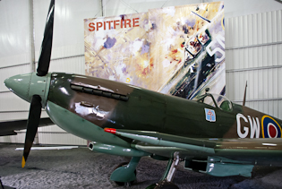

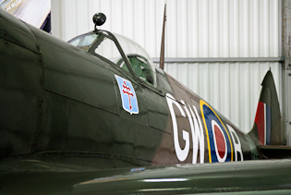
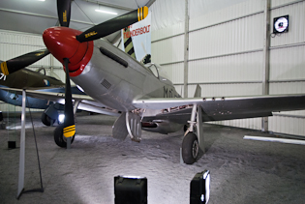Illustration 1: Thunderbolt

