Image test

A chair :
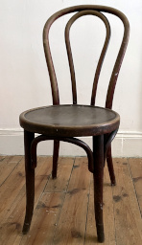Figure 1 chair

